Brett Tomita

Exercise: Auto Repair

* You are designing a database for an automobile repair shop. When a customer brings in a vehicle, a service advisor will write up a repair order. This order will identify the customer and the vehicle, along with the date of service and the name of the advisor.
* A vehicle might need several different types of service in a single visit. These could include oil change, lubrication, rotate tires, and so on.
* Each type of service is billed at a pre-determined number of hours work, regardless of the actual time spent by the technician.
* Each type of service also has a flat book rate of dollars-per-hour that is charged.
  + Describe each class in English.
    - A vehicle is a machine that is designed to help people travel at high rates of speed
    - A service is a maintenance job that is done on a vehicle
    - A Repair order is a list of services that needs to be done on a vehicle
  + Draw the class diagram, including association classes if required.
* 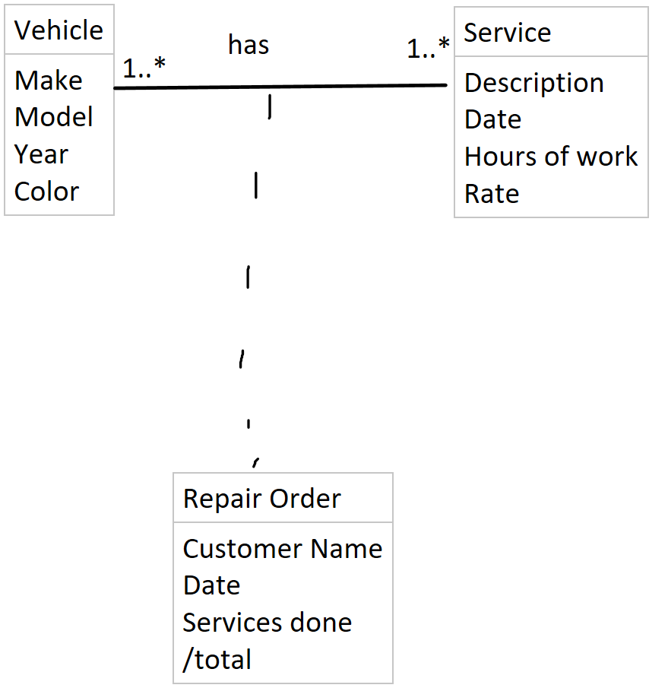
  + Describe each association in English (both directions).
    - One vehicle has one to many repair orders
    - One repair order belongs to one and only one vehicle
    - One service shows up on one to many repair orders
    - One repair order has one and only one of each type of service
  + Draw the relation scheme.
* 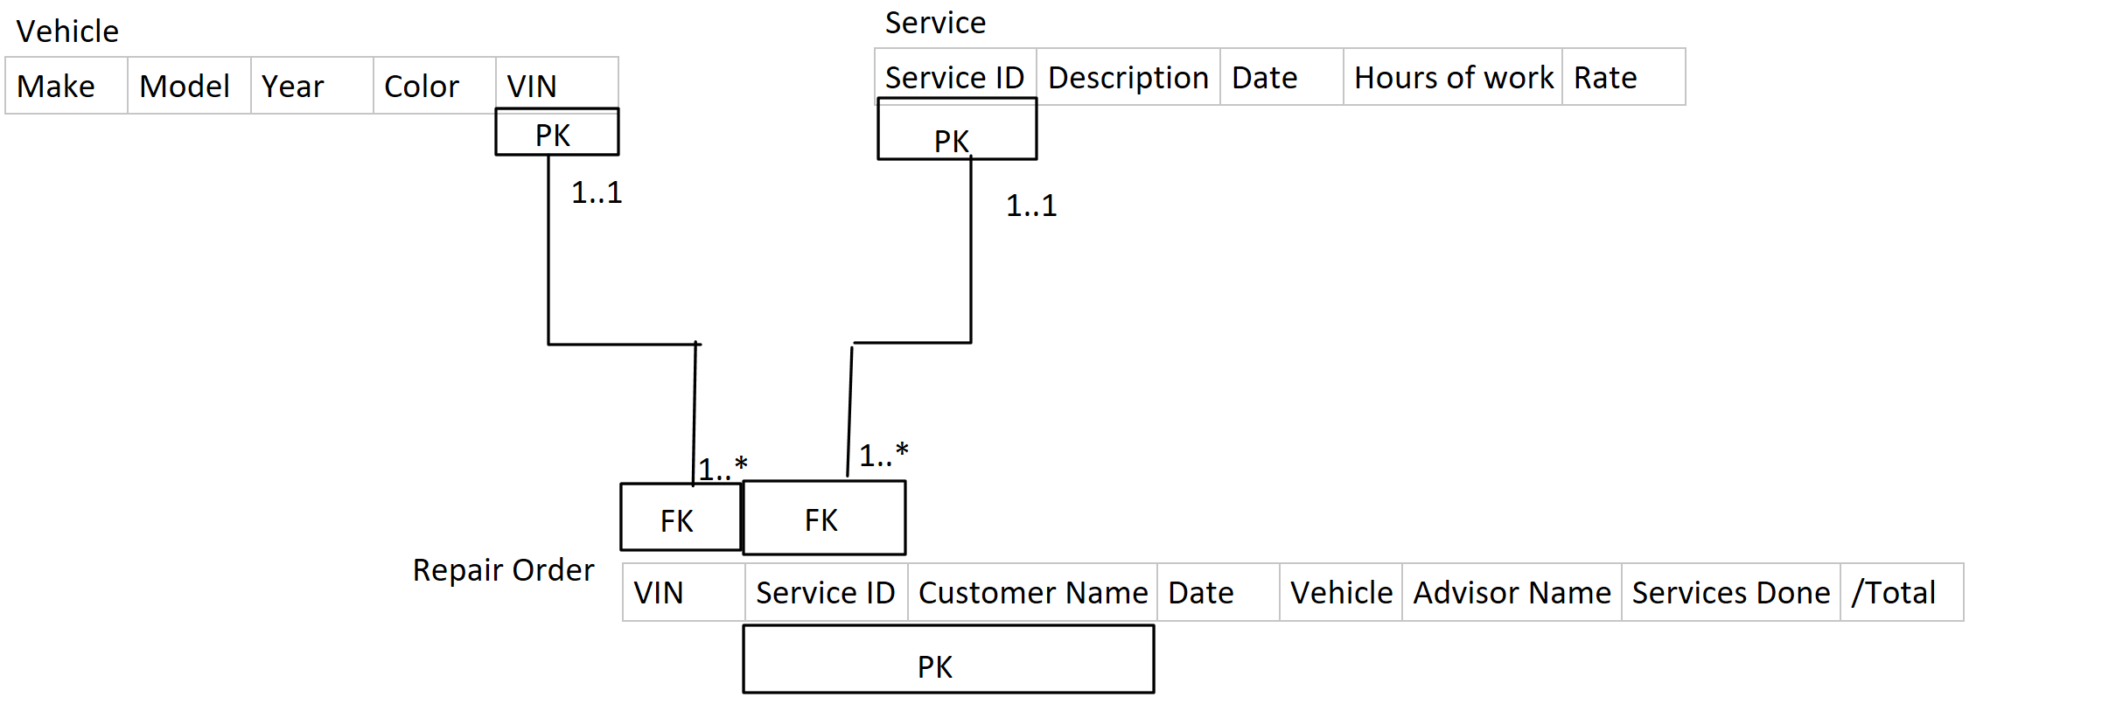
* The solution to this exercise will be discussed in class