Brett Tomita

Exercise: Book Authors

* Refer back to the [library book exercise](http://web.csulb.edu/~dbrown/CECS323/Homework/CECS%20323%20Homework%20Library%20Books.pdf) in the preceding section if necessary. Remember that we couldn't include authors in the CatalogEntry class because there might be more than one author for each book.
* In a real (old-fashioned) library catalog, there was an additional card for each author of a book. (Author and title cards were contained in different sets of card drawers.) Suppose that on these cards we would have such things as:
  + Author’s last name
  + Author’s first name
  + Author’s Date of Birth
  + Author’s death (if deceased)
  + Country of origin
* Design a class diagram that shows the catalog entry plus authors (and their attributes), the attributes of each class, and the association between the classes.
  + Describe each class in English.
    - A Catalog Entry is information about a published book that is available at the library
    - An Author list is a combination of all the people who worked on a book
    - An author card is an individual document containing information about a single person who worked on a book
  + Draw the class diagram.
* 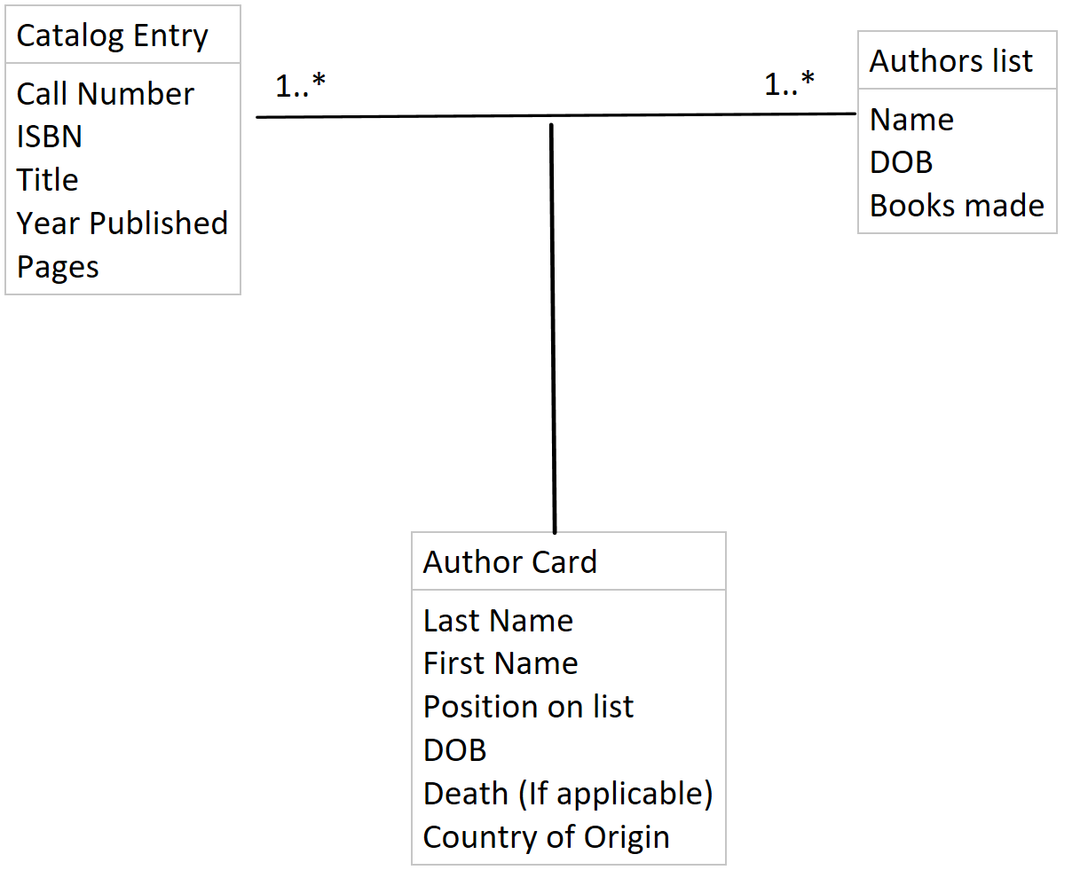
  + Describe each association in English (both directions).
    - One Catalog Entry has one to many Author Cards
    - One Author card belongs to one and only one catalog entry
    - One Authors list has one to many Author cards
    - One Author cards belongs to one and only one Authors list
  + Draw the relation scheme.
* 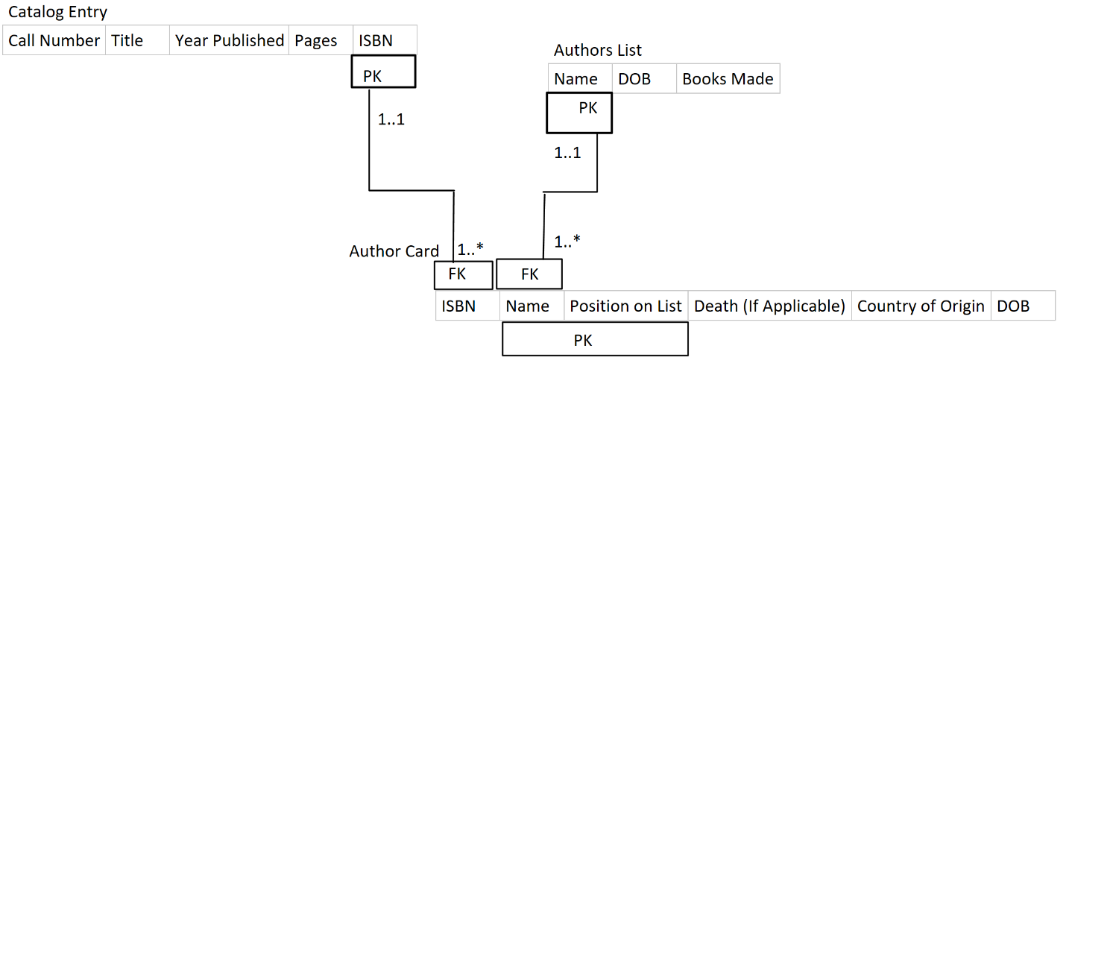
* Your first version of this model might not have included a way to identify which author should be listed first, second, and so on. In real life, authors are very sensitive about this. Revise your model if necessary to accommodate this requirement.
* The solution to this exercise will be discussed in class

**Latest Update: 3/4/2017 5:26 PM**

**David.brown@csulb.edu**