Brett Tomita

Exercise: Cities and States

* Part of a database that you are developing will contain information about cities and states in the United States. Each city is located in only one state. (Texarkana, Texas is a different city than Texarkana, Arkansas.)
  + Describe each class in English.
    - A city is a named community within a state that has its own legal government body, which may have its own set of laws and regulations that exist alongside the state and federal laws and regulations. Multiple contiguous cities make up a state.
    - A state is a large, unique territory within the United States. It has its own government body and has a certain number of congressional representatives that act on behalf of the state.
  + Draw the class diagram.
* 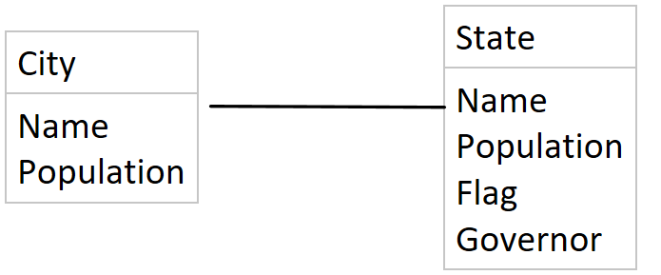
  + Describe each association in English (both directions).
    - One state has one to many cities
    - One city has one and only one state
  + Draw the relation scheme.
* 