Brett Tomita

Exercise: Library Books

* You are building a very simplified beginning of the database for a library.
* The library, of course, owns (physical) books that are stored on shelves and checked out by customers. Each of these books is represented by a catalog entry (now in the computer, but think of an old-fashioned card file as a model of this).
* Assume that there is only one title card for each book in the catalog, but there can be many physical copies of that book on the shelves.
* Call the title card class a CatalogEntry and the physical book class a BookOnShelf.
* You might think of the book's publisher as a simple attribute of the catalog entry but in fact, the library will probably want to know more than just the publisher's name (for example, the phone number where they can contact a sales representative).
* Describe each class in English.
  + A publisher is an company or organization that prints books
  + A CatalogEntry is information about a published book that is available at the library
  + A BookOnShelf is information about the availability of a specific publication that the library owns
* Draw the class diagram.
* 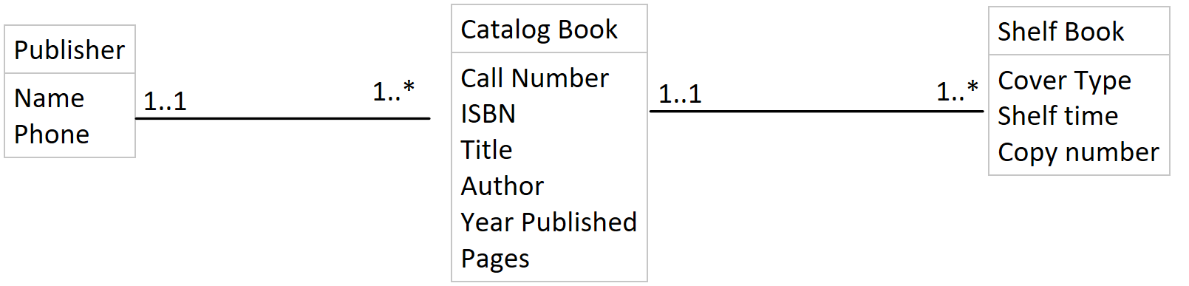
* Describe each association in English (both directions).
  + One publisher has one to many catalog books
  + One catalog book has one and only one publisher
  + One Catalog book has one to many shelf books
  + One shelf book has one and only one catalog book
* Draw the relation scheme.
* 