Brett Tomita

Exercise: Many-to-Many

Model the three many-to-many relationships listed below. You will need to model the classes, their attributes, and the relationship between them.

• Describe each class in English.

• Draw the class diagram, including association classes if required.

• Describe each association in English (both directions).

• Draw the relation scheme.

We’ll discuss the solutions in class.

1. You have a list of job applicants, and a list of interviewers. Each applicant goes through multiple interviews with different interviewers, and each interviewer hosts multiple interviews with different applicants. The applicant meets with each interviewer once.
   1. Describe each class in English
      1. A job applicant is a person who meets with a prospective employer for an interview in hopes of being hired.
      2. An interviewer is an employee who conducts a meeting with somebody looking to gain employment at the company
      3. An Interview Session is one meeting between a job applicant and an interviewer for an interview
   2. Class Diagram

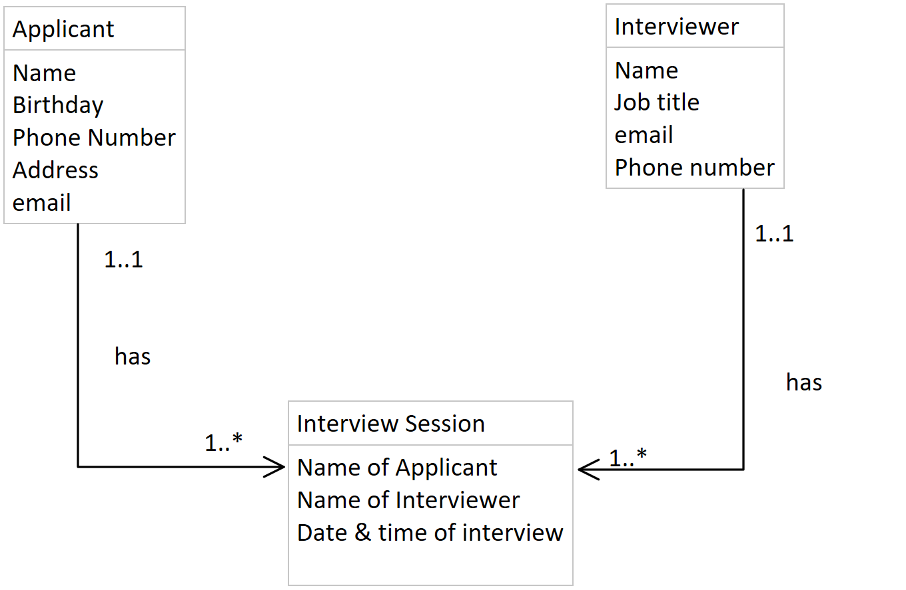

* 1. Association Description
     1. A job applicant has one to many interview session
     2. One interview session is associated with one and only one applicant
     3. One interviewer has one to many interview sessions
     4. One interview session is associated with one and only one interviewer
  2. Relation Scheme

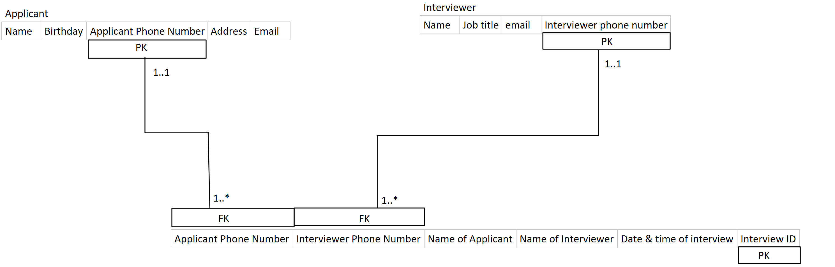

1. Developers write Technical Articles. Their Articles can be can be published in multiple Publications. Each of those Publications publish many articles.
   1. Describe each class in English
      1. A developer is a person who creates things and writes technical articles
      2. A technical article is a piece of work that discusses and informs on something a developer has created
      3. A publication is a collection of many technical articles
   2. Class diagram

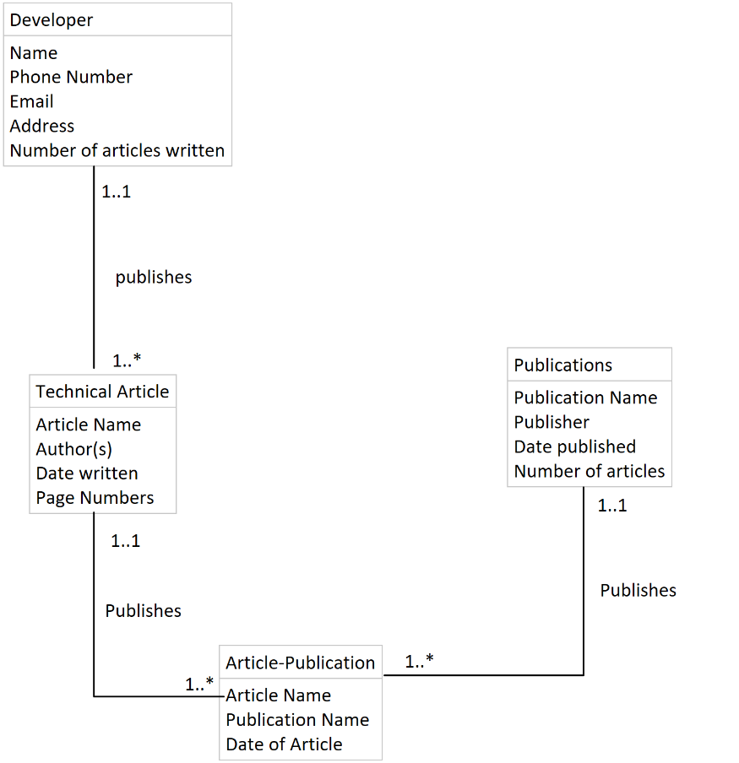

* 1. Association description
     1. One Developer publishes one to many technical articles
     2. One technical article is published by one and only one developer
     3. One technical Article is published in one to many Article Publications
     4. One Article Publication refers to one and only one published technical article
     5. One publication is published by one to many article publications
     6. One article-publication is associated with one and only one publisher
  2. Relation Scheme

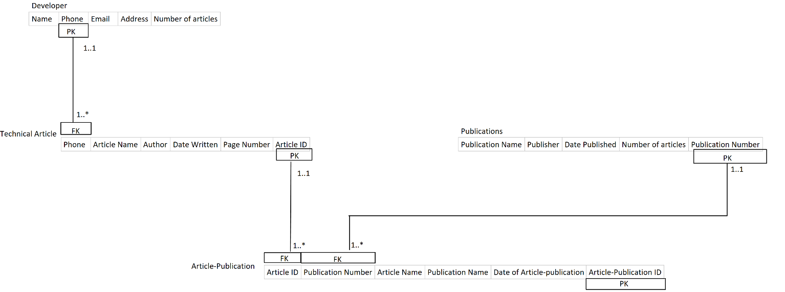

1. A hotel tracks customer reservations and the payments made for each of those reservations. A guest can have multiple reservations under their name as well as multiple payments for their stay recorded in their name.
   1. Describe each class
      1. A hotel is a business that rents rooms for people to live in for short amounts of time
      2. A guest is someone who visits the hotel
      3. A customer reservation is an agreement between the customer and hotel in regards to the rental of a room
      4. A visit is every time a customer stays at a hotel under at least one reservation
   2. Class Diagram

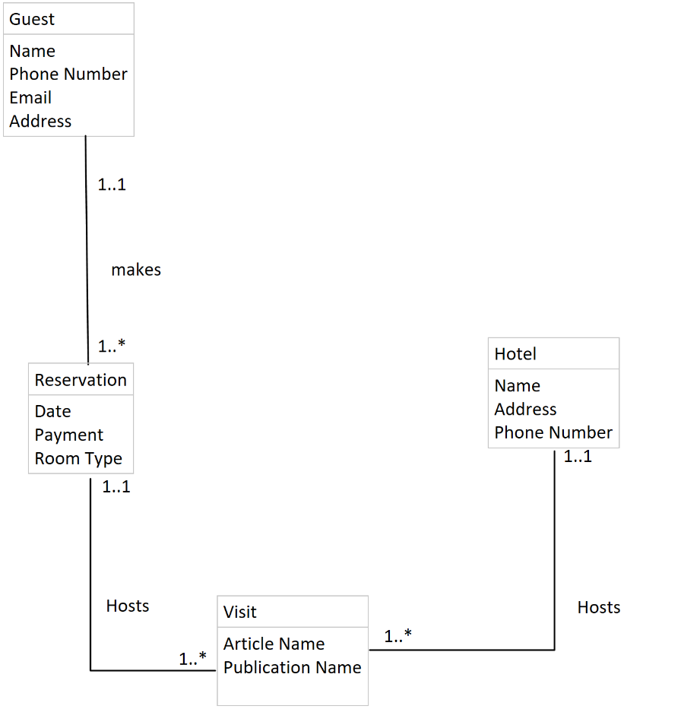

* 1. Association description
     1. A guest makes one to many reservations
     2. A reservation is made by one and only one guest
     3. A reservation hosts one to many visits
     4. One visit is a host to one and only one reservation
     5. A hotel hosts one to many visits
     6. A visit is hosted by one and only one hotel
  2. Relation Scheme