Brett Tomita

Exercise: Patients and Blood Samples

* The one-to-many association is perhaps the most common one that you will encounter in database modeling. As an example, we will look at the enterprise of a medical clinic.
* We wish to track the level of various substances (for example, cholesterol or alcohol) in the blood of patients. For each blood sample that is taken from the patient, one test will be performed and the date of the sample, the substance tested, and the measured level of that substance will be recorded in a database.
  + Describe each class in English.
    - A patient is a person who visits a medical professional for medical help or advice.
    - A blood sample is a collection of a patient’s bodily fluid that contains DNA as well as other information about that person’s health
  + Draw the class diagram.
* 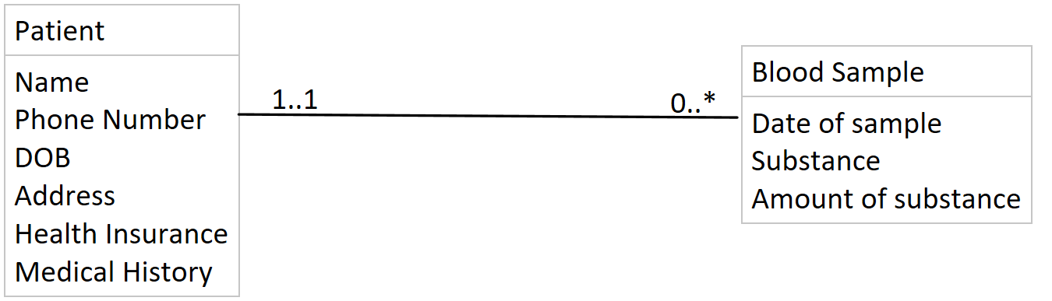
  + Describe each association in English (both directions).
    - One patient has one to many blood tests done
    - One blood test is done on one and only one patient
  + Draw the relation scheme.

