Brett Tomita

Exercise: Redbox - DVD Rentals

* You are designing a database for a DVD Rental Kiosk. To start, you need the part of the system that will allow a customer to check out a group of dvds and receive an invoice that lists them along with the cost and the date they are due.
  + Describe each class in English.
    - A DVD is a digital copy of a film
    - A rental is the temporary acquisition of a DVD for a set price.
    - A rental order is a list of all DVD rentals made by one person
  + Draw the class diagram, including association classes if required.
* 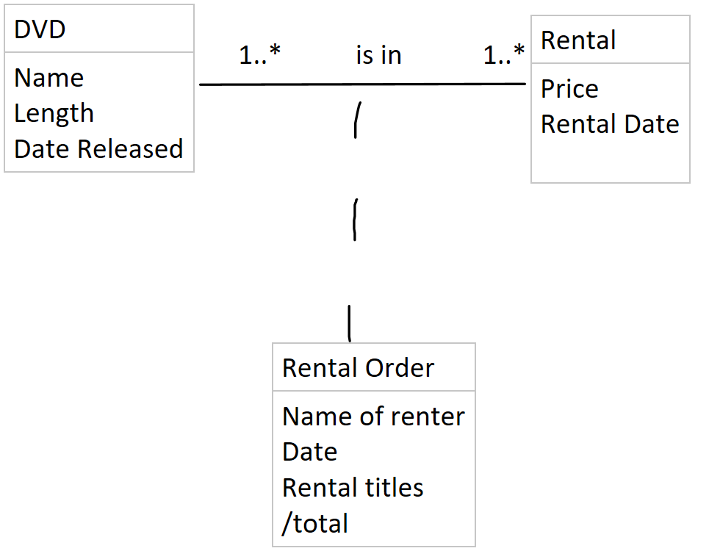
  + Describe each association in English (both directions).
    - One DVD is on one to many Rental Orders
    - One Rental Order belongs to one and only one DVD
    - One Rental is on one to many Rental Orders
    - One rental order belongs to one and only one rental
  + Draw the relation scheme.
* 