Brett Tomita

Exercise: Software List

* The following problem can be solved as either a Multi-Valued Attribute problem or a Repeated Attributes problem. Solve both correctly for five points of extra-credit.
* Sometimes it takes more than just a glance at the class diagram to spot problems with a design.
  + Consider the following class type that might be used by a software vendor to list software titles that are available.

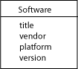

* There is nothing obviously wrong with this design. However, the users of this database might enter data that would cause problems, as shown in this table:

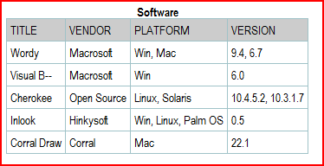

* + Revise the class diagram to correct any problems that you find in this design.
  + Then draw the relation scheme for your corrected model.
* 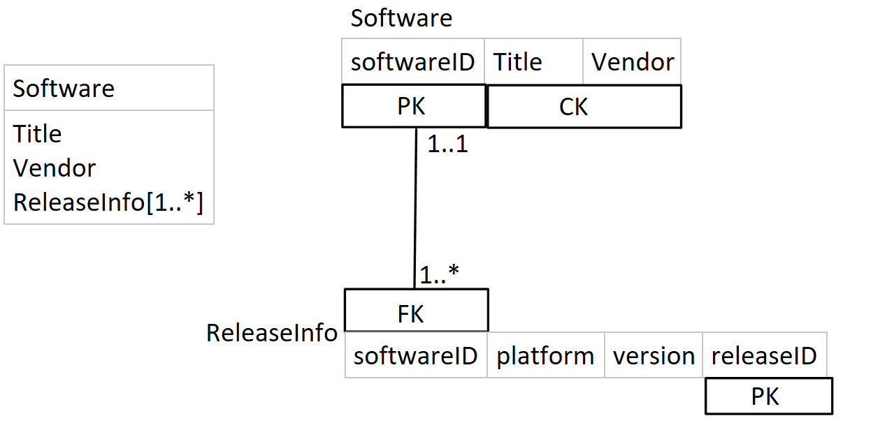

|  |
| --- |
| Software |
| Title  Vendor  ReleaseInfo[1..*]  (platform)  (version) |