Brett Tomita

Exercise: Students and Classes

* If you are using this Web site in a class at a university, you are probably interested in what grade you will get in the class.
* You will need to model the students and the (university) classes, their attributes, and the relationship between them. Be sure to show where the grade should be recorded.
  + Describe each class in English.
    - A student is a person who attends a university with the intent of gaining useful knowledge in a specified area that they will use to start their career.
    - A Class is a frequent meeting at a university, where a professor teaches students a particular subject and tests their understanding of the subject from time to time
    - A grade is a symbolic representation of a student’s understanding of a course’s material, and is assigned based on performance in a course
  + Draw the class diagram, including association classes if required.
* 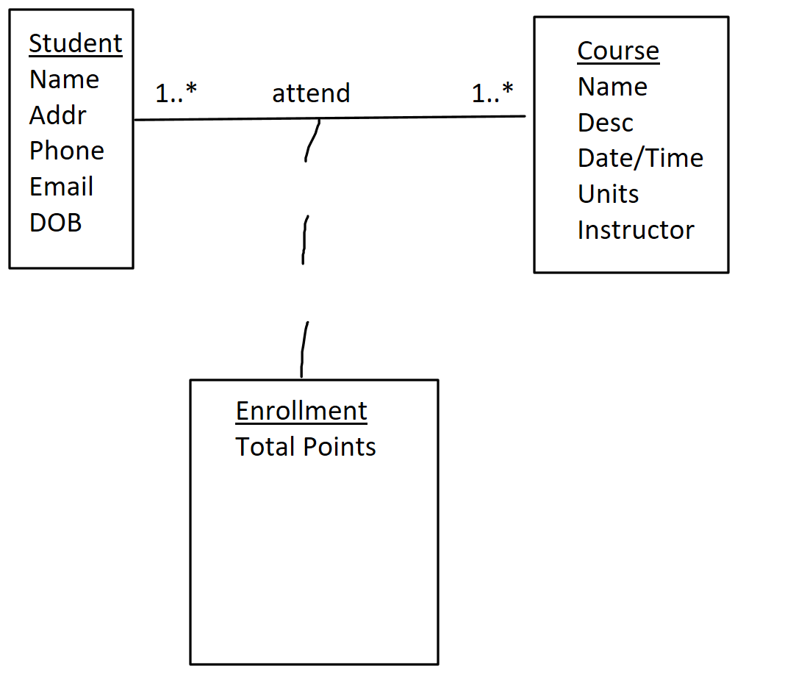
  + Describe each association in English (both directions).
    - One student takes one to many enrollments
    - One enrollment is taken by one and only one student
    - One course takes one to many enrollments
    - One enrollment is taken by one and only one course
  + Draw the relation scheme.
* 