Brett Tomita

Exercise: Employee Timecards

* You work for a startup IT company that performs web development for outside companies. In any given day, you may be working on more than one project. Projects are typically group projects so others may be working on the same project on the same day that you are.
* To keep track of what projects you and your co-workers are working on every day, each employee must create entries into the time system every night before they leave for that day. That time entry will list one project and the number of hours the employee worked on that project that day. There will be entry every day for each project that each person worked on that day.
  + Describe each class in English.
    - An employee is a person who works for a company
    - A project is an assignment that one or more employees work on
    - A time card is a document that records how long an employee worked on each project per day.
  + Draw the class diagram, including association classes if required.
    - 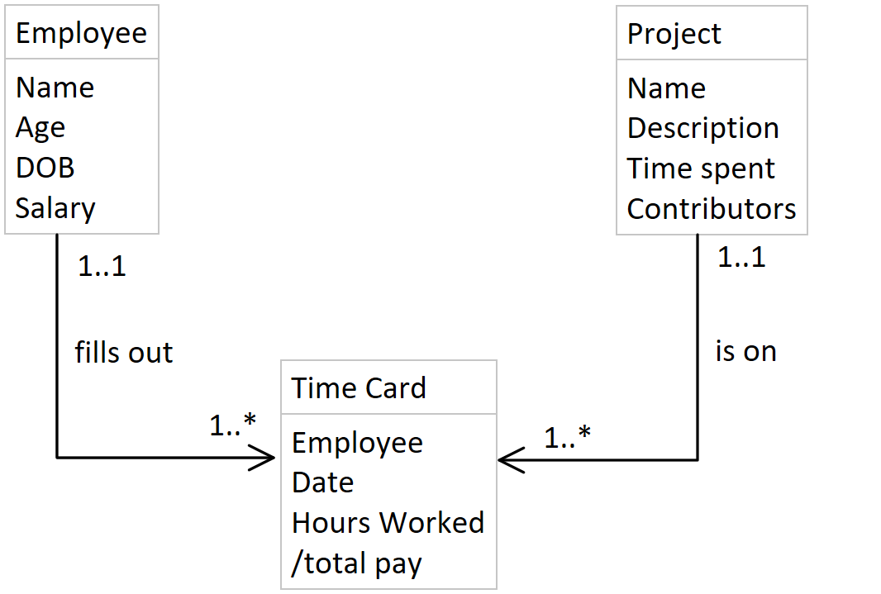
  + Describe each association in English (both directions).
    - One employee fills out one to many time cards
    - One time card belongs to one and only one employee
    - One project is on one to many time cards
    - One time card lists each project one and only one time
  + Draw the relation scheme.

