Brett Tomita

Exercise: More Many-to-Many with History
Model any three many-to-many with history relationships that you find. You will need to model the classes, their attributes, and the relationship between them.
• Describe each class in English.
• Draw the class diagram, including association classes if required.
• Describe each association in English (both directions).
• Draw the relation scheme.
We’ll discuss your examples in class.
- A movie theater with multiple showings of multiple movies
  - Describe each class
    - A movie theatre is a building with several large rooms filled with chairs facing a screen that shows a film.
    - A movie is a films shown in a movie theatre
    - A Movie viewing is a viewing of a specific movie at a specific time
  - Class Diagram
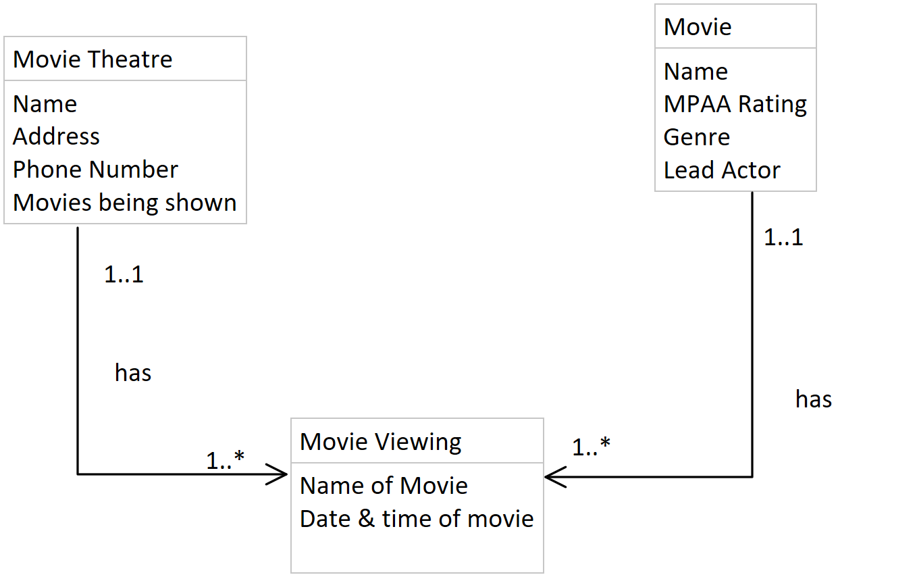
  - Describe each association in English
    - One movie theatre has one to many movie viewings
    - One movie viewing takes place in one and only one movie theatre
    - One movie has one to many movie viewings
    - One movie viewing is associated with one and only one movie
  - Relation Scheme
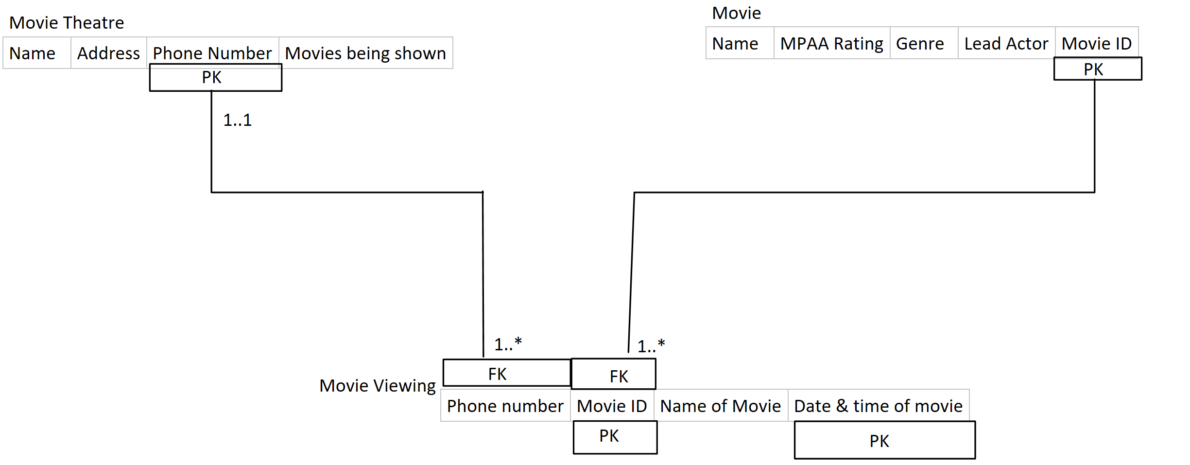

- Orders at a restaurant
  - Describe each class
    - A restaurant is a business that sells people food
    - A menu item is one food dish that the restaurant sells
    - A bill is a collection of all the menu items a party orders, as well as their prices and total
  - Class Diagram
- 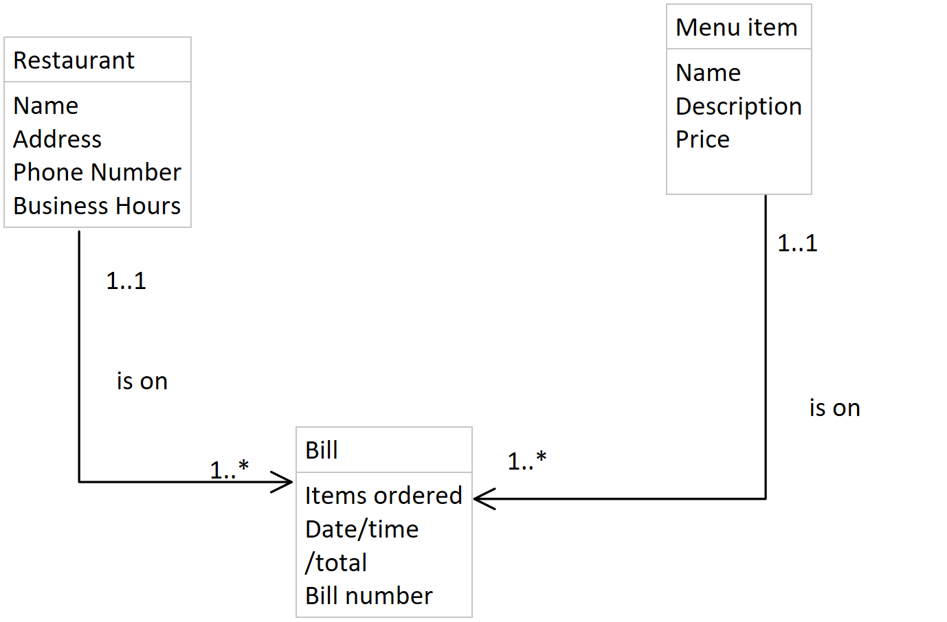

- Association Description
    - A restaurant is on one to many bills
    - A bill belongs to one and only one restaurant
    - A menu item is on one to many bills
    - A bill has one and only one of each item
- Relation Scheme
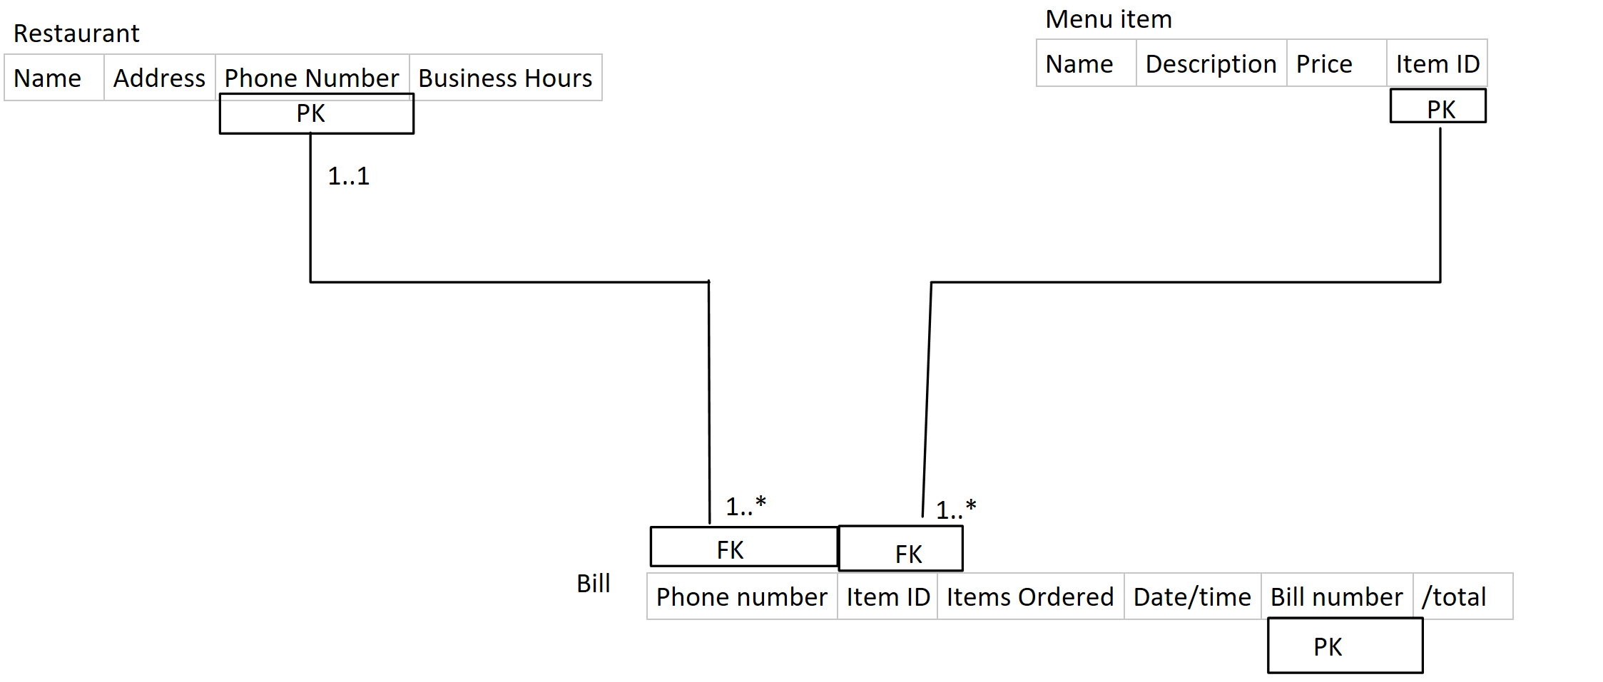
- Amazon Orders
  - Describe each class
    - A customer is anyone who purchases or plans to purchase something on Amazon
    - An Amazon item is anything Amazon sells
    - An order is a collection of Amazon items purchased by a person
  - Class diagram
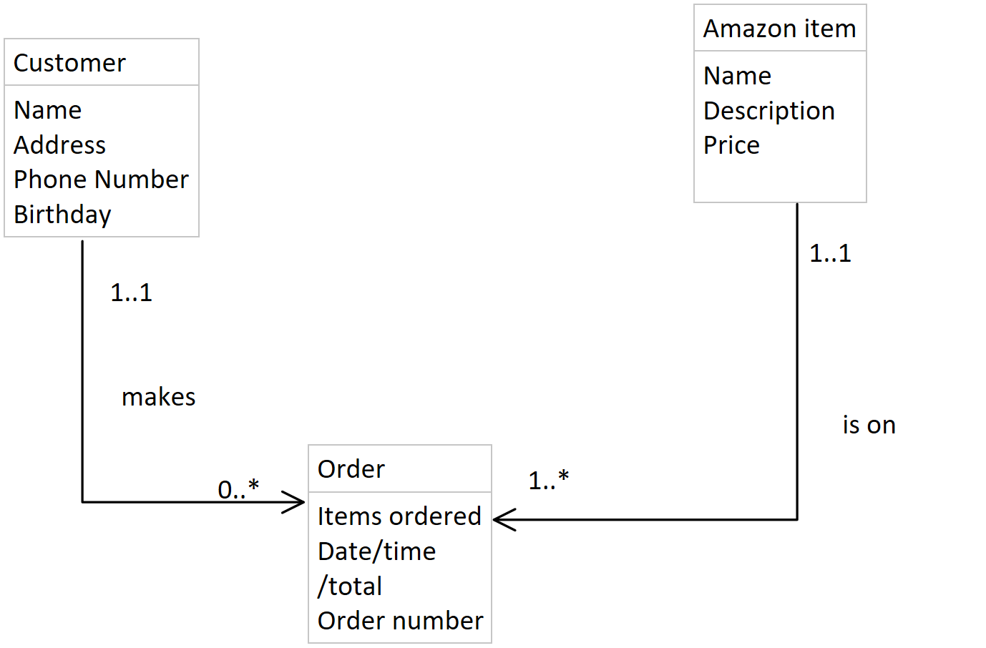
  - Association Description
    - One customer makes 0 to many orders
    - One order is made by one and only one customer
    - An amazon item is on one to many orders
    - An order contains one and only one of each amazon item
  - Relation Scheme
