Employees
EID | ENAME | DNAME | ROOM | TELNO
E01 | Smith | R&D | 101 | 2157
E02 | Jones | Sales | 105 | 2231
E03 | Wilkes | Sales | 105 | 2432
E04 | Smith | Finance | 108 | 4100
E09 | Brown | Sales | 109 | 2587

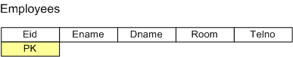

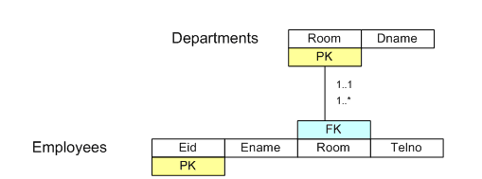

Employees
EID | ENAME | ROOM | TELNO
E01 | Smith | 101 | 2157
E02 | Jones | 105 | 2231
E03 | Wilkes | 105 | 2432
E04 | Smith | 108 | 4100
E09 | Brown | 109 | 2587
Departments
ROOM | DNAME
101 | R&D
105 | Sales
108 | Finance
109 | Sales

Suppliers
Supplier ID | Status | City | Part Number | Qty
S1 | 20 | London | P1 | 300
S1 | 20 | London | P2 | 200
S1 | 20 | London | P3 | 400
S1 | 20 | London | P4 | 200
S1 | 20 | London | P5 | 100
S1 | 20 | London | P6 | 100
S2 | 10 | Paris | P1 | 300
S2 | 10 | Paris | P2 | 400
S3 | 30 | Paris | P2 | 200
S4 | 20 | Rome | P2 | 200
S4 | 20 | Rome | P4 | 300
S4 | 20 | Rome | P5 | 400
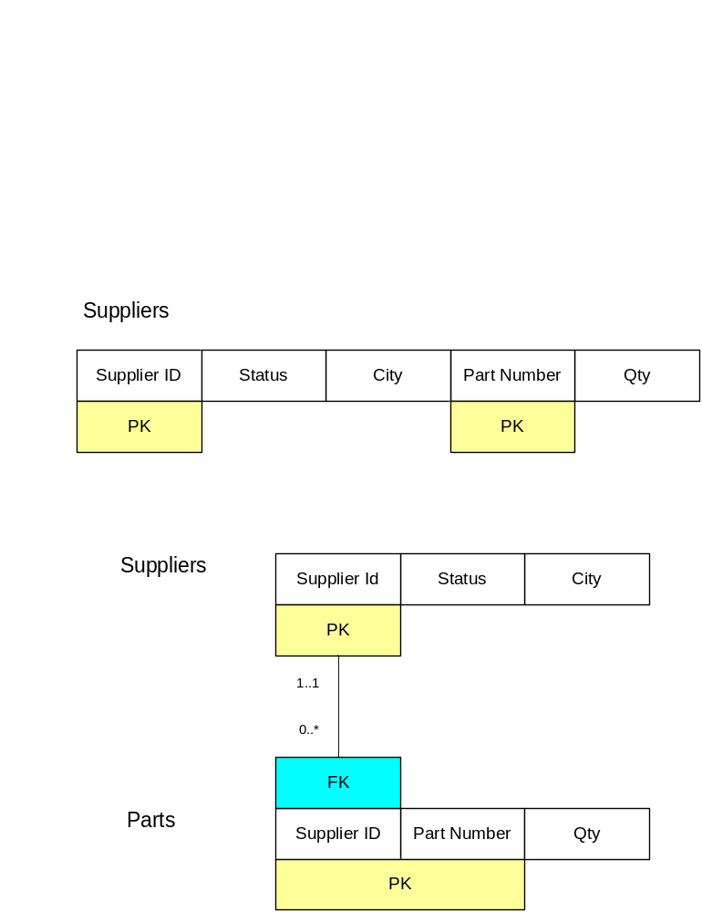

Suppliers |  |  |  | Parts
Supplier ID | Status | City |  | Supplier ID | Part Number | Quantity
S1 | 20 | London |  | S1 | P1 | 300
S2 | 10 | Paris |  | S1 | P2 | 200
S3 | 30 | Paris |  | S1 | P3 | 400
S4 | 20 | Rome |  | S1 | P4 | 200
 |  |  |  | S1 | P5 | 100
 |  |  |  | S1 | P6 | 100
 |  |  |  | S2 | P1 | 300
 |  |  |  | S2 | P2 | 400
 |  |  |  | S3 | P2 | 200
 |  |  |  | S4 | P2 | 200
 |  |  |  | S4 | P4 | 300
 |  |  |  | S4 | P5 | 400

