Launch a Redshift Cluster

**WARNING:** The cluster that you are about to launch will be live. Please note that Amazon Redshift no longer provides a free trial for provisioned clusters, and you will be charged the standard [**Amazon Redshift usage fees(opens in a new tab)**](https://aws.amazon.com/redshift/pricing/#On-demand_pricing) for the cluster until you delete it. You will not need to use the Redshift cluster in this lesson. If you create a Redshift cluster now, **Make sure to delete it each time you're finished working to avoid large, unexpected costs. Once you use your course budget, you will not be able to access the temporary AWS account you have been provided.** Instructions on deleting your cluster are included on the next page in this lesson.

Don't leave your Redshift cluster running overnight or throughout the week if you don't need to.

1. Sign in to the AWS Management Console and open the Amazon Redshift console at

[**https://us-east-1.console.aws.amazon.com/redshiftv2(opens in a new tab)**](https://us-east-1.console.aws.amazon.com/redshiftv2)

Navigate to a new service

1. From the left side panel, select Configurations → Subnet groups.

Choose **Create a cluster subnet group**

Subnet groups

Create a cluster subnet group from a default VPC

Success message/Complete status

1. By now you have created a subnet group. We will be using it while creating our cluster. On the same left side panel, choose Provisioned clusters dashboard and choose **Create cluster**. It will launch the *Create cluster* wizard.

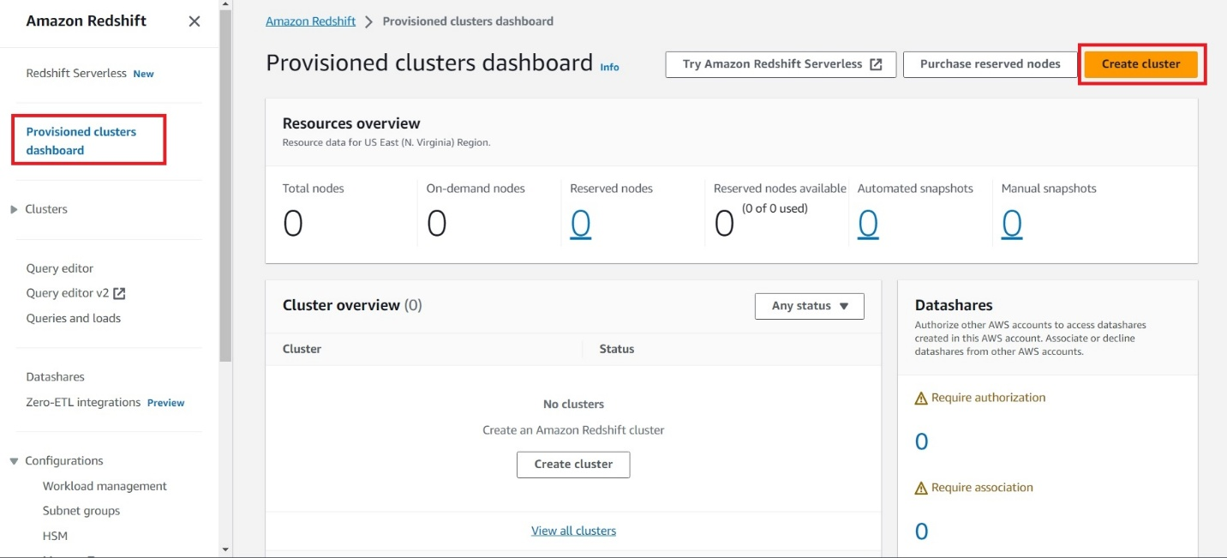

Amazon Redshift Create cluster wizard

* **Cluster configuration**

Provide a unique identifier, such as, redshift-cluster-1 and choose 1 node of dc2.large hardware type. It is a high performance with fixed local SSD storage with the below configuration:

* 1 node of dc2.large hardware type. It is a high performance with fixed local SSD storage
* 2 vCPUs
* 160 GB storage capacity

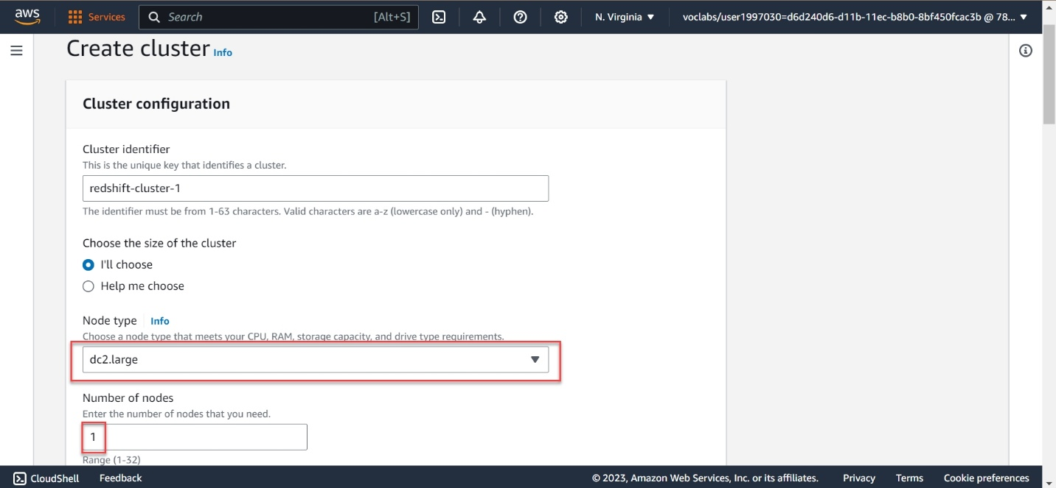

Cluster's basic configuration -1

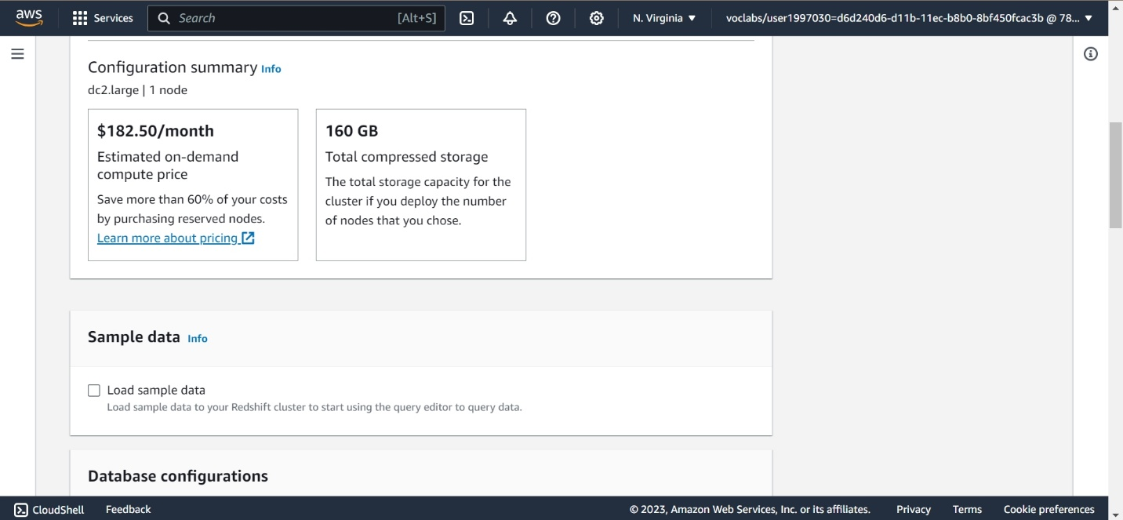

Cluster's basic configuration -2

* **Database configurations**

We will create an admin user. Choose a username, select *Manually add the admin password* and enter a password of your choice

**Please note:** We **strongly advise** you to keep these passwords closely guarded, including not putting them in your GitHub public repo, etc.

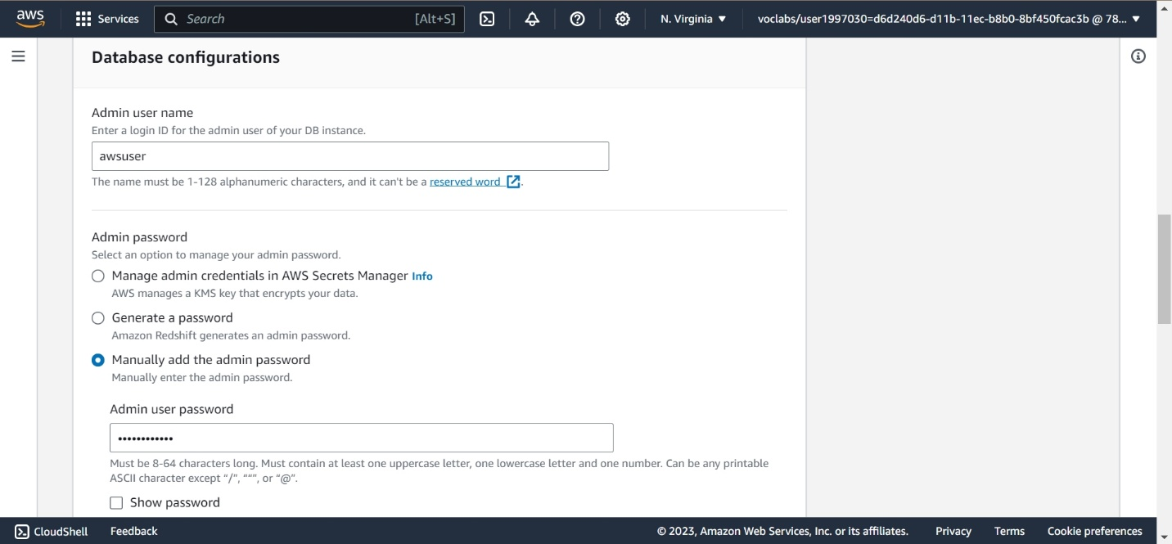

Database configurations

* **Cluster permissions (optional)**

Choose the IAM role created earlier, *myRedshiftRole*, from the drop-down and click on the *Associate IAM role* button.

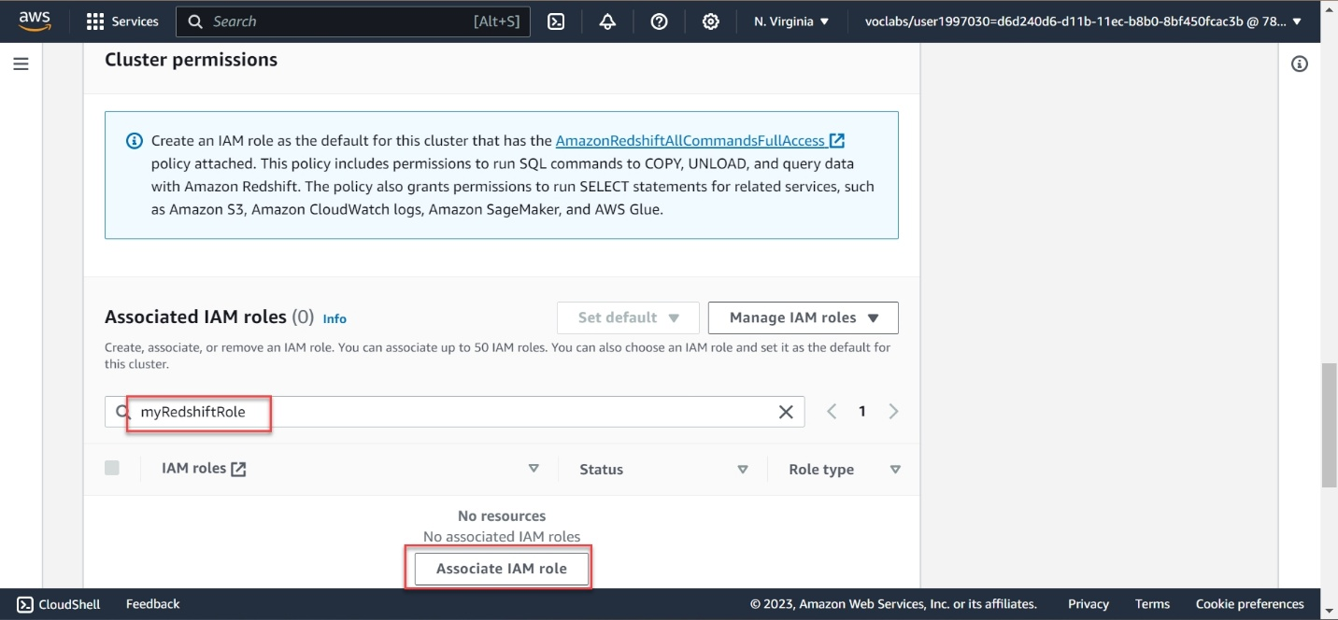

Cluster permissions

* **Additional configurations**

Toggle the button to turn off the "Use defaults" feature, and expand the **Network and security** section. Choose the following values:

| **Field** | **Value** |
| --- | --- |
| Virtual private cloud (VPC) | Default VPC If you are not able to view/select the default VPC, refer to the resolution given [**here(opens in a new tab)**](https://aws.amazon.com/premiumsupport/knowledge-center/vpc-redshift-associate/). You will have to [**create a cluster subnet group(opens in a new tab)**](https://docs.aws.amazon.com/redshift/latest/mgmt/managing-cluster-subnet-group-console.html#create-cluster-subnet-group). *(It's easy, see the steps mentioned above)* |
| VPC security groups | Choose the *redshift_security_group* created earlier. |
| Cluster subnet group | Choose the default It is the one you have just created. |
| Availability Zone | No preference |
| Enhanced VPC routing | Disabled |
| Publicly accessible | Enable |

Leave the rest **of** the values **as** **default**.

Network and security section

Now expand the **Database configurations** section

A few fields will be already filled up by default. Ensure to have to the following values:

| **Field** | **Value** |
| --- | --- |
| Database name | dev |
| Database port | 5439 |
| Encryption | Disabled |

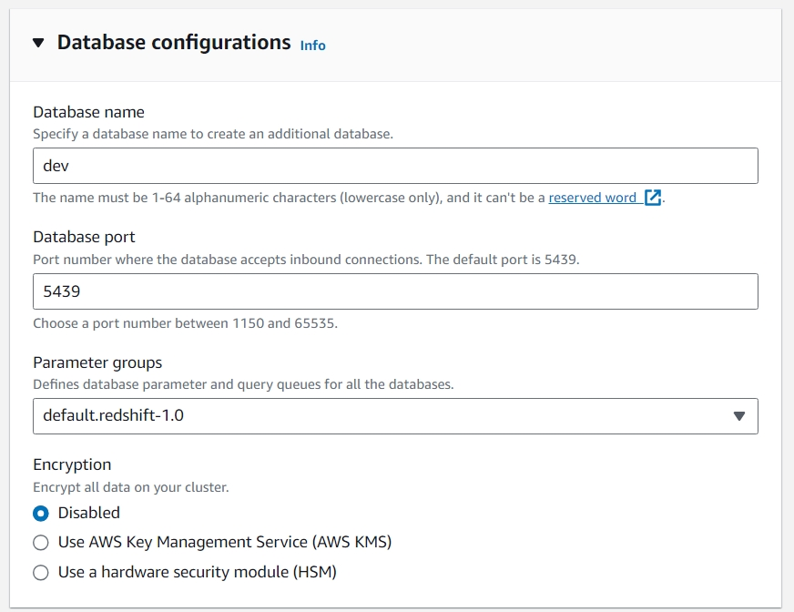

Database configurations section

Review your Cluster configuration and click on the **Create cluster** button at the bottom. It will take a few minutes to finish and show you a **Complete** status.

Click on the **Clusters** menu item from the left navigation pane, and look at the cluster that you just launched. Make sure that the **Status** is **Available** before you try to connect to the database later. You can expect this to take 5-10 minutes.

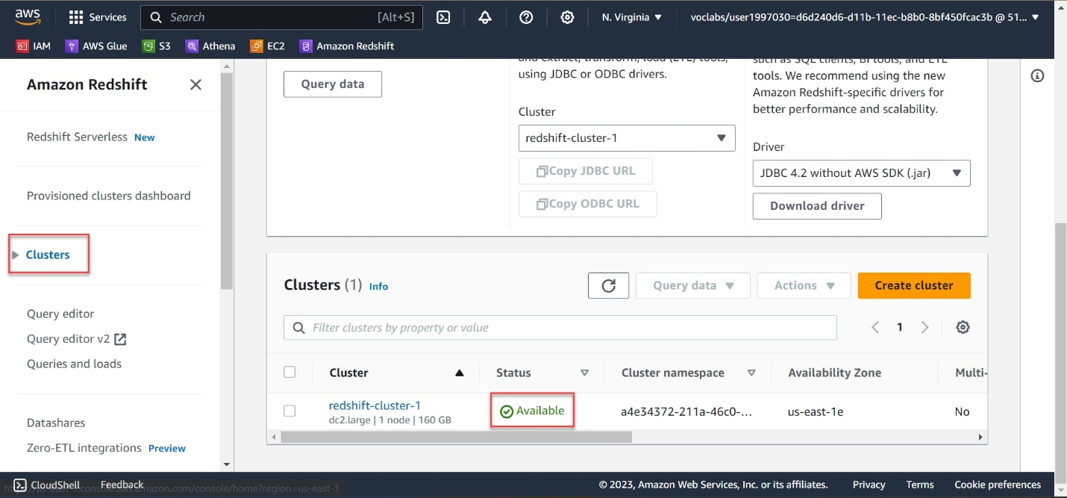

Cluster is ready