Unsupervised Learning Models

Brett T. Burtner
School of Technology, National University
Course code: DDS-8555
Dr. Sebhatleab Gezehey
March 28, 2026

Chapter Twelve Applied Question Nine
Dendrograms have the characteristical advantage that “they are readily interpretable.” (Sneath and Sokal, 1973) This is exemplified in Figure 1, below. Code to generate Figure 1 and 2 submitted as file ‘BurtnerBDDS-8555-07-01.ipynb’.

Figure 1
Dendrogram
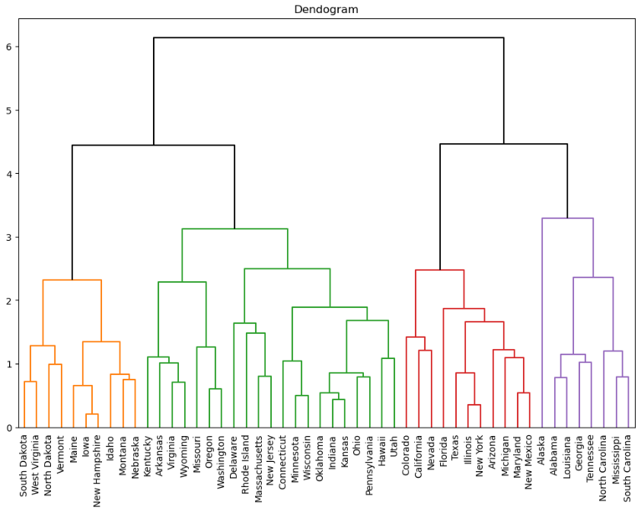

Wine Dataset from Kaggle.com
Correlation matrices, along with principal component analysis has been used to help untangle ambient noise in the ocean (Nichols & Bradley, 2019). The correlation matrix, shown as Figure 2, shows there are not many highly correlated variables. In this case, two of the highest correlations are Total_Phenols with OD280 (at 0.70), and Flavanoids with OD280 (at 0.79).
Figure 2
Confusion Matrix for Wine Dataset
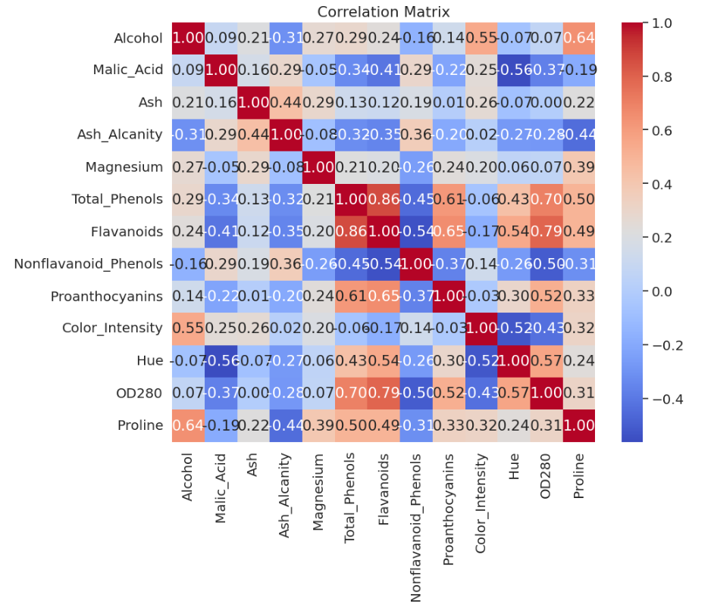

The histograms showed relatively Gaussian distributions, with a few exceptions, like Flavanoids, Nonflavanoid_Phenols, and OD280. Boxplots showed very few outliers.
Scaling was then performed on the dataset such that the means were very near zero and standard deviations were approximately one. The elbow method was then applied to assist in determining the optimum number of clusters to use. This would not have been necessary, since the task was known to be classify which of the three wine cultivars belonged to which row of data. The elbow confirms the selection of three clusters for our later k-means clustering.
Primary components analysis (PCA) revealed the scatterplot in Figure 3.
Figure 3
PCA Scatterplot
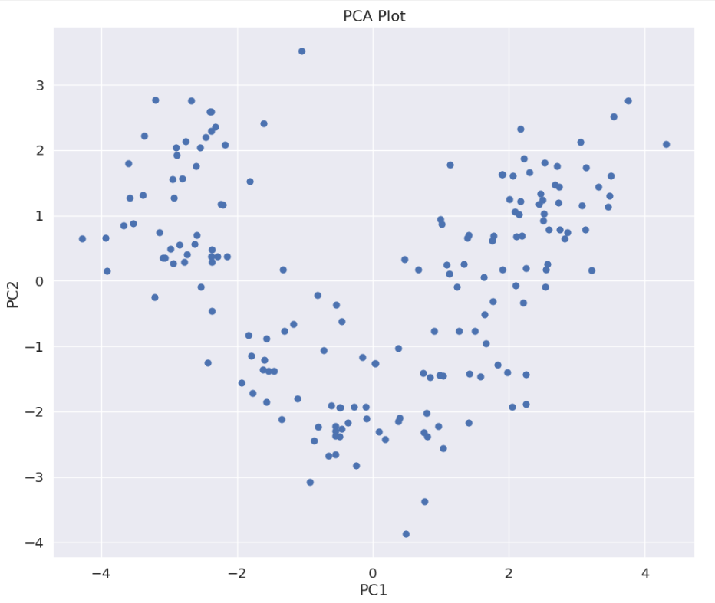

Principal component analysis, as stated above, has been utilized to determine “physical source mechanisms” in the “cacophony of information” that is a full-spectrum sound signature of ocean ambient noise (Nichols & Bradley, 2019).

Next, a plot of the number of components versus cumulative variance was created (Figure 4) to visualize that five components explain 80% of the variance.
Figure 4
Cumulative Variance
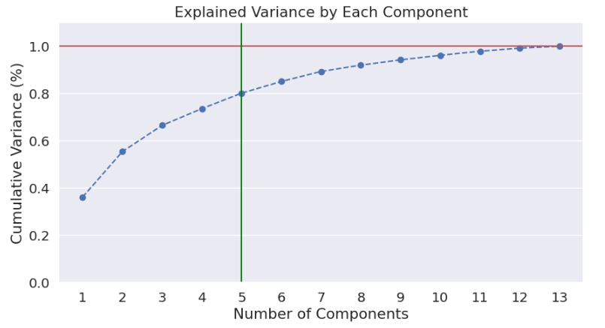

K-means clustering was then performed with k = 3, yielding Figure 5, including centroids marked with a black ‘x’.

Figure 5
Plot of K-Means with Three Clusters
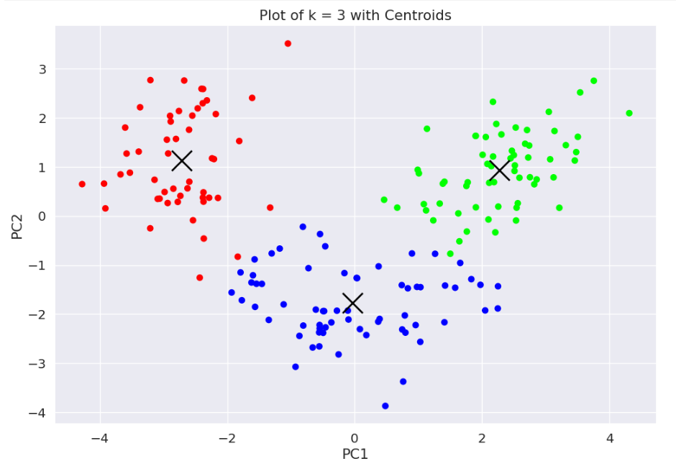

Additionally, K-means clustering with k = 4 was performed (Figure 6).
Figure 6
Plot of K-Means with Four Clusters
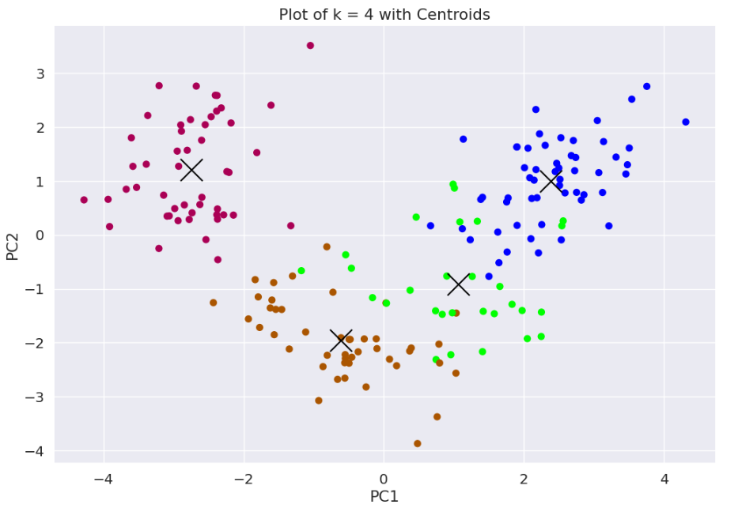

Figure 6 indicates that k = 4 clustering is not the best choice, since many of the boundaries of the clusters overlap, making for a difficult classification problem. It would appear from the data that k-means clustering with k = 3 is the best choice for this problem.

Last, a scree plot confirms our choice of k = 3, since the best number of components is indicated “where the line stops descending precipitously” and starts to level out (Brown, n.d.). This can be seen in Figure 7.

Figure 7
Scree Plot of Eigenvalues
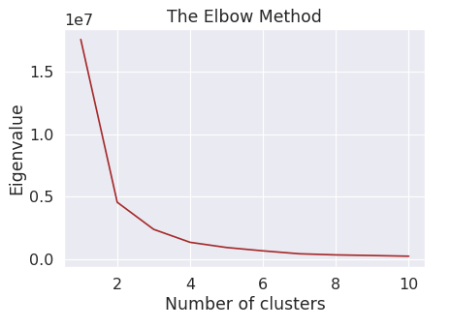

Figure 8 shows hierarchical classification of the data with truncation at level three.
Figure 8
Hierarchical Dendron
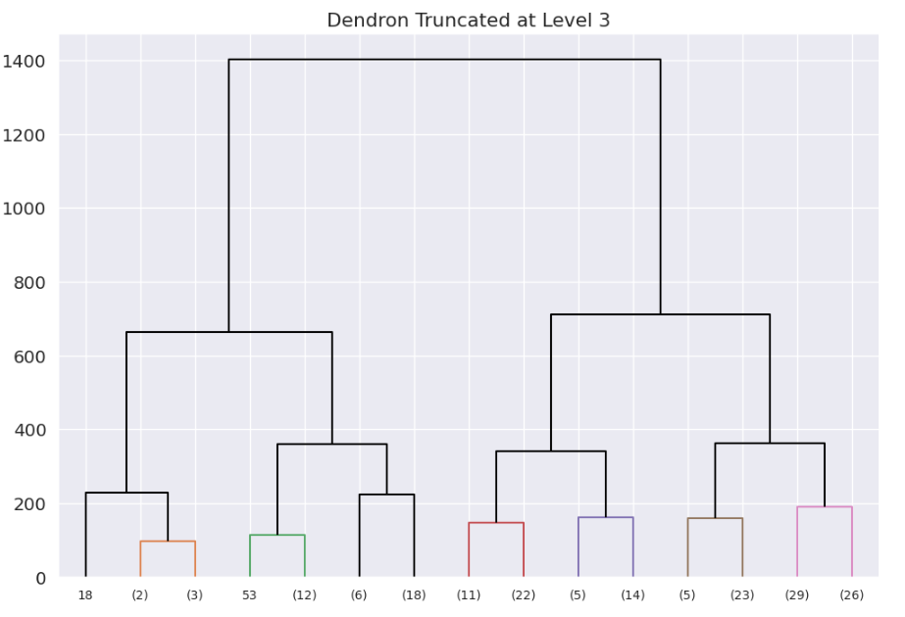

References
Brown, James Dean. “Questions and Answers about Language Testing Statistics: Choosing the Right Number of Components or Factors in PCA and EFA.” Accessed March 29, 2026. https://teval.jalt.org/test/bro_30.htm.
Nichols, S. M., & Bradley, D. L. (2019). Use of noise correlation matrices to interpret ocean ambient noise. The Journal of the Acoustical Society of America, 145(4), 2337. https://doi.org/10.1121/1.5096846
Sneath, Peter H. A., and Robert R. Sokal. 1973. Numerical taxonomy. The principles and practice of numerical classification. San Francisco: W. H. Freeman and Company.Place references here.
Shi, C., Huang, Z., Dai, H., Li, Z., Lu, G., & Wang, J. (2025). Identification and Optimization of Key Power Grid Operation Indicators Based on Indicator Correlation Matrix. 2025 4th Asia Power and Electrical Technology Conference (APET), Asia Power and Electrical Technology Conference (APET), 2025 4th, 933–938. https://doi.org/10.1109/APET68390.2025.11428895

