PartitionFinder

Rob Lanfear, August 2011

Questions, suggestions, problems, bugs? Search or post on the discussion group at:
http://groups.google.com/group/partitionfinder
Step-by-step tutorial:
http://www.robertlanfear.com/partitionfinder/tutorial/

Icon © Ainsley Seago. Thanks Ainsley!

Disclaimer 3
What PartitionFinder is for 3
What PartitionFinder is not for 3
Operating system 3
Overview 4
Running PartitionFinder 6
Before you start 6
Starting your analysis 6
Output on the screen 7
Getting help 7
Input Files 8
Alignment 8
Configuration File 8
alignment 9
branchlengths: linked | unlinked 9
models: all | raxml | mrbayes | <list> 9
model_selection: AIC | AICc | BIC 10
[data_blocks] 10
[schemes] 11
search: all | user | greedy 11
user_tree_topology 12
Output files 13
best_schemes.txt 13
all_schemes.txt 13
subsets folder 13
schemes folder 13
Credits 14
PhyML 14
PyParsing 14
Python 14
Helpful People 14

Disclaimer
Copyright © 2011 Robert Lanfear and Brett Calcott
This program is free software: you can redistribute it and/or modify it under the terms of the GNU General Public License as published by the Free Software Foundation, either version 3 of the License, or (at your option) any later version. This program is distributed in the hope that it will be useful, but WITHOUT ANY WARRANTY; without even the implied warranty of MERCHANTABILITY or FITNESS FOR A PARTICULAR PURPOSE. See the GNU General Public License for more details. You should have received a copy of the GNU General Public License along with this program. If not, see <http://www.gnu.org/licenses/>. PartitionFinder also includes the PhyML program and the PyParsing library both of which are protected by their own licenses and conditions, using PartitionFinder implies that you agree with those licences and conditions as well.

What PartitionFinder is for
PartitionFinder is a Mac program for selecting best-fit partitioning schemes and models of molecular evolution for DNA sequence data. The user provides a DNA sequence alignment with some pre-defined data blocks (e.g. 9 data blocks defining the 1st, 2nd and 3rd codon positions of 3 protein-coding genes, see Figure 1). PartitionFinder then compares this partitioning scheme to other schemes that are created by merging data blocks together into things we call subsets, at the same time as selecting best-fit substitution models for each subset. Here are a few things you can do with PartitionFinder:

- Find the best-fit partitioning scheme from all possible schemes
- Find a good partitioning scheme using a heuristic search
- Compare user-defined partitioning schemes
- Find best-fit models of molecular evolution for partitioned datasets

PartitionFinder is designed to take the hard work out of comparing partitioning schemes, and to help find a scheme that maximises the fit of the data to the model, without including more parameters than are necessary. PartitionFinder implements three information-theoretic measures for comparing models of molecular evolution and partitioning schemes: the Akaike Information Criterion (AIC), the corrected Akaike Information Criterion (AICc), and the Bayesian Information Criterion (BIC). At the end of a PartitionFinder run, you are given output files that tell you the best scheme that PartitionFinder could find, along with the best-fit model of molecular evolution for each subset (sometimes called a ‘partition’, but that term is a bit misleading) in that scheme.

What PartitionFinder is not for
PartitionFinder will not divide up a dataset into subsets from scratch, with no information from the user. That is, PartitionFinder will not try to subdivide any of your data blocks (see [data_blocks], below).

Operating system
Partitionfinder will run on intel and ppc Macintosh computers. It will not work on Linux or Windows machines. Having said that, the code was written with Windows and Linux in mind, so if you are interested in getting it running on these systems it may not be too much work to modify the source code.

Overview
A lot of people want to estimate phylogenetic trees (and other things like dates of divergence) from DNA sequence data. To do this, it is necessary to make assumptions about the way DNA sequences have evolved. Partitioning allows independent assumptions to be made for different sites in the DNA sequence alignment.

Partitioning involves splitting a DNA sequence alignment into subsets of sites. In this manual, we define two types of sets of sites: a data block is a set of sites defined by the user; a subset is a collection of one or more data blocks. For instance, it’s common to define separate data blocks for the three codon positions of a protein-coding gene (see Figure 1). The point of partitioning is to account for differences in evolutionary processes experienced by the different sites in the alignment. For instance, sites might have evolved at different rates or have experienced different mutational or substitutional processes. Accounting for these differences will improve phylogenetic analyses.

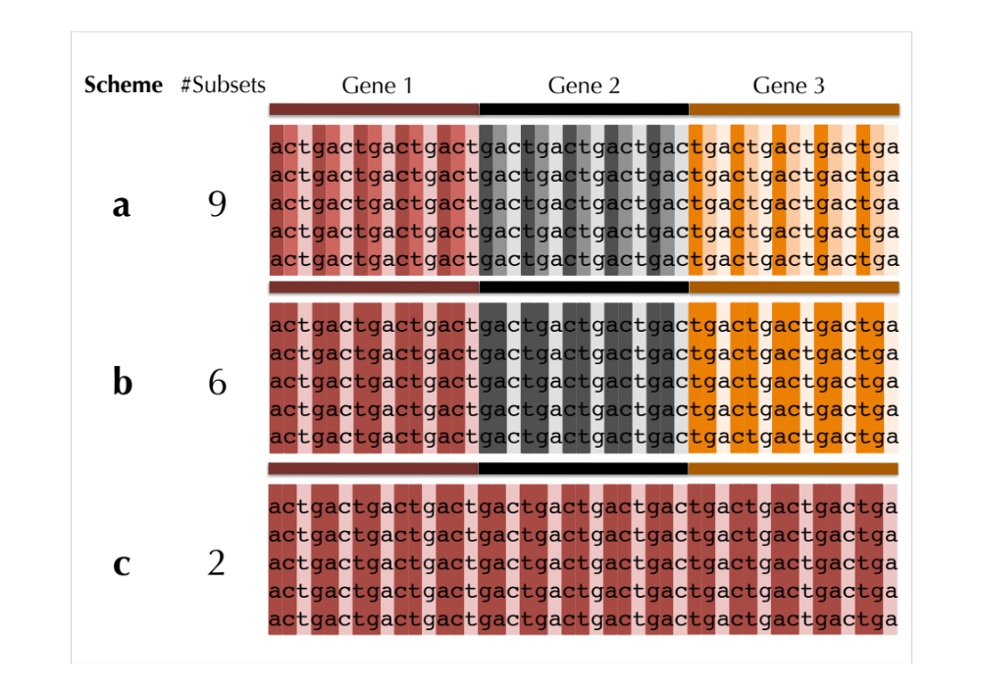
There are two things that make partitioning difficult. The first problem is how to know whether one partitioning scheme is better than some other partitioning scheme on the same data (for instance, should you use scheme a, b, or c from figure 1?). The second problem is that comparing partitioning schemes is difficult. Typically, it involves running separate analyses for each scheme you want to consider. This can be arduous, long-winded, and error prone. PartitionFinder is designed to solve both of these problems.
Figure 1. Three commonly employed partitioning schemes for DNA alignments of three protein-coding genes.

Figure 1 shows a typical partitioning problem. You might suspect that each of the three genes has been evolving differently – perhaps they come from different chromosomes, or have experienced different evolutionary constraints. Furthermore, you might think that each codon position within each gene has been evolving differently – different codon positions tend to evolve at different rates, and experience different substitutional processes thanks to the triplet structure of the genetic code. Because of this, you might split your data into 9 sets of sites for this alignment – one for each codon position in each gene (scheme a, Figure 1). But is this too many different sets? Perhaps it would be better to join together the 1st and 2nd codon sites of each gene, so defining 6 sets of sites (scheme b, Figure 1). Or perhaps it would be better to forget the divisions between genes, and define only 2 sets of sites – 1st and 2nd codon sites versus 3rd codon sites (scheme c, Figure 1). The trouble is that if you start with 9 possible sets of sites, there are a lot of different possible partitioning schemes you might consider, 21147 in fact. This creates a problem – how do we find the best scheme from that many schemes?

PartitionFinder solves this problem by quickly and efficiently comparing all of these schemes. All you need to do is define your 9 possible sets of sites (i.e. the largest number of sets of sites you think is sensible to define) as data blocks, and PartitionFinder will do the rest. At the end of a PartitionFinder run you are told not only which partitioining scheme is the best, but also which model of molecular evolution you should use for each subset of sites in that scheme (remember, a subset is a collection of one or more of your data blocks). You can then go straight on to performing your phylogenetic analysis, without any additional model-testing or comparisons of partitioning schemes.

If you don’t want to compare all possible schemes (which can be almost impossible for large datasets), you can define exactly the schemes you do want to compare (see search=user, below), or use a heuristic search algorithm to find a good scheme (see search=greedy, below). You can also tell PartitionFinder exactly which models of molecular evolution to consider (see models, below). And you can define how it should compare partitioning schemes and models (see model_selection, below). PartitionFinder uses a number of methods to speed up partitioning scheme comparison and model selection, so it’s fast too.

Running PartitionFinder

Before you start
Make sure you have Python 2.7 or later installed (but avoid installing Python 3.0 or above). Installing Python is really easy. To check which version you have, open Terminal and type “python”. It will tell you the version you have. If you have anything before 2.7, update python using the appropriate installer from here: http://www.python.org/getit/

Download the latest version of PartitionFinder from here: www.robertlanfear.com/partitionfinder

Starting your analysis
Once you have your input files set up (see below), follow these steps to run PartitionFinder.

- Open Terminal (on most Macs, this is found in Applications/Utilities)
- In the terminal, you need to type the line below, where <PartitionFinder.py> is the full path to PartitionFinder.py file and <InputFoldername> is the full path to your input folder.

python <PartitionFinder.py> <InputFoldername>

For example, if I’d downloaded PartitionFinder and put it into my ‘Applications’ folder, and I had an analysis on my Desktop in a folder called “frogs”, I would type this at the command line, and then hit Enter:

python /Applications/PartitionFinder/PartitionFinder.py ~/Desktop/frogs

There’s a trick that makes this very easy – you can drag and drop files onto the terminal and it will fill out the whole filepath for you. Once that’s done, just hit ‘Enter’ to start PartitionFinder. Here’s what it looks like in terminal, when I do that on my computer:

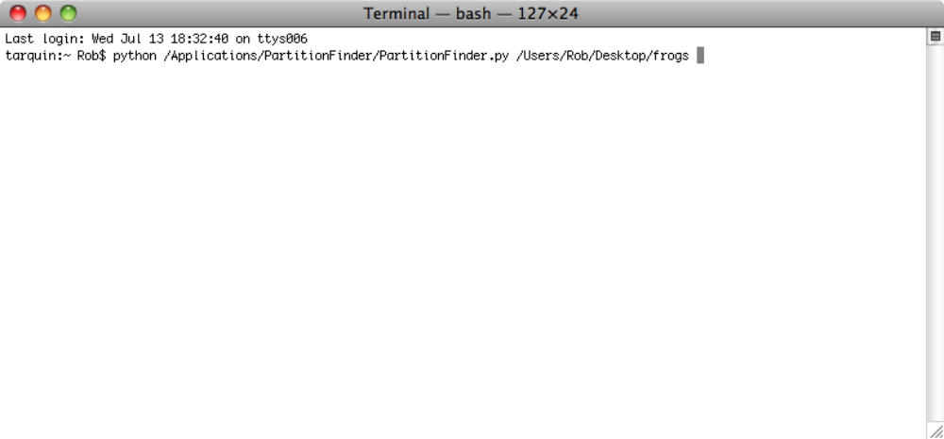

There are a couple of additional commandline options that can be useful. You add these options after you’ve typed in the rest of the commandline.

--force-restart
delete all previous output and start afresh. Useful if you made a mistake in your input files, and want to start again. Using this option is the same as manually deleting the ‘analysis’ folder before starting a new PartitionFinder analysis.

-p N
Define the number processors to use, where ‘N’ is an number. If you don’t specify this number, PartionFinder will by default use all the processors it can find. If you don’t want to do this, set N to the number of processors that you want to use. The more processors you can use, the faster PartitionFinder will be.

Output on the screen
Once PartitionFinder is running, it will keep you updated about its progress. If it hits a problem, it will (hopefully) provide you with a useful error message that will help you correct that problem. Hopefully, you won’t have too many problems and your terminal screen will look something like that shown below.

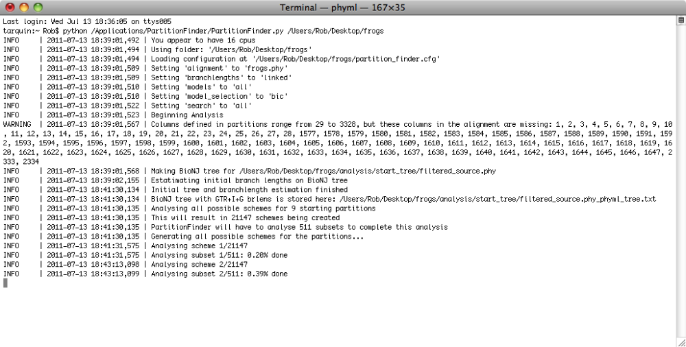

Getting help
Further help and advice on using PartitionFinder or interpreting the results is available on the google group:

http://groups.google.com/group/partitionfinder

Input Files
There are two input files, a Phylip alignment and a configuration file.

Alignment
Your DNA alignment needs to be in Phylip sequential format. We use the same version of Phylip format that PhyML uses, which is described in detail here http://www.atgc-montpellier.fr/phyml/usersguide.php?type=phylip. In brief, this format should contain a line at the top with the number of sequences, followed by the number of sites in the alignment. After that, there should be one sequence on each line, where a sequence contains a name, followed by some whitespace (either spaces or tabs) and the sequence. Names can be up to 100 characters long. There should be nothing else on the line other than the name and the sequence – watch out if you use MacClade, which adds some extra things to the end of each line.

Configuration File
PartitionFinder gets all of its information on the analysis you want to do from a configuration file. This file should always be called “partition_finder.cfg”. The best thing to do is to base your own .cfg on the example file provided in the “example” folder. An exhaustive list of everything in that file follows. Note that all lines in the .cfg file except comments and lines with square brackets have to end with semi-colons.

In the configuration file, white spaces, blank lines and lines beginning with a “#” (comments) don’t matter. You can add or remove these as you wish. All the other lines do matter, and they must all stay in the file in the order they are in below. There is one exception – the user_tree_topology option (see below).

The basic configuration file looks like this:

# ALIGNMENT FILE #
alignment = test.phy;

# BRANCHLENGTHS #
branchlengths = linked;

# MODELS OF EVOLUTION #
models = all;
model_selection = bic;

# DATA BLOCKS #
[data_blocks]
Gene1_pos1 = 1-789\3;
Gene1_pos2 = 2-789\3;
Gene1_pos3 = 3-789\3;

# SCHEMES #
[schemes]
search = user;

# user schemes
allsame = (Gene1_pos1, Gene1_pos2, Gene1_pos3);
1_2_3 = (Gene1_pos1) (Gene1_pos2) (Gene1_pos3);
12_3 = (Gene1_pos1, Gene1_pos2) (Gene1_pos3);

The options in the file are described below. Where an option has a limited set of possible commands, they are listed on the same line as the option, separated by vertical bars like this “|”

alignment
The name of your DNA sequence alignment. This file should be in the same folder as the .cfg file.

branchlengths: linked | unlinked
This setting tells PartitionFinder how to treat branch lengths of the subsets. How you set this will depend to some extent on which program you intend to use for you final phylogenetic analysis. All phylogeny programs support linked branchlenghts, but only some support unlinked branchlenghts (e.g. MrBayes, BEAST, and RaxML). If you are not sure, the best thing is to do two runs of PartitionFinder (set up two separate analysis folders for this) one with branch lengths linked, and another with branch lengths unlinked. You should then compare the best schemes from both analyses, to find the best possible scheme, and the best possible settings to use in subsequent phylogentic analyses.

branchlengths = linked; only one underlying set of branch lengths is estimated. Each subset has its own scaling parameter that changes all the branch lengths at once, but doesn’t change the length of any one branch relative to any other. The total number of branch length parameters here is quite small. If there are N species in your dataset, then there are 2N-3 branch lengths in your tree, and each subset after the first one adds an extra scaling parameter. So if there are S subsets in a given scheme, the total number of branch length parameters is:

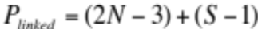

For instance, if you had a scheme with 10 subsets and a dataset with 50 species, you would have 106 branch length parameters.

branchlengths = unlinked; each subset has its own independent set of branch lengths. In this case, branch lengths are totally unrelated between subsets, and so each subset has it’s own set of 2N-3 branch length parameters. With this setting, the number of branch length parameters can be quite large. If there are S subsets in a given scheme, and N species in your dataset, the number of parameters is:

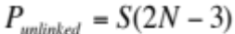

So, a scheme with 10 subsets and a dataset with 50 species would have 970 branch length parameters.

models: all | raxml | mrbayes | <list>
This setting tells PartitionFinder which models of molecular evolution to consider during model selection. PartitionFinder performs model selection on each subset in much the same way as other programs like jModelTest, MrModelTest, or ModelGenerator. Your results therefore tell you not only the best partitioning scheme, but also which model of molecular evolution is most appropriate for each subset in that scheme. This means that you don’t need to do any further model selection after PartitionFinder is done. For most people, models=all will be the most useful setting.

models = all; compare 56 models of molecular evolution for each subset. These 56 models comprise the 12 most commonly used models of molecular evolution (JC, K80, TrNef, K81, TVMef, TIMef, SYM, F81, HKY, TrN, K81uf, TVM, TIM, and GTR), each of which comes in four flavours: on its own, with invariant sites (+I), with gamma distributed rates across sites (+G), or with both gamma distributed rates and invariant sites (+I+G).

models = raxml; models = mrbayes; tells PartitionFinder to use only the models available in RaxML or MrBayes3.1.2 respectively. This can be particularly useful if you intend to use one of these programs for your phylogenetic analysis, as it restricts the models that are compared to only those that are implemented in the particular programs. This is not only the most appropriate thing to do, but also saves a lot of computational time.

models = <list> , e.g. models = GTR+G, GTR+I+G;
If you want to restrict the list of models considered, you can do that by specifying any particular list of models from the above 56 (use the terminology as given above). Each model in the list should be separated by a comma. For instance, the example given above implements only the models found in RaxML (GTR+G and GTR+I+G), so is equivalent to using the ‘raxml’ option.

model_selection: AIC | AICc | BIC
This setting tells PartitionFinder which method to use for model selection. It also defines the metric that is used for comparing partitioning schemes if you use search=greedy (see below).

The AIC, AICc, and BIC are similar in spirit – they all reward models that fit the data better, but penalise models that have more parameters. The idea is include parameters that help model what has occurred, but to avoid including too many parameters (overparameterisation). The BIC penalises extra parameters the most, followed by the AICc, and then the AIC. Which model_selection approach you use will depend on your preference. There are lots of papers comparing the merits of the different metrics, and based on those papers my own preference is to use the BIC (see especially Minin et al Syst. Biol. 52(5):674–683, 2003; and Adbo et al Mol. Biol. Evol. 22(3):691–703. 2004).

[data_blocks]
On the lines following this statement you define the starting subsets for your analysis (we call these data blocks). Each data block has a name, followed by an “=” and then a description. The description is built up as in most Nexus formats, and tells PartitionFinder which sites of your original alignment correspond to each data block. The best way to understand this it to look at a couple of examples.

Imagine a DNA sequence alignment with 1000bp of protein-coding DNA, followed by 1000bp of intron DNA. Let’s imagine that some of the intron was unalignable too, so we don’t want that included in our analysis, but we don’t want to cut it out of our alignment file. Your data block definitions might look like this:

Gene1_codon1 = 1-1000\3; ❶
Gene1_codon2 = 2-1000\3; ❷
Gene1_codon3 = 3-1000\3; ❸
intron = 1001-1256 1675-2000; ❹

❶-❸ are typical of how you might separate out codon positions for a protein coding gene. The numbers either side of the dash define the first and last sites in the data block, and the number after the backslash defines the spacing of the sites. Every third site will define a codon position, as long as your alignment stays in the same reading frame throughout that gene.

❹ shows how you can include ranges of sites without backslashes, and demonstrates that you can combine more than one range of sites in a single data block. Here, we excluded sites 1257-1674 because they were unalignable.

The total list of data blocks does not have to include all the sites in your original alignment. For instance, you might exclude some sites you’re not interested in, or that were unalignable. You’ll get a warning from PartitionFinder if all of the sites in the original alignment are not included in the data blocks you’ve defined. Also, note that data blocks cannot be overlapping. That is, each site in the original alignment can only be included in a single data block.

To help with cutting and pasting from Nexus files (like those used by MrBayes) you can leave “charset” at the beginning of each line. So, the following would be treated exactly the same as the example above:

charset Gene1_codon1 = 1-1000\3;
charset Gene1_codon2 = 2-1000\3;
charset Gene1_codon3 = 3-1000\3;
charset intron = 1001-1256 1675-2000;

[schemes]
On the lines following this statement, you define how you want to look for good partitioning schemes, and any user schemes you want to define. You only need to define user schemes if you choose search=user.

search: all | user | greedy
This option defines which partitioning schemes PartitionFinder will analyse, and how thorough the search will be. In general ‘all’ is only practical for analyses that start with 12 or fewer data blocks defined (see below).

search = all Tells PartitionFinder to analyse all possible partitioning schemes. That is, every scheme that includes all of your data blocks in any combination at all. Whether you can analyse all schemes will depend on how much time you have, and on what is computationally possible. If you have any more than 12 data blocks to start with you should not choose ‘all’. This is because the number of possible schemes can be extremely large. For instance, with 13 data blocks there are almost 28 million possible schemes, and for 16 data blocks the number of possible schemes is over 10 billion. It’s just not possible to analyse that many schemes exhaustively. For 12 data blocks, the number of possible schemes is about 4 million, so it might be possible to analyse all schemes if you have time to wait, and a fast computer with lots of processors.

search = greedy Tells PartitionFinder to use a greedy algorithm to search for a good partitioning scheme. This is a lot quicker than using search=all, and will often give you the same answer. However, it is not 100% guaranteed to give you the best partitioning scheme. The algorithm is described in the PartitionFinder paper (see Citation, below).

When you use search=greedy, PartitionFinder has to compare partitioning schemes using an information-theoretic metric (AIC, AICc, or BIC). Which metric it uses is defined using the model_selection option (see above).

search = user Use this option to compare only the partitioning schemes that you define by hand. User-defined schemes are listed, one-per-line, on the lines following “search=user”. A scheme is defined by a name, followed by an “=” and then a definition. To define a scheme, simply use parentheses to join together data blocks that you would like to combine. Within parentheses, each data block is separated by a comma. Between parentheses, there is no comma. All user schemes must contain all of the data blocks defined in [data_blocks].

Here’s an example. If I’m working on my one protein-coding gene plus intron alignment above, I might want to try the following schemes: (i) all data blocks analysed together; (ii) intron analysed separately from protein coding gene; (iii) intron separate, 1st and 2nd codon positions analysed separately from 3rd codon positions; (iv) all data blocks analysed separately. I could do this as follows, with one scheme on each line:

together = (Gene1_codon1, Gene1_codon2, Gene1_codon3, intron);
intron_123 = (Gene1_codon1, Gene1_codon2, Gene1_codon3) (intron);
intron_12_3 = (Gene1_codon1, Gene1_codon2) (Gene1_codon3) (intron);
separate = (Gene1_codon1) (Gene1_codon2) (Gene1_codon3) (intron);

user_tree_topology
This is an additional option which can be added into the .cfg file after the ‘alignment’ line. It’s used if you’d like to supply PartitionFinder with a fixed topology, rather than relying on the neighbour joining topology that the program estimates by default. This might be useful if you know ahead of time what the true tree is, for instance when doing simulations. To use the option, just add in an extra line to the .cfg file like this:

# ALIGNMENT FILE #
alignment = test.phy;
user_tree_topology = tree.phy;

Where “tree.phy” is the name of the file containing a newick formatted tree topology (with or without branch lengths). The tree file must be in the same folder as the alignment and the .cfg file. When you use this option, the topology you supply in the tree file will be fixed throughout the analysis. Branch lengths will be re-estimated using a GTR+I+G model on the whole dataset, as in a standard analysis.

If you don’t want to use this option, you can just leave out the user_tree_topology line from the .cfg file.

Output files

All of the output is contained in a folder called “analysis” which appears in the same file as your alignment. There is a lot of output, but in general you are likely to be interested in four things, maybe this order:

best_schemes.txt
has information on the best partitioning scheme(s) found. This includes a detailed description of the schemes, as well as the model of molecular evolution that was selected for each subset in the scheme.

If you search among all schemes (search=all) or some pre-defined user schemes (search=user) then this file will contain information on the best scheme under each of the three information-theory metrics: the Akaike Information Criterion (AIC), the corrected Akaike Information Criterion (AICc), and the Bayesian Information Criterion (BIC).

If you use the greedy algorithm (search=greedy), there will only be a single scheme in best_schemes.txt. This is because the greedy algorithm searches among partitioning schemes using one of the information-theory metrics to guide it (defined using model_selection, see above). Because of this, you can only find the best scheme for the metric you’ve used, and not for all three metrics at once.

all_schemes.txt
contains most of the same information as best_schemes.txt, but organised in spreadsheet format, and for all schemes that were compared during the search. This is probably only useful if you’re interested in working on methods of finding good partitioning schemes.

subsets folder
is a folder which contains detailed information on the model selection performed on each subset. This output is very similar to what you would get from any model-selection program. Each model tested is listed, in order of increasing BIC score (i.e. best model is at the top). This folder also contains alignments for each subset, and a .bin file which allows PartitionFinder to re-load information from previous analyses.

schemes folder
is a folder which contains detailed information on all the schemes that were analysed, each in a separate .txt file which has the same name as the scheme. Most of this information is contained in all_schemes.txt.

Credits
PartitionFinder relies heavily on the following things.

PhyML
PhyML does most of the sums performed by PartitionFinder. PhyML is described in this paper: New Algorithms and Methods to Estimate Maximum-Likelihood Phylogenies: Assessing the Performance of PhyML 3.0. Guindon S., Dufayard J.F., Lefort V., Anisimova M., Hordijk W., Gascuel O. Systematic Biology, 59(3):307-21, 2010.

PyParsing
PyParsing is a great Python module that we use for parsing input files.
http://pyparsing.wikispaces.com/

Python
PartitionFinder is written in Python. http://www.python.org/



Helpful People
A few people helped a lot in testing PartitionFinder and making helpful suggestions. In alphabetical order, these wonderful people are: Matt Brandley, Renee Catullo, Ainsley Seago, and Jessica Thomas. Thanks.

