
Cisco Military Unique Deployment Guide for:
IOS-XE 17 VPN Routers
DoDIN APL Tracking #2014801
Version: 1.4
January 25th, 2022

Cisco Systems Global Certification Team (GCT)
7025-2 Kit Creek Road, Research Triangle Park, North Carolina, USA 27709
certteam@cisco.com

CISCO CONFIDENTIAL
Disclose to U.S. Government Personnel and Supporting Contractors Only.
Table 1: Change Log

Version | Date | Change | Editor
1.0 | 12/18/2020 | Initial Draft | Brett Connor
1.1 | 09/20/2021 | DTR 6 & 7 | Brett Connor
1.2 | 09/29/2021 | DTR 1 | Brett Connor
1.3 | 10/18/2021 | DTR 2, 3, 4, 5, 8 | Brent Searle
1.4 | 01/25/2022 | DTR 9 | Brett Connor
Cisco Systems Global Certification Team (GCT)
7025-2 Kit Creek Rd., Research Triangle Park, North Carolina 27709
e-mail: certteam@cisco.com

Table 2: Table of Contents

1 Introduction 4
2 Cisco Network Topologies 4
3 Information Assurance 5
3.1 Protecting Protocols Without FIPS-approved Algorithms 5
3.2 Information Assurance (IA) Condition of Fielding (CoF) 5
4 System Under Test (SUT) Configuration 6
4.1 IOS-XE Generic Configuration 6
4.1.1 Cisco Software Configuration Guides 6
4.2 IOS-XE Site-to-Site IPSec VPN Configuraton 6
5 Obtaining Documentation, Support, and Security Guidelines 10
5.1 Related Documentation 10
5.1.1 DISA Approved Products List 10
5.1.2 Cisco 1000 Series Aggregation Services Routers 10
5.1.3 Cisco 4000 Series Integrated Service Routers 10
5.1.4 Cisco C8000v Series Edge Software 10
5.1.5 Cisco C8300 Series Edge Platforms 10
5.1.6 Cisco C8500 Series Edge Platforms 10
5.1.7 Cisco Catalyst IR1800 Rugged Series Routers 10
6 Acronyms 11
List of Tables

Table 1: Change Log 2
Table 2: Table of Contents 3
Table 3: Acronyms 11

List of Figures

Figure 1: Cisco Network Topology 4

Introduction
This document provides guidance to both Cisco Engineers and Cisco Customers in the deployment of Cisco’s Virtual Private Network (VPN) certified components. It supplements the information available in product documentation regarding specific component configurations and guidelines with configurations required for VPN certified components. Details about components that are VPN certified can be found at the link in paragraph 5.1.1. This component was certified against requirements defined in Department of Defense (DoD) Unified Capabilities Requirements (UCR) 2013 Change 2.

Cisco Network Topologies

Figure 1: Cisco Network Topology

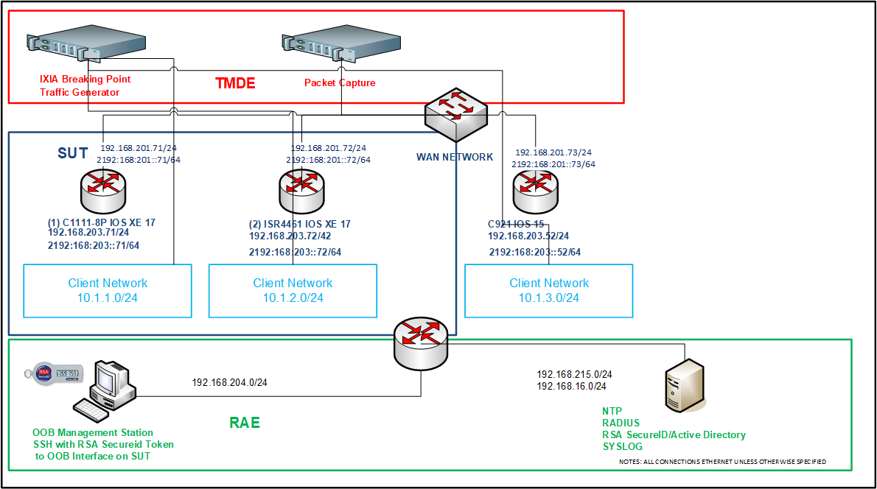

Information Assurance
The following section provides example configurations that demonstrate how to configure this component in accordance with DISA STIG and UCR 2013 Change 2 guidance.

Protecting Protocols Without FIPS-approved Algorithms
IPSec tunnels must be used to protect network protocols without support for FIPS-approved algoriithms, such as RADIUS, TACACS+, and NTP.
!
crypto keyring IPSEC-RAE-KEYRING vrf <MGMT-VRF>
pre-shared-key address <IPSEC-PEER-IP> key <IPSEC-KEY>
!
ip access-list extended IPSEC-RAE-ACL
permit ip host <MGMT-IP> <MGMT-NETWORK1> <MGMT-NETWORK1-WMASK>
!
crypto isakmp policy 10
encr aes 256
authentication pre-share
group 2
crypto isakmp keepalive 10
crypto isakmp aggressive-mode disable
crypto ipsec transform-set IPSEC-RAE-TRANS esp-aes 256 esp-sha-hmac
mode transport
no crypto ipsec nat-transparency udp-encapsulation
!
crypto map RAE-IPSEC 10 ipsec-isakmp
set peer <IPSEC-PEER-IP>
set transform-set IPSEC-RAE-TRANS
set pfs group2
match address IPSEC-RAE-ACL
!
interface <MGMT-INT>
crypto map RAE-IPSEC

Information Assurance (IA) Condition of Fielding (CoF)
When the system is deployed into an operational environment, all CoF listed in the Cybersecureity Assessment Report (CAR) must be followed.

System Under Test (SUT) Configuration
The following sections provide example configurations that demonstrate how to configure this component in accordance with Defense Information Systems Agency (DISA) Security Technical Implementation Guides (STIG) and UCR 2013 Change 2.

IOS-XE Generic Configuration
Refer to the following documents for configuration guidelines as most features are not Military Unique, and follow relevant SRGs and STIGs.

Cisco Software Configuration Guides
ISR 1000 Series: https://www.cisco.com/c/en/us/support/routers/1110-integrated-services-router/model.html#ConfigurationGuides
ISR 4000 Series: https://www.cisco.com/c/en/us/support/routers/4000-series-integrated-services-routers-isr/products-installation-and-configuration-guides-list.html
ASR 1000 Series: https://www.cisco.com/c/en/us/support/routers/asr-1000-series-aggregation-services-routers/products-installation-and-configuration-guides-list.html
Cisco Catalyst C8000v Series: https://www.cisco.com/c/en/us/td/docs/routers/C8000V/Configuration/c8000v-installation-configuration-guide/m_installation_overview.html
Cisco Catalyst C8300 Series: https://www.cisco.com/c/en/us/td/docs/routers/cloud_edge/c8300/software_config/cat8300swcfg-xe-17-book.html
Cisco Catalyst C8500 Series: https://www.cisco.com/c/en/us/td/docs/routers/cloud_edge/c8500/software-configuration-guide/c8500-software-config-guide.html
Cisco Catalyst IR1800 Rugged Series Routers: https://www.cisco.com/c/en/us/td/docs/routers/access/IR1800/software/b-cisco-ir1800-scg.html

IOS-XE Site-to-Site IPSec VPN Configuraton
The configuration below applies the IPv4/IPv6 Crypto maps to the WAN-side facing interfaces.

!
crypto ikev2 proposal IKE2-PROP
encryption aes-cbc-256
integrity sha256 sha384 sha512
group 14
!
crypto ikev2 policy IKE2-POLICY
proposal IKE2-PROP
!
crypto ikev2 keyring IKE2-KEYRING
peer <IPSEC-PEER-NAME>
address <IPSEC-PEER-IP>
pre-shared-key <IPSEC-PEER-PSK>
!
peer <IPSEC-IP6-PEER-NAME>
address <IPSEC-PEER-IP6>/<IP6-MASK>
identity address <IPSEC-PEER-IP6>
pre-shared-key <IPSEC-PEER-PSK>
!
!
crypto ikev2 profile IKE2-PROFILE
match identity remote address <IPSEC-PEER-IP> <IPSEC-PEER-MASK>
authentication remote pre-share
authentication local pre-share
keyring local IKE2-KEYRING
!
crypto ikev2 profile IKE2-PROFILE6
match identity remote address <IPSEC-PEER-IP6>/<IP6-MASK>
authentication remote pre-share
authentication local pre-share
keyring local IKE2-KEYRING
!
crypto ipsec transform-set TSET_Tunnel esp-aes esp-sha-hmac
mode tunnel
!
!On 8300 and 8500 uncomment and add the following line:
!License feature hseck9
!
crypto ipsec profile TNL_Profile
set security-association dfbit clear
set transform-set TSET_Tunnel
set ikev2-profile IKE2-PROFILE
!
crypto ipsec profile TNL_Profile6
set security-association dfbit clear
set transform-set TSET_Tunnel
set ikev2-profile IKE2-PROFILE6
!
interface Tunnel <TUN-INT>
ip address <TUN-IP> <TUN-MASK>
load-interval 30
ipv6 enable
keepalive 60 5
tunnel source <WAN-IP>
tunnel mode ipsec ipv4
tunnel destination <IPSEC-PEER-IP>
tunnel protection ipsec profile TNL_Profile
!
interface Tunnel <TUN-INT6>
bandwidth inherit
no ip address
ip mtu 68
load-interval 30
ipv6 address <TUN-IP6>/<TUN-MASK6>
ipv6 enable
ipv6 mtu 1280
keepalive 60 5
tunnel source <WAN-IP6>
tunnel mode ipsec ipv6
tunnel destination <IPSEC-PEER-IP6>
tunnel path-mtu-discovery
tunnel protection ipsec profile TNL_Profile6
!
interface <WAN-INT>
ip address <WAN-INT-IP> <WAN-INT-SUBNET>
ip tcp adjust-mss 1300
load-interval 30
negotiation auto
ipv6 address <WAN-INT-IP6>/<WAN-INT-IP6-MASK>
ipv6 mtu 1280
ipv6 nd ra suppress all
ipv6 tcp adjust-mss 1300
!

Obtaining Documentation, Support, and Security Guidelines
For information on obtaining documentation, obtaining support, providing documentation feedback, security guidelines, recommended aliases and general Cisco documents, see the monthly “What’s New in Cisco Product Documentation”, which also lists all new and revised Cisco technical documentation:
https://www.cisco.com/c/en/us/td/docs/general/whatsnew/whatsnew.html

Related Documentation
You can view the documentation for the products and software releases discussed in this document at the following URLs:

DISA Approved Products List
https://aplits.disa.mil/apl

Cisco 1000 Series Aggregation Services Routers
https://www.cisco.com/c/en/us/products/routers/asr-1000-series-aggregation-services-routers/index.html

Cisco 4000 Series Integrated Service Routers
https://www.cisco.com/c/en/us/products/routers/4000-series-integrated-services-routers-isr/index.html

Cisco C8000v Series Edge Software
https://www.cisco.com/c/en/us/products/routers/catalyst-8000v-edge-software/index.html

Cisco C8300 Series Edge Platforms
https://www.cisco.com/c/en/us/products/routers/catalyst-8300-series-edge-platforms/index.html

Cisco C8500 Series Edge Platforms
https://www.cisco.com/c/en/us/products/routers/catalyst-8500-series-edge-platforms/index.html

Cisco Catalyst IR1800 Rugged Series Routers
https://www.cisco.com/c/en/us/products/collateral/routers/catalyst-ir1800-rugged-series-routers/nb-06-cat-ir1800-rugged-ser-rout-ds-cte-en.html

Acronyms
Table 3: Acronyms

AAA | Authentication, Authorization and Accounting
ACL | Access Control List
AES | Advanced Encryption Standard
APL | Approved Products List
ARP | Address Resolution Protocol
ASLAN | Assured Services Local Areas Network
CAR | Cybersecurity Assessment Report
CI | Counter Intelligence
CIR | Commited Information Rate
CoF | Condition of Fielding
CPP | Control Plane Policing
CS | Class Selector
DISA | Defense Information Systems Agency
DoDIN | Department of Defense Information Network
USG | United States (U.S.) Government
UTC | Coordinated Universal Time
VLAN | Virtual Local Area Network
VRF | Virtual Routing and Forwarding
VRRP | Virtual Router Redundancy Protocol
VTP | VLAN Trunking Protocol
VTY | Virtual Terminal Lines

End of Document

