EXECUTIVE CONDENSED · 4 PAGES
Spine and Leaf
A Product Delivery Blueprint for the AI Era
Customer empathy is the foundation. Technology depth is the new ceiling.
One day, AGI will do everything. Until that day arrives, we have to raise our baseline based on the ecosystem we have. Using the ecosystem without raising your baseline is a recipe for failure.

The shift
The Product Manager role was forged when high-fidelity artifacts were expensive. Producing a coded prototype required engineers; an architecture diagram required architects; an interactive demo required designers. So the role evolved around the one cheap artifact: the document. The PRD. The strategy memo. The roadmap. Documents had a brutal failure mode — translation loss at every handoff — but the alternative was even more expensive. We accepted the loss.
The constraint that produced this entire grammar has lifted. Generative tools have collapsed the cost of producing high-fidelity artifacts. A coded prototype that once required a frontend engineer for a week is within reach of a PM in an afternoon. An architecture diagram can be drafted by the PM before the architect sees it. An interactive demo can be authored alongside the strategy memo that proposes it. And yet most product organizations are using the new tools to write the old artifacts faster — using a generative assistant to produce a faster PRD. The PRD is unchanged. The translation chain that consumes the next eight weeks is intact. The methodology did not move.
This is the question this paper answers, in one sentence: what is the best outcome a Product Manager can bring to the table now that the cost curves have moved? Running yesterday's process with today's tools is not the answer. The answer needs to be different, because the constraint that produced the document has lifted, and continuing to produce documents faster is not the use of leverage the role deserves.

The model: one Spine, six Leaves
A product initiative has one Spine — the immutable customer narrative — and six Leaves — high-resolution artifacts each tuned to a specific consumer. The Spine commits the customer truth. Each Leaf serves a discipline in the language that discipline already speaks. The PM authors the halfway draft of every Leaf; the discipline refines. The model meets experts halfway rather than replacing them.
Leaf | Consumer | Eliminates
Architecture | Architects, infra, security | Mermaid system diagram with explicit Build vs Leverage subgraphs. Removes prose-to-system-design loss.
Engineering | Frontend, design system | Coded prototype with the four canonical states (empty, loading, error, success). Removes wireframe-to-DOM loss.
Go-To-Market | Sales, exec, design partners | Interactive guided tour anchored to interface elements. Removes strategy-to-pitch loss.
Design | Designers, UX research | State catalogue + trust signals + motion. Removes static-frame-to-living-interface loss.
Compliance | QA, audit, support | Traceability matrix mapping features to commitments to test cases. Removes spec-to-test loss.
Sequencing | The dev team self-routing | Work-item graph with slice + discipline filters. Removes the 'what should I pick up next?' Slack message.

Every Leaf traces back to a numbered Spine commitment. When the Spine changes, propagation is mechanical: each affected Leaf is regenerated with named owners notified. This is the property that makes the methodology compound — the Leaves are code, sharing a substrate, derivatives of one source rather than parallel documents that drift.

Where the work shifts
The role shift is operational, not abstract. In the old model the PM is Accountable on one artifact (the PRD) and Informed on most others. In the new model the PM is Accountable on every artifact, and each discipline is Responsible for refining the Leaf they consume. The PM has not taken on more meetings; they have taken on more authoring.
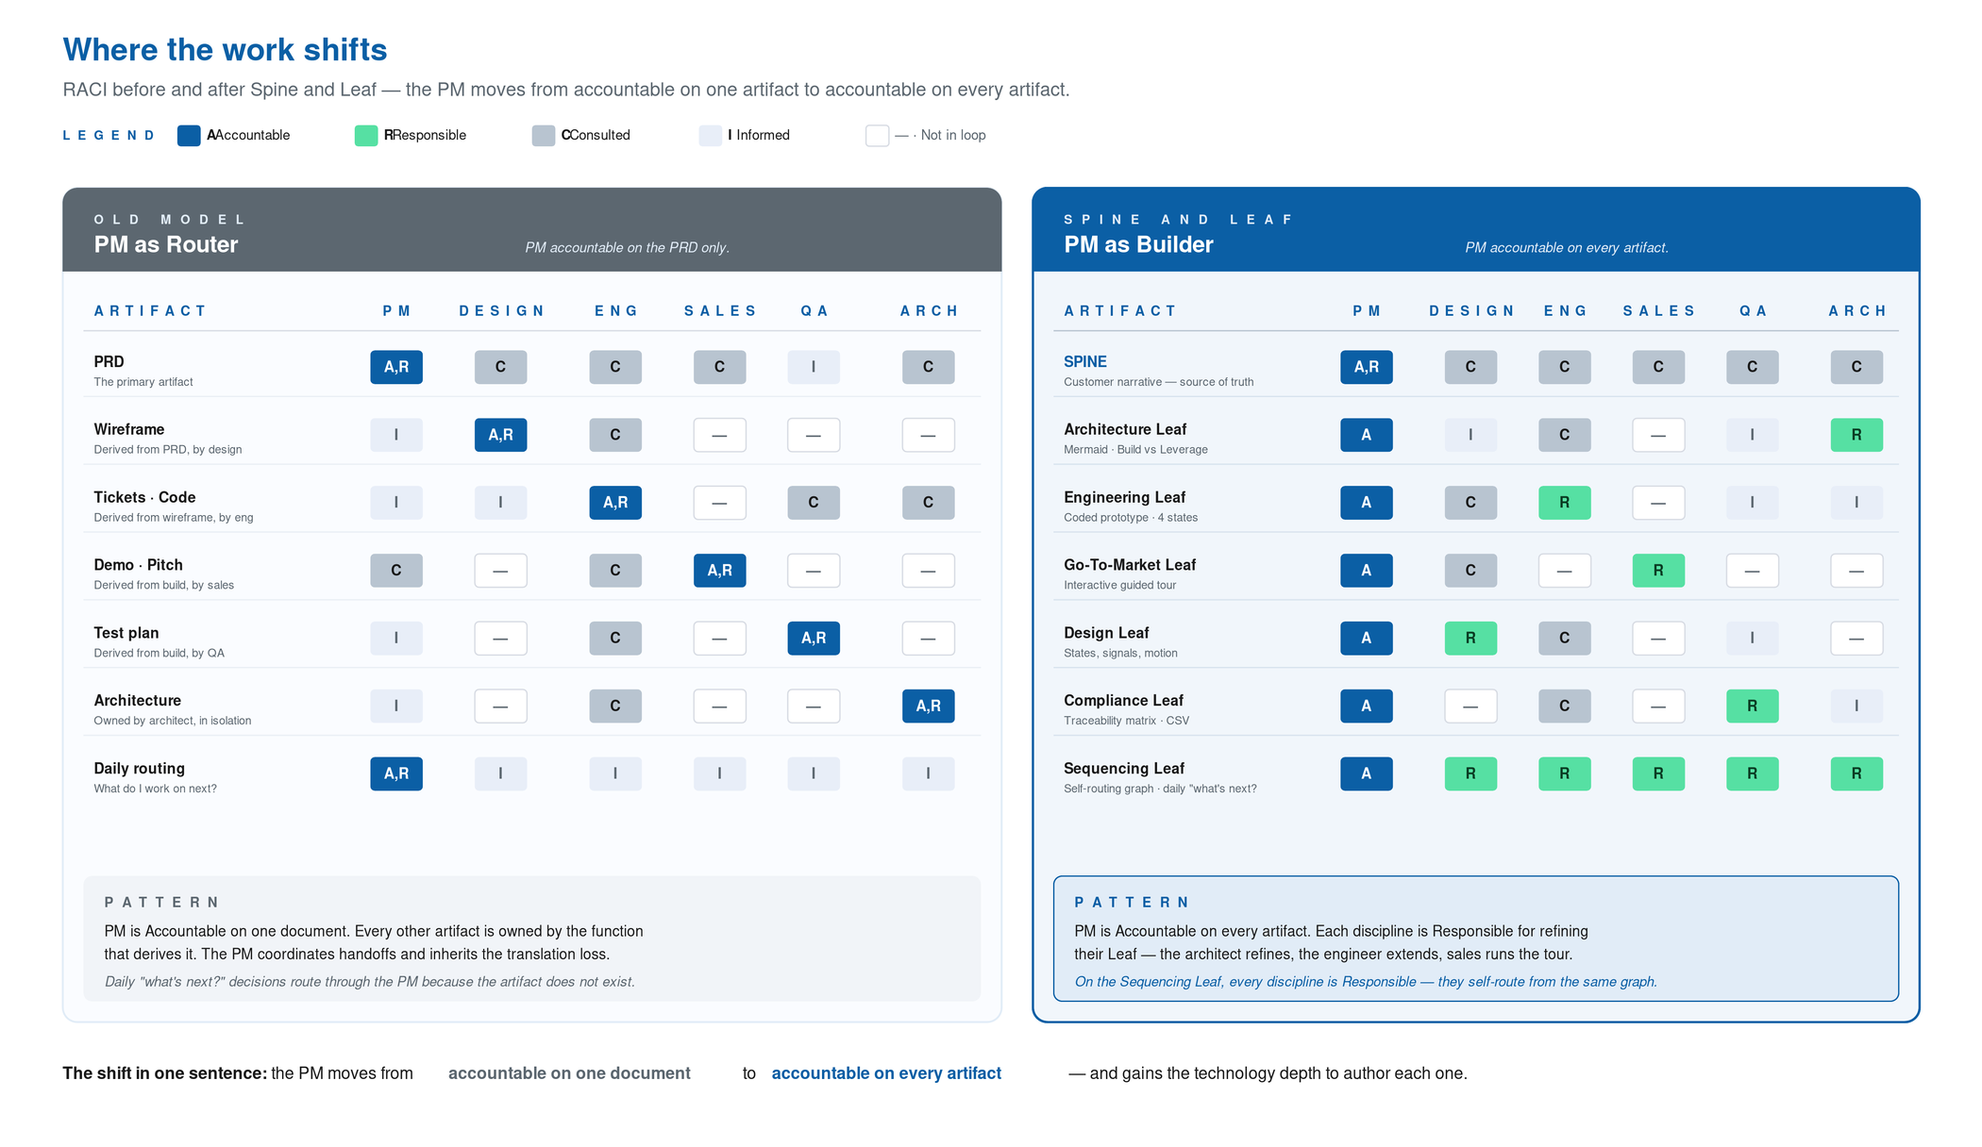
Figure 1. The PM moves from accountable on one artifact to accountable on every artifact.

Build vs. Leverage — where the moat lives
Foundation models, vector stores, evaluation frameworks, integration APIs are commodity. The team that uses them is not differentiated by using them. The team is differentiated by what it composes on top. The Build versus Leverage decision is a product decision — owned by the PM, made visible in the Architecture Leaf — and it requires the technology depth to make correctly. A small Build sitting on top of a large Leverage is almost always the right answer. The Build is the 5–10 percent of the system that encodes how the user thinks. The Leverage is everything else.
Heuristic: If a competitor can also use it tomorrow, leverage it. If it encodes how your user thinks, build it.

The rhythm — and why now
Mark McDonald's keynote at Gartner CPO 2026 named the cycle: the Intelligence Supercycle, with the explicit caveat that 'how we built IT products will not be how we build AI businesses.' The window between idea and ship has compressed. Field cases report 10× faster artifact creation, 33% lifts in deal velocity, and 28% reductions in customer acquisition cost when teams compress the artifact chain. Gunjan Gupta named the new currency: learning velocity. The methodology in this paper is one specific way to ship into that compressed window.
The two-week cycle inverts. The PM produces the Spine and first-draft Leaves on day zero. Days 1–2 are alignment, but the artifacts have already done the work. Days 3–8 are parallel execution: frontend wires the Engineering Leaf to real state, backend builds from the Architecture Leaf, GTM tests the tour with design partners. Days 9–12 reconcile via the Compliance Leaf. Days 13–14 ship. The same artifacts that aligned the team align the customer.

The thesis
Customer empathy is the floor. Without it, the methodology amplifies whatever truth or untruth the Spine encodes. Generative tools are force multipliers for being right and for being wrong, in equal measure. The empathy work is not optional in this model — it is the highest-leverage hour the PM spends.
Technology depth is the new ceiling. The PM who can read a system diagram, propose a Build versus Leverage split, sketch a data flow, and prototype an interaction has a different career trajectory than the PM who cannot. Depth does not mean becoming an engineer; it means understanding the cost curves, failure modes, and leverage points well enough to make tradeoffs before engineering is staffed. A PM with depth proposes the architecture and invites the engineer to refine it. The conversation is between peers.
The methodology is not a transformation of the role. It is a rediscovery of what the role was always trying to be. The discipline always wanted PMs to author artifacts the team could act on. The constraints around the role made it impossible. The constraints have lifted. The opportunity is to do the work the discipline always wanted, with the tools that finally make it possible.
A note on accountability. The new tools are not failing to deliver value. They are delivering exactly what we ask of them. If we keep asking for faster PRDs, we keep getting faster PRDs. The methodology is what we choose to ask the tools to produce. That part is in our hands.

How to adopt — six weeks
The methodology does not require permission, a reorganization, or a tool migration. It requires the PM to start producing different artifacts. The path below is the one most teams should run.
- Week 1 — Just the Spine. Pick one in-flight project. Write the Spine in plain markdown — two to four pages. Problem in the user's words, named persona, direction, success metrics, scope (in/out), 3–7 numbered commitments. Circulate, refine once, freeze. The hardest part is refusing to author Leaves until the Spine holds.
- Week 2 — Engineering Leaf. A coded prototype, even rough, with the four canonical states. The engineer can copy the DOM, the CSS variables, the state machine. Stop here for the week.
- Weeks 3–4 — Sequencing + GTM. List every work item. Add edges. Define MVP / Pilot / GA slices. The dev team starts self-routing from the graph on day one. GTM Leaf is a YAML tour that sales runs on a customer call by week four.
- Weeks 5–6 — Compliance, Architecture, Design. Compliance regenerates from the prototype's component tree. Architecture is one Mermaid diagram. Design is the state catalogue you already have in the prototype, documented.
- After three cycles — Audit. Compare time-to-aligned-team against your baseline. The improvement is usually large enough that the team will not let you go back.
The wave is here. The methodology is the surfboard.
See the full white paper for the worked example, the propagation playbook, the anti-patterns, and the starter templates appendix.

