Requirements Definition

*Tool Co-op*

1. **Introduction and Context**

In the neighborhood, many people have a need for tools; however, no one wants to buy tools for one-time projects. As a business venture there has been a proposed “Tool Co-op.” Rather than buying all the necessary tools for a single project, the Tool Co-op will keep a large selection of tools and allow everyone to check them out for their individual projects. This Tool Co-op will solve the problem by allowing everyone to use the tools they need for small fees instead of everyone purchasing their own tools. We have been contracted to design a system which will keep everything organized and easily managed.

This project will allow the Neighborhood Tool Co-op (the system) to manage their inventory. This includes creating new tools in the inventory, adjusting item quantities, marking where the item is located, and storing an image of the tool. The system will have full control of customer management. The system will be able to add new customer accounts and manage the customers’ information. The system will allow the submission of tool reservations, the listing of the customer requesting the reservation, and the addition of specific tools to the reservation. As tools are checked in and out, the Co-op will be able to track how many are in inventory and know which tools may be checked out to new customers. This includes knowing the dates that tools must be returned.

1. **Users and their Goals**

Shown below are user story diagrams and a brief explanation to highlight user goals

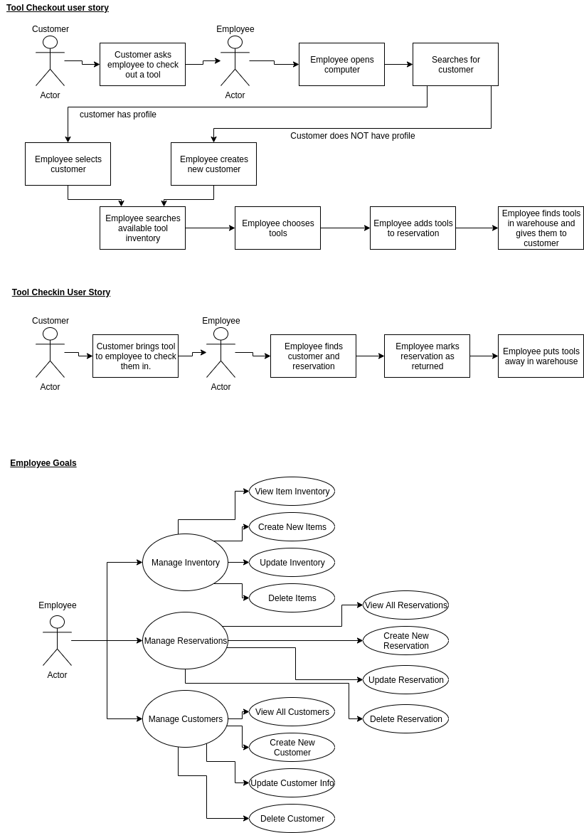

Tool Checkout User Story Explanation:

1. Customer approaches employee looking to check out a tool
2. The employee searches for the customer’s profile
   1. The employee ensures that customer information is up to date
   2. The employee checks if the customer is current on monthly dues.
   3. If the customer is not found, the employee creates a new customer
3. The employee uses the system to check if the tool is available to reserve.
4. The employee finds where the tool is located and gets the tool
5. The employee fills out required information to create a reservation for the customer
6. The customer leaves with the tool



Tool CheckIn User Story Explanation

1. The customer meets the employee at the warehouse with the tools that were borrowed
2. The employee finds the customer’s reservation
3. The employee marks the reservation as returned
4. The employee finds where the item is held in the warehouse and returns the item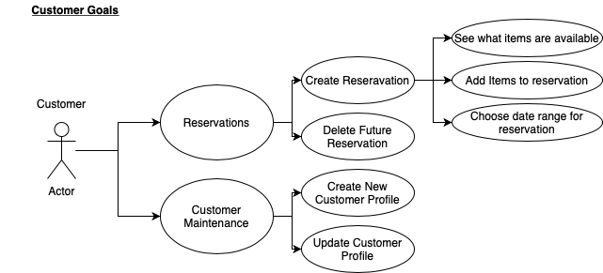

Customer Goals:

1. Customers should have a customer profile and be allowed to update the profile with their current information
2. Customers should be able to make reservations
   1. These reservations should be able to have multiple tools on them
   2. The customer should be able to decide the timeframe for the reservation



Employee Goals:

1. The employee should be able to manage inventory
   1. The employee can create new items in inventory as new inventory is purchased
   2. The employee can update items as information changes
      1. Change quantity available
      2. Change storage location information
      3. Change image
   3. The employee can inactivate items when they are no longer reservable
   4. The employee can see a list of all inventory
2. The employee should be able to manage reservations
   1. The employee should be able to see all past, present, and future reservations
      1. This includes what items are on the reservation and to what customer
   2. The employee should be able to edit existing reservations
      1. This includes changing pickup and due dates, as well as adding additional tools to a reservation
      2. The employee should be able to delete reservations after they are made
3. The employee should be able to manage customers
   1. The employee can create new customer profiles
   2. The employee can edit existing customer profiles
   3. The employee can delete customer profiles
   4. The employee can see a list of all current customer profiles
      1. This can be filtered by different criteria

Classes and their Relationships

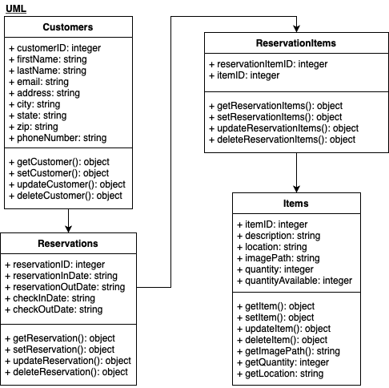

1. **Functional Requirements**
2. Employees should be able to create, view, update, and delete tools through easy user interfaces
3. Employees and customers should have access to a searchable catalog of tools
4. Employees should be able to create, view, update, and delete customer accounts
5. Employees can check out tools to customers
6. Employees can create reports with specified criteria regarding customers, items, and reservations
7. Employees can easily calculate fees that the customer owes.
8. Customers are allowed to make reservations online on a user-friendly website
9. The main page of the employee view should show which tools are to be checked out.
10. Customers will receive notifications before tools are due.
11. **Non-functional Requirements**
12. Show database of tools and allow changes to be made to database
13. Send responses of searches in less than 3 seconds
14. Sends notifications of due dates for tools from server on dates.
15. Calculates and reports fees within 3 seconds for employee to charge
16. **Future Features**
17. Categories for tools so users can search by type of tool or job type.
18. Create tool sets that can be checked out together instead of having to search one by one.
19. A wait list for users to be next in line for the tools, without having to check repeatedly
20. Notifications for tools that are back in.
21. Notifications about tools that are in high demand.
22. **Functioning Features**
23. A slideshow / carousel on the main page that changes every few seconds
24. A modal that alerts the user that their submission has been accepted,
25. A toolshed logo that appears twice on every page (both header and foot)
26. A contact us page that has a google map and a form to email questions
27. A project page that has pictures and descriptions of people using our tools for home remodel
28. **Glossary**

System *- in this case, the system is all of the programs that work together to create the tool co-op. From the front-end design (what the customers and employees see) to the database that holds all the information.*

User *- A user may be defined as either the customers and employees, or in certain cases, software systems that interact with other software.*

Reservation *- To place a tool on hold or “reserve” a tool to be checked out at a specific time.*

Wait-List *- To be placed next in line to reserve or checkout a tool.*

Server *- The server hosts the co-op online. This way a customer and/or employee can access the co-op to reserve tools.*

API *- Application Program Interface. API’s are the necessary link between programs/software.*