Uyen Dang

16227610

CS5590 Big Data Programming – Summer 2020

**PART 1 - Use Sqoop to import and export mySQL Tables to HDFS.**

Step 1: show database:

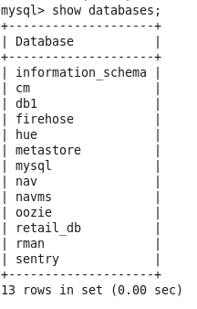

Step 2: Create available database and select database

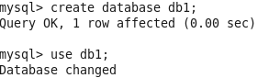

Step 3: Create table and insert value



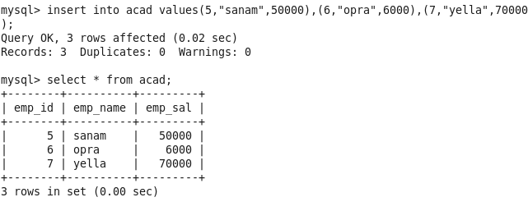

Step 4: Import Sqoop

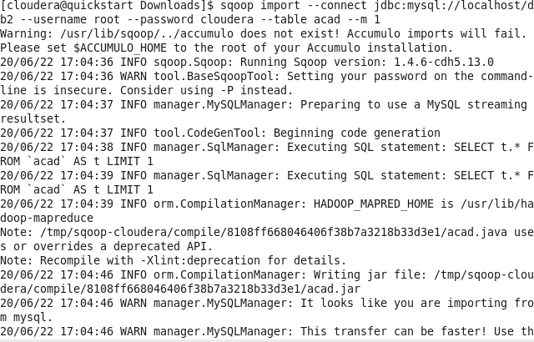

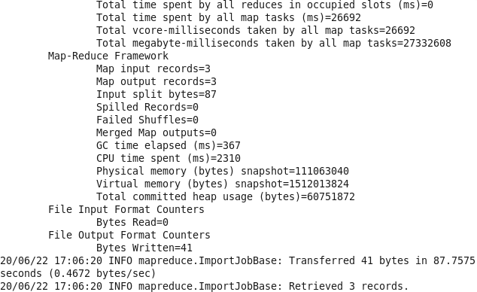

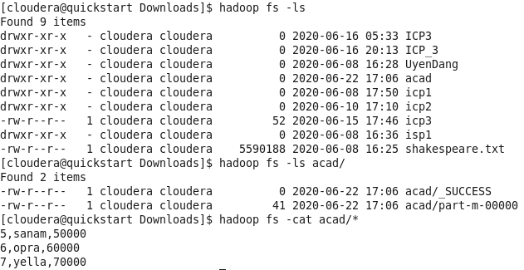

Step 5: go to Hue and see the data is successfully import to HDFS

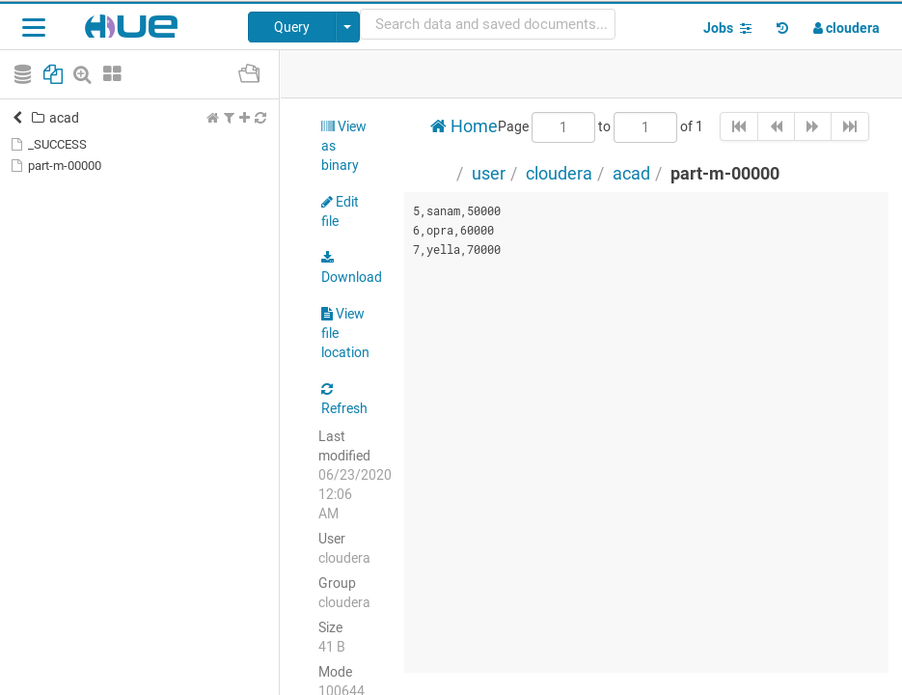

**PART2 - Create Hive Tables through HQL Script, Use Sqoop to import and export tables to Relational Databases**

Step 1: Create a hive table

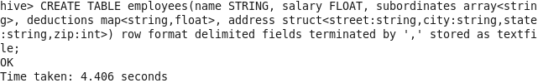

Step 2: verify table and load data into path

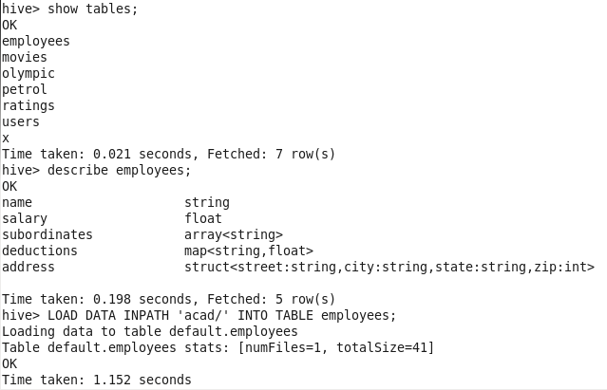

Step 3: Verify table in warehouse

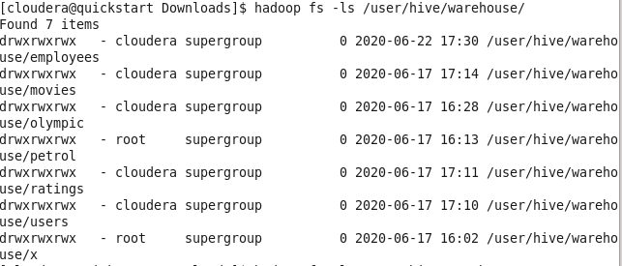

Step 4: Create an empty table in mySQL:



Step 5: Export sqoop from hive into mysql

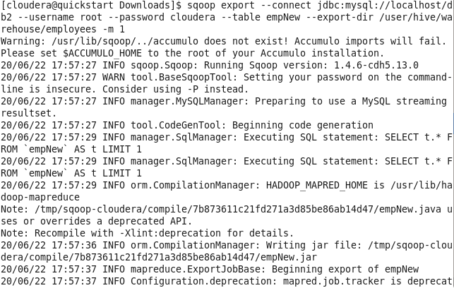

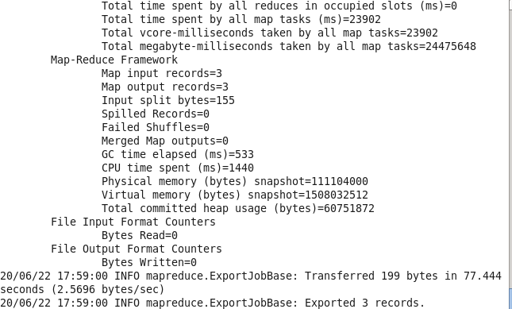

Step 6: The data is successfully export from Hive to mysql

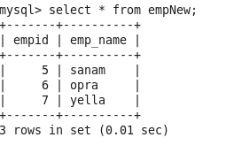

**PART 3: Perform three queries from databases**

Step 1: Statistics

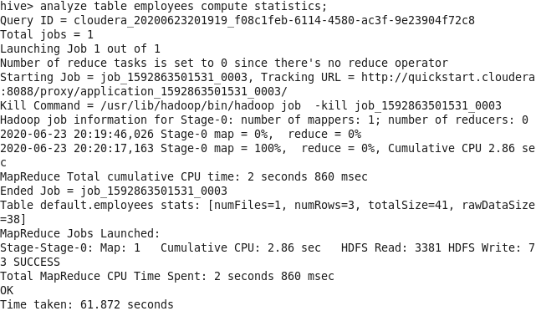

Step 2: Word Count

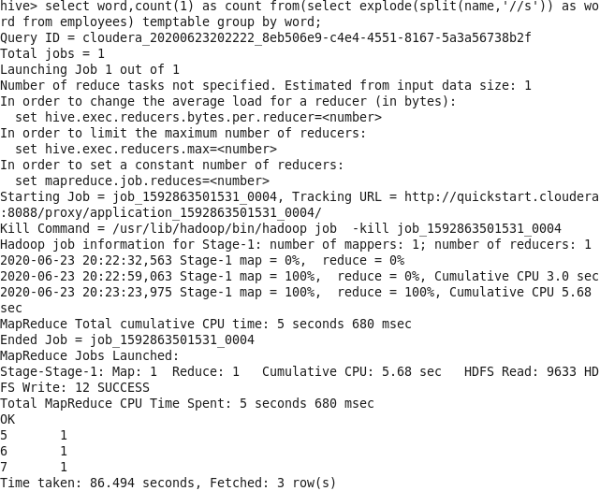

Step 3: Identifying pattern

