Uyen Dang

CS 5590 – Summer 2020

1. Download Python 2.7.X (<https://www.python.org/downloads/release/python-2717/>)
2. Install Python and during installation select Entire python paths
3. Download Cassandra Version 3.11.6 or latest (<http://cassandra.apache.org/download/>)
4. Extract it in you localsystem, i.e., C Drive
5. Add envrionemnt variable CASSNADRA_HOME with value "C:\apache-cassandra-3.11.6"

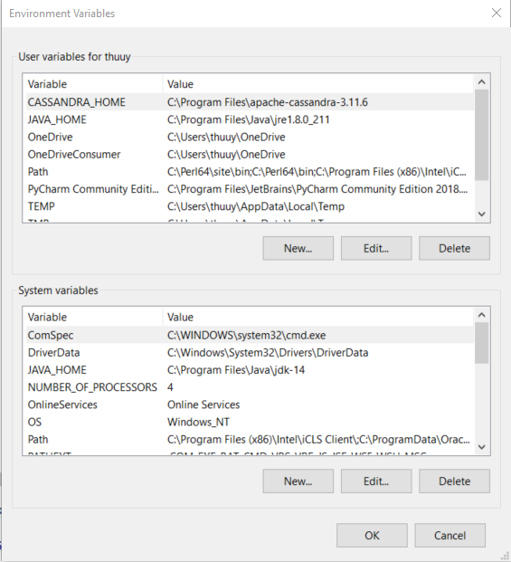

1. Navigate to "C:\apache-cassandra-3.11.6\bin" folder
2. Open command terminal window as administratior, navigate to "C:\apache-cassandra-3.11.6\bin" and Type "cassandra.bat -f" for starting cassandra server on localhost
3. Wait for server to initialize completely for atleast 3 - 5 minutes

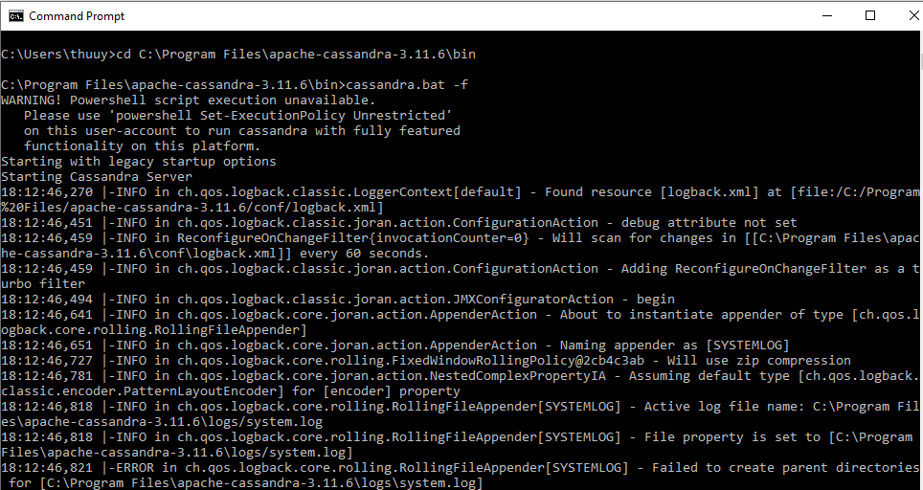

1. open new terminal windows navigate to "C:\apache-cassandra-3.11.6\bin" and type "cqlsh"

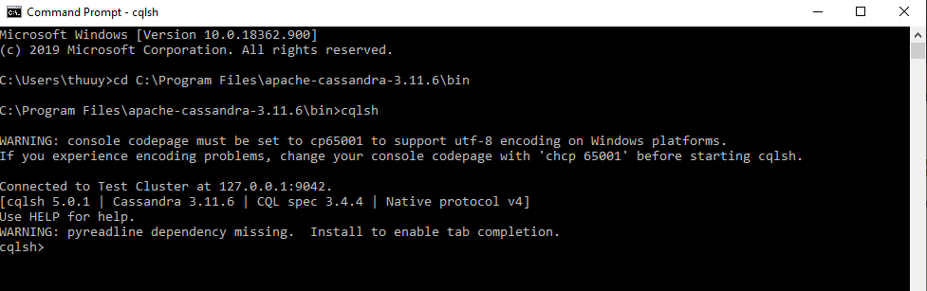

10. Create a new name space and use that namespace

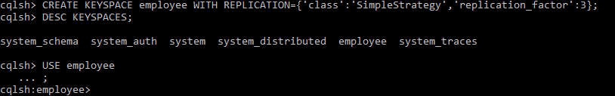

11. Create table emp and load data.

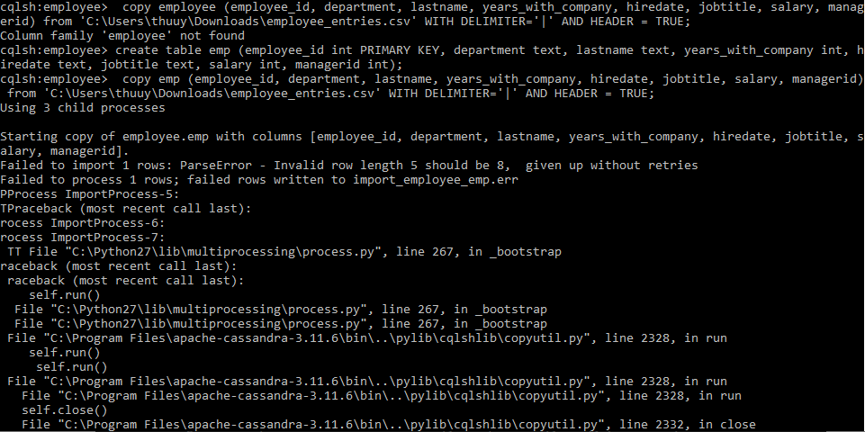

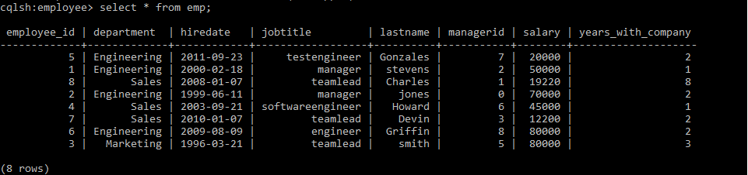

**QUERIES**

1. List the empID, ename, jobtitle and hiredate of employee from the employee table

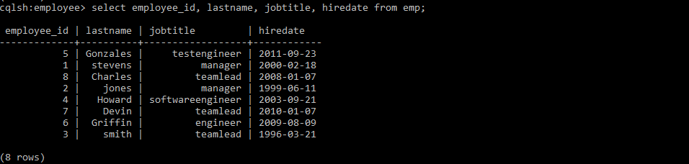

2. List the name, salary of the employees who are clerks.



3. List the name, job, salary of every employee joined on ‘february18,2000’,

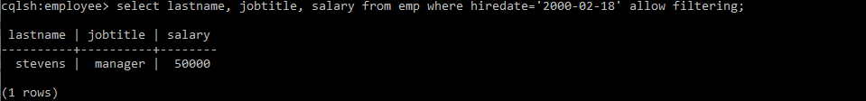

4. List name and annual salary of all the employees.

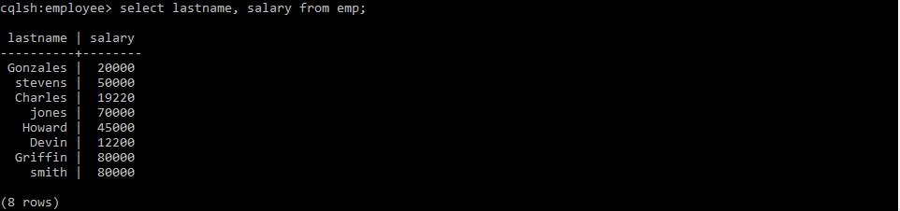

5. Display employees’ names, salary and manager values of those employees whose salary is 45000 from EMP table using SELECT statement.

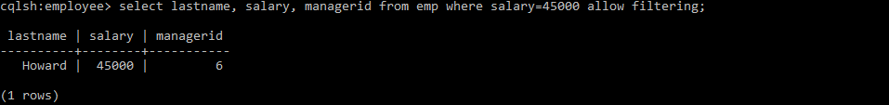

Bonus: (2) Import any data from the given data set and apply any commands like above.

Create table lights and import data

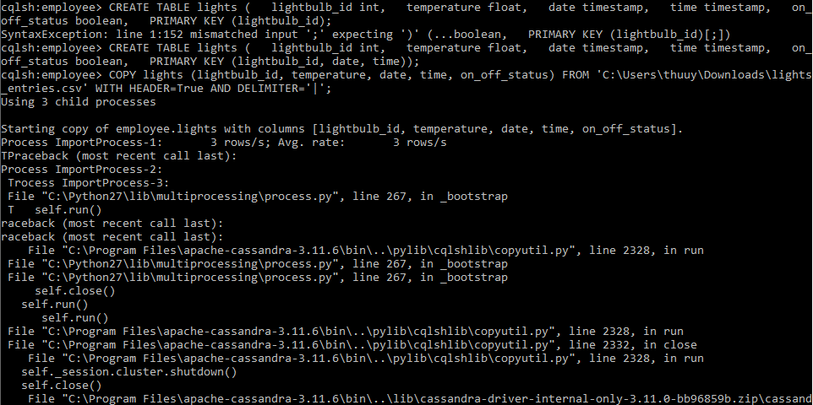

Queries 1: Select the lightbulb_id, temperature, date, time where on_off_status = true

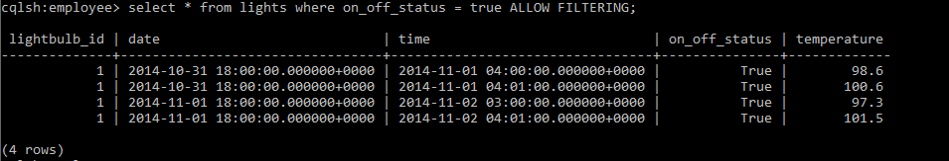

Queries 2: Find the lightbulb and date that have temperature > 97.4

