After installing JDK, Python, and Cassandra, I started the Cassandra server

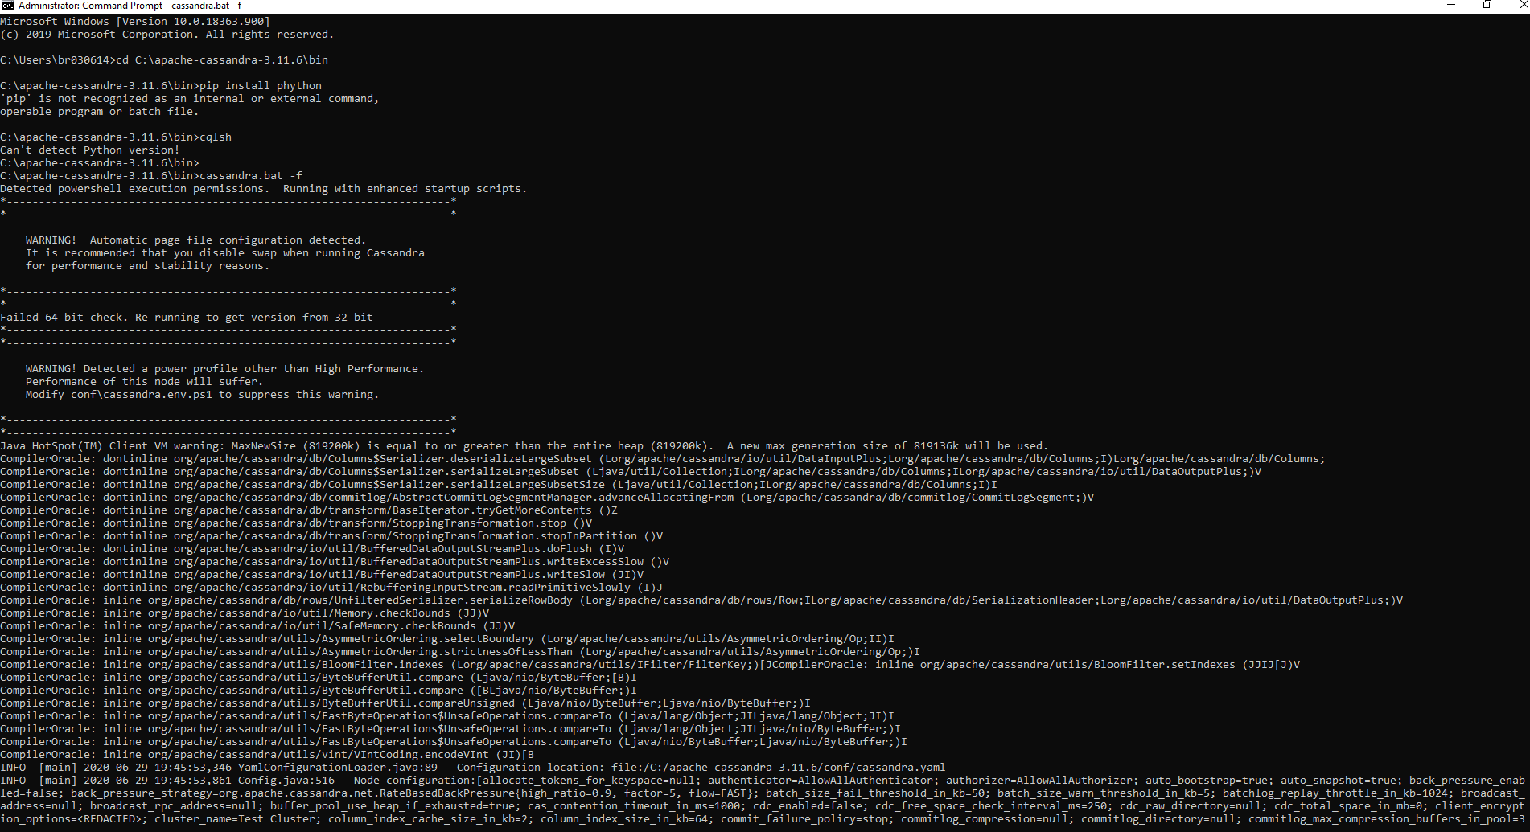

Creating the employee keyspace:



Creating the emp table in the employee keyspace

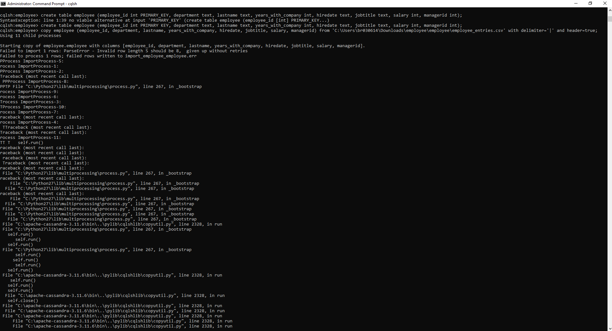

cqlsh> create keyspace employee with replication={'class':'SimpleStrategy', 'replication_factor':1};

cqlsh> use employee;

cqlsh:employee> create table employee (employee_id int PRIMARY KEY, department text, lastname text, years_with_company int, hiredate text, jobtitle text, salary int, managerid int);

cqlsh:employee> copy employee (employee_id, department, lastname, years_with_company, hiredate, jobtitle, salary, managerid) from 'C:\Users\br030614\Downloads\employee\employee\employee_entries.csv' with delimiter='|' and header=true;

cqlsh:employee> select * from employee;

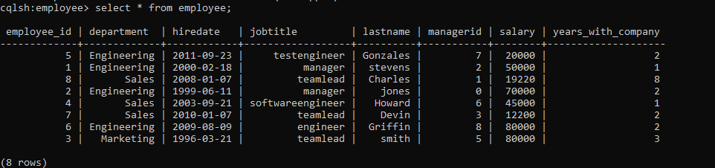

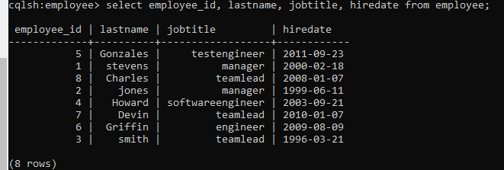

cqlsh:employee> select employee_id, lastname, jobtitle, hiredate from employee;

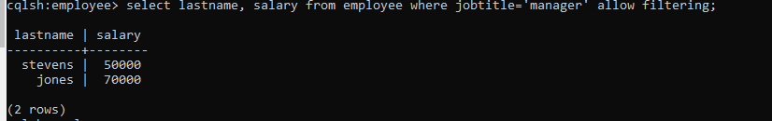

cqlsh:employee> select lastname, salary from employee where jobtitle='manager' allow filtering;

changed to manager as there are no clerks

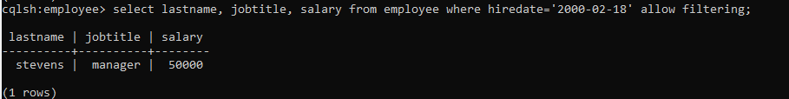

cqlsh:employee> select lastname, jobtitle, salary from employee where hiredate='2000-02-18' allow filtering;

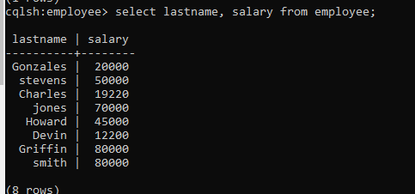

cqlsh:employee> select lastname, salary from employee;

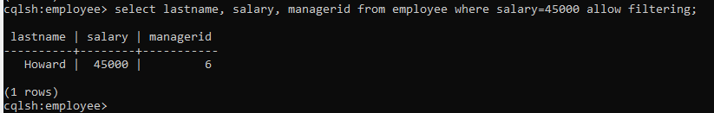

cqlsh:employee> select lastname, salary, managerid from employee where salary=45000 allow filtering;