ER Diagram For Iteration -1

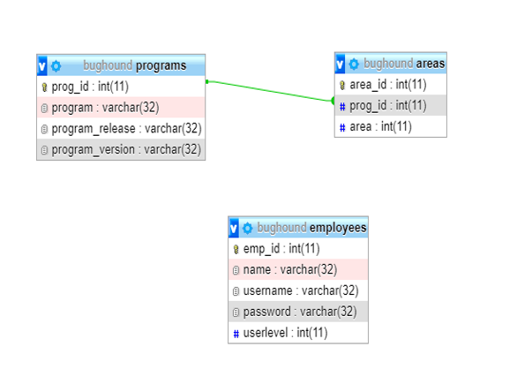

Use Cases Iteration 1

Use Case 1: Adding a Program

Actor: User

Overview: A program may be added to the bug report to test it. There is information regarding each program that must be included in the report, which will be added in the adding process.

Basic Flow: 1. The user will click on the “Add Programs” label.

2. The user will expand the drop-down menu labeled “Programs”.

3. The user will click on the program he or she wishes to add to the bug report.

4. The user will expand the drop-down menu labeled “Report Type”.

5. The user will click on the desired report type.

6. The user will expand the drop-down menu labeled “Reproducible?”.

7. The user will click on “Yes” or “No”.

8. The user will enter problem summary information into the “Problem Summary”

box.

9. The user will enter the problem information in the “Problem” box.

10. The user will click on the drop-down menu labeled “Reported By”.

11. The user will select their name from the employee list.

12. The user will add the current date in the box labeled “Date”.

13. The user will click on the submit button on the bottom of the page.

Use Case 2: Updating a Program

Actor: User

Overview: The program which the user would like to test may be updated. All information regarding all programs may be edited in this process.

Basic Flow: 1. The user will click on the “Edit Programs” label.

2. The user will expand the drop-down menu labeled “Programs”.

3. The user will click on the program he or she wishes to update.

4. The information on the page will update according to the selected program

5. The user will be able to change any information he or she wishes to change

regarding the selected program.

6. The user will expand the drop-down menu labeled “Functional Area”.

7. The user will click a functional area from the menu.

8. The user will expand the drop-down menu labeled “Assigned To”.

9. The user will click on his or her name from the list.

10. The user will write information on how to fix the bug in the “Suggested Fix”

box.

11. The user may write any additional information in the “Comments” box.

12. The user will expand the drop-down menu labeled “Status”.

13. The user will click on “Open” or “Closed”.

14. The user will expand the drop-down menu labeled “Priority”.

15. The user will click on one of the priority choices.

16. The user will expand the drop-down menu labeled “Resolution”.

17. The user will click on one of the resolution choices.

18. The user will expand the drop-down menu labeled “Resolution Version”.

19. The user will click on one of the resolution version choices.

20. The user will expand the drop-down menu labeled “Resolved By”.

21. The user will click on his or her name from the list of employees.

22. The user will enter the current date in the “Date” box.

23. The user will expand the drop-down menu labeled “Tested By”.

24. The user will click on his or her name from the list of employees.

25. The user will enter the current date in the “Date” box.

26. The user will click on the submit button on the bottom of the page.

Use Case 3: Deleting a Program

Actor: User

Overview: The program which is selected to test may be deleted from testing.

Basic Flow: 1. The user will click on the “Edit Programs” label.

2. The user will expand the drop-down menu labeled “Programs”.

3. The user will click on the program he or she wishes to delete.

4. The information on the page will update according to the selected program

5. The user will click on the delete button on the bottom of the page.

Use Case 4: Adding an area

Actor: User

Overview: Each program has areas associated with it. Areas may be added to each program.

Basic Flow: 1. The user will click on the “Area” label

2. The user will expand the drop-down menu labeled “Programs”.

3. The user will click on the program he or she wishes to add an area to.

4. The user will enter the name of the area in the box next to the “Add” label.

5. The user will click the “Add Area” Button.

Use Case 5: Updating an Area

Actor: User

Overview: Information regarding areas associated which each program may be edited.

Basic Flow: 1. The user will click on the “Area” label

2. The user will expand the drop-down menu labeled “Programs”.

3. The user will click on the program containing the area he or she wishes to

update.

4. The user will change the name of the area in the box next to the appropriate ID

label.

5. The user will click the “Update” Button.

Use Case 6: Deleting an Area

Actor: User

Overview: Areas associated with each program may be deleted.

Basic Flow: 1. The user will click on the “Area” label

2. The user will expand the drop-down menu labeled “Programs”.

3. The user will click on the program containing the area he or she wishes to

delete.

4. The user will click on the “Delete” button next to the area which he or she

wishes to delete.

Use Case 7: Adding an Employee

Actor: User

Overview: Employees may be added to the employee list. Each employee has a field for Name, User Name, Password, and User Level.

Basic Flow: 1. The user will click on the “Add Employee” label.

2. The user will enter his or her name in the “Name” box.

3. The user will enter his or her desired username in the “User Name” box.

4. The user will enter his or her password in the “Password” box.

5. The user will select a user level from the toggle menu associated with the

“User Level” box.

6. The user will click on the submit button.

7. If the desired name is already taken, a message stating “Username already

taken, please select a different username” will appear and the user will enter

a different username.

8. The user will click on the submit button.

Use Case 8: Updating an Employee

Actor: User

Overview: Information regarding each employee may be edited.

Basic Flow: 1. The user will click on the “Edit Employee” label.

2. The user enter his or her username and password in the respective boxes and click submit.

3. The user may change any information regarding his or her employee

information.

4. The user will click on the submit button.

Use Case 9: Deleting an Employee

Actor: User

Overview: Employees may be deleted by users of proper authority.

Basic Flow: 1. The user will click on the “Edit Employee” label.

2. The user enter his or her username and password in the respective boxes and click submit.

3. Assuming the user has proper authority, the user will expand the drop-down menu labeled “Employees”.

4. The user will click on the employee he or she wishes to delete.

5. The user will click on the “Delete Employee” button.