

**USER’S**

**MANUAL**

*Fitness Tie*

By Brett Schmidt

**CSCI_234 C#**

December 21, 2017

**Revision Sheet**

|  |  |  |
| --- | --- | --- |
| **Release No.** | **Date** | **Revision Description** |
| Rev. 0 | 12/1/17 | Initial User Manual |
|  |  |  |
|  |  |  |
|  |  |  |
|  |  |  |
|  |  |  |
|  |  |  |

|  |  |
| --- | --- |
|  | **User’s Manual**  **Authorization Memorandum** |

I have carefully assessed the User’s Manual for the (Fitness Tie). This document has been completed in accordance with the requirements of the Brett’s Good Application Development Morals.

MANAGEMENT CERTIFICATION - Please check the appropriate statement.

__X___ The document is accepted.

______ The document is accepted pending the changes noted.

______ The document is not accepted.

We fully accept the changes as needed improvements and authorize initiation of work to proceed. Based on our authority and judgment, the continued operation of this system is authorized.

_Brett Schmidt___________________ _12/21/2017____________

NAME DATE

Project Leader

_______________________________ _____________________

NAME DATE

Operations Division Director

_______________________________ _____________________

NAME DATE

Program Area/Sponsor Representative

_______________________________ _____________________

NAME DATE

Program Area/Sponsor Director

**USER'S MANUAL**

**TABLE OF CONTENTS**

Page #

1.0 GENERAL INFORMATION

1.1 System Overview

1.2 Project References

1.3 Authorized Use Permission

1.4 Points of Contact

1.4.1 Information

1.4.2 Coordination

1.4.3 Help Desk

1.5 Organization of the Manual

1.6 Acronyms and Abbreviations

2.0 SYSTEM SUMMARY

2.1 System Configuration

2.2 Data Flows

2.3 User Access Levels

2.4 Contingencies and Alternate Modes of Operation

3.0 GETTING STARTED

3.1 Logging On

3.2 System Menu

3.2.x [System Function Name]

3.3 Changing User ID and Password

3.4 Exit System

4.0 USING THE SYSTEM (ONLINE)

4.x [System Function Name]

4.x.y [System Sub-Function Name]

4.2 Special Instructions for Error Correction

4.3 Caveats and Exceptions

5.0 USING THE SYSTEM (BATCH)

5.x [System Function Name]

5.x.y [System Sub-Function Name]

5.2 Special Instructions for Error Correction

5.3 Caveats and Exceptions

5.4 Input Procedures and Expected Output

6.0 QUERYING

6.1 Query Capabilities

6.2 Query Procedures

7.0 REPORTING

7.1 Report Capabilities

7.2 Report Procedures

**1.0 GENERAL INFORMATION**

# GENERAL INFORMATION

## 1.1 System Overview

Features:

1. Creating workouts
2. Browsing workouts
3. Updating workouts
4. Querying workouts
5. Deleting workouts
6. Undeleting workouts
7. Purging workouts
8. System category:
9. *Major application:* Provides a form-based UI to create/modify workouts in an Access Database.
10. *General support system:* C# required
11. Operational status:
12. Operational
13. Under development
14. General description: Currently, Fitness Tie allows users to create their own exercises.
15. Runs and built with Visual Studio 2015 in C#

## 1.2 Project References

N/A

## 1.3 Authorized Use Permission

Please only use to create workouts, it will do much else and you will waste your time.

## 1.4 Points of Contact

### 1.4.1 Information

Brett Schmidt

Email: BSchmidt11@email.davenport.edu

### 1.4.2 Coordination

### 1.4.3 Help Desk

No Help Desk provided at this time.

## 1.5 Organization of the Manual

Create Exercise UI, Browse Exercise UI, About UI,

## 1.6 Acronyms and Abbreviations

Provide a list of the acronyms and abbreviations used in this document and the meaning of each.

**2.0 SYSTEM SUMMARY**

# SYSTEM SUMMARY

## 2.1 System Configuration

N/A

## 2.2 Data Flows

Application to AccessDB

## 2.3 User Access Levels

All Users have access to all controls.

## 2.4 Contingencies and Alternate Modes of Operation

**3.0 GETTING STARTED**

# GETTING STARTED

## 3.1 System Menu

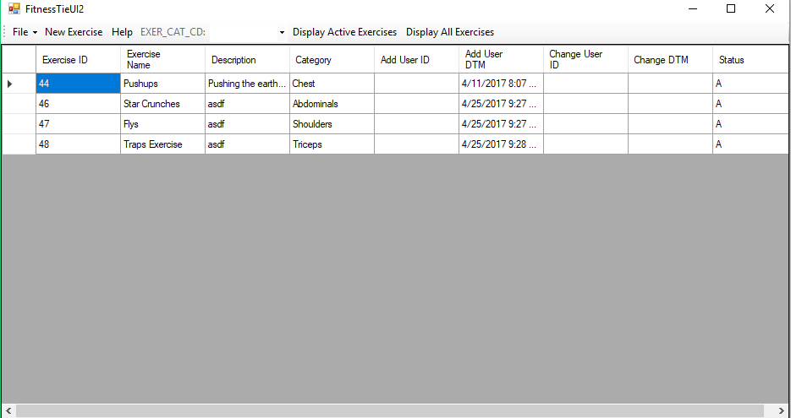

Main menu is the Create Exercise UI.

File

Exit: Exits the system completely.

Help

About: Provides a very hip and helpful Help window with a bunch of text.

New Exercise: Opens a new form to add a new workout

Category: Provides a combo box that shows all the possible categories to query from

Display Active Exercises: Shows records that are not deleted

Display All Exercises: Shows deleted records so they can be purged or undeleted

Double Click Cell: Brings up new window to allow updating the record

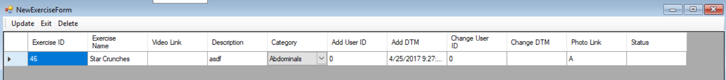

Create/Update Exercise form

Update: Updates the record and closes this window: returning user to Main menu

Exit: Exits this window and returns user to Main menu

Delete: Changes the records status to inactive and returns user to Main menu

-If the record was inactive, then the delete button is replaced with Undelete and Purge which either change the status to Active or completely deletes the record, respectively

## 3.2 Changing User ID and Password

Not currently available.

## 3.4 Exit System

Describe the actions necessary to properly exit the system.

**4.0 USING THE SYSTEM (ONLINE)**

## 4.2 Special Instructions for Error Correction

If any errors are found, please pretend you did not see them and still give me an “A”.

## 4.3 Caveats and Exceptions