

**USER’S**

**MANUAL**

*Fitness Tie*

By Brett Schmidt

**CSCI_239 Java**

April, 2017

**Revision Sheet**

|  |  |  |
| --- | --- | --- |
| **Release No.** | **Date** | **Revision Description** |
| Rev. 0 | 4/23/17 | Initial User Manual |
|  |  |  |
|  |  |  |
|  |  |  |
|  |  |  |
|  |  |  |
|  |  |  |

|  |  |
| --- | --- |
|  | **User’s Manual**  **Authorization Memorandum** |

I have carefully assessed the User’s Manual for the (Fitness Tie). This document has been completed in accordance with the requirements of the Brett’s Good Application Development Morals.

MANAGEMENT CERTIFICATION - Please check the appropriate statement.

__X___ The document is accepted.

______ The document is accepted pending the changes noted.

______ The document is not accepted.

We fully accept the changes as needed improvements and authorize initiation of work to proceed. Based on our authority and judgment, the continued operation of this system is authorized.

_Brett Schmidt___________________ _4/23/2017____________

NAME DATE

Project Leader

_______________________________ _____________________

NAME DATE

Operations Division Director

_______________________________ _____________________

NAME DATE

Program Area/Sponsor Representative

_______________________________ _____________________

NAME DATE

Program Area/Sponsor Director

**USER'S MANUAL**

**TABLE OF CONTENTS**

Page #

1.0 GENERAL INFORMATION

1.1 System Overview

1.2 Project References

1.3 Authorized Use Permission

1.4 Points of Contact

1.4.1 Information

1.4.2 Coordination

1.4.3 Help Desk

1.5 Organization of the Manual

1.6 Acronyms and Abbreviations

2.0 SYSTEM SUMMARY

2.1 System Configuration

2.2 Data Flows

2.3 User Access Levels

2.4 Contingencies and Alternate Modes of Operation

3.0 GETTING STARTED

3.1 Logging On

3.2 System Menu

3.2.x [System Function Name]

3.3 Changing User ID and Password

3.4 Exit System

4.0 USING THE SYSTEM (ONLINE)

4.x [System Function Name]

4.x.y [System Sub-Function Name]

4.2 Special Instructions for Error Correction

4.3 Caveats and Exceptions

5.0 USING THE SYSTEM (BATCH)

5.x [System Function Name]

5.x.y [System Sub-Function Name]

5.2 Special Instructions for Error Correction

5.3 Caveats and Exceptions

5.4 Input Procedures and Expected Output

6.0 QUERYING

6.1 Query Capabilities

6.2 Query Procedures

7.0 REPORTING

7.1 Report Capabilities

7.2 Report Procedures

**1.0 GENERAL INFORMATION**

# GENERAL INFORMATION

## 1.1 System Overview

Features:

1. Login UI
2. Creating workouts
3. Browsing workouts
4. Updating workouts
5. Querying workouts
6. Deleting workouts
7. Undeleting workouts
8. Purging workouts
9. System category:
10. *Major application:* Provides a form-based UI to create/modify workouts in an Access Database.
11. *General support system:* Java required
12. Operational status:
13. Operational
14. Under development
15. General description: Currently, Fitness Tie allows users to create their own custom workouts.
16. Runs and built with Java

## 1.2 Project References

N/A

## 1.3 Authorized Use Permission

Please only use to create workouts, it will do much else and you will waste your time.

## 1.4 Points of Contact

### 1.4.1 Information

Brett Schmidt

Email: BSchmidt11@email.davenport.edu

### 1.4.2 Coordination

### 1.4.3 Help Desk

No Help Desk provided at this time.

## 1.5 Organization of the Manual

Login UI, Create Workout UI, Browse Workout UI, Browse MyWorkoutUI, About UI,

## 1.6 Acronyms and Abbreviations

Provide a list of the acronyms and abbreviations used in this document and the meaning of each.

**2.0 SYSTEM SUMMARY**

# SYSTEM SUMMARY

## 2.1 System Configuration

N/A

## 2.2 Data Flows

Application to AccessDB

## 2.3 User Access Levels

All Users have equal access right now, but can only delete, undelete, and purge workouts they added.

## 2.4 Contingencies and Alternate Modes of Operation

**3.0 GETTING STARTED**

# GETTING STARTED

## 3.1 Logging On

General User

UserID = 1

Password = 1

Teacher Login

UserID = teacher

Password = teacher

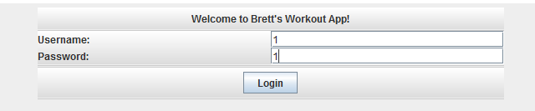

## 3.2 System Menu

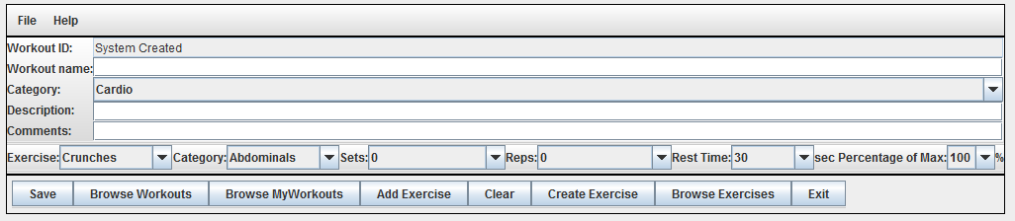

Main menu is the Create Workout UI.

File

New: Does nothing.

Exit: Exits the system completely.

Help

About: Provides a very hip and helpful Help window with a bunch of text.

Save: Saves the current workout.

Must have Workout name, Description, Sets and Reps for the workout to be saved.

The system will create the WorkoutID for you and let you know what it is after it saves.

Browse Workouts: Opens new window to view and search workouts.

Browse MyWorkouts: Opens new window to view, search, delete, undelete, and purge workouts created by you.

Add Exercise: Adds another Exercise to the current window.

Clear: Does nothing.

Create Exercise: Opens new window to create a new exercise. Does not actually save exercise currently.

Browse Exercises: Does nothing currently.

Exit: Exits system.

## 3.3 Changing User ID and Password

Not currently available.

## 3.4 Exit System

Describe the actions necessary to properly exit the system.

**4.0 USING THE SYSTEM (ONLINE)**

# USING the SYSTEM

## 4.1a Create Workout



First window after logging in brings user to this window where they can create workouts.

Buttons:

File

New: Does nothing.

Exit: Exits the system completely.

Help

About: Provides a very hip and helpful Help window with a bunch of text.

Save: Saves the current workout to the Access DB.

Must have Workout name, Description, Sets and Reps for the workout to be saved.

The system will create the WorkoutID for you and let you know what it is after it saves.

Browse Workouts: Opens new window to view and search workouts.

Browse MyWorkouts: Opens new window to view, search, delete, undelete, and purge workouts created by you.

Add Exercise: Adds another Exercise to the current window.

Clear: Does nothing.

Create Exercise: Opens new window to create a new exercise. Does not actually save exercise currently.

Browse Exercises: Does nothing currently.

Exit: Exits system.

## 4.1b Browse Workouts

Click Browse Workouts from the Main Menu to come here.

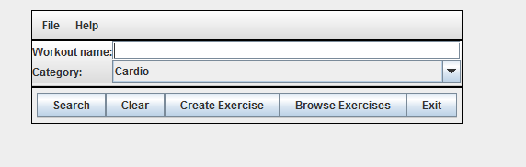

User can either type in a search query in the Workout name text field or select a category to browse workouts. Click Search after typing Workout name to initiate query.

After the Search is initiated, the window will appear with a list of workouts like so:

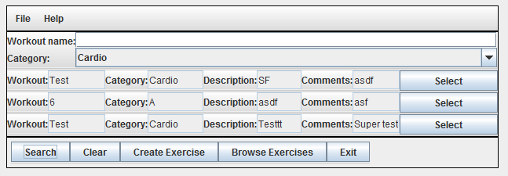

## 4.1c Update Workout

Clicking Select on any workout will transfer that data to the Main Menu to update the workout and close this window. The Main Menu will then look like this:

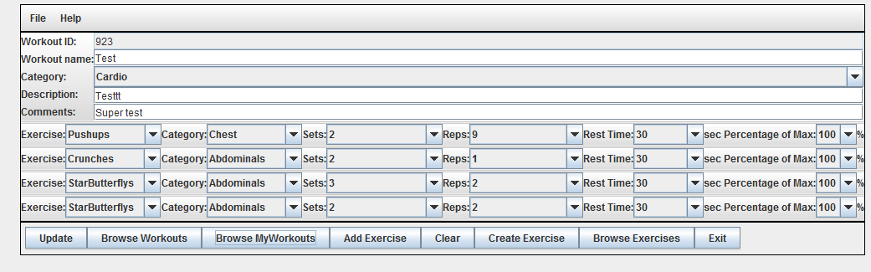

All the workout information from the selected workout will be there and the Saved button turns into an Update button that will update any changes the user makes.

## 4.1d Deleteing/UnDeleting/Purging Workouts

Clicking Browse MyWorkouts from the Main Menu will open a new window displaying all the user’s workouts with some new functions. The new window will look like so:

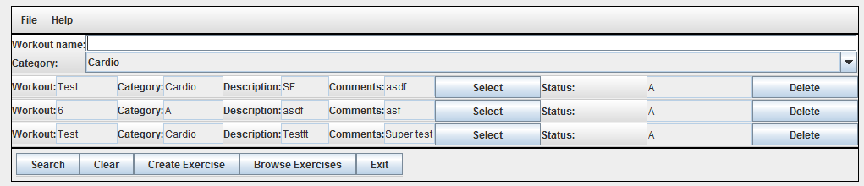

The workout’s Status Code is shown and a Delete Button is added. Clicking Delete on a workout changes the workout’s Status Code to “I” and promptly displays this after it completes the transaction. After Deleting Workout “Test” the window looks like so:

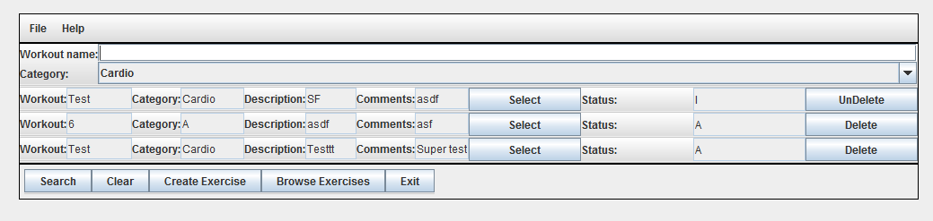

After deleting the Workout, the Status Code is now “I” and the button now says UnDelete. Clicking UnDelete will change it back to “A”.

File_Purge will permanently delete all deleted Workouts in this window because you created them all and set them to Deleted status.

## 4.2 Special Instructions for Error Correction

If any errors are found, please pretend you did not see them and still give me an “A”.

## 4.3 Caveats and Exceptions

Some buttons like Clear and Browse Exercise currently do not do anything.