Stephen Brett

# Problem 1

Discuss how you determined the reference frequency and all scale / chord frequencies for this project.

# For equal intonation, the reference frequency was calculated using A4 = 400 Hz, and the number of keys away from A4 was used to calculate the difference between the two keys. The scale/chord frequencies was found by using the number of keys away from the key corresponding to the root frequency, and multiplying the root by (2^# keys)^(1/12).

For just intonation, the task and solution were more complicated. The root frequency was found by finding the placement of A4 in the major or minor scale associated with that key, and dividing 440 Hz by the ratio to the starting point associated with that placement. If Ab was in the key, the ratio used was one step above that in the major scale of just intonation. If A# was in the key, the ratio used was one step below that in the major scale of just intonation. The scale/chord frequencies were determined by multiplying the root frequencies by the ratio corresponding to the desired note’s placement in the scale/chord.

For the tables, I was unsure of how to denote the start and end of the scale. I decided to keep the frequencies for the same note in the same octave. For just, I multiplied by 2 all of the frequencies below C. For equal intonation, I assumed A was A4, and had all frequencies above that value. Due to the way I carried out the calculations, I was unable to go back and change the just table. I made sure that the difference of the same note in the same octave was observable.

# Problem 4

With regards to the plots over a single wavelength, the just tempered major chord leads the corresponding equal tempered chord. The just tempered major chord lags the corresponding equal tempered chord.

With regards to the plots over a period of 20 wavelengths, the envelope of the just tempered chords repeats more often than that of the equal tempered chords. The equal tempered chords are less regular.

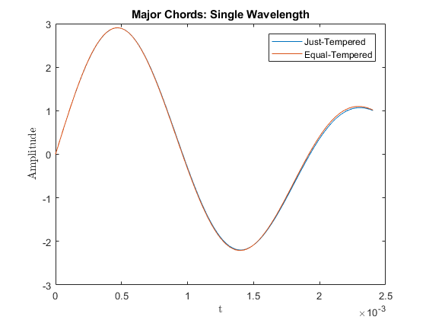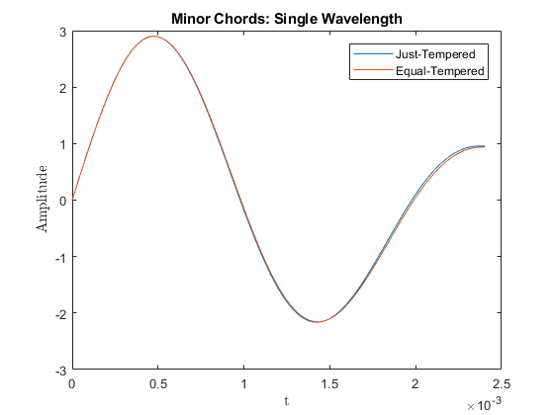

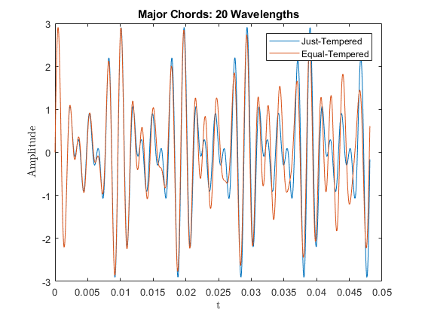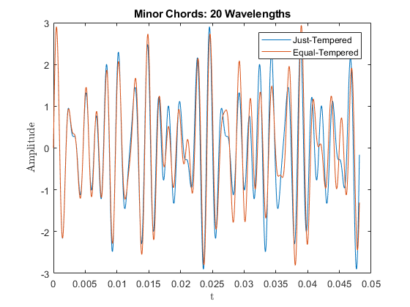

# Problem 5

1. Can you hear the difference between the just tempered Major scale and the equal tempered Major scale? Yes
2. Which one sounds better? - Why (explain) The notes of the just tempered major scale did not seem to be at an equal distance in pitch. This was more clearly evident near the end of the scale. The equal tempered major scale did appear to have equal jumps in pitch/ Therefore, the equal tempered major scale sounded better.
3. Can you hear the difference between the just tempered Minor scale and the equal tempered Minor scale? Yes
4. Which one sounds better? - Why (explain) The same effect that was evident for the major scales, was also present for the minor scales. Similarly, the equal tempered minor scale displayed equal jumps in pitch, and thus sounded better.
5. Can you hear the difference between the just tempered Major chord and the equal tempered Major chord? Yes
6. Which one sounds better? - Why (explain) While listening to the just tempered major chord, there appeared to be some noise additional to the beat frequency. This is because the separate notes in the chord are not equally separated in pitch. Since the notes in the equal tempered major chord are equally separated, this noise was not heard. Therefore, the equal tempered major chord sounded better.
7. Can you hear the difference between the just tempered Minor chord and the equal tempered Minor chord? Yes
8. Which one sounds better? - Why (explain) The same effect that was evident for the major chords, was also present for the minor chords. Similarly, the equal tempered minor chord displayed equal jumps in pitch, and thus sounded better.

# Other Comments