Process Definition Document

*Process Name: Invoice Scraping*

Table of Contents

**Introduction** **1**

Purpose of the Document 1

Objectives 1

Process Key Contact 1

Minimum Prerequisites for Automation 1

**As-Is Process Description** **2**

Process Overview 2

Applications used in the Process 3

As-Is Process Map 3

**To-Be Process Description** **4**

Detailed Process Map 4

Robot Type 4

Business Exceptions Handling 4

Known Exceptions 4

Unknown Exceptions 5

System Exceptions Handling 5

**Other Observations** **5**

**Additional sources of process documentation** **5**



# Introduction

## Purpose of the Document

The Process Definition Document outlines the business process chosen for automation using UiPath Robotic Process Automation (RPA) technology.

The document describes the sequence of steps performed as part of the business process, the conditions and rules of the process prior to automation and how they are envisioned to work after automating it, partly or entirely. This specifications document serves as a base for developers, providing them with the details required for applying robotic process automation to the selected business process.

## Objectives

The process has been selected for RPA as part of the project initiative conducted within Techno Computers Inc., the Finance department.

The objective of this process automation is linked to the project business case and is mainly intended to:

* Deliver faster processing
* Reduce redundant activities
* Improve overall performance and reliability

## Process Key Contact

The specifications document includes concise and complete requirements of the business process and it is built based on the inputs provided by the process Subject Matter Expert (SME)/ Process Owner.

The Process Owner is expected to review it and provide signoff for accuracy and completion of the steps, context, impact and a set of process exceptions. The details are to be included in the table below.

|  |  |  |  |
| --- | --- | --- | --- |
| Role | Name | Contact Details (email & phone number) | Notes |
| Process Owner | Niyaz Ahmed | [niyaz.ahmed@uipath.com](mailto:niyaz.ahmed@uipath.com) +91-9870333008 |  |
| Business Analyst | Niyaz Ahmed | [niyaz.ahmed@uipath.com](mailto:niyaz.ahmed@uipath.com) +91-9870333008 |  |

## Minimum Prerequisites for Automation

|  |  |
| --- | --- |
| Met (Y/N) | Prerequisites |
|  | A filled in and completed Process Definition Document |
|  | Closure of any open process questions |
|  | Environment set up |
|  | Test Data to support development and testing |
|  | User access and creation of user accounts (licences, permissions, restriction to create accounts for robots) |

# As-Is Process Description

## Process Overview

General information about the process selected for RPA prior to automation.

|  |  |  |
| --- | --- | --- |
| # | Item | Description |
| 1 | Process Full Name | Invoice Scraping |
| 2 | Process Area | Personal |
| 3 | Department | Finance |
| 4 | Process Short Description  (operation, activity, outcome) | A process that will scrape relevant data from the invoices for further processing. The Robot will read through emails and download the invoices received in the form of an email attachment as a PDF. It will extract specific data and store those values in an Excel spreadsheet and a subset of values will be uploaded to the Orchestrator Queue. And finally, the robot will email the spreadsheet to yourself when finished. |
| 5 | Role(s) required for performing the process | Any |
| 6 | Process schedule and frequency | As needed (recommended End of Day [EOD]) |
| 7 | # of items processed /reference period | 100-150 invoices |
| 8 | Process execution time | 4-5 seconds/invoice |
| 9 | Peak period(s) | N/A |
| 10 | Transaction Volume During Peak period | N/A |
| 11 | Total # of FTEs supporting this activity | N/A |
| 12 | Expected increase of volume in the next reference period | N/A |
| 13 | Level of exception rate | N/A |
| 14 | Input data | Invoices as an attachment over email |
| 15 | Output data | Order details uploaded to Orchestrator Queue |

*Add more rows to the table to include relevant data for the automation process. No fields should be left empty. Use “n/a” for the items that don't apply to the selected business process.

## Applications used in the Process

The table includes a comprehensive list of all the applications that are used as part of the process to be automated to perform the given steps in the flow.

|  |  |  |  |  |  |
| --- | --- | --- | --- | --- | --- |
| # | Application Name & Version | System Language | Thin/Thick Client | Environment/ Access Method | Comments |
| 1 | Google mail | English | Thin | PC | Access with temporary app password |
| 2 | Microsoft Excel 2019 | English | Thin | PC |  |
| 3 | Acrobat Reader DC | English | Thin | PC |  |

*Add more rows to the table to include the complete list of applications.

**-------------Complete the rest of the document and submit along with your final submission.-------------**

## As-Is Process Map

**High Level As-Is Process Map:** This chapter depicts the As-Is business process at a High Level to enable developers to have a high-level understanding of the current process.

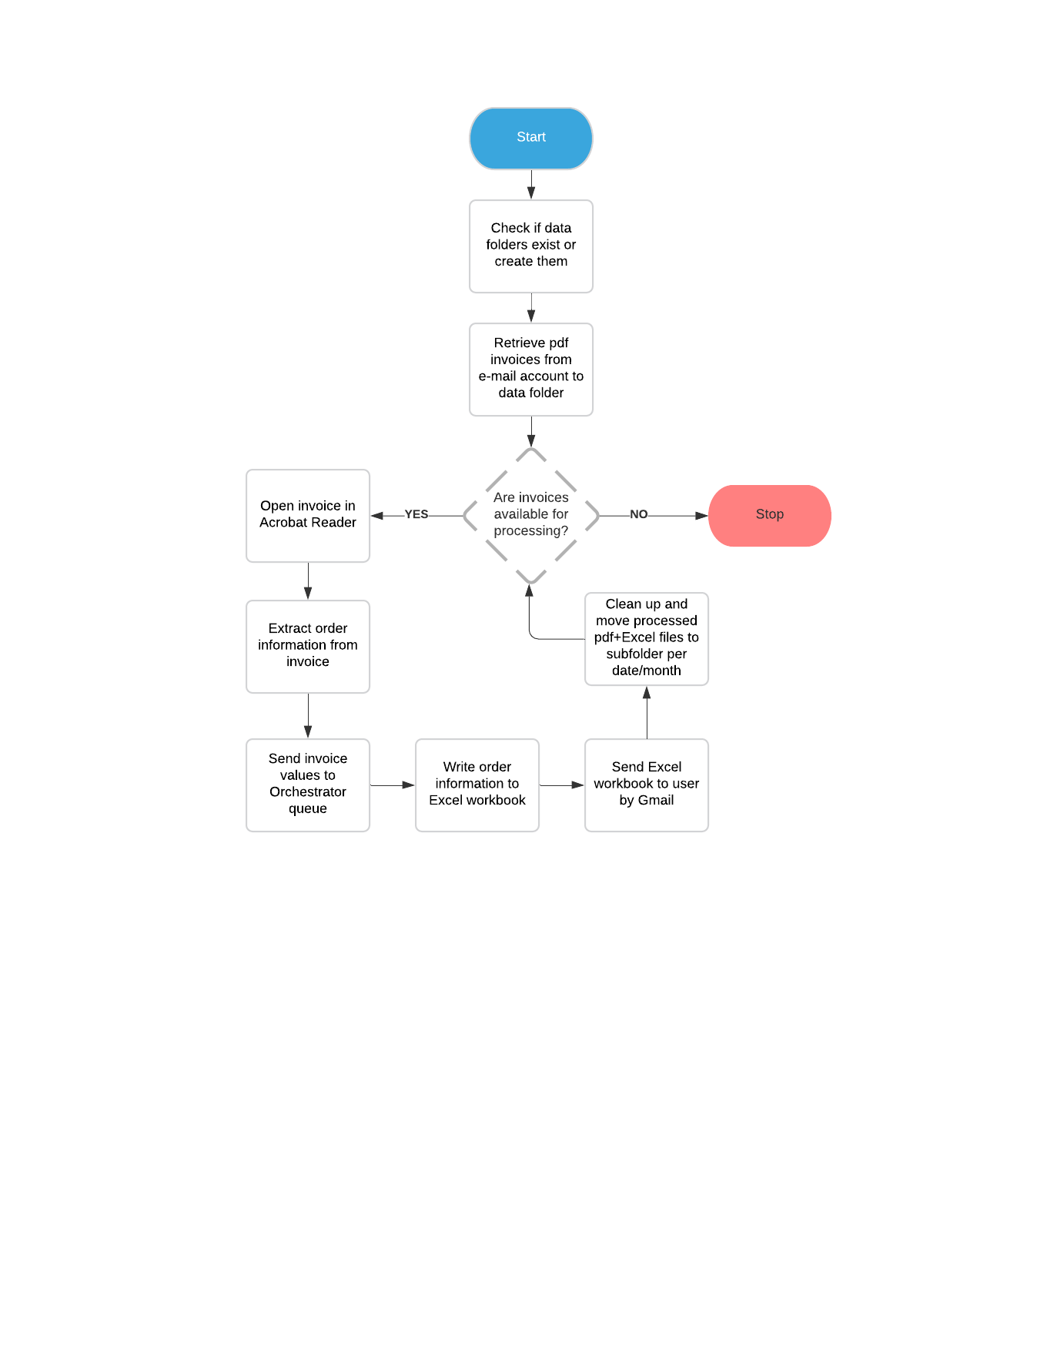

**Detailed Process Map:** This chapter depicts the As-Is business process at a detailed view to enable process owners to document their process

|  |  |  |  |
| --- | --- | --- | --- |
| # | Step Action/Description | Screenshot | Remarks |
| 1 | Assign name to data folder variable |  |  |
| 2 | Determine if invoice data folder already exists and create it if not |  |  |
| 3 | Assign name to Excel file folder variable |  |  |
| 4 | Determine if Excel data folder already exists and create it if not |  |  |
| 5 | Check Gmail and retrieve invoice pdf files from unread emails in the inbox with the subject line of “Techno Computers” |  | Invokes separate workflow: GetInvoices.xaml |
| 6 | Create a list of invoice file names once all available invoices are retrieved |  |  |
| 7 | Print a status message with the number of retrieved invoice files |  |  |
| 8 | Determine if any invoices are available for processing, end with a status message if not and continue the flow if yes |  |  |
| 9 | Main processing flow. Determine if any unprocessed invoices are available for processing, end with a status message when not and continue to next invoice if yes |  |  |
| 10 | Assign the full name with path of current invoice file to variable |  |  |
| 11 | Print a status message with the current invoice file name being processed |  |  |
| 12 | Open the current invoice file in Acrobat Reader |  |  |
| 13 | Attach to the open Acrobat application window and extract date from the current invoice |  | A separate sequence of steps |
| 14 | Pass the invoice values of Sub Total, GST and Total to an Orchestrator queue named “Order Information” |  | Invokes separate workflow: OrchestratorActions.xaml |
| 15 | Generate a full name with path to an Excel file to be generated |  |  |
| 16 | Generate an Excel file based on name assigned in previous step containing order information from the current invoice being processed |  | Invokes separate workflow: ExcelActions.xaml |
| 17 | Send the generated Excel file to Gmail recipient with a message about the user, date and number of the processed invoice |  | Invokes separate workflow: EmailActions.xaml, uses emailbody.html file for body template |
| 18 | Clear the current data table to ready it for processing of the next invoice |  |  |
| 19 | Close down the processed invoice in Acrobat Reader |  |  |
| 20 | Move processed invoice pdf and sent Excel file to sub-folders in the data folder based on invoice year and month creating these folders dynamically |  |  |
| 21 | Print a status message with the number and date of the invoice that has been processed |  |  |

# To-Be Process Description

## Detailed Process Map

**High Level To-Be Process Map:** This chapter depicts the To-Be automation process at a High Level to enable developers/COE to have a high-level understanding of the to be developed process.

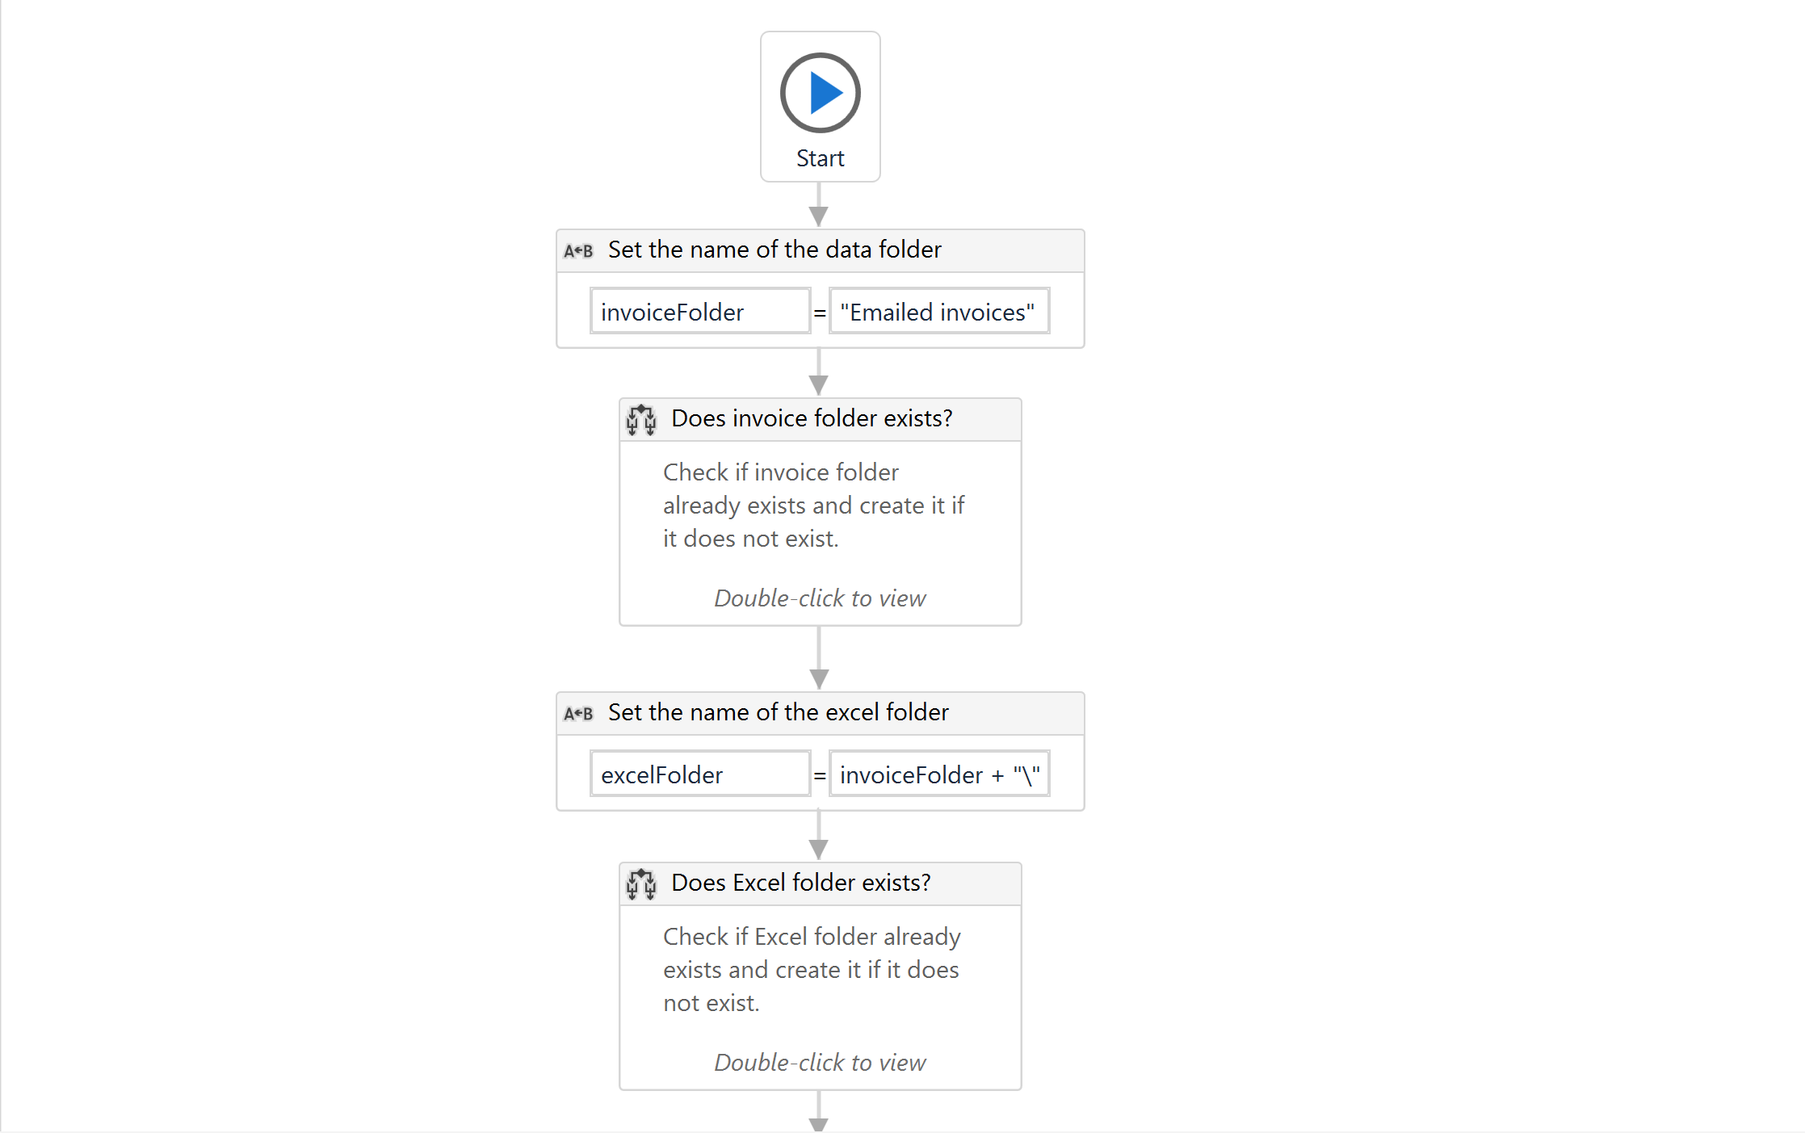

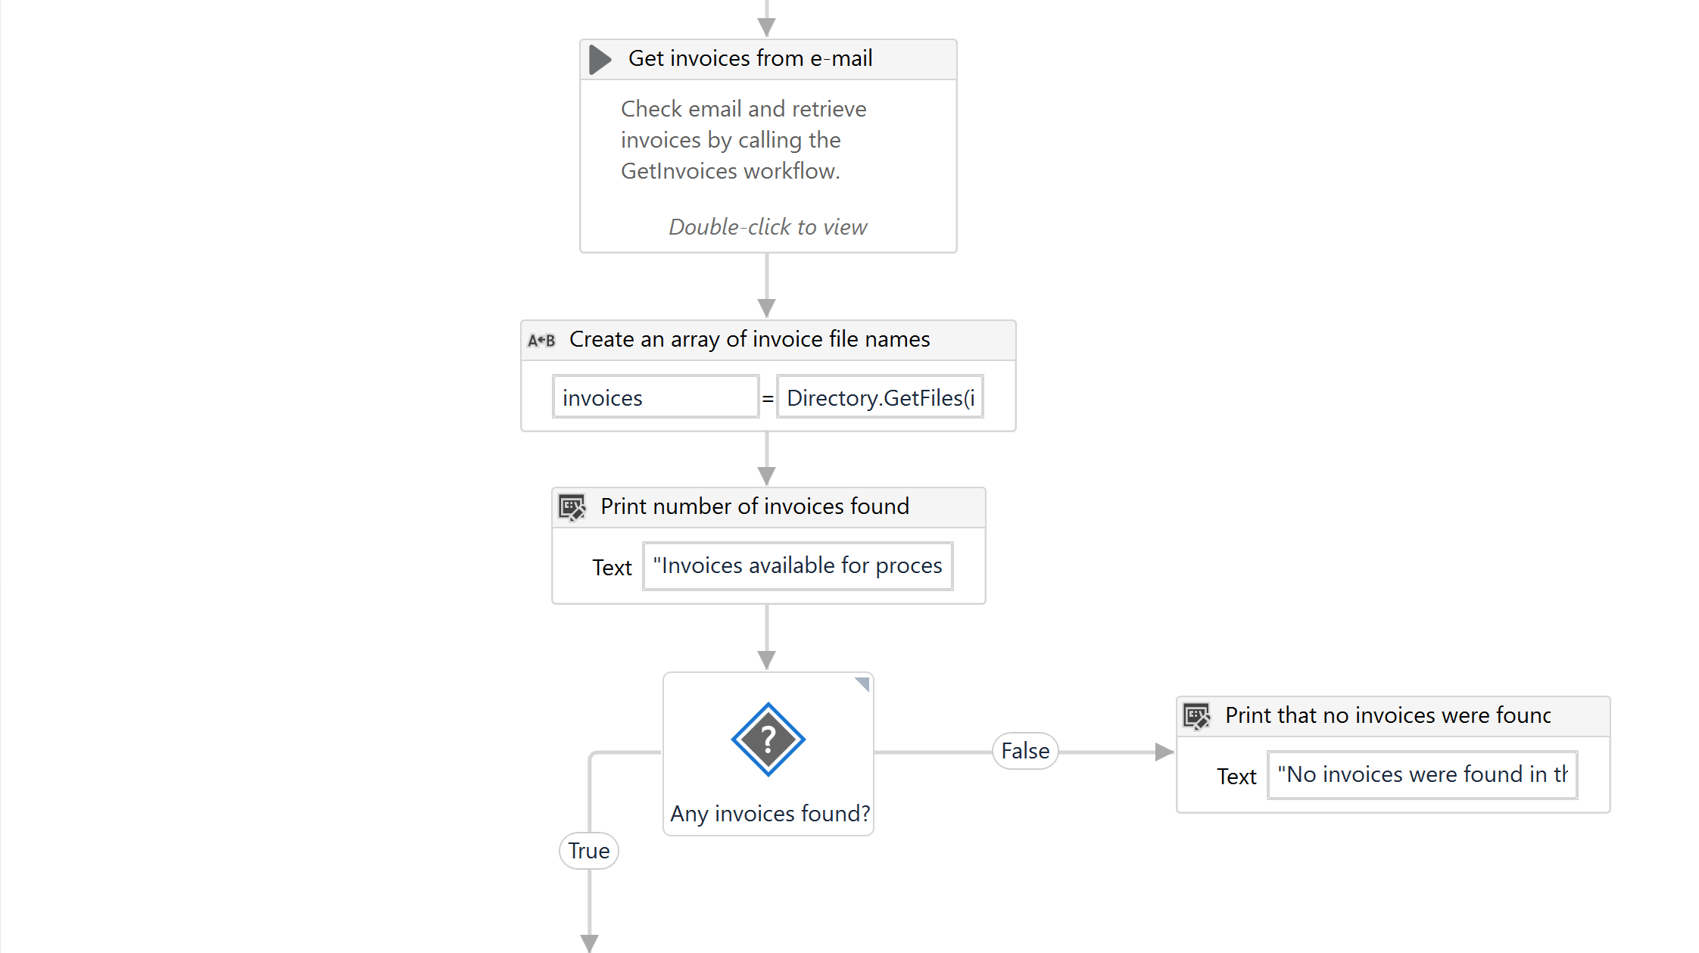

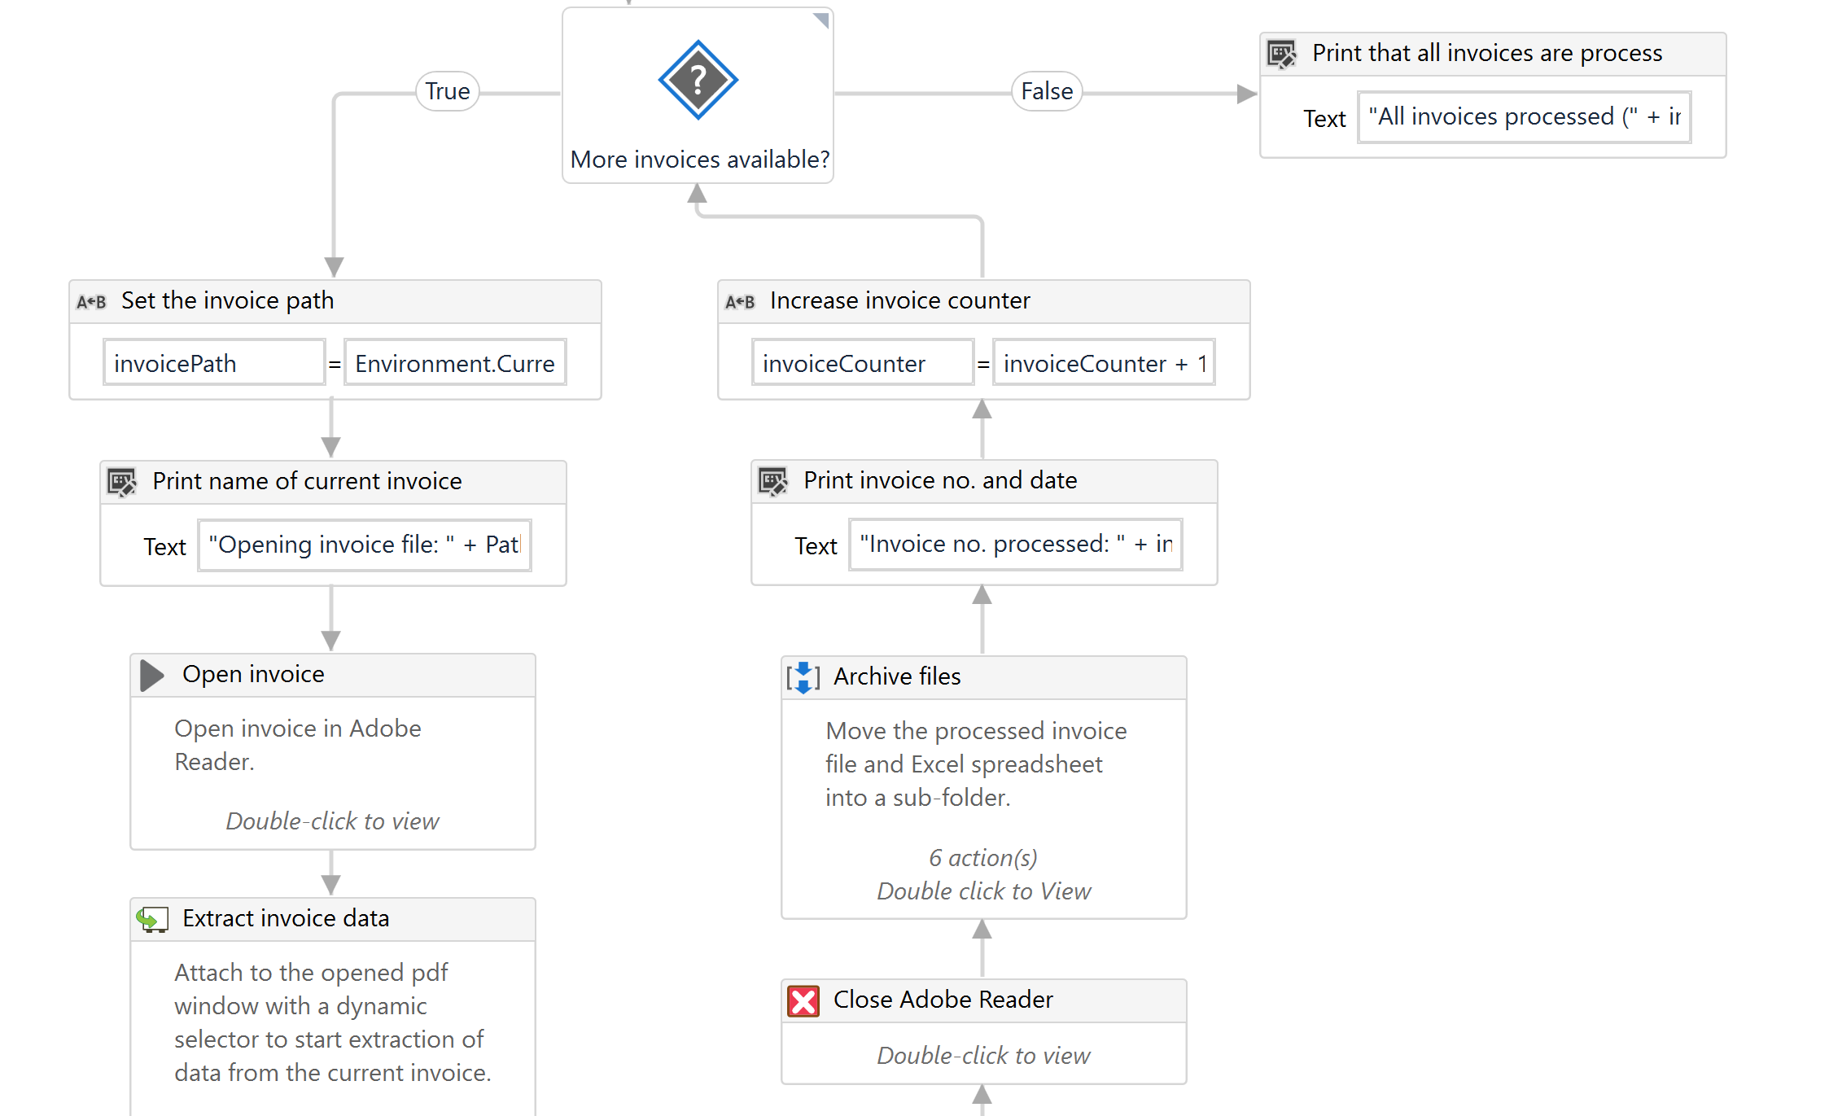

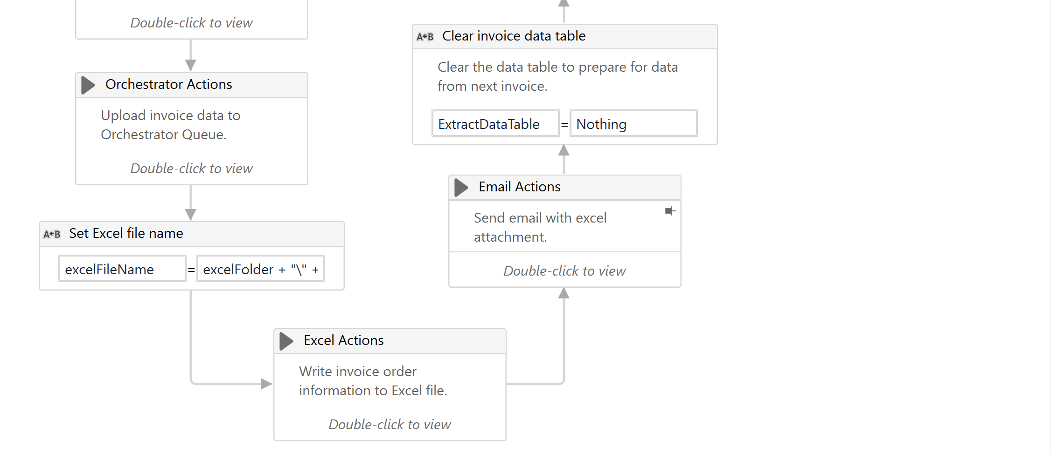

**Detailed Process Map:** This chapter depicts the To-Be automation process at a detailed view to enable developers/COE to see the workflows involved in the RPA solution

|  |  |  |  |  |  |
| --- | --- | --- | --- | --- | --- |
| **Workflow Name** | **Description** | **Pre-conditions** | **Post-actions** | **Arguments** | **Notes** |
| Main process (root) | Retrieve GMail invoice attachments and extract invoice no., date and order information tables. Create an Excel workbook for each invoice containg order information and e-mail it. Upload Subtotal, GST and Total to an Orchestrator Queue. | E-mail(s) must be sent to the GMail account with subject line "Techno Computers". Attachments must be in pdf format and named using the convention of CustomerName_InvoiceDate_InvoiceNumber.pdf. | Sends an e-mail to user with Excel attachment for each processed invoice. | None |  |
| GetInvoices | Read the last 30 unread emails from GMail account and save invoice attachments to a data folder inside the project folder. | E-mail(s) must be sent to the GMail account with subject line "Techno Computers". Attachments must be in pdf format and named using the convention of CustomerName_InvoiceDate_InvoiceNumber.pdf. | Will create data folder for invoices if none exists and save found invoices in that folder for further processing. | In_dataFolder |  |
| ExcelActions | Write order information details from invoice to Excel file in the name format “CustomerName_InvoiceNumber.xlsx”. | Requires data in data table format and a file name for the output file in string format. | Outputs Excel file at the location specified. | In_ExtractDataTable,  In_excelFileName |  |
| OrchestratorActions | Sends Sub Total, GST and Total values to an Orchestrator queue named "Order Information". | Requires the Sub Total, GST and Total values. | Adds an entry to an Orchestrator queue. | In_ExtractDataTable,  In_invoiceNumber,  In_invoiceDate |  |
| SendMail | Send an e-mail to the user with excel file containing order information. | None | None | In_customerName,  In_InvoiceNumber,  In_InvoiceDate,  In_excelFile |  |

## Robot Type

|  |  |  |  |  |
| --- | --- | --- | --- | --- |
| # | Attended | Unattended | Trigger | Comments |
| 1 | X |  |  |  |

## Business Exceptions Handling

The Business Process Owner and Business Analysts are expected to document below all the business exceptions identified in the automation process. These can be classified as:

### Known Exceptions

The table below reflects all the business process exceptions encountered during the process evaluation and documentation. These are known exceptions that occurred before. For each of these exceptions, define a corresponding expected action that the robot should complete if it encounters the exception.

|  |  |  |  |  |
| --- | --- | --- | --- | --- |
| BE # | Exception Name | Step | Parameters | Action to be Taken |
|  |  |  |  |  |
|  |  |  |  |  |
|  |  |  |  |  |

### Unknown Exceptions

For all other unanticipated or unknown business (process) exceptions, the robot should:

* Quit and send user an e-mail with relevant instructions on what was encountered and preferably how to fix it

## System Exceptions Handling

A comprehensive list of all errors, warnings or notifications should be consolidated here with the description and action to be taken, for each, by the robot.

Errors identified in the automation process can be classified as:

|  |  |  |  |  |
| --- | --- | --- | --- | --- |
| SE # | Exception Name | Step | Parameters | Action to be Taken |
| 1 | System.AggregateException | GetInvoices.xaml, occurs if existing invoice in data folder cannot be overwritten, e.g. due to being open in Acrobat Reader |  | Force close all Acrobat Reader processes |
| 2 | UiPath.Excel.ExcelException | ExcelActions.xaml, occurs randomly and seems to be related to Excel being unavailable or unable to write the datatable to the file |  | Add a 10 second delay to ensure Excel completes whatever it is doing |
|  |  |  |  |  |

For all the other unanticipated or unknown system exceptions, send an email to **<placeholder>** and attach a screenshot of the error message.

# Other Observations

Include below any other relevant observations you consider needed to be documented here.

# Additional sources of process documentation