Determining the Optimal Location for a Food Truck in Whitefish, Montana

Michael Brewer

June 5, 2021

1. **Introduction**

Whitefish is one of the most active tourist towns in Montana. People come from all over the world to catch a glimpse of the vast mountains and historic landmarks. Upon entering the area, one might immediately notice the abundance of food trucks, an industry that is apparently booming. Based upon such inspiration, this project will seek to determine the optimal location of a food truck in Whitefish, MT. Which location will attract the maximum amount of hungry tourists and consumers, thus resulting in maximum profit? This is clearly valuable information to any food truck owner.

1. **Data**

This project will utilize Foursquare location data to determine the coordinates of the highest rated food services in Whitefish MT. The logic is that the ideal location for a food truck is near other food venues that customers typically like to go when they are hungry. It may be desirable to add weights to ensure higher rated/trafficked venues are given more influence on the optimal neighborhood output.

First, I obtained the coordinates of Whitefish via Google and used Foursquare to acquire the top venues located within 1000 feet. The results were received in a JSON format and had to be normalized and parsed accordingly. Once the name, category, and coordinates of each venue were obtained, I removed any venue from the data frame with a category unrelated to food. With the data frame effectively filtered and cleaned, it was ready to be analyzed.

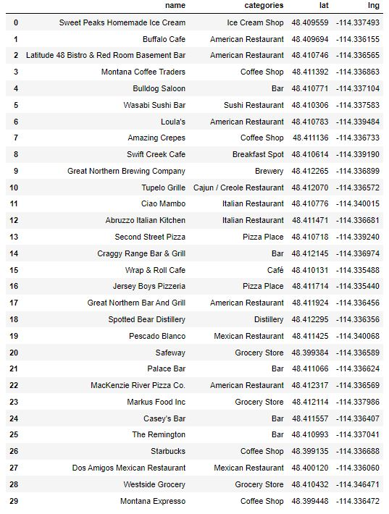

1. **Analysis**

Through the use of one-hot encoding, this data could be analyzed to determine the frequency of each venue category, which could further be ordered in descending order.

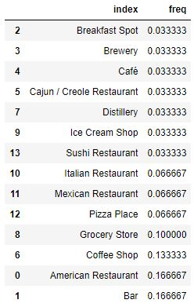

Furthermore, by calculating to average point of the collection of coordinates, we determined the optimum food truck location. I.e. where we have assumed the most hungry tourists are likely to gather.

1. **Modeling**

The venue coordinates (green) and optimal point (red) were mapped accordingly using Folium.

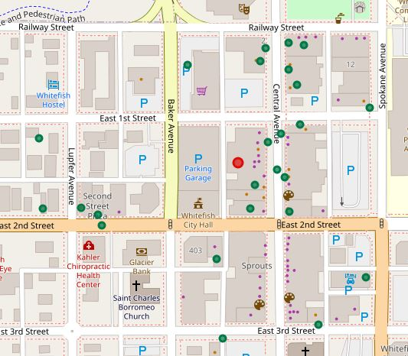

1. **Conclusion**

Thus, we have determined our optimal food truck location to be around the coordinate (48.41119933, -114.33727951). More generally, somewhere on the block bounded by East 1st Street, East 2nd Street, Central Avenue, and Baker Avenue. Obviously, a lot of assumptions were made to come to this conclusion. I would personally not be happy using this data to make this type of business decision. Nonetheless, this exercise was useful in practicing and demonstrating the concepts taught in this course.