Exposure to Change Talk vs. Participant’s Intention to Engage in Everyday Activism
Introduction
Motivational Interviewing is a therapeutic technique often applied in medical and clinical settings to encourage patients to engage in pro-health behaviors. It involves a variety of principles aimed at helping patients reflect on their motives, intentions, and goals while providing judgement-free spaces that enable autonomous and self-directed change and has seen wide success for treating addictions and decreasing vaccine hesitancy (Scales et al., 2025). Due to this success, preliminary research is being conducted to determine the efficacy of motivational interviewing tactics for tasks outside of its intended medical purposes, such as creating behavioral change in business leaders, measuring new technique uptake among physicians, or developing stronger job candidates during employment counseling (Armson et al., 2023).
One core aspect of motivational interviewing is the cultivation of change talk, which is language or statements by patients that center intent or willingness to change. The prevalence of change talk or its opposite, sustain talk, within motivational interviews is associated with the prevalence of aligned behavioral outcomes and is shown to have persistent effects, even for brief interventions (Blanc et al., 2024). Some researchers are also beginning to examine how motivational interviewing and change talk can be applied to conversations about activism and politics, though this research is few and far between (Brouwer et al., 2022).
Additionally, there has been limited to no research examining the effect of viewing change or sustain talk on participant behavior. This is an important gap, as understanding the potential effects of exposure to change talk on behavior could support the application of motivational interviewing in the context of facilitation of social change—helping advocates and activists understand how their and other’s messaging impacts decisions to engage in both small and large forms of collective action.
Therefore, this study seeks to examine whether viewing change talk would have an impact on participants intentions to participate in everyday forms of activism, including petitions and donating.
Methods
To examine this research question, an experimental study was designed. In this completely randomized design, 119 Wesleyan students and 1 non-affiliated participant were randomly assigned through Qualtrics to read one of four vignettes discussing a form of everyday collective action, either petition signing or small donations, and a student’s decision to either change their habits of not engaging or sustain their current behavior. Below is an example:
Signs asking for donations have become ubiquitous in many places, especially college campuses. On campus, students are often asked to donate for a variety of causes, whether via cash or mobile payment apps. Many students give a few dollars here or there, though not everyone contributes. On her way to lunch, Jenna, a college sophomore, is asked if she can donate to a cause. “I usually just ignore these,” she thinks, “a few dollars won’t make a real difference--I’ll pass.”
All participants were then asked a series of 5-point Likert scales about their intentions (7 questions) to engage in and belief (8 questions) in the viability of signing petition and making small donations to create change. These questions were developed into 4 composite scores Petition-Intentions composite, Petition-Beliefs composite, Donation-Intentions composite, Donation-Beliefs composite, which averaged three Likert scales each closely related to the section and mode of action.
Participants were also asked to answer several control questions (6), ranging from “In the past 30 days, how many times did you donate $1 to $5 to a cause you support?” to “To what extent do you agree… ‘I identify as an activist.’” 2 distinct composites were planned for these variables, however, due to missingness, only the variable, “In the past 30 days, how many online petitions did you sign?” was used as a covariate.
Additionally, two demographic questions about respondents’ class year and gender were asked. 30% of student identified as men (n=35), 50% identified as women (n=58), and 14% as Non-Binary or Other (n=17). Likewise, 21% of respondents were college seniors (n=24), 31% were juniors (n=36), 20% were sophomores (n=23), 23% were first years (n=27), and 5% were graduates or others (n=6).
Because of imperfect randomization and the exclusion of some responses due to lack of completion, the distribution of respondents between treatment levels isn’t evenly balanced, with 22% of respondents in the Petition-Change condition (n = 26), 27% in the Donation-Change condition (n = 32), 29% to the Petition-Sustain condition (n = 35), and 23% to the Donation-Sustain condition (n = 27). However, when collapsed to type of talk, it does balance, with 48% of participants were exposed to change-talk (n = 58) and 52% exposed to sustain-talk (n = 62). Furthermore, mode of action was evenly balanced, with 51% of participants assigned to Petitions (n = 61) and 49% assigned to Donations (n = 59). Data was collected between November 17th, 2025, and December 15th, 2025.
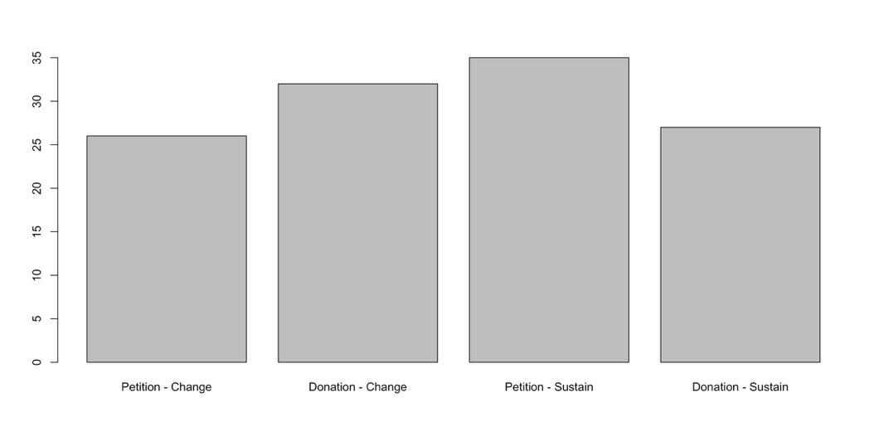
Results
To examine whether or not exposure to change talk or sustain talk impacted participants’ intentions to engage in everyday forms of collective action, a series of ANOVAs and ANCOVAs were conducted and assumptions were tested.
An ANOVA was conducted to examine whether Vignette influenced participants’ Petition Intention score. The effect of vignette on intention was not statistically significant F (3, 103) = 0.445, p = 0.721. Mean intention scores were slightly higher for participants exposed to change talk compared to sustain talk, however, the high p-value suggests that exposure to change or sustain talk did not meaningfully alter intentions in this sample.
An ANOVA was conducted to examine whether vignette influenced participants’ Donation Intention score. The effect of vignette on intention was not statistically significant F (3, 80) = 1.408, p = 0.376. Mean intention scores were slightly higher for participants exposed to change talk compared to sustain talk, though all mean composite scores were lower than those in the Petition Intentions composite. Similarly, the high p-value suggests that exposure to change or sustain talk did not meaningfully alter intentions in this sample.
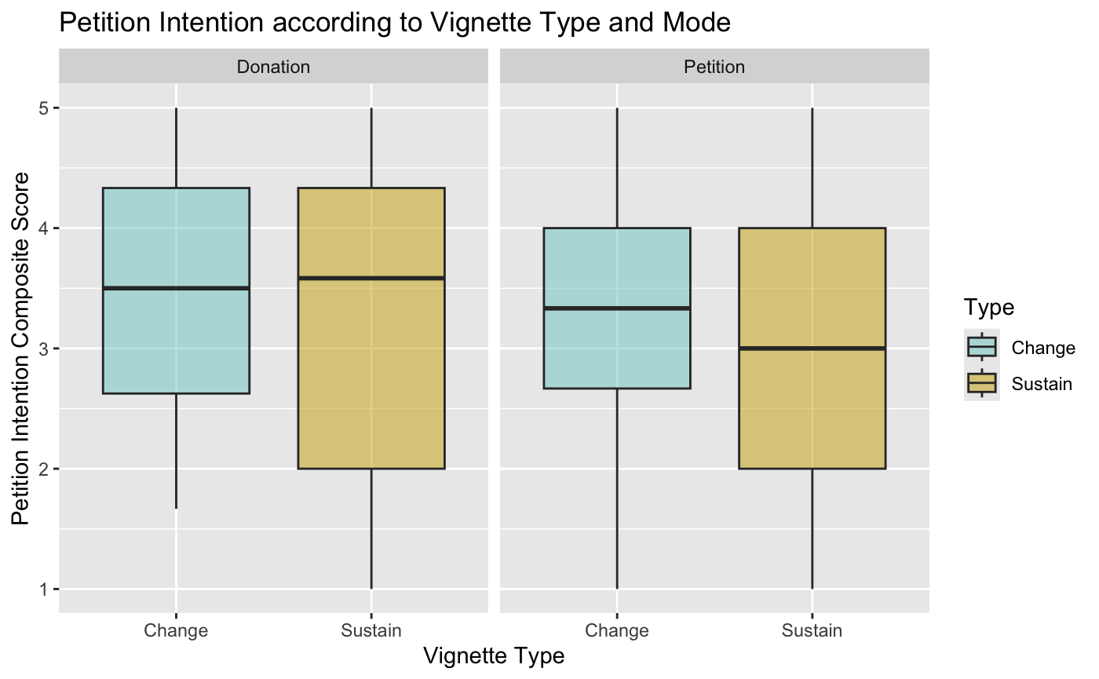
To account for baseline civic engagement, an analysis of covariance (ANCOVA) was conducted on vignette and petition intention using the question “In the past 30 days, how many online petitions did you sign?” as a covariate. However, the effect of vignette remained insignificant F (3, 91) = 0.559, p = 0.643. Previous petition signing was a significant predictor of petition intention scores, though indicating that participants who reported increased petition signing showed stronger intentions overall to sign more petitions (F (3, 91) = 5.002, p = .003).
Additionally, an ANCOVA was conducted on vignette and donation intention using the question “In the past 30 days, how many online petitions did you sign?” as a covariate. Likewise, the effect of vignette on donation intention remained insignificant F (3, 71) = 1.185, p = 0.322. Previous petition signing was not a significant predictor of donation intention scores, (F (3, 71) = .83, p = .482).
An ANCOVA was also conducted on talk type, as separate from vignette, and petition intention using the question “In the past 30 days, how many online petitions did you sign?” as a covariate. Likewise, the effect of vignette on petition intention remained insignificant F (1, 93) = 1.484, p = 0.226. Previous petition signing was a significant predictor of petition intention scores, indicating that participants who reported increased petition signing showed stronger intentions overall to sign more petitions regardless of the talk type they were exposed to (F (3, 93) = 4.801, p = .004).
Likewise, an ANOVA was conducted to examine whether talk type influenced participants’ donation intention score. The effect of talk type, change or sustain, on donation intention was not statistically significant F (1, 82) = 1.879, p = 0.174. Mean intention scores were slightly higher for participants exposed to change talk compared to sustain talk, however, the p-value suggests that exposure to change or sustain talk did not meaningfully alter intentions in this sample.
Finally, two ANOVAs were conducted to examine whether vignette influenced participated petition belief and donation belief scores. The effect of vignette on belief in petitions (F (3, 110) = 0.998, p = 0.397) and the effect of vignette on belief in donations F (3, 110) = 1.368, p = 0.256) were not statistically significant.
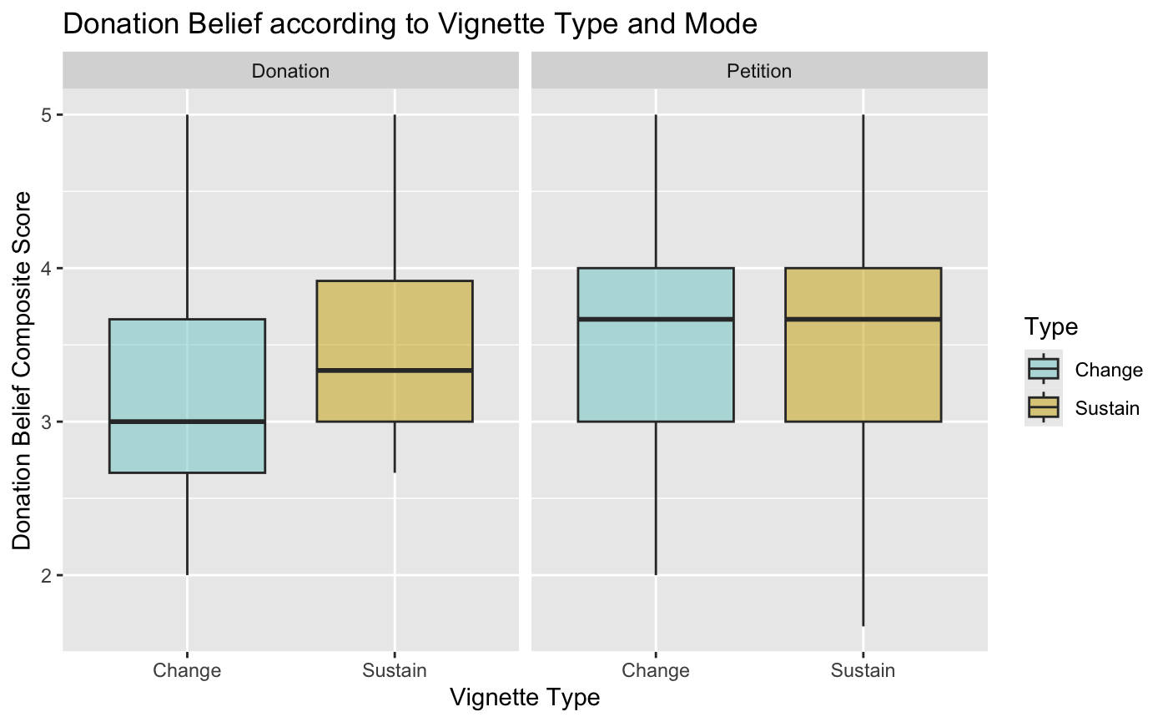

For each plot assumptions were tested. Statistical Independence is assumed that randomization as respondents received distinct surveys and were randomly assigned to treatments. Likewise, duplicate respondents were deleted. For Homogeneity of variance, the residuals vs fitted plots did not indicate heteroscedasticity. Likewise, the linearity of the model residuals vs fitted plots did not appear to violate the assumption of the linearity of the model. The Q-Q Residuals plots maintain the assumption of the normality of residuals. Additionally, an order effect plot was developed using model 1 (it had the largest number of observations) and EndDate. There did not appear to be any order effects within this data set.
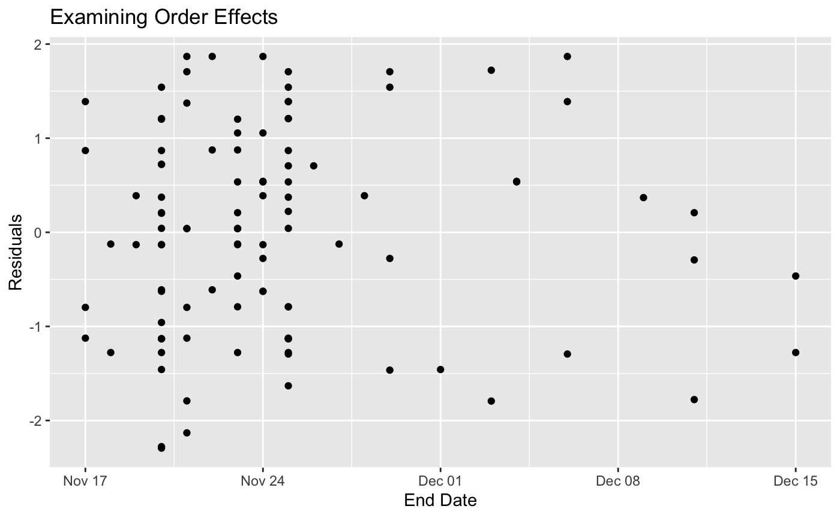
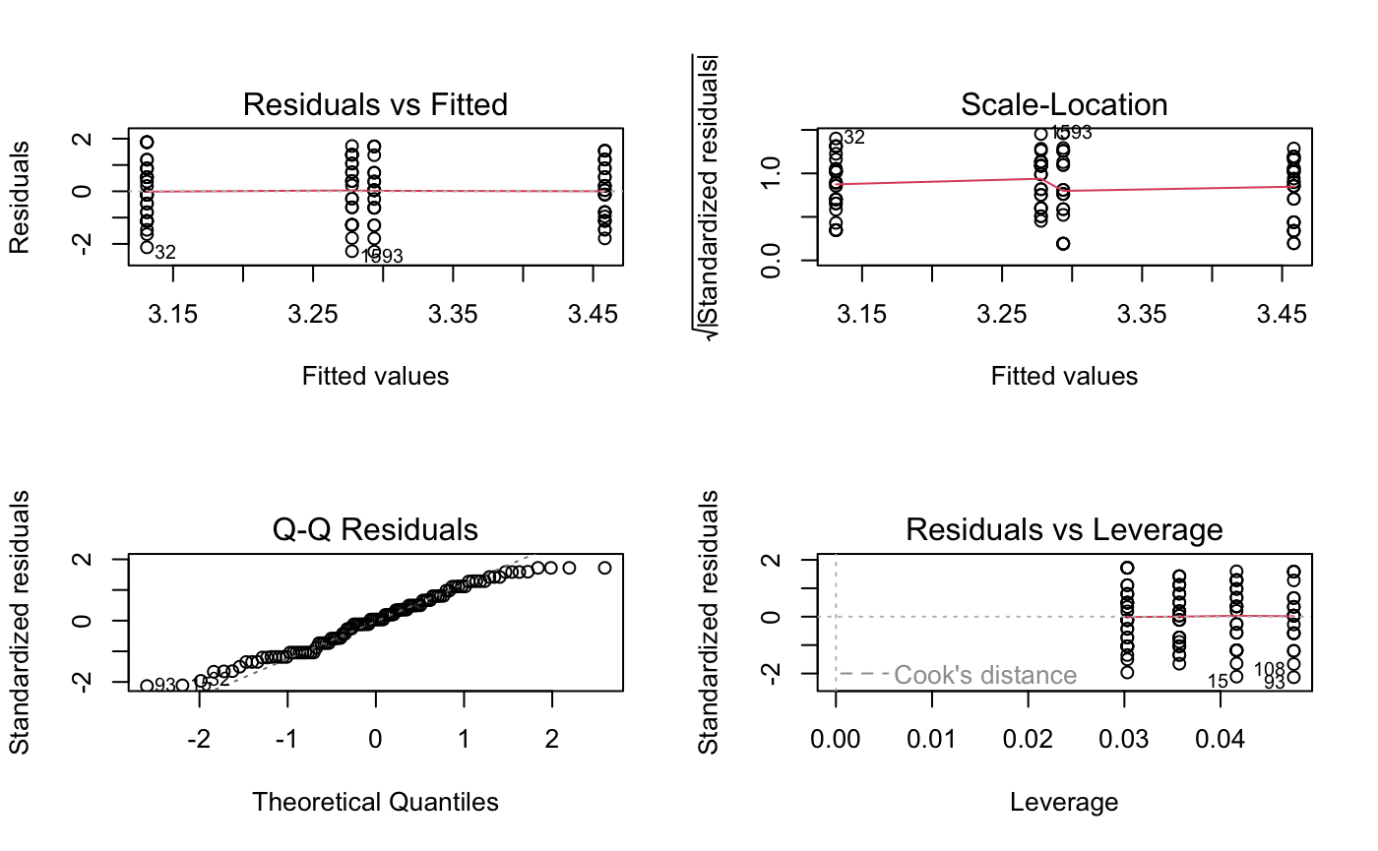

Discussion
This study examined whether exposure to change or sustain talk influenced participants’ intentions to engage in two modes of everyday civic engagement, signing petitions and making small donations, as well as whether this exposure affected respondents’ belief in the mode of collective action. Notably, exposure to change and sustain talk did not significantly alter participants’ intentions or beliefs in either domain. Differences in means did largely align with the alternative hypothesis, however, contrary to expectation, the differences and effect sizes were small and not significant. This suggests that brief exposures to change talk may not be sufficient to shift intentions, but also that exposure to sustain talk may not be able to do the same.
The absence of significant effects may also be the result of several limitations. Since the effect sizes appeared to be smaller than theorized, it is possible that research on this subject may benefit from larger sample sizes. However, based on the low effect sizes, it is unlikely that an exact replication of this study with increased participants would lead to meaningfully significant results. Therefore, addressing other limitations of the study could prove more beneficial.
One key limitation was high missing data for variables collected later in the survey prevented the use of strong composites as covariates. Future research may benefit from utilizing fewer questions or splitting analysis of intentions and beliefs into distinct studies. Furthermore, it is also possible that participants simply did not engage with the vignette. Since the attention check question came towards the end of the study, it was difficult to ascertain if all participants fully remembered the vignette when responding the questions. A future study may benefit from the addition of a reading check participants must pass to continue the survey to ensure the treatment was meaningfully applied.
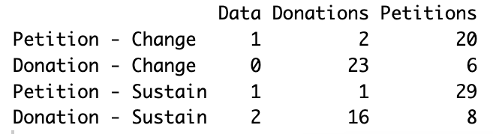
Despite these limitations, this study contributes to the growing body of research applying motivational interviewing to fields where behavioral change is a core metric of success, including civic engagement research. The findings of this study should be taken as an exploratory investigation emphasizing that exposure to change talk may not be enough to shift intentions, as well as the need for further research on this topic.

References
Armson, H., Moncrieff, K., Lofft, M., & Roder, S. (2023). ‘Change talk’ among physicians in small group learning communities: An ethnographic study. Medical Education, 57(11), 1036–1053. https://doi.org/10.1111/medu.15120
Blanc, S., Studer, J., Magill, M., McCambridge, J., Bertholet, N., Hugli, O., Daeppen, J.-B., & Gaume, J. (2024). Young Adults’ Change Talk Within Brief Motivational Intervention in the Emergency Department and Booster Sessions Is Associated With a Decrease in Heavy Drinking Over 1 Year. Psychology of Addictive Behaviors, 38(3), 243–254. https://doi.org/10.1037/adb0001000
Brouwer, C., Bolderdijk, J., Cornelissen, G., & Kurz, T. (2022). Communication strategies for moral rebels: How to talk about change in order to inspire self‐efficacy in others. Wiley Interdisciplinary Reviews. Climate Change, 13(5), Article 781. https://doi.org/10.1002/wcc.781
Llanes, K. D., Amastae, J., Amrhein, P. C., Lisha, N., Arteaga, K., Lopez, E., Moran, R. A., & Cohn, L. D. (2025). Impact of Computer-Mediated Versus Face-to-Face Motivational-Type Interviews on Participants’ Language and Subsequent Cannabis Use: Randomized Controlled Trial. Journal of Medical Internet Research, 27(2), Article 59085. https://doi.org/10.2196/59085
Scales, D., Windham, S., DiCaprio, P., Gorman, J. M., Gorman, S. E., Hurth, L., Radhakrishnan, M., Akunne, A., Leininger, L., & Starks, T. J. (2025). Community-Oriented Motivational Interviewing to Address Anti-COVID-19 Vaccine Sentiment in Virtual Communities: Manifestations of Change Talk and Sustain Talk and Practitioner Approaches. Group Dynamics, 29(1), 16–33. https://doi.org/10.1037/gdn0000233

