Original Dataset: Without oversampling, with SVM classifier

Lead 1 dataset:

Balanced accuracy score (takes care of imbalanced class) is: 33.0
Overall Accuracy of classification:37.86
The classifier correctly classify: 619 out of total 1635 samples.
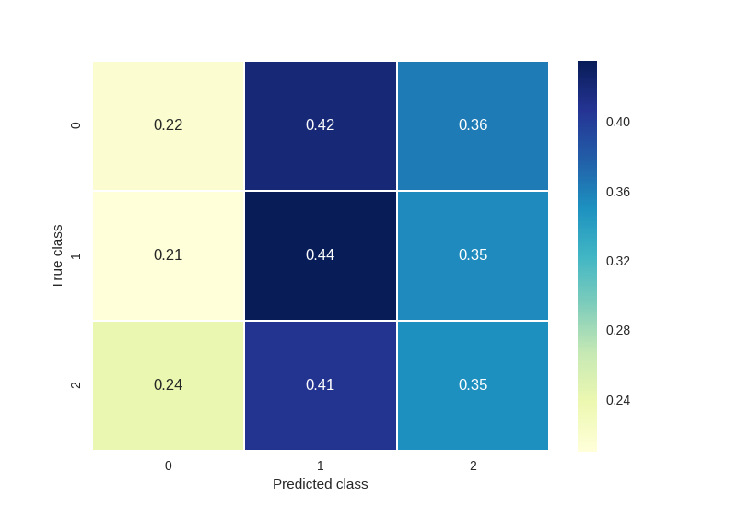
The overall classification report is as following:
precision recall f1-score support

1.0 0.20 0.22 0.21 328
2.0 0.66 0.44 0.52 1062
3.0 0.15 0.35 0.21 245

micro avg 0.38 0.38 0.38 1635
macro avg 0.34 0.33 0.31 1635
weighted avg 0.49 0.38 0.41 1635

The confusion matrix is following.
[[ 71 138 119]
[223 462 377]
[ 59 100 86]]

Lead 3 dataset:

Balanced accuracy score (takes care of imbalanced class) is: 35
Overall Accuracy of classification: 38
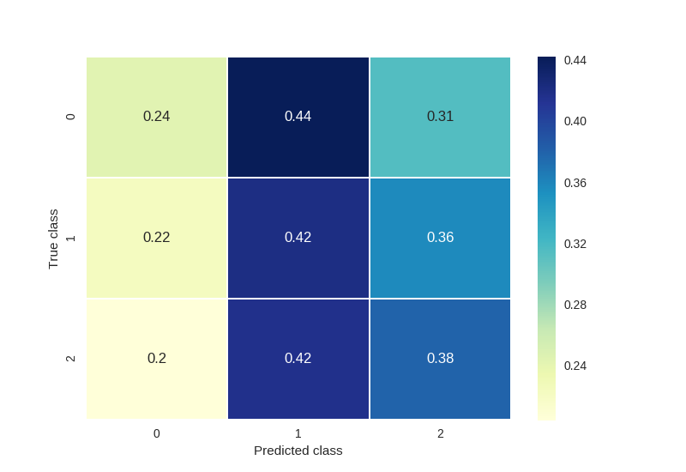
The classifier correctly classify: 619 out of total 1635 samples.
The overall classification report is as following:
precision recall f1-score support

1.0 0.22 0.24 0.23 328
2.0 0.64 0.42 0.51 1062
3.0 0.16 0.38 0.23 245

micro avg 0.38 0.38 0.38 1635
macro avg 0.34 0.35 0.32 1635
weighted avg 0.49 0.38 0.41 1635

The confusion matrix is following.
[[ 80 145 103]
[237 446 379]
[ 50 102 93]]

Lead 5 dataset:

Balanced accuracy score (takes care of imbalanced class) is: 34.33
Overall Accuracy of classification: 31.62
The classifier correctly classify: 517 out of total 1635 samples.
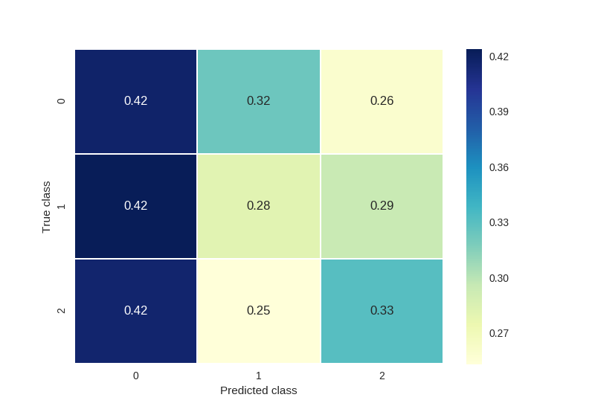
The overall classification report is as following:
precision recall f1-score support

1.0 0.20 0.42 0.27 328
2.0 0.64 0.28 0.39 1062
3.0 0.17 0.33 0.22 245

micro avg 0.32 0.32 0.32 1635
macro avg 0.34 0.34 0.29 1635
weighted avg 0.48 0.32 0.34 1635

The confusion matrix is following.
[[137 106 85]
[450 299 313]
[102 62 81]]

Lead 10 dataset:

Balanced accuracy score (takes care of imbalanced class) is: 55.00
Overall Accuracy of classification: 38.10
The classifier correctly classify: 623 out of total 1635 samples.
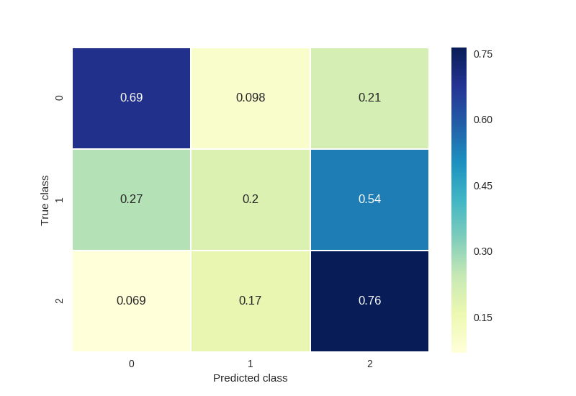
The overall classification report is as following:
precision recall f1-score support

1.0 0.43 0.69 0.53 328
2.0 0.74 0.20 0.31 1062
3.0 0.23 0.76 0.35 245

micro avg 0.38 0.38 0.38 1635
macro avg 0.47 0.55 0.40 1635
weighted avg 0.60 0.38 0.36 1635

The confusion matrix is following.
[[226 32 70]
[282 210 570]
[ 17 41 187]]

Lead 1 dataset with 3 months history:

Balanced accuracy score (takes care of imbalanced class) is: 32.34
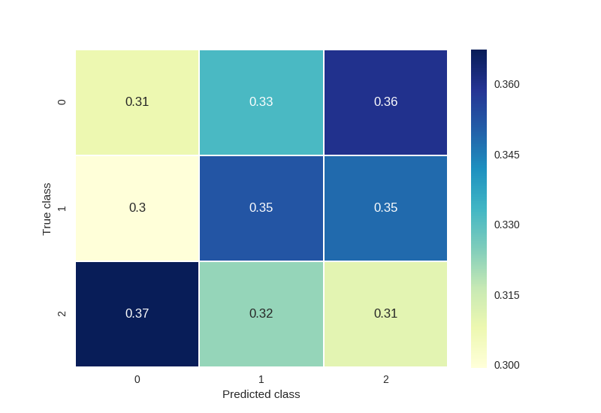
Overall Accuracy of classification: 33.70
The classifier correctly classify: 551 out of total 1635 samples.
The overall classification report is as following:
precision recall f1-score support

1.0 0.20 0.31 0.24 328
2.0 0.67 0.35 0.46 1062
3.0 0.13 0.31 0.19 245

micro avg 0.34 0.34 0.34 1635
macro avg 0.33 0.32 0.30 1635
weighted avg 0.49 0.34 0.38 1635

The confusion matrix is following.
[[101 109 118]
[318 374 370]
[ 90 79 76]]

Lead 3 dataset with 3 months history:

Balanced accuracy score (takes care of imbalanced class) is: 34.84
Overall Accuracy of classification: 36.94
The classifier correctly classify: 604 out of total 1635 samples.
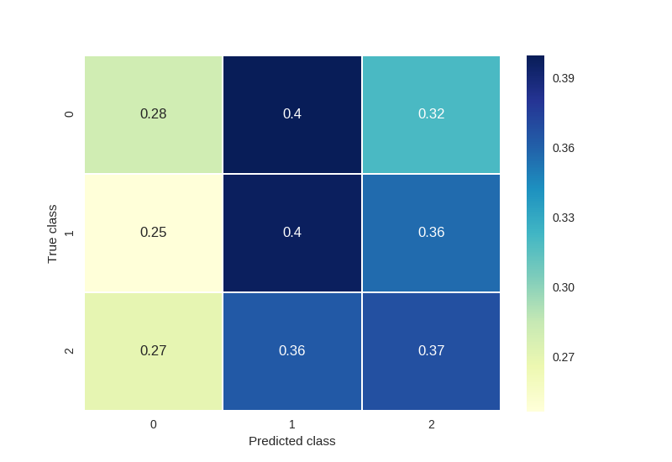
The overall classification report is as following:
precision recall f1-score support

1.0 0.22 0.28 0.25 328
2.0 0.66 0.40 0.50 1062
3.0 0.16 0.37 0.22 245

micro avg 0.37 0.37 0.37 1635
macro avg 0.34 0.35 0.32 1635
weighted avg 0.49 0.37 0.40 1635

The confusion matrix is following.
[[ 92 131 105]
[262 422 378]
[ 66 89 90]]

Lead 5 dataset with 3 months history:

Balanced accuracy score (takes care of imbalanced class) is: 33.29
Overall Accuracy of classification: 31.93
The classifier correctly classify: 522 out of total 1635 samples.
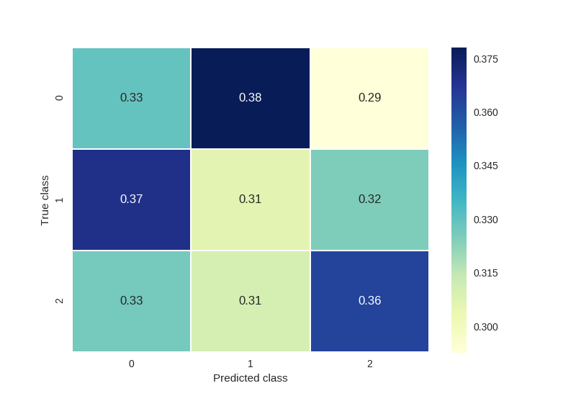
The overall classification report is as following:
precision recall f1-score support

1.0 0.19 0.33 0.24 328
2.0 0.62 0.31 0.41 1062
3.0 0.17 0.36 0.23 245

micro avg 0.32 0.32 0.32 1635
macro avg 0.32 0.33 0.29 1635
weighted avg 0.46 0.32 0.35 1635
The confusion matrix is following.
[[108 124 96]
[392 325 345]
[ 80 76 89]]
Lead 10 dataset with 3 months history:

Balanced accuracy score (takes care of imbalanced class) is: 55.14
Overall Accuracy of classification: 39.27
The classifier correctly classify: 642 out of total 1635 samples.
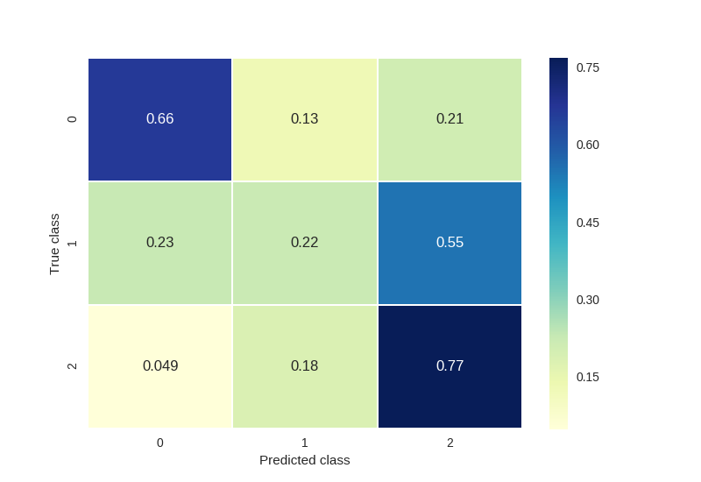
The overall classification report is as following:
precision recall f1-score support

1.0 0.46 0.66 0.55 328
2.0 0.73 0.22 0.34 1062
3.0 0.22 0.77 0.35 245

micro avg 0.39 0.39 0.39 1635
macro avg 0.47 0.55 0.41 1635
weighted avg 0.60 0.39 0.38 1635

The confusion matrix is following.
[[218 42 68]
[241 236 585]
[ 12 45 188]]

Overall Summary (we are mostly interested in class 1 and class 3)

No History
Data-set: lead 1 | Precision | Recall | F1-score | Support samples
Class 1 | 0.20 | 0.22 | 0.21 | 328
Class 2 | 0.66 | 0.44 | 0.52 | 1062
Class 3 | 0.15 | 0.35 | 0.21 | 245
Overall | 0.34 | 0.33 | 0.31 | 1635
Balanced accuracy: 33.0 |  | Accuracy: 37.86 |  | Cor. Pred: 619
Data-set: lead 3 | Precision | Recall | F1-score | Support samples
Class 1 | 0.22 | 0.24 | 0.23 | 328
Class 2 | 0.64 | 0.42 | 0.51 | 1062
Class 3 | 0.16 | 0.38 | 0.23 | 245
Overall | 0.34 | 0.35 | 0.32 | 1635
Balanced accuracy: 35.0 |  | Accuracy: 38.0 |  | Cor. Pred: 619
Data-set: lead 5 | Precision | Recall | F1-score | Support samples
Class 1 | 0.20 | 0.42 | 0.27 | 328
Class 2 | 0.64 | 0.28 | 0.39 | 1062
Class 3 | 0.17 | 0.33 | 0.22 | 245
Overall | 0.34 | 0.34 | 0.29 | 1635
Balanced accuracy: 34.33 |  | Accuracy: 31.62 |  | Cor. Pred: 517
Data-set: lead 10 | Precision | Recall | F1-score | Support samples
Class 1 | 0.43 | 0.69 | 0.53 | 328
Class 2 | 0.74 | 0.20 | 0.31 | 1062
Class 3 | 0.23 | 0.76 | 0.35 | 245
Overall | 0.47 | 0.55 | 0.40 | 1635
Balanced accuracy: 55.0 |  | Accuracy: 38.10 |  | Cor. Pred: 623
Lead 10 data set shows best performance with 69% and 76% accuracy in class 1 and class 3

With Three Months History
Data-set: lead 1 | Precision | Recall | F1-score | Support samples
Class 1 | 0.20 | 0.31 | 0.24 | 328
Class 2 | 0.67 | 0.35 | 0.46 | 1062
Class 3 | 0.13 | 0.31 | 0.19 | 245
Overall | 0.33 | 0.32 | 0.30 | 1635
Balanced accuracy: 32.34 |  | Accuracy: 33.70 |  | Cor. Pred: 551
Data-set: lead 3 | Precision | Recall | F1-score | Support samples
Class 1 | 0.22 | 0.28 | 0.25 | 328
Class 2 | 0.66 | 0.40 | 0.50 | 1062
Class 3 | 0.16 | 0.37 | 0.22 | 245
Overall | 0.34 | 0.35 | 0.32 | 1635
Balanced accuracy: 34.84 |  | Accuracy: 36.94 |  | Cor. Pred: 604
Data-set: lead 5 | Precision | Recall | F1-score | Support samples
Class 1 | 0.19 | 0.33 | 0.24 | 328
Class 2 | 0.62 | 0.31 | 0.41 | 1062
Class 3 | 0.17 | 0.36 | 0.23 | 245
Overall | 0.32 | 0.33 | 0.29 | 1635
Balanced accuracy: 33.29 |  | Accuracy: 31.93 |  | Cor. Pred: 522
Data-set: lead 10 | Precision | Recall | F1-score | Support samples
Class 1 | 0.46 | 0.66 | 0.55 | 328
Class 2 | 0.73 | 0.22 | 0.34 | 1062
Class 3 | 0.22 | 0.77 | 0.35 | 245
Overall | 0.47 | 0.55 | 0.41 | 1635
Balanced accuracy: 55.14 |  | Accuracy: 39.27 |  | Cor. Pred: 642
Lead 10 data set with 3 months history shows best performance with 66% and 77% accuracy in class 1 and class 3

