Dataset: With oversampling, with SVM classifier

Samples of each rainfall class in the whole set: ({2.0: 5372, 1.0: 1485, 3.0: 1317})

Samples of each rainfall class in the training set: ({2.0: 4310, 1.0: 1157, 3.0: 1072})

Oversampling is performed only upon training set.

Method 1: SMOTE: [(1.0, 4310), (2.0, 4310), (3.0, 4310)]

Method 2: ADASYN: [(1.0, 4201), (2.0, 4310), (3.0, 4449)]

Lead 10 dataset with 3 months history:

Up-sampled data using SMOTE..................
Balanced accuracy score (takes care of imbalanced class) is: 52.87
Overall Accuracy of classification: 38.10
The classifier correctly classify: 623 out of total 1635 samples.
The overall classification report is as following:
precision recall f1-score support
1.0 0.44 0.67 0.54 328
2.0 0.68 0.22 0.33 1062
3.0 0.21 0.69 0.33 245
micro avg 0.38 0.38 0.38 1635
macro avg 0.45 0.53 0.40 1635
weighted avg 0.57 0.38 0.37 1635

The confusion matrix is following.
[[221 46 61]
[263 232 567]
[ 14 61 170]]

Up-sampled data using ADASYN..................
Balanced accuracy score (takes care of imbalanced class) is: 53.41
Overall Accuracy of classification: 39.69
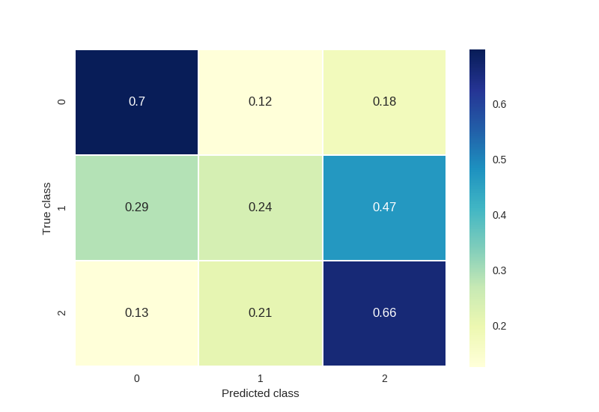
The classifier correctly classify: 649 out of total 1635 samples.
The overall classification report is as following:
precision recall f1-score support
1.0 0.40 0.70 0.51 328
2.0 0.74 0.24 0.37 1062
3.0 0.23 0.66 0.34 245
micro avg 0.40 0.40 0.40 1635
macro avg 0.46 0.53 0.40 1635
weighted avg 0.59 0.40 0.39 1635
The confusion matrix is following.
[[229 41 58]
[306 258 498]
[ 31 52 162]]
ADASYN up-sampling shows a little better performance than SMOTE, so we will use ADASYN further for all other data-sets.

Lead 1 data-set:

Balanced accuracy score (takes care of imbalanced class) is: 33.17
Overall Accuracy of classification: 32.17
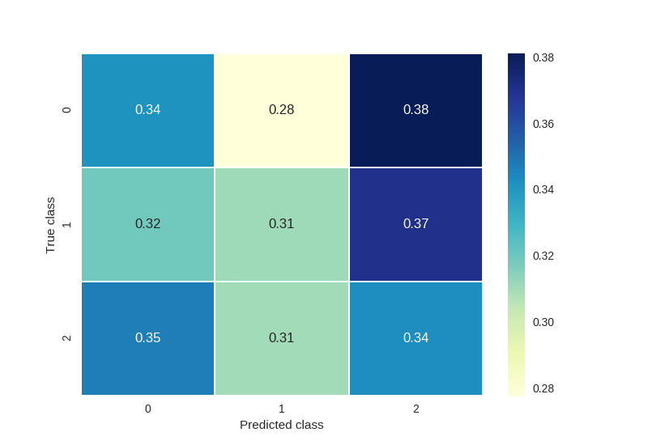
The classifier correctly classify: 526 out of total 1635 samples.
The overall classification report is as following:
precision recall f1-score support
1.0 0.21 0.34 0.26 328
2.0 0.66 0.31 0.42 1062
3.0 0.14 0.34 0.20 245
micro avg 0.32 0.32 0.32 1635
macro avg 0.34 0.33 0.29 1635
weighted avg 0.49 0.32 0.36 1635

The confusion matrix is following.
[[112 91 125]
[339 330 393]
[ 85 76 84]]

Lead 3 data-set:
Balanced accuracy score (takes care of imbalanced class) is: 36.40
Overall Accuracy of classification: 34.37
The classifier correctly classify: 562 out of total 1635 samples.
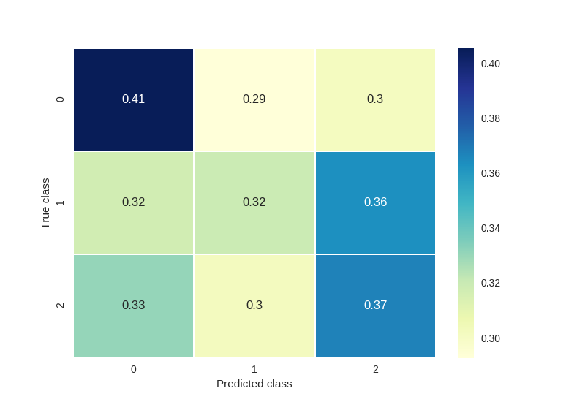
The overall classification report is as following:
precision recall f1-score support

1.0 0.24 0.41 0.30 328
2.0 0.67 0.32 0.43 1062
3.0 0.16 0.37 0.22 245

micro avg 0.34 0.34 0.34 1635
macro avg 0.35 0.36 0.32 1635
weighted avg 0.50 0.34 0.37 1635

The confusion matrix is following.
[[133 96 99]
[337 339 386]
[ 81 74 90]]

Lead 5 data-set:
Balanced accuracy score (takes care of imbalanced class) is: 34.01
Overall Accuracy of classification: 29.79
The classifier correctly classify: 487 out of total 1635 samples.
The overall classification report is as following:
precision recall f1-score support

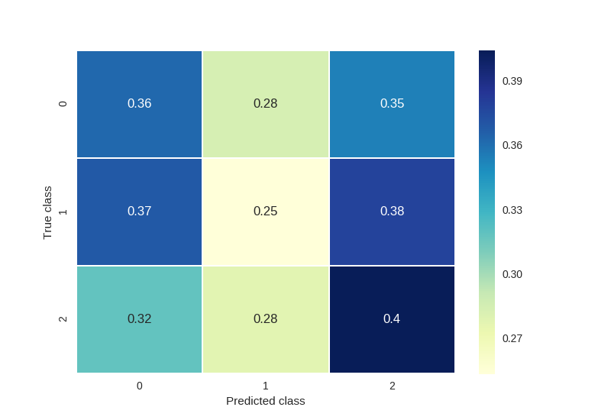
1.0 0.20 0.36 0.26 328
2.0 0.63 0.25 0.36 1062
3.0 0.16 0.40 0.23 245

micro avg 0.30 0.30 0.30 1635
macro avg 0.33 0.34 0.28 1635
weighted avg 0.47 0.30 0.32 1635

The confusion matrix is following.
[[119 93 116]
[391 269 402]
[ 78 68 99]]

Lead 10 data-set:
Balanced accuracy score (takes care of imbalanced class) is: 53.13
Overall Accuracy of classification: 37.37
The classifier correctly classify: 611 out of total 1635 samples.
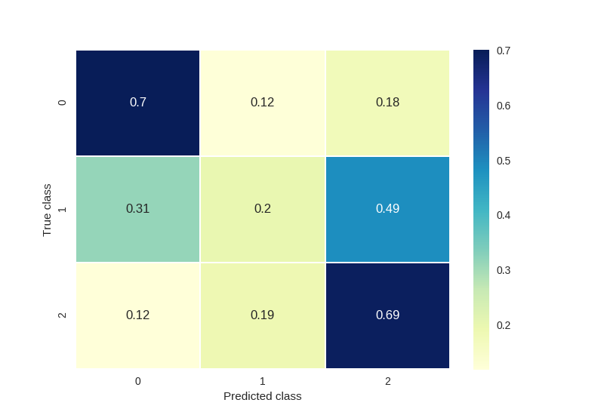
The overall classification report is as following:
precision recall f1-score support

1.0 0.39 0.70 0.50 328
2.0 0.71 0.20 0.31 1062
3.0 0.23 0.69 0.34 245

micro avg 0.37 0.37 0.37 1635
macro avg 0.44 0.53 0.38 1635
weighted avg 0.57 0.37 0.35 1635

The confusion matrix is following.
[[230 40 58]
[334 211 517]
[ 29 46 170]]

Lead 1 data-set with 3 days history:
Balanced accuracy score (takes care of imbalanced class) is: 34.75
Overall Accuracy of classification: 31.99
The classifier correctly classify: 523 out of total 1635 samples.
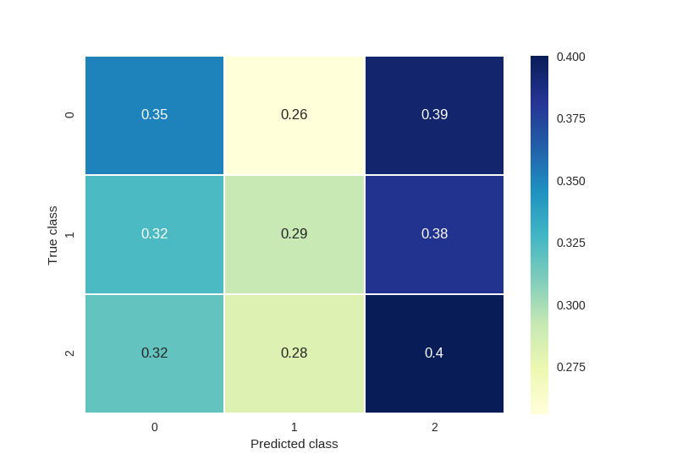
The overall classification report is as following:
precision recall f1-score support

1.0 0.21 0.35 0.27 328
2.0 0.67 0.29 0.41 1062
3.0 0.15 0.40 0.22 245

micro avg 0.32 0.32 0.32 1635
macro avg 0.35 0.35 0.30 1635
weighted avg 0.50 0.32 0.35 1635

The confusion matrix is following.
[[115 84 129]
[345 310 407]
[ 78 69 98]]

Lead 3 data-set with 3 days history:

Balanced accuracy score (takes care of imbalanced class) is: 34.94
Overall Accuracy of classification: 34.07
The classifier correctly classify: 557 out of total 1635 samples.
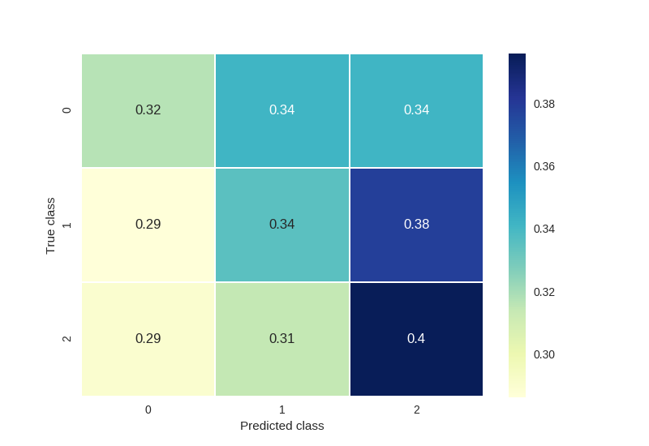
The overall classification report is as following:
precision recall f1-score support

1.0 0.22 0.32 0.26 328
2.0 0.65 0.34 0.44 1062
3.0 0.16 0.40 0.23 245

micro avg 0.34 0.34 0.34 1635
macro avg 0.34 0.35 0.31 1635
weighted avg 0.49 0.34 0.37 1635

The confusion matrix is following.
[[104 112 112]
[304 356 402]
[ 71 77 97]]

Lead 5 data-set with 3 days history:

Balanced accuracy score (takes care of imbalanced class) is: 35.89
Overall Accuracy of classification: 34.07
The classifier correctly classify: 557 out of total 1635 samples.
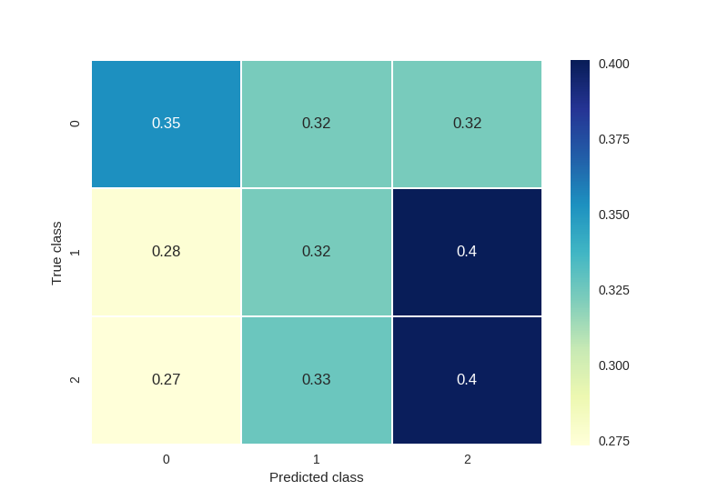
The overall classification report is as following:
precision recall f1-score support

1.0 0.24 0.35 0.29 328
2.0 0.65 0.32 0.43 1062
3.0 0.16 0.40 0.22 245

micro avg 0.34 0.34 0.34 1635
macro avg 0.35 0.36 0.31 1635
weighted avg 0.49 0.34 0.37 1635

The confusion matrix is following.
[[116 106 106]
[293 343 426]
[ 67 80 98]]

Overall Summary (we are mostly interested in class 1 and class 3)

No History
Data-set: lead 1 | Precision | Recall | F1-score | Support samples
Class 1 | 0.21 | 0.34 | 0.26 | 328
Class 2 | 0.66 | 0.31 | 0.42 | 1062
Class 3 | 0.14 | 0.34 | 0.20 | 245
Overall | 0.34 | 0.33 | 0.29 | 1635
Balanced accuracy: 33.17 |  | Accuracy: 32.17 |  | Cor. Pred: 526
Data-set: lead 3 | Precision | Recall | F1-score | Support samples
Class 1 | 0.24 | 0.41 | 0.30 | 328
Class 2 | 0.67 | 0.32 | 0.43 | 1062
Class 3 | 0.16 | 0.37 | 0.22 | 245
Overall | 0.35 | 0.36 | 0.32 | 1635
Balanced accuracy: 36.40 |  | Accuracy: 34.37 |  | Cor. Pred: 562
Data-set: lead 5 | Precision | Recall | F1-score | Support samples
Class 1 | 0.20 | 0.36 | 0.26 | 328
Class 2 | 0.63 | 0.25 | 0.36 | 1062
Class 3 | 0.16 | 0.40 | 0.23 | 245
Overall | 0.33 | 0.34 | 0.28 | 1635
Balanced accuracy: 34.01 |  | Accuracy: 29.79 |  | Cor. Pred: 487
Data-set: lead 10 | Precision | Recall | F1-score | Support samples
Class 1 | 0.39 | 0.70 | 0.50 | 328
Class 2 | 0.71 | 0.20 | 0.31 | 1062
Class 3 | 0.23 | 0.69 | 0.34 | 245
Overall | 0.44 | 0.53 | 0.38 | 1635
Balanced accuracy: 53.13 |  | Accuracy: 37.37 |  | Cor. Pred: 611
Lead 10 data set shows best performance with 70% and 69% accuracy in class 1 and class 3

With Three days History
Data-set: lead 1 | Precision | Recall | F1-score | Support samples
Class 1 | 0.21 | 0.35 | 0.27 | 328
Class 2 | 0.67 | 0.29 | 0.41 | 1062
Class 3 | 0.15 | 0.40 | 0.22 | 245
Overall | 0.35 | 0.35 | 0.30 | 1635
Balanced accuracy: 34.75 |  | Accuracy: 31.99 |  | Cor. Pred: 523
Data-set: lead 3 | Precision | Recall | F1-score | Support samples
Class 1 | 0.22 | 0.32 | 0.26 | 328
Class 2 | 0.65 | 0.34 | 0.44 | 1062
Class 3 | 0.16 | 0.40 | 0.23 | 245
Overall | 0.34 | 0.35 | 0.31 | 1635
Balanced accuracy: 34.94 |  | Accuracy: 34.07 |  | Cor. Pred: 557
Data-set: lead 5 | Precision | Recall | F1-score | Support samples
Class 1 | 0.24 | 0.35 | 0.29 | 328
Class 2 | 0.65 | 0.32 | 0.43 | 1062
Class 3 | 0.16 | 0.40 | 0.22 | 245
Overall | 0.35 | 0.36 | 0.31 | 1635
Balanced accuracy: 35.89 |  | Accuracy: 34.07 |  | Cor. Pred: 557
Data-set: lead 10 | Precision | Recall | F1-score | Support samples
Class 1 | 0.40 | 0.70 | 0.51 | 328
Class 2 | 0.74 | 0.24 | 0.37 | 1062
Class 3 | 0.23 | 0.66 | 0.34 | 245
Overall | 0.46 | 0.53 | 0.40 | 1635
Balanced accuracy: 53.41 |  | Accuracy: 39.69 |  | Cor. Pred: 649
Lead 10 data set with 3 months history shows best performance with 70% and 66% accuracy in class 1 and class 3

