Original Data-set: Oversampling with ADASYN, and Random Forest classifier

Oversampling statistics:

Samples of each rainfall class in overall set: Counter({2.0: 5372, 1.0: 1485, 3.0: 1317})

Samples in training set: Counter({2.0: 4310, 1.0: 1157, 3.0: 1072})

ADASYN: [(1.0, 4201), (2.0, 4310), (3.0, 4449)]

Lead 1 dataset:

Balanced accuracy score (takes care of imbalanced class) is: 32.80
Overall Accuracy of classification: 30.89
The classifier correctly classify: 505 out of total 1635 samples.
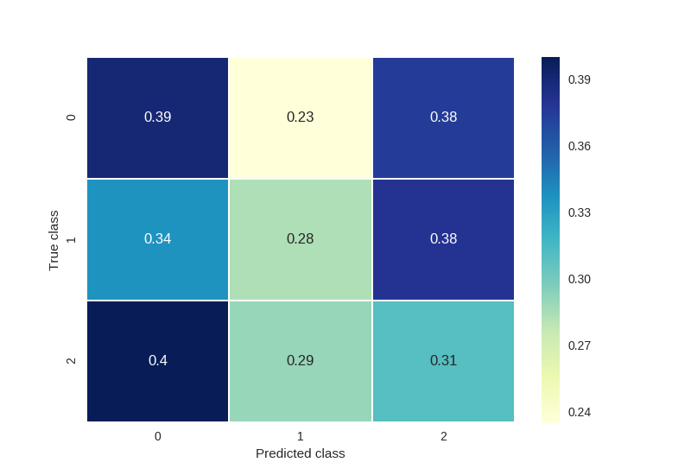
The overall classification report is as following:
precision recall f1-score support

1.0 0.22 0.39 0.28 328
2.0 0.67 0.28 0.40 1062
3.0 0.13 0.31 0.18 245

micro avg 0.31 0.31 0.31 1635
macro avg 0.34 0.33 0.29 1635
weighted avg 0.50 0.31 0.34 1635

The confusion matrix is following.
[[128 77 123]
[358 301 403]
[ 98 71 76]]

Lead 3 dataset:

Balanced accuracy score (takes care of imbalanced class) is: 34.70
Overall Accuracy of classification: 32.91
The classifier correctly classify: 538 out of total 1635 samples.
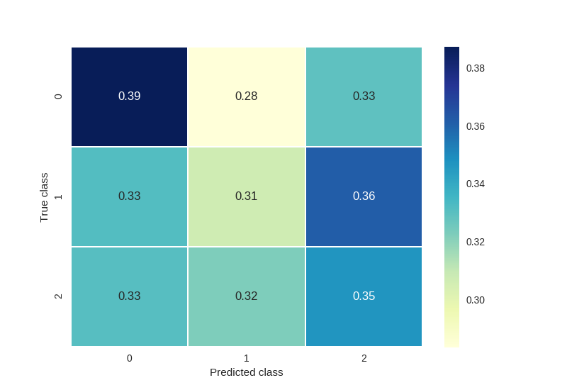
The overall classification report is as following:
precision recall f1-score support

1.0 0.23 0.39 0.29 328
2.0 0.65 0.31 0.42 1062
3.0 0.15 0.35 0.21 245

micro avg 0.33 0.33 0.33 1635
macro avg 0.34 0.35 0.30 1635
weighted avg 0.49 0.33 0.36 1635

The confusion matrix is following.
[[127 93 108]
[352 326 384]
[ 81 79 85]]

Lead 5 dataset:

Balanced accuracy score (takes care of imbalanced class) is: 33.30
Overall Accuracy of classification: 30.46
The classifier correctly classify: 498 out of total 1635 samples.
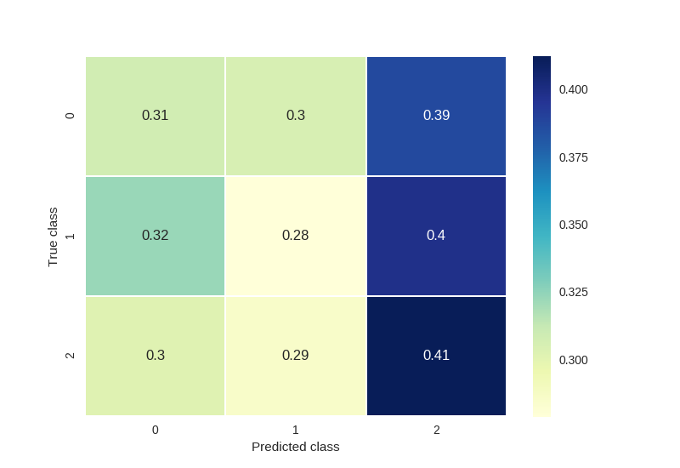
The overall classification report is as following:
precision recall f1-score support

1.0 0.19 0.31 0.24 328
2.0 0.64 0.28 0.39 1062
3.0 0.16 0.41 0.23 245

micro avg 0.30 0.30 0.30 1635
macro avg 0.33 0.33 0.28 1635
weighted avg 0.47 0.30 0.33 1635

The confusion matrix is following.
[[101 100 127]
[343 296 423]
[ 74 70 101]]

Lead 10 dataset:

Balanced accuracy score (takes care of imbalanced class) is: 53.08
Overall Accuracy of classification: 37.55
The classifier correctly classify: 614 out of total 1635 samples.
The overall classification report is as following:
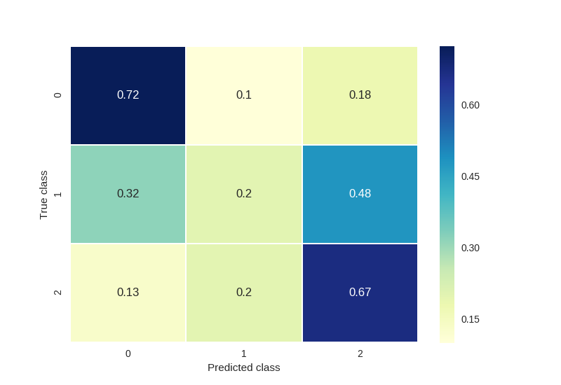
precision recall f1-score support

1.0 0.39 0.72 0.51 328
2.0 0.72 0.20 0.31 1062
3.0 0.22 0.67 0.34 245

micro avg 0.38 0.38 0.38 1635
macro avg 0.45 0.53 0.39 1635
weighted avg 0.58 0.38 0.36 1635

The confusion matrix is following.
[[237 33 58]
[338 213 511]
[ 32 49 164]]

Lead 1 dataset with 3 days history:

Balanced accuracy score (takes care of imbalanced class) is: 34.46
Overall Accuracy of classification: 32.17
The classifier correctly classify: 526 out of total 1635 samples.
The overall classification report is as following:
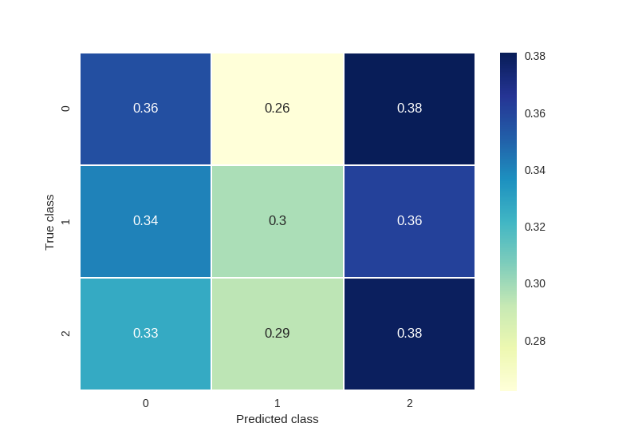
precision recall f1-score support

1.0 0.21 0.36 0.26 328
2.0 0.67 0.30 0.41 1062
3.0 0.15 0.38 0.22 245

micro avg 0.32 0.32 0.32 1635
macro avg 0.34 0.34 0.30 1635
weighted avg 0.50 0.32 0.35 1635

The confusion matrix is following.
[[117 86 125]
[362 316 384]
[ 80 72 93]]

Lead 3 dataset with 3 days history:

Balanced accuracy score (takes care of imbalanced class) is: 34.32
Overall Accuracy of classification: 33.46
The classifier correctly classify: 547 out of total 1635 samples.
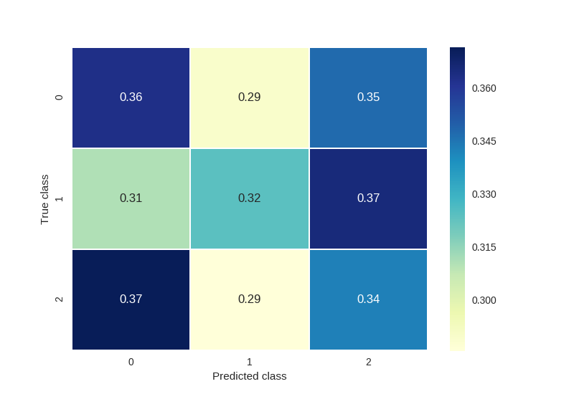
The overall classification report is as following:
precision recall f1-score support

1.0 0.22 0.36 0.27 328
2.0 0.68 0.32 0.44 1062
3.0 0.14 0.34 0.20 245

micro avg 0.33 0.33 0.33 1635
macro avg 0.35 0.34 0.30 1635
weighted avg 0.50 0.33 0.37 1635

The confusion matrix is following.
[[119 95 114]
[330 344 388]
[ 91 70 84]]

Lead 5 dataset with 3 days history:

Balanced accuracy score (takes care of imbalanced class) is: 34.46
Overall Accuracy of classification: 34.56
The classifier correctly classify: 565 out of total 1635 samples.
The overall classification report is as following:
precision recall f1-score support
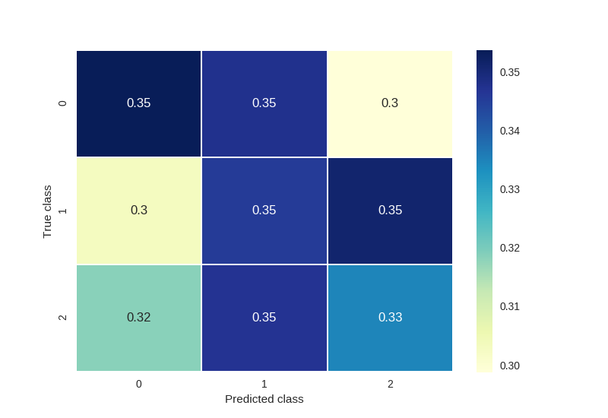
1.0 0.22 0.35 0.27 328
2.0 0.65 0.35 0.45 1062
3.0 0.15 0.33 0.21 245

micro avg 0.35 0.35 0.35 1635
macro avg 0.34 0.34 0.31 1635
weighted avg 0.49 0.35 0.38 1635

The confusion matrix is following.
[[116 114 98]
[322 367 373]
[ 78 85 82]]

Lead 10 dataset with 3 days history:

Balanced accuracy score (takes care of imbalanced class) is: 52.57
Overall Accuracy of classification: 40.43
The classifier correctly classify: 661 out of total 1635 samples.
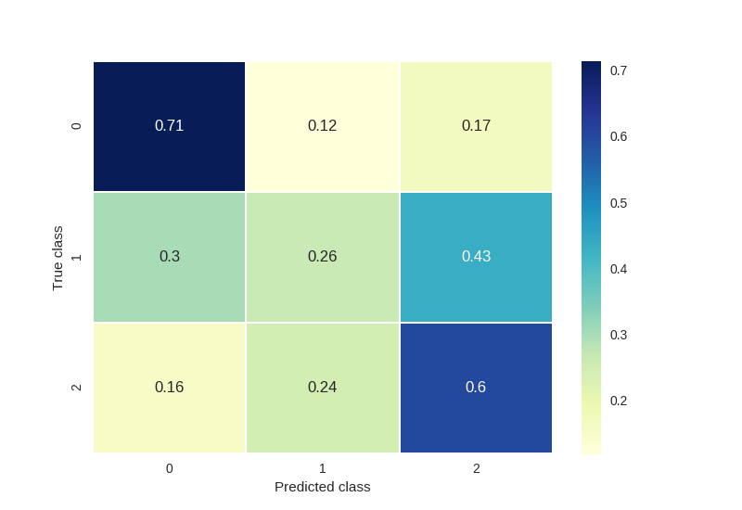
The overall classification report is as following:
precision recall f1-score support

1.0 0.39 0.71 0.51 328
2.0 0.74 0.26 0.39 1062
3.0 0.22 0.60 0.32 245

micro avg 0.40 0.40 0.40 1635
macro avg 0.45 0.53 0.41 1635
weighted avg 0.59 0.40 0.40 1635

The confusion matrix is following.
[[234 39 55]
[321 280 461]
[ 38 60 147]]

Overall Summary (we are mostly interested in class 1 and class 3)

No History
Data-set: lead 1 | Precision | Recall | F1-score | Support samples
Class 1 | 0.22 | 0.39 | 0.28 | 328
Class 2 | 0.67 | 0.28 | 0.40 | 1062
Class 3 | 0.13 | 0.31 | 0.18 | 245
Overall | 0.34 | 0.33 | 0.29 | 1635
Balanced accuracy: 32.80 |  | Accuracy: 30.89 |  | Cor. Pred: 505
Data-set: lead 3 | Precision | Recall | F1-score | Support samples
Class 1 | 0.23 | 0.39 | 0.29 | 328
Class 2 | 0.65 | 0.31 | 0.42 | 1062
Class 3 | 0.15 | 0.35 | 0.21 | 245
Overall | 0.34 | 0.35 | 0.30 | 1635
Balanced accuracy: 34.7 |  | Accuracy: 32.91 |  | Cor. Pred: 538
Data-set: lead 5 | Precision | Recall | F1-score | Support samples
Class 1 | 0.19 | 0.31 | 0.24 | 328
Class 2 | 0.64 | 0.28 | 0.39 | 1062
Class 3 | 0.16 | 0.41 | 0.23 | 245
Overall | 0.33 | 0.33 | 0.28 | 1635
Balanced accuracy: 33.3 |  | Accuracy: 30.46 |  | Cor. Pred: 498
Data-set: lead 10 | Precision | Recall | F1-score | Support samples
Class 1 | 0.39 | 0.72 | 0.51 | 328
Class 2 | 0.72 | 0.20 | 0.31 | 1062
Class 3 | 0.22 | 0.67 | 0.34 | 245
Overall | 0.45 | 0.53 | 0.39 | 1635
Balanced accuracy: 53.08 |  | Accuracy: 37.55 |  | Cor. Pred: 614
Lead 10 data set shows best performance with 72% and 67% accuracy in class 1 and class 3

With Three Days History
Data-set: lead 1 | Precision | Recall | F1-score | Support samples
Class 1 | 0.21 | 0.36 | 0.26 | 328
Class 2 | 0.67 | 0.30 | 0.41 | 1062
Class 3 | 0.15 | 0.38 | 0.22 | 245
Overall | 0.34 | 0.34 | 0.30 | 1635
Balanced accuracy: 34.46 |  | Accuracy: 32.17 |  | Cor. Pred: 526
Data-set: lead 3 | Precision | Recall | F1-score | Support samples
Class 1 | 0.22 | 0.36 | 0.27 | 328
Class 2 | 0.68 | 0.32 | 0.44 | 1062
Class 3 | 0.14 | 0.34 | 0.20 | 245
Overall | 0.35 | 0.34 | 0.30 | 1635
Balanced accuracy: 34.32 |  | Accuracy: 33.46 |  | Cor. Pred: 547
Data-set: lead 5 | Precision | Recall | F1-score | Support samples
Class 1 | 0.22 | 0.35 | 0.27 | 328
Class 2 | 0.65 | 0.35 | 0.45 | 1062
Class 3 | 0.15 | 0.33 | 0.21 | 245
Overall | 0.34 | 0.34 | 0.31 | 1635
Balanced accuracy: 34.46 |  | Accuracy: 34.56 |  | Cor. Pred: 565
Data-set: lead 10 | Precision | Recall | F1-score | Support samples
Class 1 | 0.39 | 0.71 | 0.51 | 328
Class 2 | 0.74 | 0.26 | 0.39 | 1062
Class 3 | 0.22 | 0.60 | 0.32 | 245
Overall | 0.45 | 0.53 | 0.41 | 1635
Balanced accuracy: 52.57 |  | Accuracy: 40.43 |  | Cor. Pred: 661
Lead 10 data set with 3 days history shows best performance with 71% and 60% accuracy in class 1 and class 3

