

FAMU-FSU College of Engineering

Department of Electrical and Computer Engineering

Needs Assessment

**Team # 14**

**Solar Thermal Generator**

**Members**:

Ernest Crabtree (ECE) [ehc14@my.fsu.edu](mailto:ehc14@my.fsu.edu)

Jason Galla (ECE) [jag12k@my.fsu.edu](mailto:jag12k@my.fsu.edu)

Will Sidebottom (CPE) [wks12@my.fsu.edu](mailto:wks12@my.fsu.edu)

Dylan Lee (ECE) [ddl12@my.fsu.edu](mailto:ddl12@my.fsu.edu)

Benjamin Galivan (ECE) [brg12@my.fsu.edu](mailto:brg12@my.fsu.edu)

Shazeen Tariq (CPE) [st13r@my.fsu.edu](mailto:st13r@my.fsu.edu)

**Faculty Advisor**

Dr. Simon Y. Foo, Ph.D.

**Sponsor**

Michael D. Devine, Ph.D.

**Instructors**

Dr. Rajendra K. Arora, Ph.D

Dr. Jerris W. Hooker, Ph.D

Date:  
 September 29 2016

Table of Contents

1 NEEDS ANALYSIS………………………………………………..……. 2

1.1 OVERVIEW……………………….………………………….… 3

1.2 STATEMENT OF THE PROBLEM………….…………...……. 3

1.3 BACKGROUND RESEARCH…..……………………………… 3

2 REQUIREMENTS SPECIFICATIONS……………………………..….. 4

2.1 REQUIREMENT SPECIFICATIONS……………………….…. 4

2.2 Goal Statement & Objectives……………………………………. 4

2.3 Constraints……………………………………………………….. 4

2.4 Functional Requirements…………………………………….….. 5

2.5 Implementation Considerations…………………………………. 6

2.6 Design Deliverables…………………………………..…………. 6

2.7 Preliminary System Test Plan…………………………………… 7

2.8 Quality Function Deployment…………………………………….. 7

3 CONCLUSION…………………….………………………………...….. 8

4 SCHEDULE……………………………………………………………… 8

5 REFERENCES.…………………….………………………………...….. 9

# **1. NEEDS ANALYSIS**

1.1 OVERVIEW

The objective behind this year’s senior design project is to design and build a product based on

Consumer needs. The idea behind building a Solar Thermal Generator was to provide comfort and ease to people who either go out for camping trips, survival during hurricane season or general use of charging electronic devices. This would be perfect for disaster survival applications, as it allows power generation from a less expensive and easy obtainable source.

1.2 STATEMENT OF THE PROBLEM

This project is an entrepreneurial-based mission sponsored by FAMU-FSU College of Engineering,

specifically through Dr. Michael D. Devine. Currently, there is no effective, simple, and quiet way to get power to remote locations. These remote locations include campsites, mountain sides, and third

world countries. In order to supply energy to items such as lights, heaters, or USB chargers, a

gas generator is traditionally used. These types of generators are too loud and too heavy to be

effectively used in remote locations.

While there exists solar panels or photovoltaic technology, it is important to understand that solar thermal technology is not the same as solar panels. Solar panels convert the sun’s light into electricity. This means that solar panels are only effective during daylight hours, while on the other hand heat storage is a far easier and efficient method which makes solar thermal generators much more useful and compatible. Heat can be stored during the day and then converted into electricity at night.

1.3 BACKGROUND RESEARCH

Solar thermal electric energy generation concentrates the light from the sun to create heat, and that heat then turns on the generator to make electricity. There are several ways to collect solar heat. Parabolic solar dishes are used in the solar thermal power facilities for years around the world. The system design includes a parabolic –shaped reflector focuses the sun’s rays on a receiver pipe located at the focal point of the parabola. The collector tilts with the sun as the sun moves from East to West during the day to ensure the sun is continuously focused on the receiver. To rotate the dish and for data tracking a microcontroller will be used that will track the data and rotate in the sun’s direction from East to West. Because of dish’s parabolic shape, a trough can focus the sun from 30 times to 100 times its normal intensity (concentration ratio) on the receiver pipe located along the focal line of the trough, achieving operating temperatures higher than 750°F.

The heat energy collected will then be converted to electric energy with the help of a thermoelectric generator. TEG is a solid-state device that converts the heat directly into electrical energy through a phenomenon called “The Seebeck effect”. 4

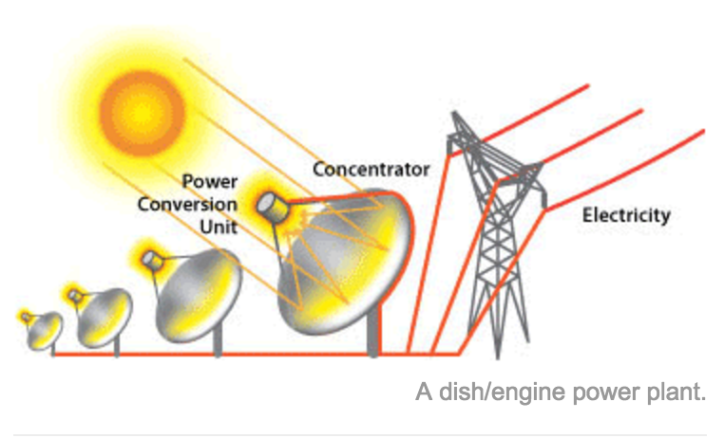

*Fig 1.1 Parabolic solar collector* .3

Dish/engine systems use a parabolic dish of mirrors to direct and concentrate sunlight onto a central engine that produces electricity. The dish/engine system is a concentrating solar power (CSP) technology that produces smaller amounts of electricity than other CSP technologies—typically in the range of 3 to 25 kilowatts1—but is beneficial for modular use. The two major parts of the system are the solar concentrator and the power conversion unit

*2.*  REQUIREMENTS SPECIFICATIONS

2.1 REQUIREMENTS SPECIFICATIONS

After defining the problem and gathering a lot of data the next step is to specify the requirements. During research several factors were considered to help us figure out the requirements of the design. Requirements were set according to taking into account the needs of the consumer than the wants. Before developing a prototype a lot of data and information was collected to get maximum possible results from the product.

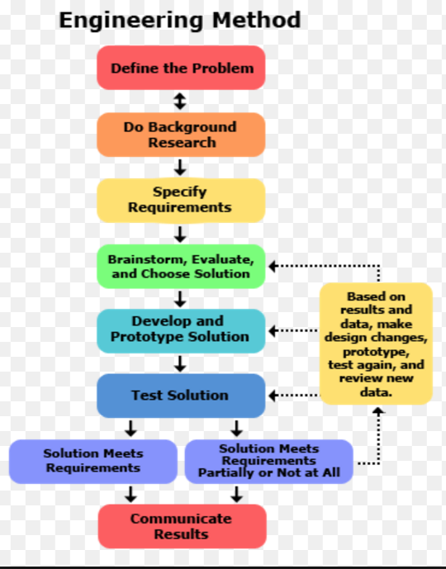

*Fig 2.1 Flow chart for Design specifications.* 2

2.2 Goal Statement & Objectives

**Goal Statement:**

“Develop a portable device that transforms solar thermal energy into usable electricity.”

**Objectives:**

• Produce 20 W of power from accessible sun source under defined constraints.

• Minimize the weight of the device to ensure portability.

• Produce a device that is safe to operate and leaves negligible negative ecological

consequences.

• Produce a device that is conveniently setup and disassembled.

2.3 Constraints

• Device weight must not exceed 50lbs

• Compact (less than 3 ft^3)   
 • Waterproof / (resistant to corrosion)

• Portable and durable

• Operate in the confines of the provided budget

• Meet with all effected safety standards applicable

• Provides maximum stand by time

• Comply with all good standards and consumer needs

*2.4* Functional Requirements

|  |  |  |
| --- | --- | --- |
| *No.* | *Needs* | *Wants* |
| *1.* | *Generate 20W of power* | *Portability* |
| *2.* | *Energy Storage & efficiency* | *Low cost* |
| *3.* | *Solar tracking* | *User friendly* |
| *4.* | *Shock resistant* | *GPS modulator* |

Table1- Needs And Wants for the design

2.5 Implementation Considerations

In order to make this project a useable device, it is necessary that outputs are regulated and protected in order to keep the device, users, and any devices that may be connected safe. In order to generate a stable voltage, it is necessary to create a voltage regulator. Because this project is limited to how much power it can use, this must be a very efficient voltage regulator. While a linear voltage regulator would be easiest to implement, it will waste a lot of energy. Linear regulators monitor the output voltage and in order to keep the voltage steady, they dissipate energy as heat. This is not acceptable for our application.

Instead, a switching power supply would be much more efficient. A switching power supply uses the properties of inductors to store energy to either step up or down DC voltages. A boost converter (steps up DC voltage) charges an inductor by switching it between charging a capacitor and shorting to ground. When the inductor is shorted to ground, the voltage rises and is then switched back to the capacitor where it dumps the energy at a high voltage. Depending on the switching speed, size of capacitor, and size of inductor, a very high voltage with very little ripple can be implemented. If necessary, in order to perfectly smooth the output, a Zener diode may be used in parallel with the capacitor.

*2.6* Design Deliverables

The team will deliver a functional Solar Thermal Generator prototype that will fulfill all the needs and the requirement specifications. The product will provide the maximum efficiency and the expected power output. The deliverable product will be ready for customer by April 2017, along with all the documentation including a user manual with troubleshooting flowchart(s) and component specifications.

*2.7* Preliminary System Test Plan

To verify and test the design a systematic approach will be performed. The design will go through several test stages for increased efficiency and better performance.

**Test-01:** Power Test - With the help of all the data and equations the theoretical numbers will be compared to the actual results.

**Test-02:** Data Tracking – The functionality and coding will be tested to confirm performance.

**Test-03:** Data Verification – Testing and performance of the microcontroller will be tested against code.

**Test-04:** Test Runs – Several test runs will be made for better performance and design efficiency.

2.8 Quality Function Deployment

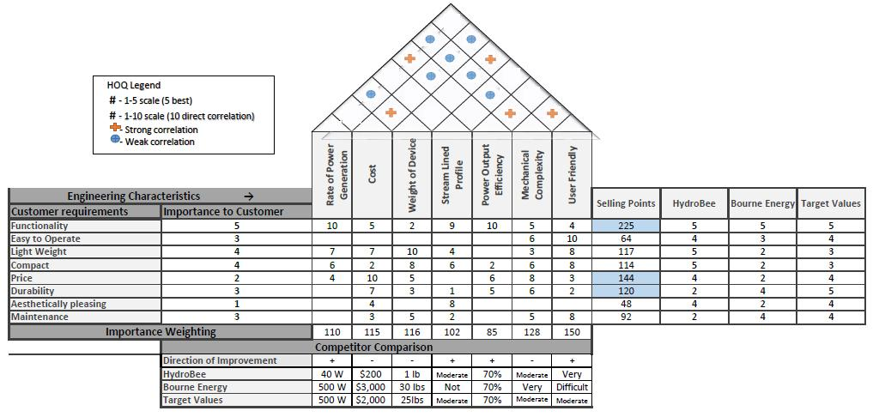

Table. 1 House of Quality

3. CONCLUSION

The assigned Senior Design Project relies on a sun’s heat energy to generate useable electrical energy. The finished product is ideally portable and will be used under such applications as lights and heaters in a relatively remote location where a power grid is unavailable or unreliable. Our research into solar thermal generators has shown an efficiency of about 80%, with power generation of above 20W. The Generators produce electricity through the use of Faraday’s principle of electromagnetic induction.This allows the generated mechanical power to be transformed into a higher quality and more useful electrical power. The design of our device should include a microcontroller, thermoelectric generator, anchor mount, and output ports as the main components. A new innovative set of prototype will be designed and tested in order to determine which is most efficient and practical. An established data is very helpful to calculate maximum efficiency and to determine the importance of functionality, durability, and price as the most important characteristics of our project.

4. Schedule



* 1. References

1. How Does a Generator Create Electricity? (2013). Retrieved from Diesel Service & Supply: http://www.dieselserviceandsupply.com/How_Generators_Work.aspx
2. Generator Fundamentals. (2011, 08 19). Retrieved from Aurora Generators Inc.: http://www.auroragenerators.com/news/29-products/generator-controllers/29-generator-fundamentals
3. History of Solar Thermal Generator (n.d.). Retrieved from https://www.eia.gov/energyexplained/?page=solar_thermal_power_plant
4. Backpack Power Plant. (2014). Retrieved from Bourne Energy: http://www.bourneenergy.com/futuremain.html
5. Dieter, G. E., & Schmidt, L. C. (2013). Engineering Design Fifth Edition. New York