Cross-Family Comparison of Host-Switching Grammar in Arthropod-Borne Viruses Reveals Convergent Evolution of Family-Specific Immune Evasion Strategies
Brhanu F. Znabu¹, Nicole R. Sexton^{1,2*}
¹ Nebraska Center for Virology, University of Nebraska–Lincoln, Lincoln, NE, USA
² Department of Biological Sciences, University of Nebraska–Lincoln, Lincoln, NE, USA
* Corresponding author: E-mail: nsexton@unl.edu

Abstract
Arthropod-borne viruses (arboviruses) capable of infecting vertebrate hosts have evolved independently in multiple RNA virus families, each of which also harbors insect-specific viruses (ISVs) restricted to arthropod hosts. Whether the genomic determinants distinguishing arboviruses from ISVs represent universal signatures of vertebrate competence or family-specific adaptations remains unknown. We extended a leakage-aware evaluation framework using DNABERT-2 foundation model embeddings to four arbovirus families spanning three genome architectures: Flaviviridae and Togaviridae (monopartite +ssRNA), Rhabdoviridae (monopartite −ssRNA, dimarhabdovirus supergroup), and Peribunyaviridae (tri-segmented −ssRNA). Across 6,052 genomes and 124,883 genomic windows, we demonstrate that evaluation leakage inflates classification performance by 15–36 percentage points across families, confirming the necessity of lineage-aware evaluation. A 4×4 cross-family transfer matrix reveals limited and asymmetric transferability of host-range classifiers, with no correlation between transfer performance and genome architectural similarity. Comparative motif analysis shows that host-switching grammar is predominantly family-specific: top-50 enriched 6-mer sets exhibit near-zero cross-family overlap (maximum Jaccard = 0.042), with no motifs shared across all four families. Strikingly, Flaviviridae discriminative motifs are dominated by UpA dinucleotides (70%), implicating OAS/RNaseL, while Peribunyaviridae motifs are dominated by CpG dinucleotides (90%), implicating ZAP-mediated restriction. Positional hotspots converge near polymerase-encoding regions in three of four families despite distinct genome organizations. These results support convergent evolution of family-specific immune evasion strategies rather than ancestral inheritance of universal host-switching grammar, with implications for the design of pan-viral emergence prediction tools.

Author Summary
Many dangerous human pathogens—including dengue, Zika, and chikungunya viruses—are transmitted by mosquitoes and other arthropods. These “arboviruses” can infect both insect and vertebrate hosts, but closely related “insect-specific viruses” are restricted to insects and cannot infect humans. Understanding what distinguishes these two groups at the genomic level could help scientists identify which newly discovered insect viruses might pose future threats to human health. In a previous study, we used artificial intelligence to identify sequence patterns (“grammar elements”) that distinguish arboviruses from insect-specific viruses within one virus family. Here, we asked whether these patterns are the same across four different virus families that independently evolved the ability to infect vertebrates. Surprisingly, we found that each family uses a largely unique set of sequence patterns, with almost no overlap between families. Different families appear to evade different arms of the vertebrate immune system: one family’s patterns relate to the OAS/RNaseL antiviral pathway, while another’s relate to the ZAP pathway. These findings suggest that vertebrate infection capability evolved independently in each family through distinct molecular strategies, meaning that predicting which new viruses might threaten human health will require family-specific rather than universal approaches.

Introduction
Arthropod-borne viruses (arboviruses) constitute a persistent and expanding threat to global public health. Dengue virus alone causes an estimated 390 million infections annually, while Zika, West Nile, yellow fever, and Japanese encephalitis viruses collectively account for substantial morbidity and mortality across tropical and temperate regions [1,2]. These pathogens share a defining biological characteristic: the capacity to replicate in both arthropod vectors and vertebrate hosts, completing a transmission cycle that enables epidemic spread. Critically, arboviruses are not confined to a single viral family. Dual-host cycling has evolved independently in multiple RNA virus families, including Flaviviridae (+ssRNA, monopartite), Togaviridae (+ssRNA, monopartite), Peribunyaviridae (−ssRNA, tri-segmented), and Rhabdoviridae (−ssRNA, monopartite), among others [2,3]. Each of these families also harbors insect-specific viruses (ISVs)—phylogenetically interspersed lineages that remain restricted to arthropod hosts, unable to establish productive infection in vertebrate cells [3,4]. The repeated, independent emergence of dual-host competence across these phylogenetically distant families raises a fundamental question: do arboviruses from different families solve the problem of vertebrate infection using the same molecular strategies, or has each lineage evolved its own solution?
Understanding the genomic determinants of the arbovirus–ISV boundary has direct relevance to viral emergence prediction and public health preparedness. As metagenomic surveillance continues to uncover novel insect-associated viruses at an accelerating pace [5,6], the ability to assess vertebrate competence from sequence alone would enable risk stratification of newly discovered viruses before costly experimental characterization. Several mechanisms have been proposed to underlie vertebrate host restriction. Vertebrate cells deploy innate immune sensors that recognize specific dinucleotide patterns in viral RNA: the zinc-finger antiviral protein (ZAP) targets CpG dinucleotides and recruits RNA degradation machinery [7,8], while 2′-5′-oligoadenylate synthetase (OAS)-activated RNaseL preferentially cleaves at UpA (UA in RNA) dinucleotides [9,10]. Comparative genomic analyses have demonstrated that vertebrate-infecting viruses exhibit genome-wide suppression of these targeted dinucleotides relative to invertebrate-restricted relatives [11,12,13], though whether specific motif contexts, genomic localization, or higher-order sequence patterns distinguish arboviruses from ISVs within individual families—let alone across families—remains incompletely understood.
Machine learning approaches have shown considerable promise for predicting viral host range from genomic sequence [14,15,16]. Deep learning models and pre-trained nucleotide foundation models can extract rich sequence representations without task-specific training [17,18,19], enabling powerful classification frameworks. However, these approaches suffer from a critical methodological limitation: evaluation leakage. When phylogenetically related viral genomes appear in both training and test sets—an inevitability given the clustered structure of viral sequence databases—performance metrics are inflated by the model’s ability to recognize lineage-specific signatures rather than generalizable host-range determinants [20,21]. The magnitude of this inflation and its variation across viral families had not been systematically quantified prior to our work.
In our foundational study [22], we addressed these limitations by developing a leakage-aware evaluation framework for identifying host-switching grammar elements in Flaviviridae using DNABERT-2 foundation model embeddings [17]. Using 3,031 complete flavivirus genomes (2,816 dual-host arboviruses [ARB], 215 ISV), we demonstrated that standard evaluation inflates Average Precision (AP) by 15 percentage points (AP = 0.982 under accession-grouped vs. 0.832 under species-grouped cross-validation), identified an 18× enrichment hotspot at the NS3–NS5 junction, and extracted UpA-enriched 6-mer motifs as candidate grammar elements associated with vertebrate competence. However, a central question remained: are these findings specific to Flaviviridae, or do they represent universal features of arbovirus host-switching grammar?
Two competing hypotheses frame this question. Under the ancestral inheritance model, universal grammar elements were inherited from a common arbovirus ancestor that first acquired vertebrate competence, predicting substantial motif overlap and consistent dinucleotide signatures across families. Under the convergent evolution model, each family independently evolved distinct molecular strategies for crossing the arthropod–vertebrate interface under shared selection pressure from vertebrate innate immunity, predicting family-specific motifs, positional hotspots, and dinucleotide compositions. Distinguishing between these models requires systematic cross-family comparison—an analysis that has not previously been attempted for arbovirus host-switching grammar.
Here, we extend the validated leakage-aware framework to three additional arbovirus families—Togaviridae, Peribunyaviridae, and Rhabdoviridae (scoped to the dimarhabdovirus supergroup)—and test whether host-switching grammar is conserved across evolutionarily divergent lineages spanning three genome architectures. We exploit the diversity of genome organizations (monopartite +ssRNA, monopartite −ssRNA, tri-segmented −ssRNA) and the asymmetric ISV availability across families to rigorously dissect universal versus family-specific signals. Specifically, we pursue four aims: (1) establish leakage-aware performance baselines within each evaluable family; (2) test cross-family transferability of host-range classifiers through a 4×4 transfer matrix; (3) identify shared versus family-specific grammar elements by comparing positional hotspots, 6-mer motif enrichment, and dinucleotide usage patterns; and (4) characterize how the tri-segmented Peribunyaviridae genome distributes host-switching signals across its L, M, and S segments. The resulting analysis—encompassing 6,052 genomes, 124,883 windows, and four families—provides the first comprehensive test of whether vertebrate competence signatures in arboviruses are universal or convergently evolved.

Results

Multi-family dataset construction spanning three genome architectures
We assembled curated datasets from four arbovirus families to test whether the host-switching grammar elements identified in Flaviviridae [22] generalize across evolutionarily divergent lineages. The four families collectively represent three distinct RNA genome architectures: monopartite +ssRNA (Flaviviridae, Togaviridae), monopartite −ssRNA (Rhabdoviridae, scoped to the dimarhabdovirus supergroup), and tri-segmented −ssRNA (Peribunyaviridae) (Fig 1A–B).
After family-specific quality control filtering, the combined dataset comprised 6,052 unique genomes (7,396 metadata rows including per-segment entries for Peribunyaviridae): 3,031 Flaviviridae (2,816 ARB, 215 ISV), 2,116 Togaviridae (2,108 ARB, 8 ISV), 672 Peribunyaviridae isolates (666 ARB, 6 ISV; 2,016 segment-level accessions), and 233 Rhabdoviridae (210 ARB, 23 ISV). The dataset spanned 311 species (109 ARB genera, 43 ISV genera) and exhibited pronounced variation in class imbalance across families, ranging from 9.1:1 (Rhabdoviridae) to 264:1 (Togaviridae) (Fig 1C, left panel).
Genome length distributions differed substantially among families, reflecting their distinct genome organizations (Fig 1C, right panel). Flaviviridae genomes ranged from 9,210 to 11,723 nt (mean: 10,674 nt), Togaviridae from 10,990 to 12,000 nt (mean: 11,637 nt), and Rhabdoviridae from 10,667 to 15,444 nt (mean: 11,980 nt), with the broader Rhabdoviridae distribution reflecting variable numbers of accessory open reading frames in dimarhabdovirus genomes. For Peribunyaviridae, concatenated L+M+S genome lengths ranged from approximately 10,800 to 13,400 nt, with individual segment lengths showing tight distributions for L (mean: 6,846 nt) and S (mean: 891 nt) segments and greater variability for M segments (mean: 4,398 nt).
Architecture-aware windowing (1,000 nt windows, 500 nt stride) produced 124,883 windows across all families (59,980 Flaviviridae; 46,077 Togaviridae; 13,572 Peribunyaviridae; 5,254 Rhabdoviridae). For Peribunyaviridae, each segment was windowed independently: L segments yielded a mean of 12.0 windows per segment, M segments 7.2 windows, and S segments a single window each (reflecting the sub-kilobase segment length). All windows were embedded using DNABERT-2 with frozen weights and mean-pooled to 768-dimensional vectors (Fig 1A).
The ISV availability varied markedly across families, creating an asymmetric experimental design that was exploited to test different aspects of host-switching grammar. Flaviviridae (215 ISV genomes, 22 species) and Rhabdoviridae (23 ISV, 13 species) provided sufficient diversity for within-family cross-validation. Peribunyaviridae (6 ISV isolates, 3 species) permitted within-family evaluation with reduced statistical power. Togaviridae (8 ISV genomes, 5 species) was designated exclusively as a cross-family transfer challenge set.
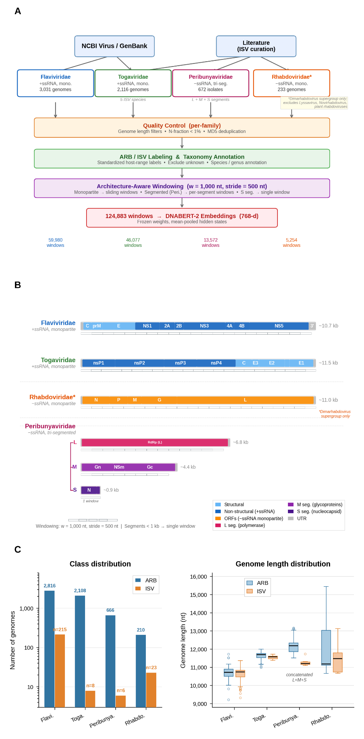
Fig 1. Multi-family dataset construction and genome architecture. (A) Analytical pipeline showing data retrieval from NCBI Virus/GenBank and literature curation of ISV genomes, family-specific quality control filtering, standardized ARB/ISV labeling, architecture-aware windowing (w = 1,000 nt, stride = 500 nt), and DNABERT-2 embedding generation (768-d vectors). Per-family window counts are indicated below. (B) Genome architecture comparison across the four families: monopartite +ssRNA (Flaviviridae, Togaviridae), monopartite −ssRNA (Rhabdoviridae, scoped to the dimarhabdovirus supergroup), and tri-segmented −ssRNA (Peribunyaviridae: L, M, S segments). Gene maps with sliding window overlays illustrate the architecture-aware windowing strategy; S segments (<1 kb) yield a single window. (C) Left: Class distribution showing ARB (blue) and ISV (orange) genome counts per family on a log scale, highlighting the pronounced class imbalance ranging from 9.1:1 (Rhabdoviridae) to 264:1 (Togaviridae). Right: Genome length distributions per family, with Peribunyaviridae shown as concatenated L+M+S lengths.

Within-family classification performance and leakage inflation across families
To establish per-family performance baselines and determine whether the evaluation leakage phenomenon documented in Flaviviridae [22] extends to other arbovirus families, we applied the leakage-aware evaluation framework independently to each evaluable family (Fig 2).
Under accession-grouped cross-validation, DNABERT-2 embeddings achieved high classification performance across all three evaluable families: Flaviviridae AP = 0.982 ± 0.006, Peribunyaviridae AP = 0.777 ± 0.140, and Rhabdoviridae AP = 0.769 ± 0.141 (Fig 2A). The substantially higher Flaviviridae AP reflects both the larger training set (3,031 genomes vs. 672 and 233) and the greater ISV diversity (22 species vs. 3 and 13), which enable more robust generalization within cross-validation folds.
Transitioning to species-grouped evaluation revealed pronounced performance degradation in all three families: Flaviviridae AP = 0.832 ± 0.120, Peribunyaviridae AP = 0.416 ± 0.154, and Rhabdoviridae AP = 0.509 ± 0.306 (Fig 2B). The magnitude of leakage inflation, quantified as ΔAP = AP_{accession} − AP_{species}, varied substantially across families (Fig 2C): Peribunyaviridae exhibited the largest inflation (ΔAP = 36.1 percentage points), followed by Rhabdoviridae (26.0 pp) and Flaviviridae (15.0 pp). These results demonstrate that evaluation leakage is not unique to Flaviviridae but is a pervasive phenomenon across arbovirus families, with smaller and more imbalanced datasets exhibiting greater susceptibility to inflated performance estimates.
The elevated variance under species-grouped evaluation (Rhabdoviridae SD = 0.306, compared to 0.141 under accession-grouped) reflects the heterogeneity of test-set difficulty when entire species are held out: folds containing phylogenetically divergent ISV lineages are disproportionately challenging. The wide confidence intervals for Peribunyaviridae (3 ISV species under leave-one-species-out evaluation) underscore the statistical limitations imposed by the scarcity of insect-specific bunyaviruses.
Togaviridae was excluded from within-family evaluation due to its 8 ISV genomes (5 species), which are insufficient to populate minority-class examples across cross-validation folds. This family instead served as a stringent cross-family transfer target (see below).
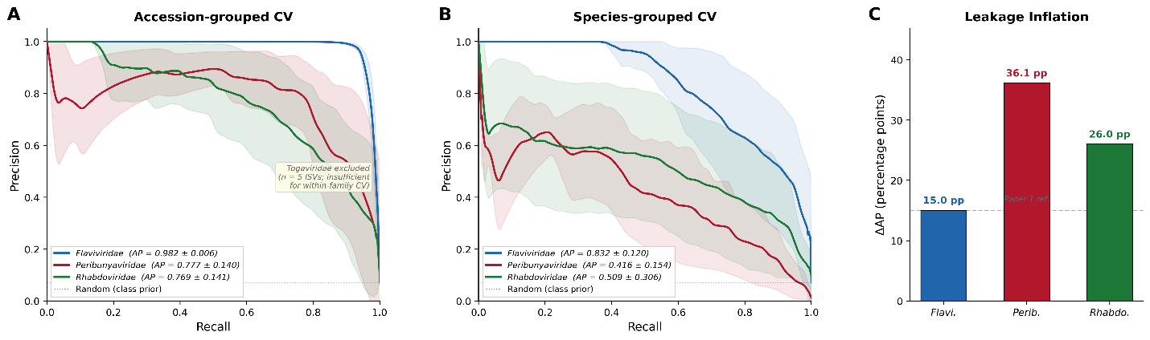
Fig 2. Within-family classification performance and leakage inflation. (A) Precision-recall curves under accession-grouped cross-validation for Flaviviridae (blue; AP = 0.982 ± 0.006), Peribunyaviridae (red; AP = 0.777 ± 0.140), and Rhabdoviridae (green; AP = 0.769 ± 0.141). Shaded regions indicate ±1 SD across cross-validation folds. Togaviridae was excluded due to insufficient ISVs (n = 8) for within-family cross-validation. Dashed line indicates random classifier performance (class prior). (B) Precision-recall curves under species-grouped cross-validation, revealing pronounced performance degradation: Flaviviridae AP = 0.832 ± 0.120, Peribunyaviridae AP = 0.416 ± 0.154, Rhabdoviridae AP = 0.509 ± 0.306. (C) Leakage inflation magnitude (ΔAP = AP_accession − AP_species) across the three evaluable families. Peribunyaviridae exhibits the largest inflation (36.1 percentage points), followed by Rhabdoviridae (26.0 pp) and Flaviviridae (15.0 pp). Dashed line indicates the Flaviviridae reference value from our prior study [22].

Cross-family transfer reveals asymmetric but significant host-range signal sharing
To determine whether host-switching grammar learned from one family can predict host phenotype in phylogenetically distant families, we constructed a 4×4 cross-family transfer matrix (Fig 3A). The diagonal entries (within-family full-training AP) ranged from 0.865 (Peribunyaviridae) to 0.986 (Flaviviridae), confirming strong within-family discriminability. Off-diagonal transfer AP values were generally low, indicating that the majority of discriminative signal is family-specific. However, two notable exceptions emerged.
First, Rhabdoviridae→Flaviviridae transfer achieved the highest off-diagonal AP (0.696), suggesting that these two monopartite families share a substantial component of host-range signal despite having opposite genome sense (+ssRNA vs. −ssRNA). The reciprocal Flaviviridae→Rhabdoviridae transfer was lower (AP = 0.412), indicating asymmetric signal sharing. Second, Togaviridae→Flaviviridae transfer (AP = 0.459) and Peribunyaviridae→Rhabdoviridae transfer (AP = 0.330) also exceeded the levels expected from chance, consistent with partial conservation of embedding-level host signatures across families.
The critical Flaviviridae→Togaviridae transfer test—designed as the most biologically informative comparison between two +ssRNA families—yielded an AP of only 0.010, suggesting minimal transferability of the overall score distribution. However, ranking-based analysis revealed that 5 of 8 Togaviridae ISV genomes were ranked in the top 10% of all Togaviridae predictions (expected by chance: 0.8 genomes), representing a 6.3-fold enrichment (hypergeometric P = 4.1 × 10⁻⁴). All 8 ISV genomes received P(ISV) scores exceeding 0.94. These results demonstrate that the Flaviviridae-trained classifier assigns elevated ISV probability to Togaviridae ISVs but cannot overcome the extreme class imbalance (264:1) in the AP metric, which is dominated by the large number of ARB genomes receiving intermediate scores.
Transfer performance did not correlate significantly with genome organization distance (Spearman ρ = −0.30, P = 0.346; Fig 3B), suggesting that architectural similarity alone does not predict cross-family transferability. The highest transfer AP (Rhabdoviridae→Flaviviridae, 0.696) involved families of different genome sense, while the lowest non-trivial transfer pairs involved families with matching sense polarity.
A pooled multi-family model trained on genome-mean embeddings from all four families performed worse than within-family models for all three evaluable families (Fig 3C): pooled AP was 0.786 versus 0.832 for Flaviviridae (Δ = −0.046), 0.305 versus 0.416 for Peribunyaviridae (Δ = −0.111), and 0.247 versus 0.509 for Rhabdoviridae (Δ = −0.262). These results indicate that cross-family training introduces confounding family-level variation that degrades within-family discrimination, rather than providing complementary signal from additional host-switching examples.
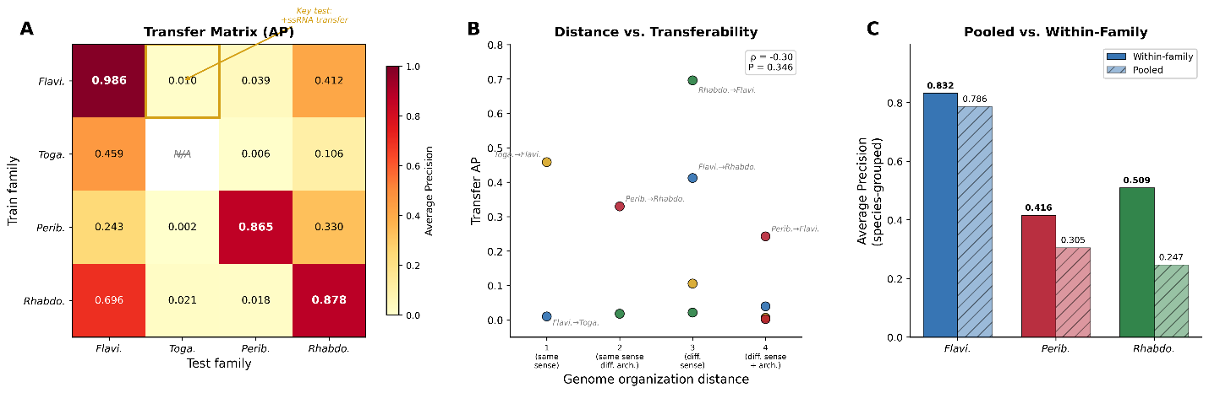
Fig 3. Cross-family transfer matrix and pooled model performance. (A) 4×4 transfer matrix showing Average Precision when a logistic regression probe trained on one family (rows) is evaluated on another family (columns). Diagonal entries (red) represent within-family full-training AP. Off-diagonal values indicate cross-family transferability; the highest off-diagonal transfer is Rhabdoviridae→Flaviviridae (AP = 0.696). Gold box highlights the key +ssRNA transfer test (Flaviviridae→Togaviridae). Togaviridae diagonal is marked N/A due to exclusion from within-family evaluation. (B) Transfer AP versus genome organization distance for all off-diagonal family pairs, showing no significant correlation (Spearman ρ = −0.30, P = 0.346). Points are colored by train family. Selected transfer pairs are labeled. (C) Comparison of within-family species-grouped AP (solid bars) versus pooled multi-family model AP (hatched bars) for each evaluable family. The pooled model underperforms within-family models in all three families, indicating that cross-family training introduces confounding variation.

Multi-family embedding space is dominated by family-level structure with embedded host-range signal
Uniform Manifold Approximation and Projection (UMAP) of genome-mean embeddings from all four families (n = 6,052 genomes; 5,800 ARB, 252 ISV) revealed a hierarchical organization in which family identity is the primary axis of variation and host-range distinction is embedded within each family cluster (Fig 4A–B). The four families occupied largely distinct regions of the embedding space (Fig 4B), consistent with the phylogenetic divergence and architectural differences among these lineages.
Within family clusters, ISV genomes were visually distinguishable from ARB genomes (Fig 4A), though the degree of separation varied by family. Flaviviridae ISVs formed a compact cluster distinct from the dispersed ARB population, replicating the pattern observed in our prior study [22]. Rhabdoviridae ISVs were similarly separated from their ARB counterparts. Peribunyaviridae and Togaviridae ISVs, while fewer in number, occupied peripheral positions relative to their respective ARB clusters.
Quantitative assessment of embedding quality using k-nearest neighbor (kNN) purity (k = 15) yielded a pooled score of 0.994, computed on all genome-mean embeddings (Fig 4C). This value significantly exceeded the permutation-based null expectation (null mean = 0.920 ± 0.002; Z = 42.8, P < 0.001), confirming that DNABERT-2 embeddings capture host-range-associated sequence features beyond what would be expected from phylogenetic structure alone. Per-family kNN purity scores were uniformly high: Flaviviridae (0.992), Togaviridae (0.992), Peribunyaviridae (0.938), and Rhabdoviridae (0.992). The slightly lower Peribunyaviridae value reflects the reduced ISV representation (6 of 672 isolates) and the influence of the tri-segmented genome architecture on embedding geometry.
The silhouette score for the pooled dataset was 0.270, indicating moderate but positive cluster separation by host-range label across all families. Per-family silhouette scores ranged from 0.290 (Peribunyaviridae) to 0.580 (Rhabdoviridae), with the lower values reflecting within-class heterogeneity among the diverse ARB lineages spanning multiple genera and species complexes. The discrepancy between high kNN purity and moderate silhouette scores is expected when clusters differ substantially in density, as is the case for the majority ARB class relative to the compact ISV cluster.
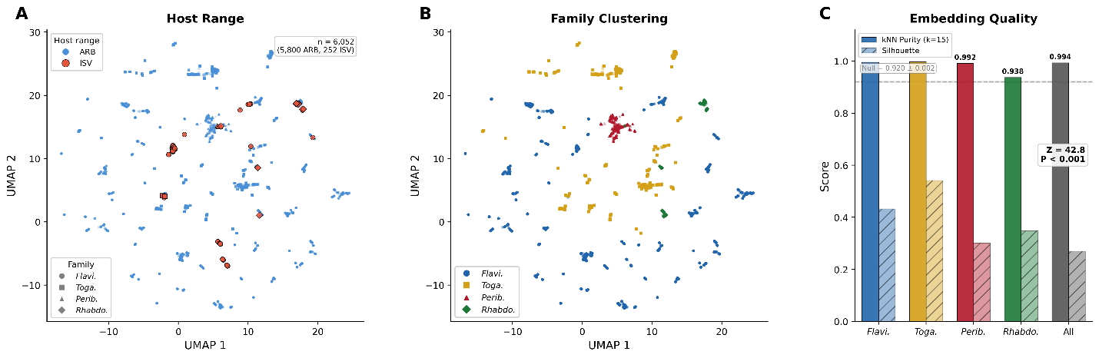
Fig 4. Multi-family embedding space visualization. (A) UMAP projection of genome-mean DNABERT-2 embeddings from all four families (n = 6,052 genomes; 5,800 ARB, 252 ISV), colored by host-range class (ARB: blue, ISV: red). Point shapes distinguish viral families (circle: Flaviviridae, square: Togaviridae, triangle: Peribunyaviridae, diamond: Rhabdoviridae). ISV genomes are visually distinguishable from ARB genomes within each family cluster. (B) UMAP projection colored by viral family, revealing that family identity is the primary axis of variation in the embedding space. The four families occupy largely distinct regions, consistent with phylogenetic divergence. (C) Quantitative embedding quality metrics. kNN purity (k = 15; solid bars) and silhouette scores (hatched bars) per family and pooled. Pooled kNN purity = 0.994 significantly exceeds the permutation-based null expectation (null mean = 0.920 ± 0.002; Z = 42.8, P < 0.001). Dashed line indicates null expectation.

Comparative genome-localized attribution reveals family-specific positional hotspots
Mapping window-level prediction scores to normalized genome positions revealed that each family exhibits a distinct positional enrichment profile, with discriminative signal concentrated in family-specific genomic regions (Fig 5A).
Flaviviridae showed peak enrichment at bin 11 (relative position ~0.55; 3.6× enrichment), corresponding to the NS3–NS5 coding region, consistent with the 18× enrichment hotspot identified at position 0.68 in our prior study [22]. Togaviridae (scored using the Flaviviridae-trained probe) exhibited its strongest enrichment at bin 16 (relative position ~0.80; 3.8× enrichment), mapping to the structural protein region (E2–E1) at the 3′ end of the alphavirus genome—a reversed genomic organization relative to flaviviruses, where structural proteins occupy the 5′ end. Rhabdoviridae showed peak enrichment at bin 18 (relative position ~0.90; 3.3× enrichment), corresponding to the L (polymerase) gene that dominates the 3′ portion of dimarhabdovirus genomes. Peribunyaviridae exhibited enrichment at bin 5 (relative position ~0.25; 3.3× enrichment), though interpretation of Peribunyaviridae positional profiles requires caution due to sparse bins arising from the segmented genome architecture. Bins containing fewer than 50 windows (flagged with red hollow markers in Fig 5A) were excluded from peak identification.
Pairwise Spearman rank correlations between family-level enrichment profiles (20-bin resolution) were generally weak and non-significant (Fig 5A inset). The sole significant correlation was between Flaviviridae and Togaviridae (ρ = +0.48, P = 0.031), consistent with partial conservation of positional signal between the two +ssRNA monopartite families. All other pairwise correlations were non-significant (P > 0.05), indicating that the genomic distribution of host-range signal is largely family-specific. Hierarchical clustering of the family × position-bin enrichment heatmap (Fig 5B) grouped Flaviviridae and Togaviridae together, with Rhabdoviridae and Peribunyaviridae forming a separate branch, consistent with the correlation results.
Segment-level attribution in Peribunyaviridae. Analysis of the three Peribunyaviridae genomic segments revealed pronounced differential attribution across segments (Fig 5C). The L segment (RNA-dependent RNA polymerase) showed the highest mean P(ISV) for ISV windows (0.881), while the S segment (nucleocapsid protein) showed the highest fraction of ISV windows in the top 10% (0.026; mean P(ISV) = 0.547). The M segment (glycoproteins Gn/Gc) showed intermediate values. Mann–Whitney U tests confirmed significant differences between ARB and ISV scores within all three segments (L: U = 496,253, P = 3.4 × 10⁻⁵¹; M: U = 59,062, P = 6.1 × 10⁻¹⁰; S: U = 1,153, P = 2.0 × 10⁻⁵; all P values indicate highly significant ARB-ISV discrimination). Permutation testing confirmed that L-segment enrichment (observed: 0.1152) significantly exceeded the null expectation (null mean: 0.1012; P < 0.001), and between-segment comparison demonstrated significant heterogeneity (χ² = 48.0, df = 1, P = 2.5 × 10⁻¹⁰ for L vs. S comparison).
These results suggest that while host-range signal is present in all three Peribunyaviridae segments, the signal intensity varies by segment function. The prominence of the S segment was unexpected; however, we note that ISV sample sizes per segment are small (L: 78 windows, M: 25 windows, S: 6 windows), and the S-segment result should be interpreted with caution given the limited statistical power.
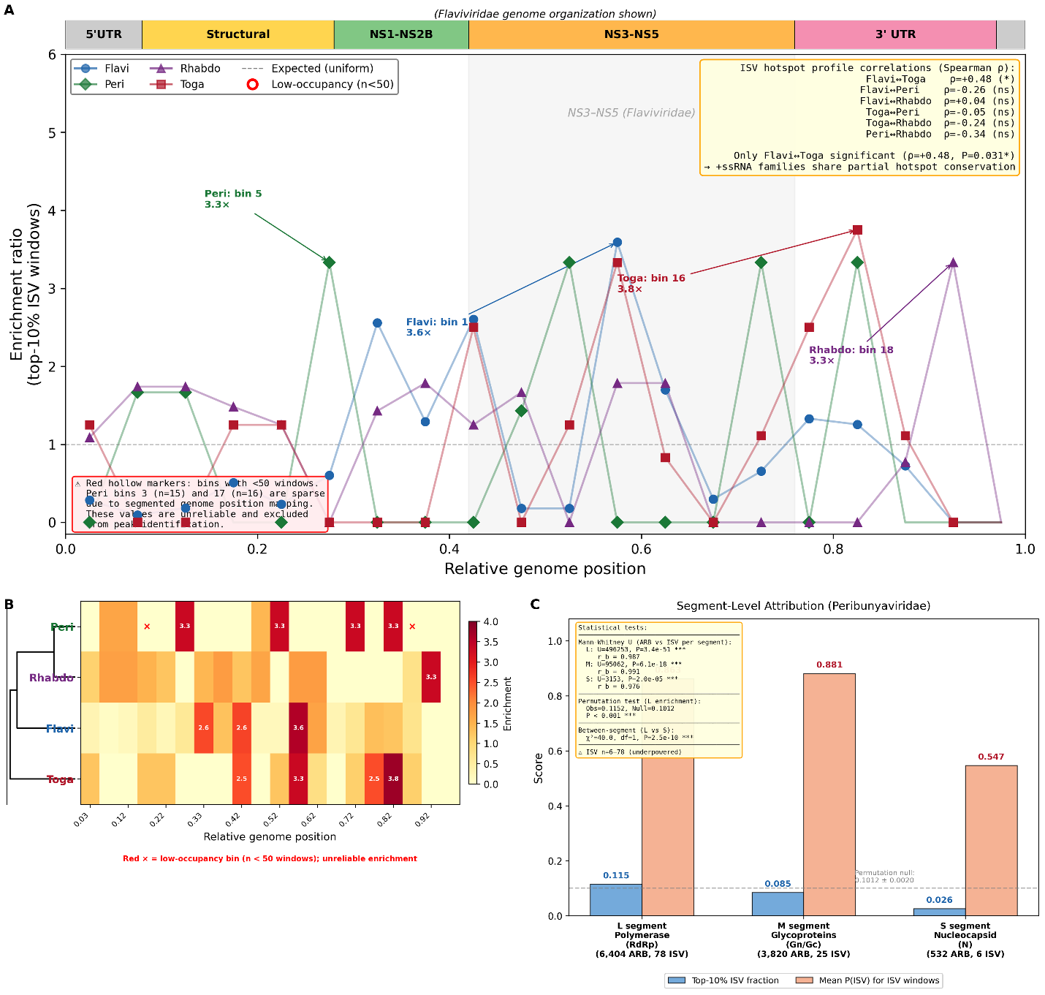
Fig 5. Comparative genome-localized attribution and segment-level analysis. (A) Positional enrichment profiles for each family, showing the ratio of observed to expected top-10% scoring windows across 20 normalized genome position bins (0.0–1.0). Flaviviridae peaks at bin 11 (~0.55; NS3–NS5 region), Togaviridae at bin 16 (~0.80; E2–E1 structural proteins), Rhabdoviridae at bin 18 (~0.90; L polymerase gene), and Peribunyaviridae at bin 5 (~0.25). Red hollow markers indicate low-occupancy bins (<50 windows) excluded from peak identification. Inset: pairwise Spearman rank correlations between family enrichment profiles; only Flaviviridae–Togaviridae is significant (ρ = +0.48, P = 0.031). (B) Family × position-bin enrichment heatmap with hierarchical clustering, grouping Flaviviridae and Togaviridae together. (C) Segment-level attribution for Peribunyaviridae. Left: mean P(ISV) scores for ARB (blue) and ISV (orange) windows within each segment (L, M, S), with Mann–Whitney U test significance indicated. Right: fraction of ISV windows in the top 10% by segment, compared against permutation null expectations. All three segments show significant ARB–ISV discrimination (P ≤ 2.0 × 10⁻⁵ for all).

Host-switching grammar is predominantly family-specific with divergent dinucleotide strategies
Cross-family comparison of the top-50 enriched 6-mer motifs from each family revealed minimal overlap, indicating that host-switching grammar is predominantly family-specific (Fig 6A). The UpSet plot showed that the vast majority of top motifs were unique to a single family: 48 of 50 Flaviviridae motifs (96.0%), 45 of 50 Peribunyaviridae motifs (90.0%), 43 of 50 Rhabdoviridae motifs (86.0%), and 46 of 50 Togaviridae motifs (92.0%) appeared in only one family’s top-50 set. No motifs were shared across all four families, and no motifs were shared across any combination of three families. Only 9 motifs were shared between any two families (4 between Peribunyaviridae and Rhabdoviridae, 2 between Rhabdoviridae and Togaviridae, 1 between Flaviviridae and Togaviridae, 1 between Flaviviridae and Rhabdoviridae, and 1 between Peribunyaviridae and Togaviridae).
Pairwise Jaccard similarity indices between top-50 motif sets ranged from 0.000 (Flaviviridae–Peribunyaviridae) to 0.042 (Peribunyaviridae–Rhabdoviridae), confirming sparse motif-level overlap. However, pairwise Spearman correlations of log₂ enrichment values across all 4,096 possible 6-mers revealed weak but statistically significant correlations for several family pairs (Fig 6B): Flaviviridae–Peribunyaviridae (ρ = 0.11, P < 0.001), Rhabdoviridae–Peribunyaviridae (ρ = 0.15, P < 0.001), Rhabdoviridae–Togaviridae (ρ = 0.36, P < 0.001), Togaviridae–Flaviviridae (ρ = 0.20, P < 0.001), Togaviridae–Peribunyaviridae (ρ = 0.09, P < 0.001), and Flaviviridae–Rhabdoviridae (ρ = 0.13, P < 0.001). These modest but pervasive correlations suggest that while the top discriminative motifs differ across families, the broader landscape of 6-mer enrichment shows weak concordance, potentially reflecting shared compositional constraints imposed by vertebrate innate immunity.
Dinucleotide composition reveals family-specific strategies. The dinucleotide composition of top-20 enriched motifs per family diverged dramatically across families (Fig 6C). In Flaviviridae, 70% of top-20 motifs (14 of 20) contained UpA dinucleotides and none contained CpG, replicating the UpA-dominant signature identified in our prior study [22]. In stark contrast, Peribunyaviridae top motifs were dominated by CpG-containing motifs (90%, 18 of 20) with no UpA-containing motifs. Rhabdoviridae showed a mixed composition (40% CpG, 10% UpA), and Togaviridae exhibited a balanced profile (45% CpG, 20% UpA). Fisher’s exact tests confirmed that these proportions differed significantly across families (global χ² = 56.1, df = 9, P = 7.6 × 10⁻⁹; Cramér’s V = 0.48). Key pairwise contrasts included Flaviviridae vs. Peribunyaviridae (UpA: P = 3.3 × 10⁻⁵; CpG: P = 3.4 × 10⁻⁹) and Flaviviridae vs. Rhabdoviridae (CpG: P = 3.4 × 10⁻⁴). These results demonstrate that the UpA enrichment pattern observed in Flaviviridae is not a universal feature of arbovirus host-switching grammar; instead, each family appears to employ a distinct dinucleotide strategy for navigating vertebrate innate immune barriers.
Conservation differential of shared motifs. For the 9 motifs shared between two families, conservation differentials (fraction ARB − fraction ISV) showed variable patterns across families (Fig 6D). The most strongly shared motif, GGTGGG (Peribunyaviridae and Togaviridae), exhibited a large positive conservation differential in the families where it was enriched (0.83 in one family), consistent with preferential retention in ARB genomes. However, several shared motifs showed discordant conservation patterns across families, including TGCGTG (conservation differential = −0.10 in Peribunyaviridae, +0.37 in Rhabdoviridae), suggesting that shared top-ranked status does not necessarily imply shared functional significance. Family-exclusive motifs generally showed positive conservation differentials in their respective families, with Rhabdoviridae motifs such as ACCCCC exhibiting particularly strong ARB-preferential conservation (0.63).
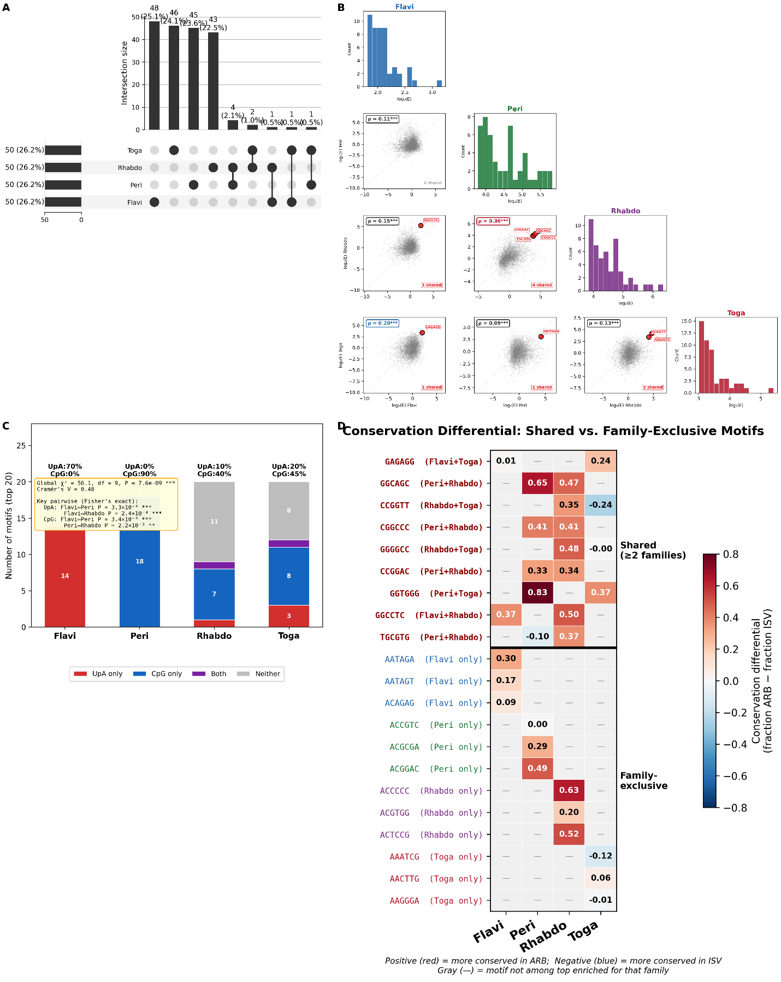
Fig 6. Cross-family motif comparison and dinucleotide strategies. (A) UpSet plot showing the intersection structure of top-50 enriched 6-mer motif sets across four families. The vast majority of motifs are family-unique (86–96%), with no motifs shared across all four or any three families. Only 9 motifs are shared between any two families (maximum pairwise Jaccard = 0.042). (B) Pairwise scatter plots of log₂ enrichment values across all 4,096 possible 6-mers for each family pair, with Spearman rank correlations annotated. Correlations are weak but statistically significant (ρ = 0.09–0.36, all P < 0.001), suggesting shared compositional constraints. (C) Dinucleotide composition of top-20 enriched motifs per family. Flaviviridae motifs are dominated by UpA dinucleotides (70%, 14/20) with no CpG, while Peribunyaviridae motifs are dominated by CpG (90%, 18/20) with no UpA. Rhabdoviridae (40% CpG, 10% UpA) and Togaviridae (45% CpG, 20% UpA) show mixed profiles. Global χ² = 56.1, P = 7.6 × 10⁻⁹. (D) Conservation differential heatmap (fraction ARB − fraction ISV) for shared and family-exclusive motifs, showing variable conservation patterns across families.

Ablation analyses reveal family-dependent signal distribution and context-dependence
Window masking ablation tests assessed whether discriminative signal is distributed across the genome or concentrated in high-scoring regions, extending this analysis from Flaviviridae [22] to two additional families (Fig 7A). Masking the top 5% highest-scoring windows per genome produced significant AP decreases in all three families, but the magnitude of degradation varied substantially. Flaviviridae showed modest performance loss (ΔAP = −3.2 percentage points, P < 0.01), Rhabdoviridae exhibited a larger but still moderate decline (ΔAP = −8.6 pp, P < 0.01), and Peribunyaviridae showed dramatic degradation (ΔAP = −20.3 pp, P = 0.01). In all three families, the observed ΔAP from top-5% masking exceeded the null distribution from random-5% masking, confirming that high-scoring windows carry disproportionate signal.
The 6-fold greater sensitivity of Peribunyaviridae to top-window removal relative to Flaviviridae likely reflects the interaction of smaller genome size (fewer total windows per isolate, hence each window contributes a larger fraction of the genome-mean embedding), extreme class imbalance (6 ISV isolates), and the concentration of S-segment windows in specific positional bins. Rhabdoviridae, with intermediate dataset size and ISV count, showed intermediate sensitivity. These results suggest that the distributed-signal property documented in Flaviviridae in our prior study [22] is partially family-dependent: while discriminative information is present throughout the genome in all families, the degree of concentration increases in families with smaller ISV representation and segmented architectures.
DNABERT-2 captures substantial information beyond motif composition. Direct comparison of DNABERT-2 embedding probes with transparent motif-based scoring revealed consistent performance advantages for the foundation model across all three evaluable families (Fig 7B). Under species-grouped cross-validation, DNABERT-2 outperformed motif-based scoring in Flaviviridae (AP = 0.832 vs. 0.446, Δ = +38.6 pp, P = 0.031), Peribunyaviridae (AP = 0.416 vs. 0.032, Δ = +38.4 pp, n = 2 folds), and Rhabdoviridae (AP = 0.509 vs. 0.318, Δ = +19.1 pp, P = 0.031). These context-dependence gaps indicate that DNABERT-2 embeddings capture higher-order sequence information—including positional patterns, inter-motif dependencies, and sequence context—that is absent from simple 6-mer presence features. The magnitude of the gap was largest for Peribunyaviridae, consistent with the hypothesis that segmented genome architectures encode host-range information through inter-segment patterns not captured by individual motifs.
Positional hotspot profiles are stable across bin resolutions. Hotspot enrichment profiles computed at 10, 20, and 40 bins showed high pairwise Spearman correlations across all families (Fig 7C). Correlations ranged from ρ = 0.87 (Flaviviridae, 10↔20 bins) to ρ = 0.99 (all families, 20↔40 bins), confirming that identified positional signatures are robust to analytical parameter choices and are not artifacts of bin resolution. Togaviridae showed the highest cross-resolution stability (ρ ≥ 0.94 for all pairs), while Flaviviridae showed the lowest minimum correlation (ρ = 0.87 for 10↔20), likely reflecting the more complex multi-peak enrichment profile in this family.
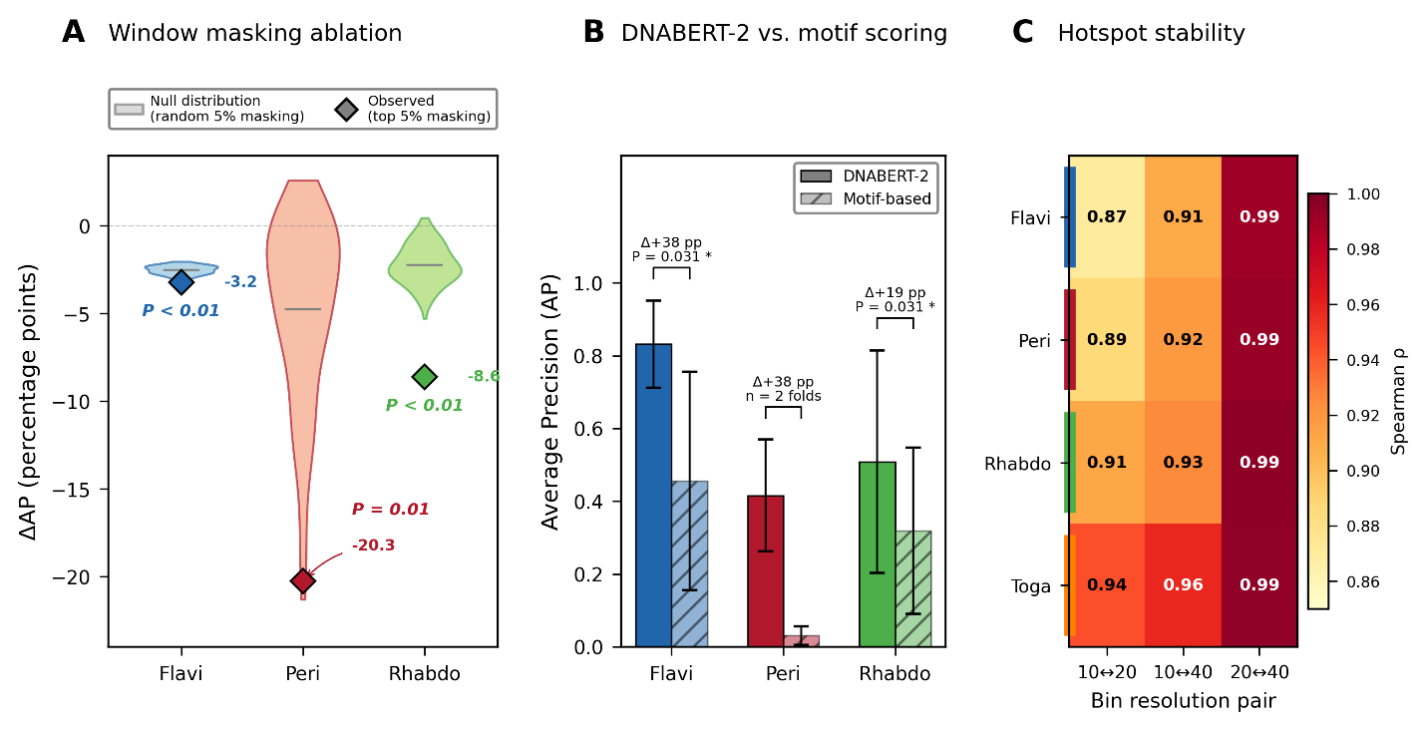
Fig 7. Ablation and robustness analyses. (A) Window masking ablation results showing ΔAP when the top 5% highest-scoring windows are removed per genome, compared to random 5% masking (null distribution). Flaviviridae: ΔAP = −3.2 pp; Rhabdoviridae: ΔAP = −8.6 pp; Peribunyaviridae: ΔAP = −20.3 pp. The 6-fold greater sensitivity of Peribunyaviridae reflects smaller genome size, extreme class imbalance, and segmented architecture. (B) Performance comparison of DNABERT-2 embedding probes versus transparent motif-based scoring under species-grouped cross-validation. DNABERT-2 outperforms the motif-based approach in all three evaluable families (context-dependence gap: +19.1 to +38.6 pp), confirming that the foundation model captures higher-order sequence information beyond simple 6-mer presence. (C) Hotspot profile stability across bin resolutions (10, 20, 40 bins). Pairwise Spearman correlations range from ρ = 0.87 to ρ = 0.99 across all families and resolution pairs, confirming that positional enrichment findings are robust to analytical parameter choices.

Biological integration supports convergent evolution of family-specific immune evasion strategies
The divergent dinucleotide strategies identified across families map to distinct components of the vertebrate innate immune system (Fig 8A). Flaviviridae grammar is dominated by UpA-containing motifs (70% of top-20), implicating the OAS/RNaseL pathway, which preferentially cleaves viral RNA at UpA (UA in RNA) dinucleotides [9]. In contrast, Peribunyaviridae grammar is dominated by CpG-containing motifs (90%), implicating the zinc-finger antiviral protein (ZAP), which recognizes and degrades CpG-rich RNA [7]. Rhabdoviridae and Togaviridae showed mixed dinucleotide profiles (40% and 45% CpG, respectively), suggesting these families may navigate multiple innate immune barriers simultaneously. The absence of universal motifs across all four families (maximum pairwise Jaccard = 0.042) indicates that each family has evolved an independent molecular strategy for crossing the arthropod–vertebrate interface.
Candidate shared grammar elements. Although no motifs were universally shared, 9 motifs appeared in the top-50 set of at least two families (Fig 8B). The highest-ranked shared element was GGGGCC (mean log₂ enrichment = 3.02 across the two families in which it was enriched), a GC-rich motif shared between Rhabdoviridae (log₂E = +4.70) and Togaviridae (log₂E = +4.16). CGGCCC, also shared between Peribunyaviridae and Rhabdoviridae, contained a single CpG dinucleotide (mean log₂E = 2.70), potentially implicating ZAP-mediated restriction. Other shared motifs included GGCAGC (Peribunyaviridae–Rhabdoviridae), GGTGGG (Peribunyaviridae–Togaviridae), GAGAGG (Flaviviridae–Togaviridae), and GGCCTC (Flaviviridae–Rhabdoviridae). Per-family enrichment values varied widely for shared motifs (ranging from −1.96 to +5.29 in log₂ enrichment), indicating that shared top-50 status does not imply equivalent enrichment magnitude. Mean conservation differentials for shared motifs ranged from 0.026 to 0.300, with most showing modest ARB-preferential conservation.
Convergent versus ancestral grammar. The combination of family-specific positional hotspots, divergent dinucleotide strategies, and sparse motif overlap collectively argues against a model of ancestral grammar inheritance (Fig 8C). Under the ancestral model, universal grammar elements would be expected to be inherited from a common arbovirus ancestor, producing high motif overlap and consistent dinucleotide composition across families. Instead, the observed pattern—independent motif sets, family-specific UpA/CpG ratios, and distinct positional signatures—is most parsimoniously explained by convergent evolution, in which each family independently evolved distinct molecular strategies for evading shared vertebrate innate immune barriers. The weak but significant genome-wide 6-mer enrichment correlations (ρ = 0.09–0.36 across all family pairs) may reflect residual constraints from shared vertebrate host physiology rather than common ancestry.
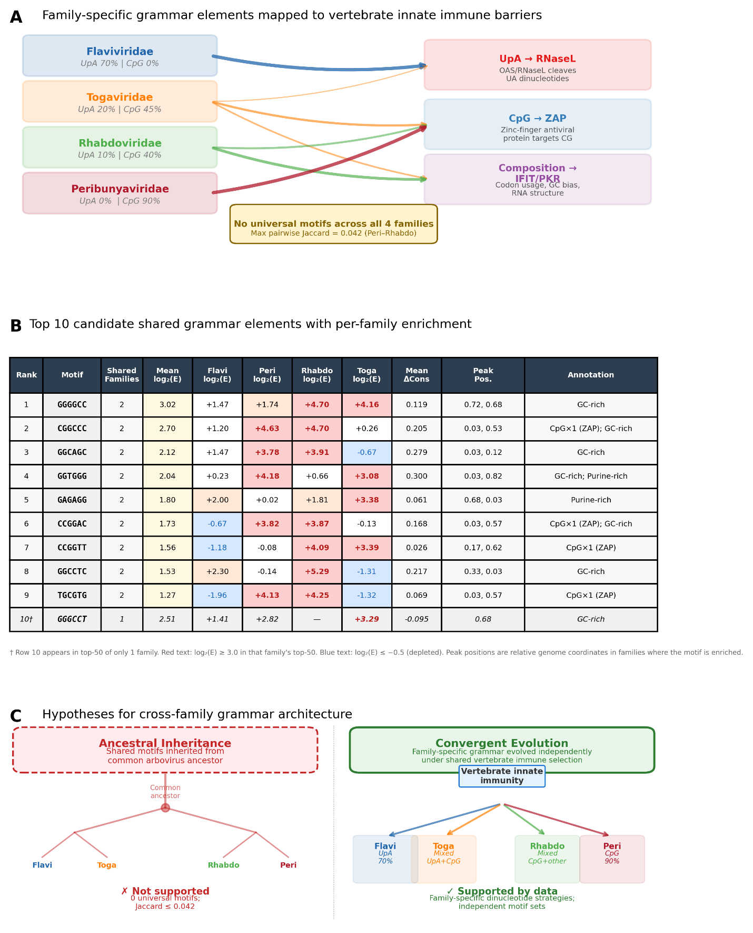
Fig 8. Biological integration and convergent evolution model. (A) Schematic mapping divergent dinucleotide strategies to distinct vertebrate innate immune pathways. Flaviviridae grammar is dominated by UpA motifs (70%), implicating the OAS/RNaseL pathway; Peribunyaviridae grammar is dominated by CpG motifs (90%), implicating ZAP-mediated restriction. Rhabdoviridae and Togaviridae show mixed profiles suggesting navigation of multiple immune barriers. (B) Prioritization table of top candidate shared grammar elements appearing in the top-50 set of at least two families, with per-family log₂ enrichment values, conservation differentials (ARB − ISV), positional peak bins, and biological annotations. (C) Conceptual diagram contrasting the ancestral inheritance model (universal grammar elements inherited from a common arbovirus ancestor, predicting high cross-family overlap) versus the convergent evolution model (family-specific strategies independently evolved under shared vertebrate immune selection pressure, predicting sparse overlap). The observed data—family-specific motif sets, divergent dinucleotide strategies, and near-zero cross-family Jaccard indices—support convergent evolution.

Discussion
This study provides the first systematic cross-family comparison of host-switching grammar elements in arthropod-borne viruses, testing whether the sequence signatures of vertebrate competence identified in Flaviviridae [22] generalize across evolutionarily divergent arbovirus families spanning three distinct genome architectures. Our principal finding is that host-switching grammar is predominantly family-specific rather than universal: each family employs an independent set of discriminative motifs, distinct positional hotspots, and divergent dinucleotide strategies to navigate the arthropod–vertebrate interface. This result has fundamental implications for our understanding of arbovirus emergence, predictive modeling across viral families, and the evolution of dual-host competence in RNA viruses.

Evaluation leakage is pervasive across arbovirus families
The leakage-aware evaluation framework, originally developed and validated in Flaviviridae [22], revealed that performance inflation from phylogenetic leakage is not unique to a single viral family but is a general phenomenon across arbovirus genomics (Fig 2). The magnitude of leakage inflation varied substantially, from 15.0 percentage points in Flaviviridae to 36.1 pp in Peribunyaviridae and 26.0 pp in Rhabdoviridae, with smaller and more imbalanced datasets exhibiting greater susceptibility. These findings extend prior warnings about leakage in machine learning-based science [20] and data with phylogenetic structure [21] to the specific domain of viral host prediction, where the clustered nature of viral sequence databases makes evaluation leakage nearly inevitable under standard protocols. Recent work by Perelygin and colleagues [23] highlighted the effect of taxonomic features on virus host prediction accuracy but did not quantify the specific contribution of phylogenetic leakage; our framework addresses this gap by providing explicit, quantitative estimates of performance inflation that should be adopted as standard reporting practice in the field. The inverse relationship between dataset size and leakage magnitude observed here—Peribunyaviridae (672 isolates, ΔAP = 36.1 pp) versus Flaviviridae (3,031 genomes, ΔAP = 15.0 pp)—suggests that leakage inflation is particularly severe in the data-sparse families where accurate host prediction would be most valuable.

Cross-family transfer reveals partial but asymmetric signal sharing
The 4×4 transfer matrix (Fig 3A) demonstrated that host-range classifiers exhibit limited but non-random cross-family transferability. The strongest transfer was Rhabdoviridae→Flaviviridae (AP = 0.696), a surprising result given that these families differ in genome sense (+ssRNA vs. −ssRNA). This asymmetric transfer—the reciprocal Flaviviridae→Rhabdoviridae was substantially lower (AP = 0.412)—may reflect the broader genus-level diversity of Rhabdoviridae ISVs (13 species across 2 genera, compared to 22 Flaviviridae ISV species confined to a single genus), which could expose the classifier to a more generalizable representation of insect-specific sequence features. The lack of correlation between transfer AP and genome organization distance (ρ = −0.30, P = 0.346; Fig 3B) indicates that genome architecture alone is a poor predictor of cross-family transferability, consistent with the hypothesis that host-range signals are embedded in family-specific sequence contexts rather than in conserved architectural features.
The Flaviviridae→Togaviridae transfer test yielded a low AP (0.010) but significant ISV ranking enrichment (5/8 ISVs in top 10%, P = 4.1 × 10⁻⁴), demonstrating that transfer success metrics must be carefully chosen for extreme class imbalance settings. This result suggests that the Flaviviridae-trained classifier does capture some +ssRNA host-range features that transfer to alphaviruses, but these features are insufficient to overcome the overwhelming ARB majority in the AP calculation. The Togaviridae ISVs—including Eilat virus [24], Agua Salud alphavirus [25], and Yada yada virus [26]—all received elevated P(ISV) scores (>0.94), indicating that the foundation model embeddings encode shared +ssRNA features that distinguish these insect-restricted viruses from their dual-host relatives.
The pooled multi-family model consistently underperformed within-family models (Fig 3C), indicating that family-level variation in the embedding space acts as a confound rather than a source of complementary information. This finding contrasts with the general machine learning expectation that larger and more diverse training sets improve generalization [27], and suggests that the host-range decision boundary is oriented differently in each family’s embedding subspace. Future approaches may benefit from domain adaptation techniques [28] that explicitly account for family-level distributional shift rather than naively pooling across families.

Family-specific positional hotspots reflect distinct genome organizations
The comparative attribution analysis (Fig 5) revealed that each family concentrates discriminative signal in distinct genomic regions, with hotspot positions corresponding to family-specific functional genomic contexts. The Flaviviridae hotspot at relative position ~0.55 (NS3–NS5 region) is consistent with the 18× enrichment at position 0.68 identified in our prior study [22], corresponding to the non-structural replication machinery including the NS3 helicase/protease and NS5 RNA-dependent RNA polymerase [29,30]. The Togaviridae hotspot at position ~0.80, when scored using the Flaviviridae-trained probe, maps to the structural protein region (E2–E1), reflecting the reversed genome organization of alphaviruses relative to flaviviruses—in alphaviruses, non-structural proteins are encoded at the 5′ end and structural proteins at the 3′ end [31]. The Rhabdoviridae hotspot at position ~0.90 maps to the L (polymerase) gene, which occupies the 3′ half of dimarhabdovirus genomes [32,33]. Despite the different genomic positions, the convergence of hotspots near replication-associated genes across families suggests that the polymerase and its genomic neighborhood may be subject to particularly strong selection from vertebrate host factors.
The sole significant pairwise correlation in positional profiles was between Flaviviridae and Togaviridae (ρ = +0.48, P = 0.031), the two +ssRNA monopartite families. This partial conservation may reflect shared constraints imposed by positive-sense RNA replication strategies, where the genome serves directly as mRNA and interacts with host translation machinery [29,31]. The absence of significant correlations involving the −ssRNA families (Rhabdoviridae, Peribunyaviridae) is consistent with the fundamentally different replication and gene expression strategies of negative-sense RNA viruses [34].

Segment-level attribution reveals differential signal distribution in Peribunyaviridae
The segment-resolved analysis of Peribunyaviridae (Fig 5C) demonstrated that host-switching signal is non-uniformly distributed across genomic segments. All three segments showed significant discrimination between ARB and ISV (Mann–Whitney P ≤ 2.0 × 10⁻⁵ for all), but the signal intensity varied by segment function. The L segment (RNA-dependent RNA polymerase) showed the highest absolute P(ISV) scores for ISV windows (mean 0.881), paralleling the concentration of discriminative signal in polymerase-encoding regions observed in Flaviviridae (NS5) and Rhabdoviridae (L gene). This convergent pattern across three families with independent genome architectures supports the hypothesis that replication machinery is a primary target of vertebrate host adaptation, potentially through differential interactions with host restriction factors or temperature-dependent enzyme function [1,3].
However, these results must be interpreted cautiously given the small ISV sample size (6 isolates, 3 species). The S segment showed the highest top-10% ISV fraction but contained only 6 ISV windows, making this estimate highly unstable. The Peribunyaviridae segment-level analysis should be considered hypothesis-generating rather than conclusive, and validation with expanded ISV sampling—as new insect-specific bunyaviruses are discovered [35,36]—will be essential.

Divergent dinucleotide strategies implicate distinct innate immune pathways
Perhaps the most striking finding of this study is the dramatic divergence in dinucleotide composition of discriminative motifs across families (Fig 6C, Fig 8A). The Flaviviridae grammar, dominated by UpA-containing motifs (70% of top-20), implicates the OAS/RNaseL pathway as the primary innate immune axis distinguishing arboviruses from ISVs in this family. RNaseL preferentially cleaves single-stranded RNA at UA and UU dinucleotides [9,10], and the enrichment of UpA in arbovirus-associated windows suggests that flaviviruses have evolved context-dependent UpA usage patterns that modulate RNaseL susceptibility. This finding replicates and extends the UpA enrichment pattern from our prior study [22] and is consistent with prior work demonstrating that CpG and UpA frequencies influence RNA virus replication in vertebrate cells [11,12,37].
In stark contrast, Peribunyaviridae grammar was dominated by CpG-containing motifs (90% of top-20), implicating the zinc-finger antiviral protein (ZAP) [7,8] as the predominant selective pressure on host-range motifs in bunyaviruses. ZAP binds CpG dinucleotides in viral RNA and recruits degradation machinery, and CpG suppression is a well-documented feature of vertebrate-infecting RNA viruses [11,13]. The near-complete absence of UpA motifs in Peribunyaviridae and the near-complete absence of CpG motifs in Flaviviridae suggest that these two families have specialized their immune evasion strategies along orthogonal dinucleotide axes. Rhabdoviridae and Togaviridae displayed mixed profiles (40% and 45% CpG, respectively; Fig 6C), potentially navigating both ZAP and RNaseL simultaneously.
These family-specific dinucleotide strategies are consistent with the known biology of each family’s replication cycle. Flaviviruses replicate in membrane-associated replication compartments that may provide partial protection from cytoplasmic restriction factors [29,30], potentially allowing the retention of UpA dinucleotides in specific genomic contexts. Bunyaviruses replicate through a distinct mechanism involving cap-snatching and segmented genome replication [34], which may expose different genomic regions to ZAP surveillance. The interaction between replication strategy and innate immune exposure likely shapes the family-specific dinucleotide landscape and explains why universal grammar elements were not observed.

Evidence favors convergent evolution over ancestral inheritance
The combination of sparse motif overlap (maximum pairwise Jaccard = 0.042; Fig 6A), divergent dinucleotide strategies, and family-specific positional hotspots collectively favors a model of convergent evolution over ancestral grammar inheritance (Fig 8C). Under the ancestral model, universal motifs inherited from a common arbovirus ancestor would be expected to produce substantial cross-family overlap and consistent dinucleotide composition. Instead, the data indicate that each family has independently evolved distinct molecular strategies for crossing the arthropod–vertebrate interface under shared selection pressure from vertebrate innate immunity. The weak but significant genome-wide 6-mer enrichment correlations (ρ = 0.09–0.36 across all family pairs; Fig 6B) likely reflect residual compositional constraints imposed by the shared vertebrate host environment rather than common ancestry of specific grammar elements.
This conclusion has direct implications for emergence prediction. If host-switching grammar were universal, a single pan-viral classifier could predict vertebrate competence across families. Our results demonstrate that this approach is unlikely to succeed (pooled model AP consistently lower than within-family AP; Fig 3C), and that family-specific models will be required for accurate host-range prediction. The 9 candidate shared motifs (Fig 8B) represent the most promising leads for cross-family signatures, but their modest enrichment values and variable conservation differentials suggest limited predictive utility compared to family-specific motif sets.

Limitations
Several limitations of this study warrant consideration. First, the extreme class imbalance in Togaviridae (264:1) and Peribunyaviridae (111:1) limits the statistical power of analyses involving these families. The 8 Togaviridae ISV genomes and 6 Peribunyaviridae ISV isolates represent the entirety of publicly available insect-specific viruses with complete genomes in these families, and results should be revisited as additional ISVs are characterized. Second, the Togaviridae attribution analysis used Flaviviridae-trained probe scores rather than within-family out-of-fold predictions, introducing potential bias from the transfer model. Third, the motif enrichment analysis is based on 6-mer sequences, which cannot capture longer-range sequence dependencies or RNA secondary structure features that may contribute to host-range determination [30,38]. The 19–39 percentage-point performance advantage of DNABERT-2 over motif-based scoring (Fig 7B) confirms that substantial host-range information resides in higher-order sequence features that are not captured by simple motif presence.
Fourth, all computational predictions remain unvalidated experimentally. The candidate grammar elements identified here represent hypotheses for functional follow-up rather than confirmed determinants of vertebrate competence. Fifth, the Rhabdoviridae dataset was scoped to the dimarhabdovirus supergroup [32,33], excluding the broader Rhabdoviridae diversity; extension to additional rhabdovirus clades would test whether the patterns observed here generalize within this taxonomically complex family. Finally, our use of a single foundation model (DNABERT-2) [17] means that the identified grammar elements are conditioned on the representational biases of this specific model; replication with alternative foundation models [18,19] would strengthen confidence in the biological relevance of the findings.

Future directions
Several extensions of this work are warranted. Experimental validation of candidate grammar elements using reverse genetics systems—as has been done for insect-specific flaviviruses [39,40]—would directly test the functional importance of identified motifs in vertebrate versus insect cell replication fitness. Extension to additional arbovirus families, particularly Reoviridae (dsRNA, segmented) and Phenuiviridae (another segmented bunyavirus family), would further test the generality of our findings. Domain adaptation approaches that explicitly model family-level distributional shift could potentially improve cross-family transfer beyond the naive pooling strategy evaluated here [28]. Integration with RNA structure prediction tools [38] could test whether discriminative motifs are enriched in specific structural contexts that modulate immune recognition. Finally, the leakage-aware evaluation framework should be applied retrospectively to published host prediction studies [14,15,16] to establish the extent of performance inflation across the field and calibrate expectations for model generalization to novel viral lineages.

Conclusions
This study demonstrates that host-switching grammar in arboviruses is predominantly family-specific, with each of four families employing distinct motif sets, positional hotspots, and dinucleotide strategies to navigate the arthropod–vertebrate interface. Evaluation leakage inflates performance by 15–36 percentage points across families, underscoring the necessity of lineage-aware evaluation in viral machine learning. Cross-family transfer is limited and asymmetric, with no correlation to genome architectural similarity. The convergence of discriminative signal near polymerase-encoding regions across families with independent genome architectures suggests shared selection from vertebrate host factors acting on replication machinery, while the divergent UpA (Flaviviridae) versus CpG (Peribunyaviridae) dinucleotide strategies implicate distinct innate immune pathways. These findings argue against universal host-switching grammar and instead support convergent evolution of family-specific immune evasion strategies, with important implications for the design of pan-viral emergence prediction tools.

Materials and Methods

Multi-family dataset construction and curation
Complete genomes from four arbovirus families were assembled to enable cross-family comparison of host-switching sequence signatures. Family selection was guided by three criteria: (i) each family harbors both dual-host arboviruses (ARB) and insect-specific viruses (ISV) with documented host-range phenotypes, (ii) the families collectively span diverse RNA genome architectures, and (iii) sufficient complete genome sequences are available in public databases. The four families represent monopartite positive-sense single-stranded RNA (+ssRNA; Flaviviridae, Togaviridae), monopartite negative-sense single-stranded RNA (−ssRNA; Rhabdoviridae), and tri-segmented −ssRNA (Peribunyaviridae) genome organizations.
Flaviviridae. The Flaviviridae dataset was adopted from our prior study [22] without modification. Briefly, complete genomes were retrieved from NCBI Virus (https://www.ncbi.nlm.nih.gov/labs/virus/) and GenBank, filtered for genome length (9,000–12,000 nt), ambiguous base content (<1%), and exact-sequence deduplication by MD5 hash. The curated dataset comprised 3,031 genomes: 2,816 ARB (23 species) and 215 ISV (22 species). All genomes belong to the genus Flavivirus. Genome lengths ranged from 9,210 to 11,723 nt (mean ± SD: 10,674.3 ± 267.7 nt).
Togaviridae. Togaviridae genomes were retrieved from NCBI Virus with filters: Family = Togaviridae, Host = Vertebrata (taxid:7742), Sequence Type = Complete genome. ISV genomes were curated from published literature, comprising five species with experimentally confirmed arthropod restriction: Eilat virus (EILV) [24], Mwinilunga alphavirus (MWAV) [41], Yada yada virus (YYV) [26], Agua Salud alphavirus (ASALV) [25], and Tai Forest alphavirus [42]. Quality control filters retained genomes with lengths of 9,700–12,000 nt, ambiguous base content <1%, and no exact duplicates. The curated dataset comprised 2,116 genomes: 2,108 ARB (48 species) and 8 ISV genomes representing 5 species. Genome lengths ranged from 10,990 to 12,000 nt (mean ± SD: 11,637.2 ± 183.4 nt). Given the small number of ISV genomes, Togaviridae was designated exclusively as a cross-family transfer target and was excluded from within-family cross-validation (see Cross-family transfer learning below).
Peribunyaviridae. Peribunyaviridae genomes were retrieved from NCBI Virus with filters: Family = Peribunyaviridae, Host = Vertebrata, Sequence Type = Complete genome. Because Peribunyaviridae possess tri-segmented genomes (L, M, and S segments), curation required matching segment triplets to individual isolates using strain name and BioSample identifiers. Only isolates for which all three segments were available were retained. ISV genomes were identified from published reports of insect-specific bunyaviruses, including Herbert virus [35], Tai virus [35], and Kibale virus [43]. Per-segment quality control filters were applied: L segment 6,500–7,200 nt, M segment 3,800–4,800 nt, and S segment 700–1,200 nt. Genomes with ambiguous base content ≥1% or exact-sequence duplicates within each segment were removed. The curated dataset comprised 672 isolates (2,016 segment-level accessions): 666 ARB isolates (176 species) and 6 ISV isolates (3 species) representing 4 isolates of Herbert virus, 1 of Tai virus, and 1 of Kibale virus. Segment lengths were: L, 6,401–7,454 nt (mean: 6,846.1 ± 111.6); M, 2,649–4,988 nt (mean: 4,397.9 ± 204.9); S, 701–1,461 nt (mean: 891.2 ± 131.4).
Rhabdoviridae. To restrict the analysis to arthropod-associated rhabdoviruses, the Rhabdoviridae dataset was scoped to the dimarhabdovirus supergroup, which comprises genera with known arthropod–vertebrate transmission cycles or arthropod restriction. ARB genera included Vesiculovirus, Ephemerovirus, Ledantevirus, Tibrovirus, Hapavirus, Sripuvirus, and Curiovirus; ISV genera included Sigmavirus and Almendravirus [32,33]. Genera with non-arthropod ecology were excluded, including Lyssavirus (direct vertebrate transmission), Novirhabdovirus (fish), and plant-associated rhabdoviruses (Cytorhabdovirus, Nucleorhabdovirus). Complete genomes were retrieved from NCBI Virus and GenBank, filtered for genome length (10,500–15,500 nt), ambiguous base content <1%, and exact-sequence deduplication. Only viruses with experimentally documented host-range data were labeled; genomes with ambiguous host range were excluded. The curated dataset comprised 233 genomes: 210 ARB (64 species across 7 genera) and 23 ISV (13 species across 2 genera). Genome lengths ranged from 10,667 to 15,444 nt (mean ± SD: 11,979.5 ± 1,460.7 nt), reflecting the variable number of accessory open reading frames in rhabdovirus genomes [32].
Standardized labeling and cross-family metadata. Each genome was annotated with accession number, family, genus, species, binary host-range label (ARB or ISV), and genome length. For Peribunyaviridae, additional fields included segment identity (L, M, or S) and isolate identifier to link segment triplets. The combined cross-family metadata file comprised 7,396 rows (3,031 Flaviviridae + 2,116 Togaviridae + 2,016 Peribunyaviridae segment accessions + 233 Rhabdoviridae). All metadata and accession lists are provided in S1 Table and are available in the project repository.

Architecture-aware windowing strategy
To enable genome-localized attribution while maintaining cross-family comparability, each genome was segmented into overlapping windows of 1,000 nucleotides (nt) with a stride of 500 nt (50% overlap), consistent with the windowing scheme established in our prior study [22]. Each window inherited the host-range label, taxonomic annotations, and family identity of its parent genome. Windows were assigned a relative genomic position (pos_rel) calculated as the window midpoint divided by genome length, and positions were discretized into 20 equal-width bins (bin width = 0.05 genome fraction) for downstream positional enrichment analyses.
Monopartite genomes. For Flaviviridae, Togaviridae, and Rhabdoviridae, the sliding window procedure was applied directly to complete genome sequences. This yielded 59,980 windows for Flaviviridae (mean: 19.8 windows per genome), 46,077 windows for Togaviridae (mean: 21.8 windows per genome), and 5,254 windows for Rhabdoviridae (mean: 22.5 windows per genome).
Segmented genomes. For Peribunyaviridae, each of the three genomic segments (L, M, S) was windowed independently, and each window carried segment identity as additional metadata. For segments shorter than the window size (primarily S segments, mean length 891.2 nt), the entire segment was treated as a single window without truncation or padding. This architecture-aware design ensures that windows are not generated across segment boundaries, which would produce biologically meaningless chimeric sequences. The procedure yielded 13,572 total windows for Peribunyaviridae: 8,093 from L segments (mean: 12.0 windows per segment), 4,807 from M segments (mean: 7.2 windows per segment), and 672 from S segments (1 window per segment, reflecting the short segment length).
The combined cross-family window dataset comprised 124,883 windows across all four families (Fig 1). Each window record included: window identifier, parent genome accession, start and end coordinates, genome length, relative position, positional bin, host-range label, species, genus, family, and for Peribunyaviridae, segment identity and isolate identifier.

Foundation model embedding generation
All windows were embedded using DNABERT-2 [17], a pre-trained nucleotide foundation model based on the BERT architecture with byte-pair encoding (BPE) tokenization. The model (zhihan1996/DNABERT-2-117M) was loaded with frozen pre-trained weights from the Hugging Face model repository; no fine-tuning was performed. For each window sequence, tokenized inputs were passed through the model with padding enabled to accommodate variable-length sequences (particularly short Peribunyaviridae S-segment windows), and the final hidden states were mean-pooled across the sequence dimension to produce a single 768-dimensional embedding vector per window.
Embedding generation was performed using PyTorch 2.1 on NVIDIA V100 GPUs at the University of Nebraska Holland Computing Center. Flaviviridae embeddings were reused from our prior study [22], as the identical model version and extraction procedure were employed. Togaviridae, Peribunyaviridae, and Rhabdoviridae windows were embedded using the same pipeline. The use of identical model weights and pooling strategy across all four families ensures that the resulting embedding vectors occupy a shared representational space, enabling direct cross-family comparison of embedding geometry, transfer learning experiments, and pooled multi-family analyses.
For cross-family analyses requiring genome-level representations (embedding space visualization, transfer learning), genome-mean embeddings were computed by averaging all window embeddings belonging to each genome. For Peribunyaviridae, genome-mean embeddings were computed across all segments of an isolate (i.e., averaging L, M, and S window embeddings for the same isolate), producing a single 768-dimensional vector per isolate.

Lineage-aware within-family evaluation
A central methodological concern in machine learning-based viral host prediction is evaluation leakage, wherein phylogenetically related sequences appearing in both training and test sets inflate performance estimates beyond what would generalize to novel lineages [20,21]. In our prior study [22], we demonstrated that standard evaluation inflates Average Precision (AP) by 15 percentage points in Flaviviridae. To assess whether this phenomenon extends to other arbovirus families and to establish leakage-resistant performance baselines, we applied a hierarchical grouped cross-validation framework independently to each evaluable family.
Grouping schemes. Two progressively stringent grouping levels were implemented for each family (Fig 2). In accession-grouped cross-validation, all windows derived from a single genome were constrained to appear exclusively in either the training or test fold, preventing within-genome information leakage. In species-grouped cross-validation, all genomes belonging to the same viral species were assigned to the same fold, providing a more stringent test of generalization to phylogenetically distinct lineages. Both schemes employed grouped k-fold cross-validation using scikit-learn’s GroupKFold implementation [44]. The difference in AP between accession-grouped and species-grouped evaluation (ΔAP) quantifies the magnitude of leakage inflation for each family.
Family-specific grouping considerations. For Peribunyaviridae, the grouping variable for accession-grouped evaluation was the isolate identifier rather than individual segment accessions, ensuring that all three segments (L, M, S) from the same isolate remained in the same fold. Failure to group by isolate would constitute a severe form of leakage, as segments from the same virus share co-evolutionary history and would allow the model to exploit cross-segment correlations during evaluation. For species-grouped evaluation, all isolates of the same species were assigned to the same fold, with species names prefixed by family to prevent inadvertent cross-family group merging in downstream pooled analyses.
Evaluable families. Within-family evaluation was performed for three families: Flaviviridae, Peribunyaviridae, and Rhabdoviridae. Togaviridae was excluded from within-family evaluation because its 8 ISV genomes (5 species) are insufficient to populate minority-class examples across multiple cross-validation folds; instead, Togaviridae served exclusively as a cross-family transfer target (see Cross-family transfer learning below). For Flaviviridae, within-family results from our prior study [22] were reused without modification.
Number of folds. The number of cross-validation folds was set to k = 5 for families with sufficient ISV species groups, consistent with our prior study [22]. For families with fewer than 5 ISV species groups under species-grouped evaluation (Peribunyaviridae: 3 ISV species; Rhabdoviridae: 13 ISV species), the number of folds was set to the minimum of 5 and the number of ISV species groups to ensure that each fold contained at least one ISV species. Where the number of ISV groups was critically low (Peribunyaviridae, 3 species), leave-one-species-out cross-validation was employed as a fallback.
Classifier. A logistic regression probe with balanced class weights (to address class imbalance; see below) and a maximum of 1,000 iterations was trained on the frozen DNABERT-2 embeddings for each fold. The use of a lightweight linear classifier on frozen embeddings, rather than fine-tuning the foundation model, ensures that discriminative signal is attributable to the pre-trained representations rather than task-specific parameter adaptation, and facilitates direct comparison of embedding quality across families.
Performance metrics. Classification performance was evaluated using Average Precision (AP) and area under the receiver operating characteristic curve (ROC-AUC). AP was emphasized as the primary metric given the pronounced class imbalance across all families [45]: Flaviviridae (ARB:ISV = 13.1:1), Togaviridae (264:1), Peribunyaviridae (111:1), and Rhabdoviridae (9.1:1). All metrics are reported as mean ± standard deviation across cross-validation folds. Out-of-fold predicted probabilities were retained for downstream genome-localized attribution analyses.
Class imbalance. The class imbalance ratios varied substantially across families, ranging from 9.1:1 (Rhabdoviridae) to 264:1 (Togaviridae). For the three evaluable families, balanced class weights were applied in the logistic regression classifier, which inversely weights each class by its frequency in the training fold. We note that the extreme imbalance in Peribunyaviridae (6 ISV isolates across 3 species) limits the statistical power of within-family evaluation for this family, and results should be interpreted with appropriate caution. The wide confidence intervals observed for Peribunyaviridae (see Results) reflect this limitation.

Baseline feature representations
To contextualize DNABERT-2 embedding performance and assess whether host-range discrimination requires complex learned representations or can be achieved with simpler sequence descriptors, two interpretable baseline feature representations were evaluated under identical grouped cross-validation protocols.
k-mer TF-IDF baseline. Each window was represented as a term frequency–inverse document frequency (TF-IDF) vector computed over all 6-mer subsequences (4,096 features), using scikit-learn’s TfidfVectorizer [44]. This representation captures local sequence composition without positional information and serves as a transparent alternative to learned embeddings.
Composition-only baseline. Each window was represented by 17 features: GC content and the 16 canonical dinucleotide frequencies (AA, AC, AG, AT, CA, CC, CG, CT, GA, GC, GG, GT, TA, TC, TG, TT). This minimal representation tests whether gross compositional differences, including the CpG and UpA dinucleotide frequencies implicated in vertebrate innate immune recognition [7,9], are sufficient to discriminate ARB from ISV genomes.
Both baselines were evaluated using the same logistic regression classifier (balanced class weights, maximum 1,000 iterations) and the same grouped cross-validation schemes as the primary DNABERT-2 analysis, enabling direct performance comparison.

Cross-family transfer learning
To test whether host-range classifiers trained on one arbovirus family can predict host phenotype in phylogenetically distant families, we constructed a 4×4 cross-family transfer matrix (Fig 3A). For each ordered family pair (i, j), a logistic regression probe (balanced class weights, maximum 1,000 iterations) was trained on all genome-mean embeddings from family i and evaluated on all genome-mean embeddings from family j, with AP as the primary performance metric. The diagonal entries (i = j) represent within-family performance using the full training set (not cross-validated); off-diagonal entries quantify cross-family transferability. For Togaviridae, the diagonal entry was left blank because within-family cross-validation was not performed (see above).
Key transfer tests. The Flaviviridae→Togaviridae transfer constituted the most biologically informative test, as both families share +ssRNA monopartite genome organization and the alphavirus–flavivirus comparison has direct relevance to arbovirus emergence. Because Togaviridae contains only 8 ISV genomes within a pool of 2,116 total genomes, AP alone may be an unreliable summary statistic. We therefore supplemented AP with a ranking-based analysis: for each ISV genome, we recorded its percentile rank among all Togaviridae genomes ordered by predicted P(ISV), and tested whether ISV genomes were enriched in the upper tail of the score distribution using a hypergeometric test. Specifically, we quantified the number of ISV genomes ranked in the top 10% of all Togaviridae predictions and computed the expected count under random ranking for comparison.
Genome organization distance. To assess whether transfer performance correlates with phylogenetic or architectural relatedness, we defined an ordinal genome organization distance metric with four levels: (1) same sense, same architecture (e.g., Flaviviridae↔Togaviridae: both +ssRNA monopartite); (2) same sense, different architecture (not applicable in the current dataset); (3) different sense (e.g., Flaviviridae↔Rhabdoviridae: +ssRNA vs. −ssRNA monopartite); and (4) different sense and different architecture (e.g., Flaviviridae↔Peribunyaviridae: +ssRNA monopartite vs. −ssRNA tri-segmented). Spearman rank correlation between genome organization distance and transfer AP was computed across all off-diagonal family pairs (Fig 3B).

Pooled multi-family model
To test whether combining training data across families improves host-range prediction by exposing the classifier to a broader diversity of host-switching signals, we trained a single logistic regression probe on genome-mean embeddings pooled from all four families. Evaluation was performed using species-grouped 5-fold cross-validation on the pooled dataset, with species names prefixed by family (e.g., “Flaviviridae_Dengue virus 1”) to prevent accidental merging of species groups across families. Pooled model AP was compared to the best within-family species-grouped AP for each evaluable family (Fig 3C), enabling assessment of whether cross-family training provides complementary signal or introduces confounding family-level variation.

Multi-family embedding space analysis
To characterize the global organization of the shared embedding space across families, genome-mean embeddings from all four families were projected into two dimensions using Uniform Manifold Approximation and Projection (UMAP; n_neighbors = 15, min_dist = 0.1, random_state = 42) [46]. Projections were visualized with points colored by host-range class (ARB vs. ISV; Fig 4A) and by viral family (Fig 4B) to assess whether embedding geometry reflects host phenotype, phylogenetic family, or both.
Quantitative cluster assessment. Embedding space quality was quantified using two complementary metrics computed on the full-dimensional (768-d) genome-mean embeddings, not the reduced UMAP coordinates. k-nearest neighbor (kNN) purity (k = 15) measured the fraction of each genome’s 15 nearest neighbors sharing the same host-range label, averaged across all genomes. Statistical significance was established by comparing observed purity to a permutation-based null distribution (1,000 label shuffles), yielding a Z-score and empirical P-value. The silhouette score [47] was computed over all genome-mean embeddings using host-range labels to quantify cluster compactness and separation. Both metrics were computed per family and for the pooled dataset (Fig 4C).

Genome-localized attribution across families
To identify genomic regions carrying host-range discriminative signal within each family, window-level prediction scores were mapped to normalized genome coordinates. For the three evaluable families (Flaviviridae, Peribunyaviridae, Rhabdoviridae), out-of-fold predicted probabilities from within-family species-grouped cross-validation were used as the primary scoring function. For Togaviridae, which lacks within-family evaluation, predicted probabilities were obtained from a Flaviviridae-trained logistic regression probe applied to Togaviridae embeddings, simulating a cross-family transfer attribution scenario.
Positional enrichment analysis. To quantify whether discriminative signal concentrates in specific genomic regions, windows were assigned to 20 positional bins based on their relative genome position (0.0–1.0). Windows with predicted P(ISV) scores in the top 10th percentile (computed within each family) were designated as top-scoring windows. For each positional bin, enrichment was computed as the ratio of the observed fraction of top-scoring ISV windows to the expected fraction under uniform distribution (1/20 = 0.05). Values exceeding 1.0 indicate positional enrichment. Enrichment profiles were computed independently for each family and overlaid on a common normalized genome position axis to enable cross-family comparison (Fig 5A). Bins containing fewer than 50 windows were flagged as low-occupancy and excluded from peak identification, as enrichment ratios in sparse bins are unreliable. This primarily affected Peribunyaviridae, where the segmented genome architecture produces uneven window distributions across positional bins when mapped to concatenated genome coordinates.
Cross-family hotspot comparison. To assess whether positional enrichment patterns are conserved across families, pairwise Spearman rank correlations were computed between the 20-bin enrichment profiles of all family pairs. A family × position-bin enrichment heatmap with hierarchical clustering (average linkage, Euclidean distance) was constructed to visualize similarities and differences in hotspot architecture across families (Fig 5B).
Segment-level attribution for Peribunyaviridae. To test whether host-switching signal is uniformly distributed across genomic segments or concentrated on specific segments, we performed segment-resolved analysis for Peribunyaviridae (Fig 5C). For each segment (L, M, S), two metrics were computed: (i) the fraction of ISV windows in the top 10% of all Peribunyaviridae windows by P(ISV) score, and (ii) the mean P(ISV) score for ISV windows within each segment. These metrics were compared against a permutation null distribution generated by shuffling segment labels within each isolate (1,000 permutations), preserving the isolate-level correlation structure. Statistical significance of between-segment differences was assessed using the Mann–Whitney U test (ARB vs. ISV scores within each segment) and the chi-squared test (comparing segment-level enrichment fractions).

Discriminative motif identification and cross-family comparison
To extract interpretable sequence features underlying host-range discrimination, we performed comparative 6-mer enrichment analysis independently within each family, following the procedure established in our prior study [22].
Per-family motif enrichment. For each evaluable family, windows were stratified by predicted P(ISV) score into a high-confidence stratum (top 5% by P(ISV)) and a low-confidence stratum (bottom 5%). For each of the 4,096 possible 6-mer sequences, prevalence was computed as the fraction of windows in each stratum containing at least one occurrence of the motif. Enrichment was quantified as the log₂ ratio of prevalence in the high-confidence versus low-confidence stratum. Motifs with bottom-stratum prevalence below 0.1% were excluded to avoid division instability. For Togaviridae, window scores from the Flaviviridae-trained probe were used for stratification, consistent with the transfer attribution approach described above. The top 50 enriched motifs per family were retained for downstream cross-family comparison.
Cross-family motif overlap. To quantify the degree of shared versus family-specific grammar, pairwise Jaccard similarity indices were computed between the top-50 enriched motif sets of all family pairs. The Jaccard index J(A, B) = |A ∩ B| / |A ∪ B| ranges from 0 (no overlap) to 1 (identical sets). An UpSet plot [48] was constructed to visualize the intersection structure of top-50 motif sets across all four families (Fig 6A), showing the number of motifs unique to each family and shared across family combinations. Pairwise motif enrichment scatter plots with Spearman rank correlation were generated for all family pairs, using log₂ enrichment values for all 4,096 6-mers (Fig 6B).
Dinucleotide annotation. To link enriched motifs to candidate biological mechanisms, each motif in the top 20 per family was annotated for the presence of CpG dinucleotides (targeted by the zinc-finger antiviral protein ZAP [7]) and UpA dinucleotides (corresponding to UA in RNA, targeted by OAS-activated RNaseL [9]). Motifs were classified as “CpG-containing,” “UpA-containing,” “both,” or “neither.” The proportions of each dinucleotide class within the top-20 motif sets were compared across families using Fisher’s exact test (Fig 6C). This analysis tests whether the UpA enrichment pattern observed in Flaviviridae in our prior study [22] is a universal feature of arbovirus host-switching grammar or a family-specific signature.
Conservation differential. For motifs shared across two or more families (appearing in the top-50 enriched set of multiple families), conservation differential was computed as the difference in motif prevalence between ARB and ISV genomes (fraction of ARB genomes containing the motif minus fraction of ISV genomes containing the motif) within each family. Positive values indicate preferential conservation in ARB genomes; negative values indicate ISV enrichment. A heatmap of conservation differentials for shared and family-exclusive motifs was constructed to visualize the consistency of motif–host-range associations across families (Fig 6D).

Ablation and robustness analyses
To assess the contribution of specific genomic regions and sequence features to classification performance, and to evaluate the robustness of positional findings across analytical parameters, we conducted a series of ablation and sensitivity analyses independently for each evaluable family (Flaviviridae, Peribunyaviridae, Rhabdoviridae).
Window masking ablation. To test whether discriminative signal is concentrated in a small number of high-scoring genomic windows or distributed across the genome, genome-level embeddings were recomputed after excluding specific window subsets [22]. For each family, the top 5% of windows ranked by P(ISV) score were identified per genome, and genome-mean embeddings were recomputed from the remaining 95% of windows. The masked embeddings were then evaluated under the same species-grouped cross-validation protocol as the primary analysis, and the change in AP (ΔAP) relative to the unmasked baseline was recorded. To establish a null expectation for the effect of window removal, a matched random masking control was performed: for each genome, 5% of windows were selected uniformly at random and masked, with ΔAP computed over 100 random draws. The distribution of ΔAP under random masking provides a reference against which the effect of targeted top-window removal can be assessed (Fig 7A). A significant difference between top-5% masking ΔAP and the random masking null distribution (assessed by permutation P-value) indicates that discriminative signal is non-uniformly distributed across the genome, while a non-significant difference indicates distributed signal.
DNABERT-2 versus transparent motif-based scoring. To quantify the extent to which DNABERT-2 embeddings capture information beyond interpretable sequence features, we compared the foundation model probe against a transparent motif-based scoring approach (Fig 7B). For each family, a motif-based score was computed for each window as the sum of log₂ enrichment weights for all 6-mers present in the window sequence, using the family-specific top-50 enriched motifs identified in the motif enrichment analysis (see above). This interpretable score was then used in place of the DNABERT-2 embedding to train and evaluate a logistic regression classifier under the same species-grouped cross-validation protocol. The difference in AP between the DNABERT-2 probe and the motif-based approach (context-dependence gap) quantifies the contribution of higher-order sequence context, positional patterns, and inter-motif interactions captured by the foundation model but absent from simple motif presence features. Statistical significance of the AP difference was assessed using a paired Wilcoxon signed-rank test across cross-validation folds.
Hotspot profile stability. To confirm that positional enrichment findings are not artifacts of the chosen bin resolution, enrichment profiles were recomputed at three bin resolutions (10, 20, and 40 bins) for each family. Pairwise Spearman rank correlations between profiles at different resolutions were computed to quantify stability (Fig 7C). High cross-resolution correlations (ρ > 0.85) indicate that hotspot identification is robust to analytical parameter choices.

Statistical analysis and reproducibility
All statistical analyses were performed in Python 3.11 using NumPy 1.26, SciPy 1.11, pandas 2.1, and scikit-learn 1.4 [44]. Precision-recall analysis followed established recommendations for imbalanced classification [45]. For permutation-based significance tests, 1,000 permutations were performed unless otherwise specified. Effect sizes are reported with standard deviations across cross-validation folds. Random seeds were fixed at 42 for all stochastic operations (cross-validation splitting, UMAP projection, permutation tests) to ensure reproducibility.
Multiple comparison correction was not applied to cross-family pairwise tests (6 family pairs for Spearman correlations, Fisher’s exact tests), as these comparisons are treated as descriptive rather than confirmatory, and results are reported with exact P-values for transparency. Bonferroni-corrected significance thresholds are noted where applicable.
Figures were generated using matplotlib 3.8 and seaborn 0.13. All analysis code, curated multi-family accession lists, per-family window metadata, cross-family transfer matrices, and intermediate results will be deposited in a public GitHub repository (https://github.com/brhanufen/host-switching-grammar) with a permanent Zenodo DOI upon acceptance. The repository extends the codebase from our prior study [22] with family-specific modules and cross-family comparison pipelines. Raw DNABERT-2 embeddings will be made available to enable replication of transfer learning and embedding space analyses.

References
- Pierson TC, Diamond MS. The continued threat of emerging flaviviruses. Nat Microbiol. 2020;5(6):796–812.
- Weaver SC, Reisen WK. Present and future arboviral threats. Antiviral Res. 2010;85(2):328–345.
- Blitvich BJ, Firth AE. Insect-specific flaviviruses: A systematic review of their discovery, host range, mode of transmission, superinfection exclusion potential and genomic organization. Viruses. 2015;7(4):1927–1959.
- Bolling BG, Weaver SC, Tesh RB, Vasilakis N. Insect-specific virus discovery: significance for the arbovirus community. Viruses. 2015;7(9):4911–4928.
- Shi M, Lin XD, Tian JH, Chen LJ, Chen X, Li CX, et al. Redefining the invertebrate RNA virosphere. Nature. 2016;540(7634):539–543.
- Harvey E, Holmes EC. Diversity and evolution of the animal virome. Nat Rev Microbiol. 2022;20(6):321–334.
- Takata MA, Gonçalves-Carneiro D, Zang TM, Soll SJ, York A, Blanco-Melo D, et al. CG dinucleotide suppression enables antiviral defence targeting non-self RNA. Nature. 2017;550:124–127.
- Gonçalves-Carneiro D, Mastrocola E, Lei X, DaSilva J, Chan YF, Bieniasz PD. Rational attenuation of RNA viruses with zinc finger antiviral protein. Nat Microbiol. 2022;7(10):1558–1567.
- Odon V, Fros JJ, Goonawardane N, Dietrich I, Ibrahim A, Sherber F, et al. The role of ZAP and OAS3/RNAseL pathways in the attenuation of an RNA virus with elevated frequencies of CpG and UpA dinucleotides. Nucleic Acids Res. 2019;47(15):8061–8083.
- Silverman RH. Viral encounters with 2′,5′-oligoadenylate synthetase and RNase L during the interferon antiviral response. J Virol. 2007;81(23):12720–12729.
- Atkinson NJ, Witteveldt J, Evans DJ, Simmonds P. The influence of CpG and UpA dinucleotide frequencies on RNA virus replication and characterization of the innate cellular pathways underlying virus attenuation and enhanced replication. Nucleic Acids Res. 2014;42(7):4527–4545.
- Tulloch F, Atkinson NJ, Evans DJ, Ryan MD, Simmonds P. RNA virus attenuation by codon pair deoptimisation is an artefact of increases in CpG/UpA dinucleotide frequencies. eLife. 2014;3:e04531.
- Simmonds P, Xia W, Baillie JK, McKinnon K. Modelling mutational and selection pressures on dinucleotides in eukaryotic phyla – selection against CpG and UpA in cytoplasmically expressed RNA and in RNA viruses. BMC Genomics. 2013;14:610.
- Mock F, Viehweger A, Tangermann E, Rabalski L, Krawczyk A, Bernhard J, et al. VIDHOP, viral host prediction with deep learning. Bioinformatics. 2021;37(3):318–325.
- Young F, Rogers S, Robertson DL. Predicting host taxonomic information from viral genomes: A comparison of feature representations. PLoS Comput Biol. 2020;16(5):e1007894.
- Liu D, Young F, Lamb KD, Robertson DL, Yuan K. Prediction of virus-host associations using protein language models and multiple instance learning. PLoS Comput Biol. 2024;20(11):e1012597.
- Zhou Z, Ji Y, Li W, Dutta P, Davuluri R, Liu H. DNABERT-2: Efficient foundation model and benchmark for multi-species genomes. arXiv. 2023;2306.15006.
- Dalla-Torre H, Gonzalez L, Mendoza-Revilla J, Carranza NL, Grzesik LH, de Pouplana LR, et al. Nucleotide Transformer: building and evaluating robust foundation models for human genomics. Nat Methods. 2025;22(2):287–297.
- Nguyen E, Poli M, Faizi M, Thomas AW, Birber M, Erber R, et al. HyenaDNA: Long-range genomic sequence modeling at single nucleotide resolution. Adv Neural Inf Process Syst. 2023;36:43177–43201.
- Kapoor S, Narayanan A. Leakage and the reproducibility crisis in machine-learning-based science. Patterns. 2023;4(9):100804.
- Roberts DR, Bahn V, Ciuti S, Boitani L, Dormann CF, Ewers RM, et al. Cross-validation strategies for data with temporal, spatial, hierarchical, or phylogenetic structure. Ecography. 2017;40(8):913–929.
- Znabu BF, Sexton NR. Deciphering the host-switching grammar of flaviviruses using foundation model embeddings. Virus Evolution. 2026 (in press).
- Perelygin FS, Lukashev AN, Aleshina YA. The effect of taxonomic, host-dependent features and sample bias on virus host prediction using machine learning and short sequence k-mers. Sci Rep. 2025;15:31592.
- Nasar F, Palacios G, Gorchakov RV, Guzman H, Da Rosa AP, Savji N, et al. Eilat virus, a unique alphavirus with host range restricted to insects by RNA replication. Proc Natl Acad Sci USA. 2012;109:14622–14627.
- Hermanns K, Marklewitz M, Zirkel F, Overby AK, Drosten C, Junglen S. Agua Salud alphavirus defines a novel lineage of insect-specific alphaviruses discovered in the New World. J Gen Virol. 2020;101:96–104.
- Batovska J, Buchmann JP, Holmes EC, Lynch SE. Coding-complete genome sequence of Yada yada virus, a novel alphavirus detected in Australian mosquitoes. Microbiol Resour Announc. 2020;9:e01476-19.
- Halevy A, Norvig P, Pereira F. The unreasonable effectiveness of data. IEEE Intell Syst. 2009;24(2):8–12.
- Pan SJ, Yang Q. A survey on transfer learning. IEEE Trans Knowl Data Eng. 2010;22(10):1345–1359.
- Chambers TJ, Hahn CS, Galler R, Rice CM. Flavivirus genome organization, expression, and replication. Annu Rev Microbiol. 1990;44:649–688.
- Ramos-Lorente S, Romero-López C, Berzal-Herranz A. Information encoded by the flavivirus genomes beyond the nucleotide sequence. Int J Mol Sci. 2021;22(7):3738.
- Strauss JH, Strauss EG. The alphaviruses: gene expression, replication, and evolution. Microbiol Rev. 1994;58(3):491–562.
- Walker PJ, Blasdell KR, Calisher CH, Dietzgen RG, Kondo H, Kurath G, et al. ICTV virus taxonomy profile: Rhabdoviridae 2022. J Gen Virol. 2022;103:001689.
- Walker PJ, Firth C, Widen SG, Blasdell KR, Guzman H, Wood TG, et al. Evolution of genome size and complexity in the Rhabdoviridae. PLoS Pathog. 2015;11:e1004664.
- Elliott RM. Orthobunyaviruses: recent genetic and structural insights. Nat Rev Microbiol. 2014;12(10):673–685.
- Marklewitz M, Zirkel F, Kurth A, Drosten C, Junglen S. Evolutionary and phenotypic analysis of live virus isolates suggests arthropod origin of a pathogenic RNA virus family. Proc Natl Acad Sci USA. 2015;112:7536–7541.
- Marklewitz M, Handrick S, Grasse W, Kurth A, Lukashev A, Drosten C, et al. Gouleako virus isolated from West African mosquitoes constitutes a proposed novel genus in the family Bunyaviridae. J Virol. 2011;85(17):17227–17234.
- Fros JJ, Dietrich I, Alshaikhahmed K, Pascoal TL, Evans DJ, Simmonds P. CpG and UpA dinucleotides in both coding and non-coding regions of echovirus 7 inhibit replication initiation post-entry. eLife. 2017;6:e29112.
- Abram QH, Landry BN, Wang AB, Kothe RF, Hauch HCH, Sagan SM. The myriad roles of RNA structure in the flavivirus life cycle. RNA Biol. 2024;21(1):14–30.
- Piyasena TBH, Setoh YX, Hobson-Peters J, Newton ND, Vet LJ, Bielefeldt-Ohmann H, et al. Infectious DNAs derived from insect-specific flavivirus genomes enable identification of pre- and post-entry host restrictions in vertebrate cells. Sci Rep. 2017;7:2940.
- Piyasena TBH, Newton ND, Hobson-Peters J, Vet LJ, Setoh YX, Bielefeldt-Ohmann H, et al. Chimeric viruses of the insect-specific flavivirus Palm Creek with structural proteins of vertebrate-infecting flaviviruses identify barriers to replication of insect-specific flaviviruses in vertebrate cells. J Gen Virol. 2019;100:1580–1586.
- Marklewitz M, Dutari LC, Gräber AL, Hember S, Junglen S. Elucidation of the Mwinilunga alphavirus host range. J Gen Virol. 2018;99:1507–1517.
- Hermanns K, Zirkel F, Kopp A, Dial T, Junglen S, Drosten C. Discovery of a novel alphavirus related to Eilat virus. J Gen Virol. 2017;98:43–49.
- Ledermann JP, Zeidner N, Borland EM, Mutebi JP, Lanciotti RS, Miller BR, et al. Kibale virus: a novel virus related to orthobunyaviruses, isolated from bats and arthropods in Uganda. Virology. 2014;460–461:124–133.
- Pedregosa F, Varoquaux G, Gramfort A, Michel V, Thirion B, Grisel O, et al. Scikit-learn: Machine learning in Python. J Mach Learn Res. 2011;12:2825–2830.
- Saito T, Rehmsmeier M. The precision-recall plot is more informative than the ROC plot when evaluating binary classifiers on imbalanced datasets. PLoS One. 2015;10(3):e0118432.
- McInnes L, Healy J, Melville J. UMAP: Uniform Manifold Approximation and Projection for dimension reduction. arXiv. 2018;1802.03426.
- Rousseeuw PJ. Silhouettes: A graphical aid to the interpretation and validation of cluster analysis. J Comput Appl Math. 1987;20:53–65.
- Lex A, Gehlenborg N, Strobelt H, Vuillemot R, Pfister H. UpSet: Visualization of intersecting sets. IEEE Trans Vis Comput Graph. 2014;20(12):1983–1992.

