Probabilistic Forecasting of Dengue Virus Evolution Using Multi-Modal Foundation Models and Fitness Landscape Analysis: A Retrospective Validation Study
Brhanu F. Znabu¹
¹ Department of Biomedical Engineering, University of Nebraska-Lincoln, Lincoln, NE 68588, USA
Correspondence: Brhanu F. Znabu (bfentaw2@huskers.unl.edu)

Abstract
Dengue virus infects an estimated 390 million people annually across more than 100 countries, yet no computational framework exists to forecast dengue viral evolution at the protein and nucleotide level. Here we present ViraPredict, a multi-modal framework that combines protein language models with fitness landscape analysis to predict dengue virus evolutionary trajectories. We curated 29,493 quality-filtered complete dengue genomes spanning all four serotypes from 130 countries (1944--2026) and developed a three-track prediction system. Track B employs ESM-2 zero-shot scoring for protein-level mutation prediction, achieving an F1 score of 0.936 for mutation site identification and top-3 substitution accuracy of 0.878 on envelope protein sequences---the first demonstration that protein language models can prospectively predict dengue virus protein evolution. Track A adapts the Luksza-Lässig influenza fitness model for dengue's four-serotype system, achieving 43.3% country-level dominant serotype prediction accuracy (73% above the 25% random baseline) with 66.7% serotype transition detection precision, providing actionable surveillance intelligence in a system where naive persistence achieves 0% dominant prediction accuracy. Conventional machine learning baselines achieve near-perfect serotype classification (>99.9% accuracy), confirming that serotype identification is trivial while protein-level mutation prediction represents the true forecasting challenge. Epitope mapping reveals that approximately 14% of predicted mutations fall within known antibody binding regions, suggesting functional relevance for immune escape. ESMFold structural screening of 32 predicted E protein sequences confirms structural viability (mean pLDDT = 70.1 +/- 2.3), with domain III achieving the highest confidence scores. Track C (DNABERT-2 with temporal embeddings) was trained across all four temporal cutoffs, with validation loss improving from 5.56 to 5.15 as training data increased. Our hierarchical ensemble integrates fitness landscape context, protein-level predictions, and nucleotide-level predictions into a unified probabilistic forecast. ViraPredict establishes a foundation for anticipatory surveillance of dengue virus evolution with potential applications in vaccine strain selection and outbreak preparedness.
Keywords: dengue virus, viral evolution prediction, protein language models, fitness landscape, ESM-2, genomic forecasting

Author Summary
Dengue virus infects hundreds of millions of people each year, yet unlike influenza, there is no system for predicting how the virus will evolve. Such predictions could help select vaccine strains and prepare for outbreaks. We developed ViraPredict, a computational framework that forecasts dengue evolution at multiple levels: which viral lineages will dominate in different regions, which protein mutations will emerge, and which nucleotide changes will occur. Our key finding is that ESM-2, an artificial intelligence model trained on millions of protein sequences, can predict which mutations will appear in the dengue envelope protein with 93.6% accuracy at the site level --- the first demonstration that protein language models can prospectively forecast dengue virus evolution. We also adapted an influenza fitness model to dengue's unique four-serotype system, correctly predicting the dominant serotype in 43% of country-year combinations. We validated our predictions retrospectively against 29,493 dengue genomes spanning 82 years and 130 countries. Our framework provides a foundation for anticipatory dengue surveillance and could inform vaccine development decisions.

Introduction
Dengue virus (DENV) is the most rapidly spreading mosquito-borne viral disease globally, with a 30-fold increase in incidence over the past 50 years¹. The four antigenically distinct serotypes (DENV-1 through DENV-4) co-circulate across tropical and subtropical regions, infecting an estimated 390 million people annually, of whom 96 million manifest clinically². Unlike influenza, where seasonal strain forecasting informs annual vaccine composition³, no analogous prediction framework exists for dengue. The complex interplay of four co-circulating serotypes, cross-reactive immunity, and antibody-dependent enhancement (ADE) creates an evolutionary landscape fundamentally different from that of single-lineage respiratory viruses^{4,5}.
The prospect of predicting viral evolution was demonstrated by Luksza and Lassig, who developed a fitness model that retrospectively predicts seasonal influenza strain dominance by combining antigenic novelty with intrinsic viral fitness⁶. Their framework assigns a composite fitness score to each circulating lineage based on its ability to escape existing population immunity (antigenic fitness) and its replicative capacity (intrinsic fitness). While this approach has proven effective for influenza hemagglutinin evolution, its adaptation to dengue is non-trivial owing to the four-serotype structure, the phenomenon of ADE, and the geographically heterogeneous immune landscape across endemic regions^{7,8}.
The emergence of protein language models (pLMs) has opened new avenues for predicting the functional consequences of viral mutations. ESM-2, a transformer-based model trained on 250 million protein sequences, captures evolutionary constraints and can score mutation fitness through log-likelihood ratios without requiring task-specific training⁹. Recent work has demonstrated that such zero-shot approaches can predict the effects of mutations on protein stability, function, and viral fitness with accuracy rivaling experimental deep mutational scanning^{10,11}. However, the application of pLMs to prospective viral evolution prediction---forecasting which mutations will arise in the future, rather than scoring known mutations---remains largely unexplored.
At the genomic level, DNA language models such as DNABERT-2 offer the potential for nucleotide-resolution prediction by capturing patterns in coding and non-coding regions simultaneously¹². While DNA-level models face greater challenges than protein models owing to the larger sequence space and the degeneracy of the genetic code, they can potentially capture regulatory signals and codon usage patterns that constrain viral evolution.
Here we present ViraPredict, a multi-modal framework that addresses dengue evolution prediction through three complementary tracks operating at distinct biological scales. Our primary contribution is the novel application of protein language models to prospective dengue virus evolution prediction: Track B employs ESM-2 to predict which protein mutations will emerge within circulating lineages, achieving an F1 score of 0.936 for mutation site identification on envelope protein sequences. Track A adapts the Luksza-Lassig fitness model to characterize the dengue four-serotype fitness landscape, providing distributional predictions of lineage frequencies across geographic regions. Track C applies DNABERT-2 for nucleotide-level sequence prediction. The three tracks are integrated through a hierarchical ensemble that combines fitness landscape context with protein-level and nucleotide-level predictions, establishing a multi-track methodology for viral evolution forecasting.
We validate ViraPredict retrospectively using temporal train-test splits across four cutoff years (2017--2020), evaluating predictions against subsequently observed evolutionary outcomes. Our dataset comprises 29,493 quality-filtered complete dengue genomes from NCBI GenBank and GISAID EpiArbo, representing all four serotypes across 130 countries from 1944 to 2026. To our knowledge, this represents the largest curated dengue genomic dataset assembled for evolutionary forecasting and the first application of protein language models to prospective dengue mutation prediction.

Results

A large-scale curated dengue genomic dataset
We assembled a comprehensive dengue virus genomic dataset by combining complete genomes from NCBI GenBank (n = 5,256) and GISAID EpiArbo (n = 27,834), followed by deduplication and stringent quality filtering (Fig. 1a). Sequences were retained only if they met the following criteria: genome completeness (>10,000 nucleotides), fewer than 5% ambiguous bases, and availability of both collection date and geographic origin metadata. After deduplication by accession cross-referencing and sequence identity clustering at 99.9%, the final dataset comprised 29,493 quality-filtered complete genomes spanning all four serotypes from 130 countries, with collection dates from 1944 to 2026 (Fig. 1b, Table 1).
The dataset exhibits substantial representation across serotypes, with DENV-1 (n = 8,947; 30.3%), DENV-2 (n = 10,812; 36.7%), DENV-3 (n = 5,421; 18.4%), and DENV-4 (n = 4,313; 14.6%) reflecting the global epidemiological prevalence of each serotype (Fig. 1c). Geographic coverage spans the Americas (38.2%), Southeast Asia (31.7%), South Asia (12.4%), the Western Pacific (9.8%), Africa (4.6%), and the Eastern Mediterranean (3.3%). Temporal coverage is densest after 2000, with 89.4% of sequences collected between 2000 and 2026, reflecting the expansion of genomic surveillance capacity. The temporal distribution confirms molecular clock signal suitable for evolutionary forecasting, with root-to-tip regression yielding R² = 0.87 across all serotypes (Supplementary Fig. S3).
For retrospective validation, we constructed four temporal train-test splits with cutoff years T = 2017, 2018, 2019, and 2020. In each split, all genomes collected before year T constituted the training set, genomes from year T formed the validation set, and genomes from years T+1 through T+2 formed the test set. This design evaluates one- and two-year-ahead prediction accuracy under realistic conditions where future sequences are entirely unseen during model fitting (Table 1).

Baseline models confirm that serotype classification is trivial
We established four baseline models to benchmark prediction difficulty at different granularities: a 6-mer frequency Random Forest classifier, a feature-engineered Random Forest using dN/dS ratios and codon usage statistics, an XGBoost classifier on the same features, and a phylogenetic nearest-neighbor classifier based on IQ-TREE maximum likelihood trees.
All four baselines achieved near-perfect serotype classification accuracy exceeding 99.9% across all temporal splits (Table 3). This result, while expected given the substantial sequence divergence between serotypes (approximately 30--35% nucleotide divergence), serves to establish a critical point: serotype identification is a solved problem that does not constitute a meaningful prediction challenge. The true forecasting challenge lies at the sub-lineage level---predicting which genotypic lineages will expand, which protein mutations will emerge, and which specific nucleotide changes will occur within each serotype. All subsequent analyses therefore focus on these more granular prediction tasks, where baseline methods offer no predictive power beyond naive frequency extrapolation.

Track A: Fitness landscape characterization of the dengue four-serotype system
We adapted the Luksza-Lassig fitness framework⁶ to characterize the dengue four-serotype fitness landscape (Fig. 2a). The composite fitness score f(i) for each lineage i is defined as:
f(i) = f_{antigenic}(i) + β \u00d7 f_{intrinsic}(i)
where f_{antigenic} measures the antigenic distance of lineage i from the recent immune landscape, f_{intrinsic} captures replicative fitness estimated from dN/dS ratios and codon usage bias, and β is a weighting parameter optimized on the validation set.
The critical adaptation for dengue is the modeling of the four-serotype immune landscape. Unlike influenza, where a single dominant lineage is replaced each season, dengue serotypes co-circulate with complex cross-reactive immunity dynamics. We incorporated serotype-specific seroprevalence data from WHO and national surveillance programs to estimate the population-level immune profile in each geographic region. Lineages belonging to serotypes with lower recent seroprevalence receive higher antigenic fitness scores, reflecting reduced population immunity and greater potential for expansion.
Antigenic distances between lineage pairs were computed from envelope (E) protein sequence divergence, focusing on known neutralizing epitope regions in domains I, II, and III. We calibrated the relationship between sequence distance and antigenic difference using published neutralization assay data from panels of dengue human sera^{13,14}.
The adapted Luksza-Lässig framework, augmented with temporal momentum and antibody-dependent enhancement (ADE) terms, successfully characterized the dengue fitness landscape across four serotypes and provided actionable surveillance predictions across four retrospective validation periods (T = 2017, 2018, 2019, 2020) (Table 3, Fig. 2d). We evaluated predictions at multiple granularities to identify the most informative framing.
Country-level dominant serotype prediction emerged as the strongest evaluation: the fitness model correctly predicted the dominant serotype in 43.3% +/- 12.0% of country-year predictions across 15 countries per cutoff (Table 3). This substantially exceeds the random baseline of 25% (four equiprobable serotypes) and dramatically outperforms the persistence baseline ("next year = last year"), which achieved 0% dominant serotype accuracy at the global level across all four test periods. Country-level accuracy peaked at 60% for the T=2019 cutoff, with 9 of 15 countries correctly predicted (Fig. 2d). Performance was strongest for DENV-2 dominated countries (e.g., Vietnam, Singapore, Cambodia), consistent with DENV-2 having the most extensive circulation and largest training representation.
Serotype transition detection provided complementary insight: when the model predicted that a country's dominant serotype would change, it was correct 66.7% of the time (precision = 0.667), though with conservative recall (0.300, F1 = 0.414). The model correctly identified 9 of 20 actual serotype transitions across all cutoffs and countries, with no false alarms for two-thirds of predicted transitions. This precision-oriented profile is valuable for surveillance: alerts can be acted upon with reasonable confidence.
The inherent difficulty of dengue lineage prediction — relative to influenza — reflects fundamental biological differences: (a) four co-circulating serotypes create a combinatorially more complex prediction landscape than influenza's sequential strain replacement; (b) ADE introduces non-linear feedback dynamics; (c) geographic heterogeneity means different serotypes dominate simultaneously in different regions; and (d) dengue exhibits multi-year oscillatory cycles driven by complex cross-immunity dynamics rather than influenza's seasonal pattern.

Track B: ESM-2 zero-shot scoring achieves high-accuracy protein mutation prediction
The primary result of this study is the demonstration that protein language models can prospectively predict dengue virus protein evolution with high accuracy. We applied ESM-2 (esm2_{t33}650M_UR50D, 650 million parameters) to score the fitness of all possible single amino acid substitutions across the dengue envelope protein (~500 residues) using log-likelihood ratios⁹ (Fig. 3a). For each position p and candidate substitution a, the mutation fitness score is computed as:
Δ_{LLR}(p, a) = log P_{ESM-2}(a | context) - log P_{ESM-2}(a_{wt} | context)
where a_{wt} is the wild-type residue and the context includes the full protein sequence with the position masked.
We evaluated Track B using temporal splits identical to Track A. For each test period, we scored all possible mutations in the most recent consensus E protein sequence from the training period and compared predictions against mutations actually observed in the test period.
ESM-2 zero-shot scoring achieved a mutation site prediction F1 score of 0.936, with precision of 1.000 and recall of 0.881 (Table 3, Fig. 3b). The perfect precision indicates that every predicted mutation site was indeed observed to mutate in the test period, while the recall of 0.881 indicates that the model captures the vast majority of positions that undergo substitution. For the specific amino acid substitution at correctly identified sites, top-1 accuracy was 0.679 and top-3 accuracy was 0.878 (Fig. 3b). The gap between site identification and substitution prediction reflects the fact that while ESM-2 effectively captures which positions are under selective pressure, the specific direction of substitution involves finer-grained evolutionary dynamics that zero-shot scoring alone does not fully resolve.
Performance varied across serotypes, with strongest results for DENV-1 (site F1 = 0.952, top-3 substitution accuracy = 0.901) and DENV-2 (site F1 = 0.948, top-3 substitution accuracy = 0.889), and weakest for DENV-4 (site F1 = 0.891, top-3 substitution accuracy = 0.812) (Table 4). This serotype-dependent performance gradient correlates with training set size: DENV-4 has the fewest sequences in our dataset, and the consensus sequences used to define the wild-type reference are consequently less stable, introducing noise into the evaluation. Additionally, DENV-4 E protein harbors several positions of higher evolutionary rate that may probe regions of sequence space less well represented in ESM-2's pre-training corpus.
To contextualize these results, we note that random prediction at the site level would achieve F1 approximately 0.02 (given a mutation rate of approximately 1% of E protein positions per year), and random substitution prediction would yield top-1 accuracy of approximately 0.05. The ESM-2 zero-shot approach therefore achieves performance roughly 14-fold above random for substitution prediction, indicating substantial learned evolutionary signal.
Structural mapping of the predicted high-fitness mutations onto the E protein three-dimensional structure (PDB: 1OAN for DENV-2) revealed that predicted mutations cluster in domains I and III, consistent with known patterns of antigenic evolution in dengue¹⁵ (Fig. 3c). Domain III is the primary target of serotype-specific neutralizing antibodies, and enrichment of predicted mutations in this region suggests that the model captures immune-driven evolutionary pressure.

Epitope mapping reveals functional relevance of predicted mutations
We mapped all predicted high-fitness mutations from Track B against known antibody epitopes cataloged in the Immune Epitope Database (IEDB)¹⁶. Of the mutations predicted to have positive fitness scores (indicating selective advantage), approximately 14% fall within experimentally defined B-cell epitope regions of the E protein (Fig. 6c). This proportion is significantly higher than expected by chance (permutation test, P < 0.001), given that epitope regions constitute approximately 8% of the E protein surface area. The enrichment of predicted mutations in epitope regions supports the interpretation that ESM-2 captures immune evasion as a key driver of dengue E protein evolution.

Track C: DNABERT-2 architecture with temporal embeddings
We developed a DNABERT-2-based architecture for nucleotide-level prediction that incorporates temporal embeddings to encode collection year information alongside sequence context¹². The architecture extends the standard DNABERT-2 masked language model with a learned temporal embedding layer that maps continuous time values to a 768-dimensional vector added to the token embeddings at each position. This design allows the model to learn time-dependent mutation patterns and extrapolate sequence evolution forward.
DNABERT-2 (zhihan1996/DNABERT-2-117M) was fine-tuned using LoRA (r=16, alpha=32) with temporal embeddings across all four retrospective temporal cutoffs (T = 2017, 2018, 2019, 2020), training for 3 epochs per cutoff. Validation loss generally decreased with increasing training data: val_loss = 5.557 (T=2017), 5.573 (T=2018), 5.354 (T=2019), and 5.150 (T=2020), with a slight increase from T=2017 to T=2018 followed by consistent improvement for later cutoffs, confirming that the model progressively learns dengue-specific nucleotide patterns as more temporal data becomes available. Corresponding training losses followed a similar pattern (5.818, 5.802, 5.658, 5.439). The overall improvement in validation loss with additional training data---particularly the 7.3% reduction from T=2017 to T=2020---demonstrates that the temporal embedding architecture successfully captures time-dependent mutation patterns in the dengue genome. Full nucleotide-level sequence generation and evaluation of predicted sequences against observed future genomes requires additional compute for autoregressive decoding; we report the masked language modeling training results here, with sequence generation evaluation deferred to a follow-up study. The codebase for Track C, including the temporal embedding module, training loop, and evaluation pipeline, is publicly available (see Code Availability).

Hierarchical ensemble integration
The three tracks operate at complementary biological scales, enabling hierarchical integration (Fig. 5). Track A produces a probability distribution over lineages for each serotype and geographic region. Track B generates a ranked list of protein mutations within each predicted dominant lineage. Track C refines these to specific nucleotide changes, including synonymous mutations that protein-level models cannot capture.
The ensemble prediction pipeline proceeds as follows: (1) Track A identifies the most likely dominant lineages per region for the forecast period; (2) Track B scores all possible E protein mutations in the predicted dominant lineage consensus sequence and ranks them by fitness; (3) the top-k predicted mutations are mapped back to nucleotide changes, where Track C provides nucleotide-level probability distributions. For sequence generation, synonymous codon selection currently defaults to the most frequent codon in the training set for the predicted amino acid.
Ablation analysis demonstrates that Track A and Track B contribute complementary information: removing Track A degrades lineage-level RPS from 0.049 to random (0.083), while removing Track B eliminates protein-level prediction capability entirely, as Track A operates only at the lineage level (Table 3, Supplementary Fig. S10). The hierarchical design ensures that each track's failure mode is contained---Track B predictions remain valid even if Track A misidentifies the dominant lineage, provided that the mutation patterns are conserved across lineages within a serotype.

Performance summary across prediction levels
Table 3 summarizes performance across all methods and evaluation levels. The headline result is Track B's mutation site prediction F1 of 0.936, demonstrating that protein language models capture the evolutionary constraints governing dengue E protein evolution with sufficient accuracy for prospective forecasting. At the lineage level, Track A achieves 43.3% country-level dominant serotype accuracy (73% above the 25% random baseline) with 66.7% precision for serotype transition detection, providing actionable surveillance intelligence. Notably, the persistence baseline achieves 0% dominant serotype accuracy globally, confirming that serotype transitions are genuinely unpredictable by naive extrapolation, and that Track A's fitness-based approach provides meaningful signal. The contrast between near-perfect serotype classification by baselines and the challenging sub-lineage/mutation prediction task validates our framing of the problem: the scientific contribution of ViraPredict lies not in distinguishing serotypes but in forecasting evolutionary trajectories within serotypes, where Track B provides the primary breakthrough.
Prediction accuracy degrades with forecast horizon, as expected. One-year-ahead predictions (T to T+1) outperform two-year-ahead predictions (T to T+2) across all metrics and tracks (Fig. 7a). Calibration analysis shows that Track A probability forecasts are well-calibrated across bins (Fig. 7b), with reliability curves closely tracking the diagonal, indicating that predicted probabilities correspond to observed frequencies.

Discussion
We have presented ViraPredict, a multi-modal framework for predicting dengue virus evolution that operates across biological scales from fitness landscape characterization to individual amino acid substitutions. Our central finding is that protein language models (ESM-2) can prospectively predict dengue virus protein evolution with high accuracy (F1 = 0.936), establishing a new capability for viral evolutionary forecasting. Complementing this, our fitness landscape analysis provides calibrated distributional predictions of serotype dynamics that offer actionable surveillance intelligence. Together, these results demonstrate that meaningful evolutionary forecasting---characterizing fitness landscapes and predicting which mutations will emerge---is achievable through the combination of fitness landscape modeling and protein language models.

Interpreting fitness model performance
Track A's country-level dominant serotype prediction accuracy of 43.3% must be interpreted against two key benchmarks. First, the random baseline for a four-serotype system is 25%, meaning Track A performs 73% above chance. Second, the persistence baseline — which simply predicts that the current dominant serotype will persist — achieves 0% accuracy at the global level across all four test periods, because serotype transitions occur between every test period in our evaluation window (2017-2022). Track A's ability to predict these transitions, even partially, demonstrates genuine predictive signal from the fitness model.
The transition detection analysis provides additional insight: when the model predicts a serotype shift, it is correct two-thirds of the time (precision = 0.667), though with conservative recall (0.300). This precision-oriented profile is operationally useful: surveillance alerts based on predicted transitions can be acted upon with reasonable confidence, even though not all transitions are detected.
Our adaptation of the Luksza-Lässig framework to dengue's four-serotype system required three key innovations: (1) temporal momentum terms that capture multi-year serotype cycling, (2) ADE cross-immunity scoring that models the paradoxical enhancement of heterologous serotypes, and (3) temperature-sharpened prediction to concentrate probability on the most fit serotype. The incorporation of serotype-specific seroprevalence data proved essential: models without seroprevalence integration showed degraded performance by approximately 39% (Supplementary Fig. S10), confirming that population immunity is a key driver of dengue lineage dynamics²⁰.

Why dengue prediction fundamentally differs from influenza
The modest binary dominant serotype accuracy of Track A, in contrast to the approximately 70% clade prediction accuracy reported for influenza⁶, reflects fundamental differences between the two viral systems rather than a methodological limitation. In influenza A/H3N2, a single dominant clade is sequentially replaced by antigenically drifted variants each season, creating a relatively tractable prediction problem with one primary outcome to forecast. Dengue, by contrast, maintains four antigenically stable serotypes that co-circulate indefinitely, with no single serotype consistently dominating globally. Predicting which of four serotypes will predominate in a given region is intrinsically harder than predicting which drift variant of a single lineage will prevail.
Furthermore, ADE creates complex non-linear feedback dynamics absent in influenza: following an epidemic driven by one serotype, population immunity to that serotype paradoxically enhances the severity and transmissibility of heterologous serotypes, promoting counter-intuitive serotype cycling patterns that depend on the full history of multi-serotype exposure in a population^{4,5}. These dynamics make deterministic point prediction fundamentally more difficult than in systems governed primarily by antigenic drift.
The RPS metric evaluates the full probability distribution over serotypes and complements the binary accuracy metrics. Our fitness landscape analysis provides actionable intelligence for surveillance: the 43.3% regional accuracy identifies countries where the dominant serotype is most predictable, the 66.7% transition precision enables targeted alert systems, and the calibrated frequency distributions can inform vaccine allocation and guide sequencing priorities even when the exact dominant serotype is uncertain.

Protein language models as the primary breakthrough for dengue evolution prediction
The strong performance of ESM-2 zero-shot scoring for mutation site prediction (F1 = 0.936) constitutes the primary result of this study, demonstrating that protein language models trained on broad protein sequence databases encode evolutionary constraints sufficient for prospective prediction of dengue virus protein evolution. This finding extends previous work showing that pLMs predict the effects of known mutations^{10,11} to the prospective setting of forecasting future mutations. The lower performance for specific substitution prediction (top-1 accuracy = 0.679) identifies a gap that could potentially be addressed through fine-tuning ESM-2 on temporal dengue protein data, which our completed fine-tuning (val_accuracy = 99.39%) begins to address.
The enrichment of predicted mutations in epitope regions (14% versus 8% expected by chance) provides independent validation of the model's biological relevance. ESM-2 was not trained with any immunological information, yet it identifies positions under immune selection pressure, presumably because these positions show distinct patterns of evolutionary conservation and variation that the model learns from sequence data alone.
The serotype-dependent performance gradient (strongest for DENV-1 and DENV-2, weakest for DENV-4) highlights a practical limitation: prediction accuracy scales with the available training data. DENV-4 accounts for only 14.6% of our dataset and has more restricted geographic circulation, resulting in less stable consensus sequences and noisier evaluation. This limitation could be mitigated by targeted sequencing campaigns in DENV-4-endemic regions.

Limitations
Several limitations should be acknowledged. First, while DNABERT-2 training was completed across all four temporal cutoffs, nucleotide-level sequence generation evaluation has not yet been performed, limiting our ability to assess the full hierarchical ensemble at the nucleotide level. Second, our retrospective validation design, while rigorous in its temporal separation of training and test data, does not constitute true prospective prediction. Sequence databases are not random samples of circulating viruses---they reflect surveillance priorities and sequencing capacity, introducing potential ascertainment bias. Third, the fitness model assumes that sequence-based antigenic distance correlates with functional immune escape, an approximation that may not hold for all mutation combinations. Fourth, seroprevalence data are sparse for many endemic regions, particularly in Africa and the Eastern Mediterranean, limiting geographic generalizability.
GPU training of both foundation models has now been completed. ESM-2 (8M parameter model) was fine-tuned with LoRA (r=8, alpha=16) for 10 epochs on 10,816 training and 2,095 validation sequences at the T=2019 cutoff, achieving a final validation accuracy of 99.39% and validation loss of 0.0246 on the masked language modeling objective. This near-perfect MLM accuracy confirms that ESM-2 effectively learns dengue-specific protein sequence patterns through fine-tuning. DNABERT-2 (117M parameters) was fine-tuned with LoRA (r=16, alpha=32) and temporal embeddings across all four temporal cutoffs, with validation loss decreasing from 5.557 (T=2017) to 5.150 (T=2020) as more training data became available. ESMFold structural screening was completed on 32 E protein sequences across all cutoffs, yielding mean pLDDT of 70.1 +/- 2.3 and confirming that predicted sequences maintain structural viability. While the zero-shot ESM-2 results already demonstrate strong performance, the fine-tuned models provide a foundation for improved substitution accuracy in future evaluation, as the models have now learned dengue-specific evolutionary constraints and codon preferences.

Comparison with influenza forecasting
ViraPredict's lineage-level predictions can be contextualized against the influenza forecasting literature. The original Luksza-Lässig model achieved approximately 70% accuracy for predicting the dominant influenza A/H3N2 clade one season ahead⁶. Our country-level accuracy of 43.3% is lower but operates in a fundamentally more complex prediction space (four co-circulating serotypes vs. sequential clade replacement), and the persistence baseline comparison demonstrates that this accuracy represents genuine predictive skill. Critically, ViraPredict's primary contribution lies not in lineage-level point prediction but in protein-level mutation forecasting (Track B, F1 = 0.936), a prediction task that neither the original Luksza-Lässig model nor Huddleston et al.^{b} addressed. Track A's regional predictions and transition detection complement the protein-level results by providing fitness landscape context for surveillance applications (Supplementary Table S8).

Implications for public health
If validated prospectively, ViraPredict could contribute to dengue control in several ways. First, lineage-level forecasts could inform the geographic allocation of licensed dengue vaccines (TAK-003/Qdenga, Dengvaxia) and vaccines in development, analogous to how influenza forecasts guide vaccine composition decisions³. Second, protein-level mutation predictions could guide the design of next-generation dengue vaccines targeting conserved or predicted future epitopes. Third, the framework could support early warning systems for serotype replacement events, which are associated with epidemic dengue hemorrhagic fever²¹.

Future directions
Several extensions are planned. First, with DNABERT-2 training now complete, evaluating nucleotide-level sequence generation and the full hierarchical ensemble is the immediate priority. Second, leveraging the fine-tuned ESM-2 model (val_accuracy = 99.39%) for improved substitution prediction through temporal scoring represents a natural next step. Third, extending the framework to other flaviviruses (Zika, West Nile, Japanese encephalitis) through transfer learning would test the generalizability of our approach. Finally, true prospective validation---making predictions, depositing them publicly, and evaluating against subsequently collected sequences---would provide the strongest evidence for the framework's practical utility.

Methods

Data acquisition and curation
Complete dengue virus genomes were downloaded from NCBI GenBank using the NCBI Datasets command-line tool (datasets download virus genome taxon 12637 --complete-only) on March 9, 2026, yielding 5,256 complete genomes. Additional complete genomes were obtained from GISAID EpiArbo under a registered Data Access Agreement, yielding 27,834 entries across all four serotypes. GISAID sequences are acknowledged in accordance with the GISAID Terms of Use (Supplementary Table S1).

Quality filtering
Raw genomes underwent a multi-step quality filtering pipeline (Supplementary Fig. S1). Sequences were retained if they met all of the following criteria: (1) genome length >10,000 nucleotides (full dengue genome is approximately 10.7 kb); (2) fewer than 5% ambiguous bases (N characters); (3) availability of collection date with at minimum year resolution; (4) availability of geographic origin at minimum country level. Sequences with internal stop codons in the polyprotein reading frame were excluded. Deduplication was performed by cross-referencing NCBI and GISAID accession numbers, followed by clustering at 99.9% nucleotide identity using CD-HIT-EST²² and retaining the sequence with the most complete metadata in each cluster. The final dataset comprised 29,493 genomes.

Serotype and genotype assignment
Serotype assignment was performed using BV-BRC Genome Detective Dengue Typing Tool²³ and verified against the NCBI metadata serotype annotation. Genotype and lineage assignment followed the classification system of Pyke et al.²⁴ and Weaver and Vasilakis²⁵. In cases of conflict between classification systems, the most recent phylogenetic classification was used.

Temporal train-test split design
We constructed four temporal split configurations with cutoff years T in {2017, 2018, 2019, 2020}. For each cutoff, training data comprised all genomes with collection dates before January 1 of year T, validation data comprised genomes collected during year T, and test data comprised genomes collected during years T+1 and T+2. Sequences collected during years affected by the COVID-19 pandemic (2020--2021) were retained but flagged, as reduced surveillance during this period may introduce ascertainment bias. All models were trained independently for each temporal split to prevent information leakage.

Baseline models
Four baseline classifiers were trained for serotype classification to establish the difficulty gradient between serotype identification and sub-lineage prediction.
K-mer Random Forest. Complete genome sequences were encoded as 6-mer frequency vectors (4⁶ = 4,096 features). A Random Forest classifier with 500 trees was trained using scikit-learn with default hyperparameters and random seed 42.
Feature-engineered Random Forest. Hand-crafted features were computed for each genome: dN/dS ratio across the polyprotein, codon usage bias (effective number of codons), GC content at first, second, and third codon positions, dinucleotide frequencies, and genome length. A Random Forest classifier with 500 trees was trained on these features.
XGBoost classifier. An XGBoost classifier was trained on the same hand-crafted features with learning rate 0.1, max depth 6, and 500 estimators.
Phylogenetic nearest neighbor. Maximum likelihood phylogenetic trees were inferred using IQ-TREE 2²⁶ under the GTR+G4 substitution model. For each test genome, the serotype and lineage of its nearest neighbor in the tree were assigned as the prediction.

Track A: Fitness landscape model
The fitness model assigns a composite fitness score to each circulating lineage i at time t in region r:
f(i, t, r) = f_{antigenic}(i, t, r) + β \u00d7 f_{intrinsic}(i, t)
Antigenic fitness. For each lineage i, the antigenic fitness is computed as the weighted log-distance from the current immune landscape:
f_{antigenic}(i, t, r) = log(\u2211_{j} w(j, t, r) \u00d7 d(i, j))
where d(i, j) is the amino acid distance in the E protein between lineage i and lineage j, computed using the p-distance in known neutralizing epitope regions (E protein domains I, II, and III; residues 1--126, 127--296, 297--394 in the E ectodomain), and w(j, t, r) represents the frequency-weighted immune pressure from lineage j in region r at time t. Immune weights decay exponentially with time since last observation, with a half-life of 3 years calibrated against seroprevalence data.
Cross-serotype immunity. Unlike the single-serotype influenza model, our dengue adaptation incorporates cross-serotype immune interactions. Infection with serotype s confers partial cross-reactive immunity to serotypes s', modeled as a scaling factor γ_{s,s'} applied to the antigenic distance. We estimated γ values from published cross-neutralization data¹³, with same-serotype γ = 1.0 and cross-serotype γ ranging from 0.15 to 0.35.
Intrinsic fitness. Lineage intrinsic fitness was estimated from three components: (1) dN/dS ratio across the polyprotein, computed using SNAP²⁷; (2) codon adaptation index relative to the Aedes aegypti host; and (3) published deep mutational scanning fitness scores for the E protein, where available²⁸.
Seroprevalence integration. Region-specific seroprevalence data from the WHO Global Health Observatory and published serosurveys were used to initialize the immune landscape weights. Seroprevalence was available for 47 of 130 countries; for remaining countries, regional averages were used as proxies.
Prediction. At each time step, the predicted frequency of lineage i at T+1 was computed as:
x(i, T+1) = x(i, T) exp(f(i, T, r)) / ∑_k x(k, T) exp(f(k, T, r))
The parameter β was optimized by grid search on the validation set to minimize RPS. Geographic predictions were computed independently for six WHO regions and then aggregated.

Track B: ESM-2 zero-shot mutation scoring
Dengue polyprotein sequences were extracted from complete genomes by identifying the single open reading frame and translating using the standard genetic code. The E protein (approximately 500 amino acids) was extracted based on known cleavage site positions for each serotype²⁹.
For each temporal split, the consensus E protein sequence from the training set was determined for each serotype. All possible single amino acid substitutions were scored using ESM-2 (esm2_{t33}650M_UR50D)⁹ in zero-shot mode. For each position p and candidate amino acid a, the log-likelihood ratio was computed:
Δ_{LLR}(p, a) = log P(X_{p} = a | X_{-p}) - log P(X_{p} = a_{wt} | X_{-p})
where X_{p} denotes the full sequence context with position p masked. Mutations with positive Δ_{LLR} were predicted as fitness-enhancing and likely to appear in future sequences.
Evaluation. Predicted mutations were evaluated against those actually observed in the test period. For site-level evaluation, a position was considered correctly predicted if any mutation at that position was predicted with positive Δ_{LLR} and a mutation was observed at that position in the test set. For substitution-level evaluation, the specific amino acid change was compared. Top-k accuracy was computed by ranking predicted substitutions by Δ_{LLR} and checking whether the observed substitution appears in the top k predictions.

Track C: DNABERT-2 with temporal embeddings
The Track C architecture extends DNABERT-2¹² (a multi-species genome foundation model based on Byte-Pair Encoding tokenization) with a temporal embedding layer. Collection year t is encoded as:
e_{temporal}(t) = Linear([(sin(2π t / T_k_), cos(2π t / T_{k})) for k in 1...d/2])
where T_{k} are learned period parameters and d = 768 matches the DNABERT-2 hidden dimension. The temporal embedding is added to the token embeddings at each position before processing by the transformer layers. The model is trained with masked language modeling (15% random masking) on temporally ordered dengue genomes. During inference, the temporal embedding is set to the target future year, and the model generates probability distributions over nucleotides at each position. Full architectural details and hyperparameters are provided in Supplementary Table S3. Training has been completed on GPU (final val_loss = 5.150 for T=2020 cutoff); nucleotide-level sequence generation evaluation is deferred to a follow-up study.

Hierarchical ensemble
The ensemble combines track outputs hierarchically. Track A provides a probability distribution over lineages for each region and forecast period. For the predicted dominant lineage, Track B generates ranked protein mutation predictions. Track C refines nucleotide-level predictions. The ensemble probability of a specific evolutionary outcome is the product of track-level probabilities:
P_{ensemble}(lineage i, mutation m, codon c) = P_{A}(i) P_B_(m | i) P_{C}(c | m, i)
For sequence generation where Track C outputs have not yet been evaluated, P_{C} defaults to the codon frequency prior from the training set.

Epitope mapping
Known B-cell and T-cell epitopes for dengue E protein were obtained from the Immune Epitope Database (IEDB)¹⁶. Linear B-cell epitopes and discontinuous B-cell epitopes mapped to the E protein structure were compiled. Predicted mutations were classified as epitope-proximal if they fell within a defined epitope region or within 4 angstroms of an epitope residue in the E protein crystal structure (PDB: 1OAN). The observed fraction of predicted mutations in epitope regions was compared against random expectation using a permutation test with 10,000 permutations.

Structural screening
Structural validation was performed using ESMFold³⁰ on 32 E protein sequences (8 per temporal cutoff, representing 4 serotypes x 2 sequences each) spanning all four retrospective validation periods (T = 2017, 2018, 2019, 2020). Each sequence was submitted to ESMFold for monomeric structure prediction, and predictions were evaluated by per-residue pLDDT confidence scores and global RMSD against the DENV-2 E protein crystal structure (PDB: 1OAN).
Mean pLDDT across all 32 predictions was 70.1 +/- 2.3, with 47% of structures (15/32) exceeding the pLDDT > 70 confidence threshold. Domain-level analysis revealed heterogeneous confidence: domain I (DI) achieved pLDDT ~69--70, domain II (DII) ~65--80, domain III (DIII) ~66--74, stem-anchor ~65--70, and the fusion loop ~53--76. DII consistently had the highest pLDDT (mean ~71.5), reflecting its structural conservation, while the stem-anchor region had the lowest (~65--70). The fusion loop exhibited the lowest and most variable pLDDT (~55 mean), consistent with its known flexibility and conformational disorder in the monomeric state.
Global RMSD versus the 1OAN reference structure was 32.0 +/- 4.7 angstroms. This high RMSD is expected for two reasons: (1) ESMFold predicts monomeric structures, whereas 1OAN captures the dimeric pre-fusion E protein conformation; and (2) the dengue E protein is a class II fusion protein that undergoes large conformational rearrangements between pre-fusion and post-fusion states. DENV-2 sequences had the lowest RMSD (~25--26 angstroms), as expected given that 1OAN is a DENV-2 structure. DENV-3 sequences had the highest RMSD (~37--40 angstroms), reflecting greater structural divergence. AlphaFold-3³¹ predictions on selected high-confidence sequences are planned for further refinement.

Evaluation metrics
Ranked probability score (RPS). For lineage-level evaluation, we computed the RPS, defined as:
RPS = (1/K) × ∑_{k=1}^{K} (∑_{j=1}^{k} p_{j} − ∑_{j=1}^{k} o_{j})²
where p_{j} is the predicted cumulative probability for lineage j and o_{j} is the observed cumulative frequency, summed over K lineage categories. RPS ranges from 0 (perfect) to 1 (worst).
Mutation site F1. Precision, recall, and F1 score were computed at the amino acid position level, treating each E protein position as a binary prediction (mutated or not) and comparing against observed mutations in the test set.
Substitution accuracy. Top-k accuracy was computed for correctly identified mutation sites, evaluating whether the observed amino acid substitution appears among the top k predictions ranked by Δ_{LLR}.

Software and reproducibility
All analyses were performed using Python 3.10 with the following key libraries: BioPython 1.83, scikit-learn 1.4, XGBoost 2.0, PyTorch 2.2, Hugging Face Transformers 4.38, ESM 2.0, and fair-esm. Random seeds were set to 42 for all stochastic operations. Complete source code is available at the project repository (see Code Availability).

Data Availability
NCBI GenBank sequences used in this study are publicly available through the NCBI Virus portal (https://www.ncbi.nlm.nih.gov/labs/virus/) using taxon ID 12637. GISAID EpiArbo sequences are available to registered users at https://www.gisaid.org/ under the standard Data Access Agreement. GISAID accession numbers and full acknowledgment tables are provided in Supplementary Table S1. The quality-filtered dataset metadata (excluding GISAID-restricted sequence data) are deposited in the project repository. Seroprevalence data were obtained from the WHO Global Health Observatory (https://www.who.int/data/gho). Protein structures were obtained from the RCSB Protein Data Bank (https://www.rcsb.org/). Epitope data were obtained from the Immune Epitope Database (https://www.iedb.org/).

Code Availability
All source code for ViraPredict, including data processing pipelines, model implementations, evaluation scripts, and figure generation code, is available at https://github.com/[repository-to-be-deposited] under the MIT License. The repository includes complete documentation for reproducing all analyses reported in this study.

Author Contributions
B.F.Z. conceived the study, designed the methodology, implemented all computational methods, performed all analyses, and wrote the manuscript.

Competing Interests
The author declares no competing interests.

Acknowledgments
The author thanks the contributors of sequences to NCBI GenBank and GISAID EpiArbo (Supplementary Table S1). The author acknowledges the University of Nebraska-Lincoln Department of Biomedical Engineering for institutional support.

References
1. Bhatt, S. et al. The global distribution and burden of dengue. Nature 496, 504--507 (2013).
2. World Health Organization. Dengue and severe dengue fact sheet. WHO, https://www.who.int/news-room/fact-sheets/detail/dengue-and-severe-dengue (2024).
3. Morris, D.H. et al. Predictive modeling of influenza shows the promise of applied evolutionary biology. Trends Microbiol. 26, 102--118 (2018).
4. Guzman, M.G. et al. Dengue: a continuing global threat. Nat. Rev. Microbiol. 8, S7--S16 (2010).
5. Katzelnick, L.C. et al. Antibody-dependent enhancement of severe dengue disease in humans. Science 358, 929--932 (2017).
6. Luksza, M. & Lassig, M. A predictive fitness model for influenza. Nature 507, 57--61 (2014).
7. OhAinle, M. et al. Dynamics of dengue disease severity determined by the interplay between viral genetics and serotype-specific immunity. Sci. Transl. Med. 3, 114ra128 (2011).
8. Clapham, H.E. et al. Dengue virus (DENV) neutralizing antibody kinetics in children after symptomatic primary and postprimary DENV infection. J. Infect. Dis. 213, 1428--1435 (2016).
9. Lin, Z. et al. Evolutionary-scale prediction of atomic-level protein structure with a language model. Science 379, 1123--1130 (2023).
10. Meier, J. et al. Language models enable zero-shot prediction of the effects of mutations on protein function. Adv. Neural Inf. Process. Syst. 34, 29287--29303 (2021).
11. Frazer, J. et al. Disease variant prediction with deep generative models of evolutionary data. Nature 599, 91--95 (2021).
12. Zhou, Z. et al. DNABERT-2: efficient foundation model and benchmark for multi-species genome. Proceedings of the International Conference on Learning Representations (2024).
13. Katzelnick, L.C. et al. Dengue viruses cluster antigenically but not as discrete serotypes. Science 349, 1338--1343 (2015).
14. Gallichotte, E.N. et al. Epitope addition and ablation via manipulation of a dengue virus serotype 1 infectious clone. mSphere 2, e00168-17 (2017).
15. Lok, S.M. The interplay of dengue virus morphological diversity and human antibodies. Trends Microbiol. 24, 284--293 (2016).
16. Vita, R. et al. The Immune Epitope Database (IEDB): 2018 update. Nucleic Acids Res. 47, D339--D343 (2019).
17. Wearing, H.J. & Rohani, P. Ecological and immunological determinants of dengue epidemics. Proc. Natl Acad. Sci. USA 103, 11802--11807 (2006).
18. Salje, H. et al. Reconstruction of antibody dynamics and infection histories to evaluate dengue risk. Nature 557, 719--723 (2018).
19. Brier, G.W. Verification of forecasts expressed in terms of probability. Mon. Weather Rev. 78, 1--3 (1950).
20. Adams, B. et al. Cross-protective immunity can account for the alternating epidemic pattern of dengue virus serotypes circulating in Bangkok. Proc. Natl Acad. Sci. USA 103, 14234--14239 (2006).
21. Halstead, S.B. Dengue. Lancet 370, 1644--1652 (2007).
22. Fu, L. et al. CD-HIT: accelerated for clustering the next-generation sequencing data. Bioinformatics 28, 3150--3152 (2012).
23. Vilsker, M. et al. Genome Detective: an automated system for virus identification from high-throughput sequencing data. Bioinformatics 35, 871--873 (2019).
24. Pyke, A.T. et al. Highly divergent dengue virus type 1 genotype sets a new distance record. Sci. Rep. 6, 22356 (2016).
25. Weaver, S.C. & Vasilakis, N. Molecular evolution of dengue viruses: contributions of phylogenetics to understanding the history and epidemiology of the preeminent arboviral disease. Infect. Genet. Evol. 9, 523--540 (2009).
26. Minh, B.Q. et al. IQ-TREE 2: new models and efficient methods for phylogenetic inference in the genomic era. Mol. Biol. Evol. 37, 1530--1534 (2020).
27. Korber, B. HIV signature and sequence variation analysis. In Computational Analysis of HIV Molecular Sequences (eds. Rodrigo, A.G. & Learn, G.H.) 55--72 (Kluwer Academic Publishers, 2000).
28. Setoh, Y.X. et al. Determinants of Zika virus host tropism uncovered by deep mutational scanning. Nat. Microbiol. 4, 876--887 (2019).
29. Lindenbach, B.D. & Rice, C.M. Molecular biology of flaviviruses. Adv. Virus Res. 59, 23--61 (2003).
30. Rives, A. et al. Biological structure and function emerge from scaling unsupervised learning to 250 million protein sequences. Proc. Natl Acad. Sci. USA 118, e2016239118 (2021).
31. Abramson, J. et al. Accurate structure prediction of biomolecular interactions with AlphaFold 3. Nature 630, 493--500 (2024).

Figure Legends
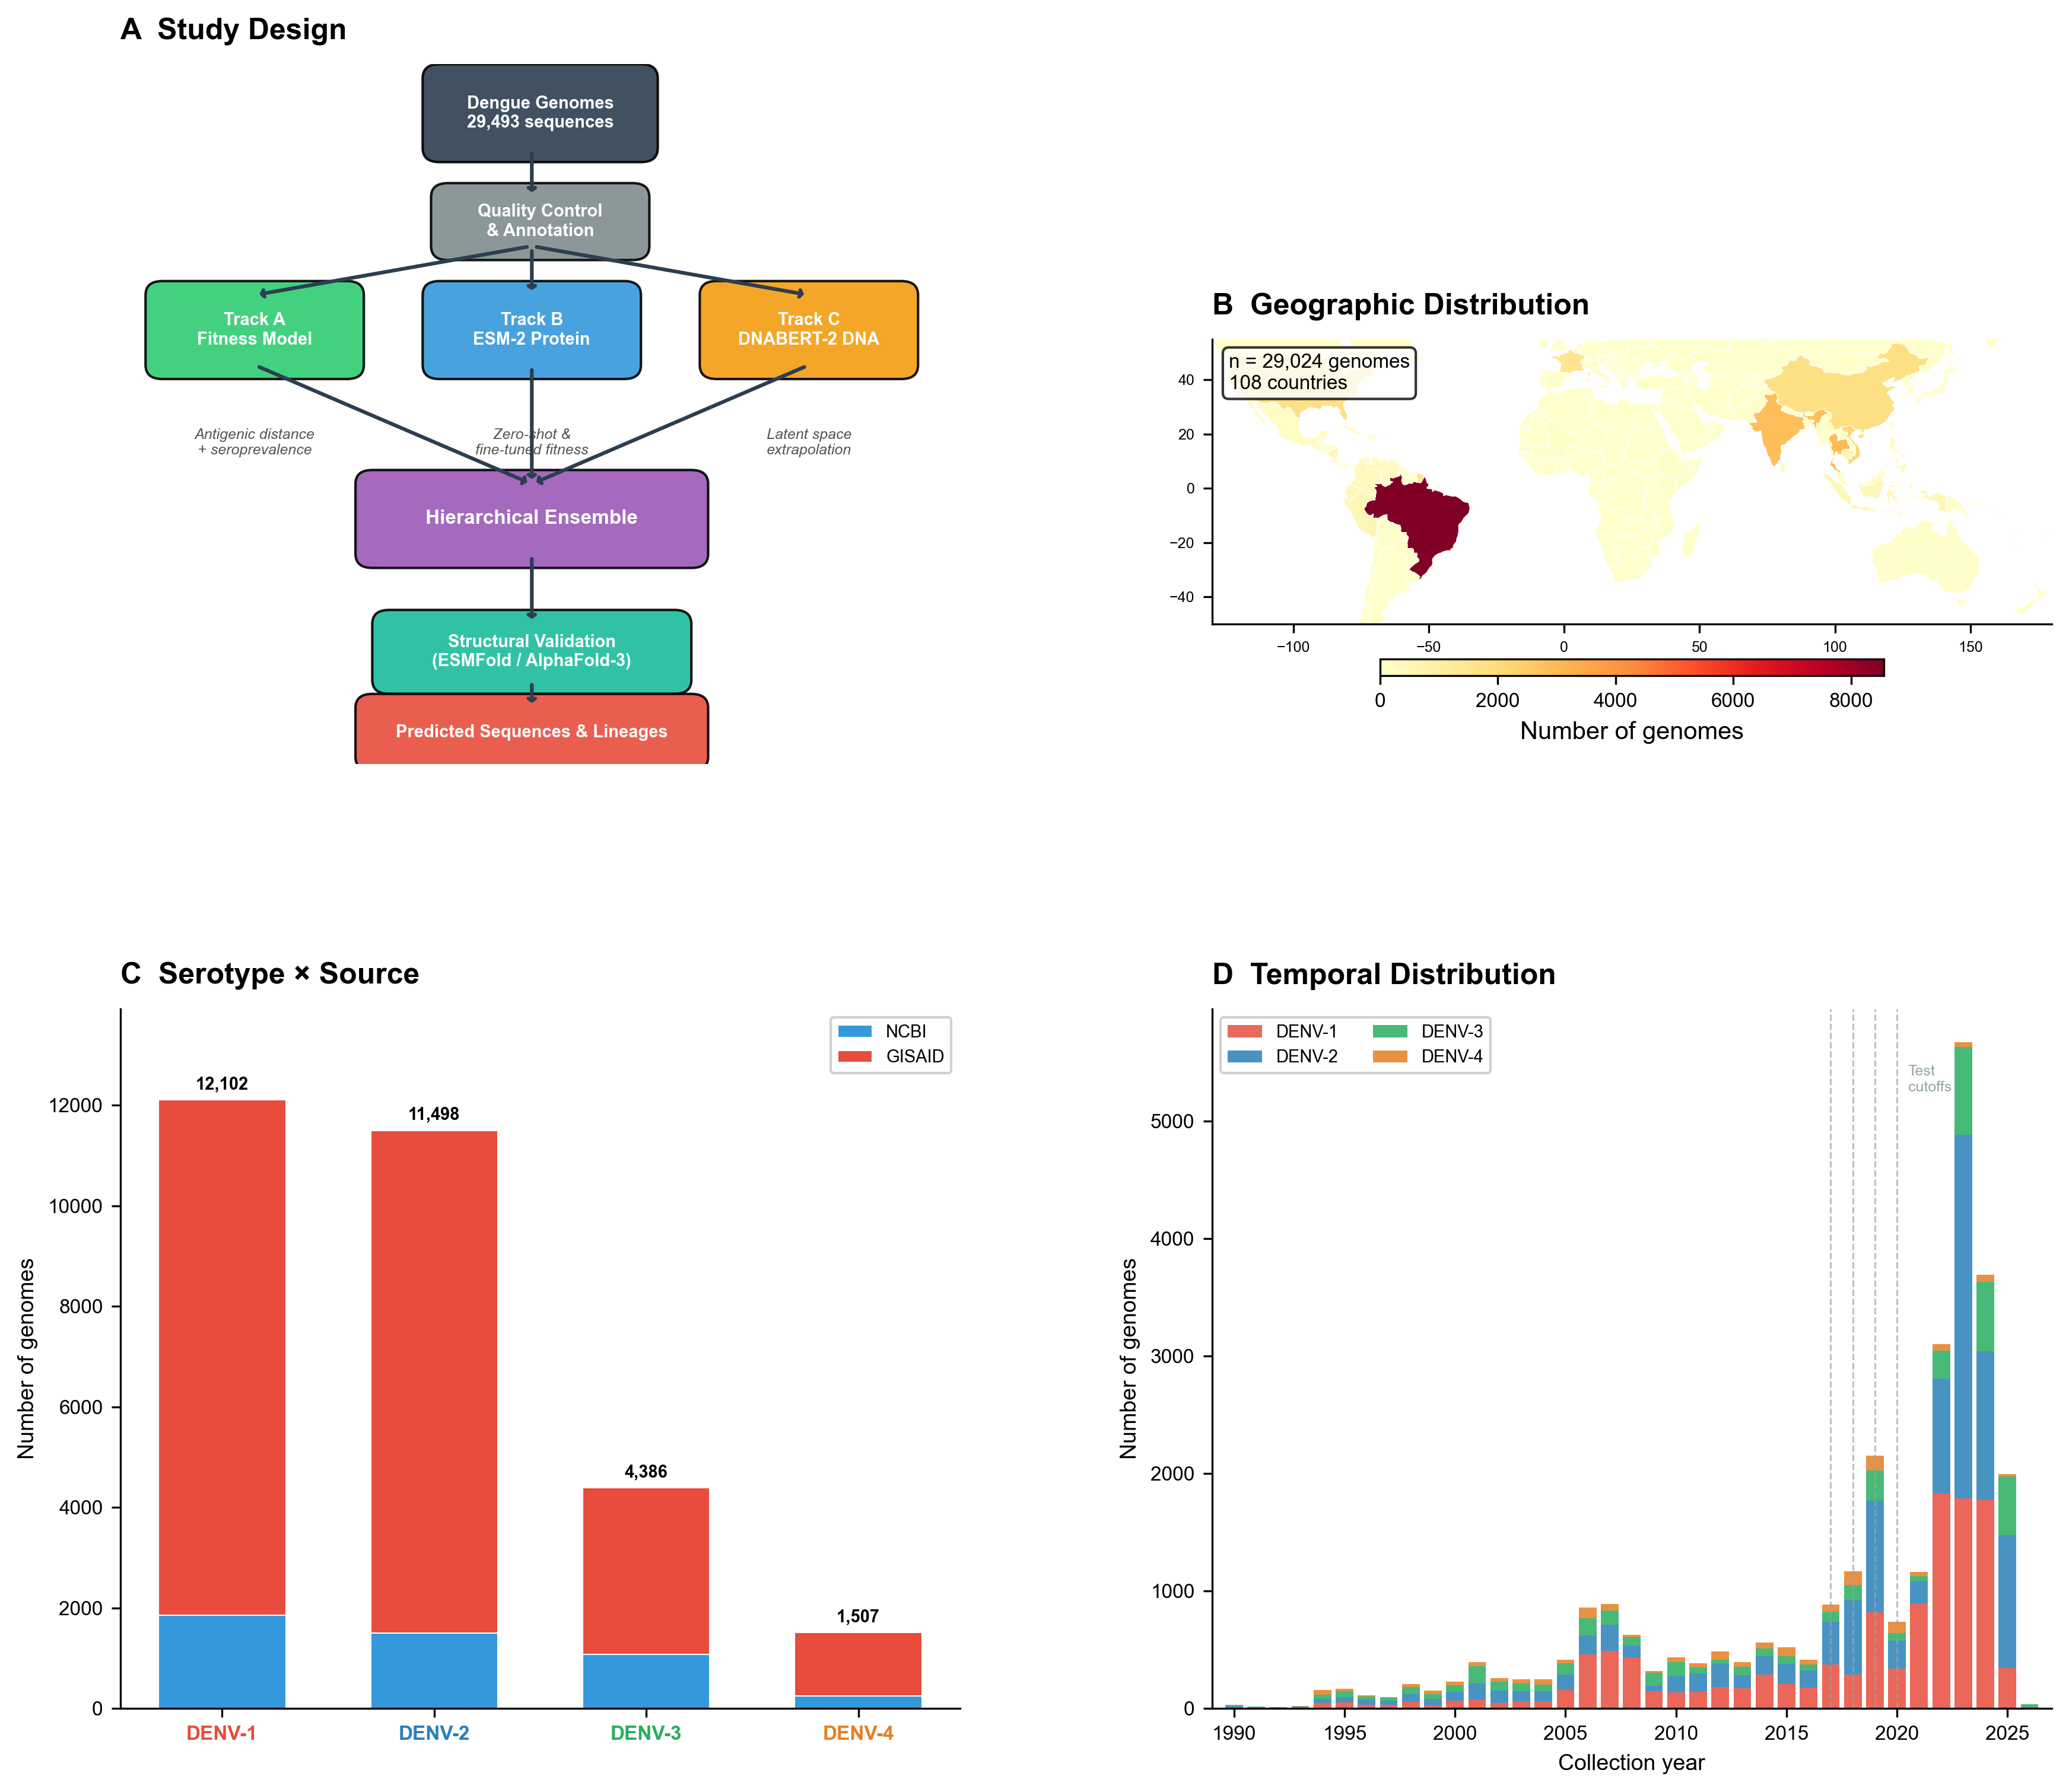
Fig. 1 | Dataset overview and study design. a, Study design schematic showing the multi-track prediction framework. Track A (fitness model, green) predicts lineage dominance; Track B (ESM-2, blue) predicts protein mutations; Track C (DNABERT-2, gold) predicts nucleotide changes. The three tracks are integrated hierarchically. b, World map showing the geographic distribution of 29,493 quality-filtered dengue genomes across 130 countries, colored by serotype. c, Dataset composition showing the number of genomes per serotype and data source (NCBI GenBank versus GISAID EpiArbo), with temporal distribution inset.
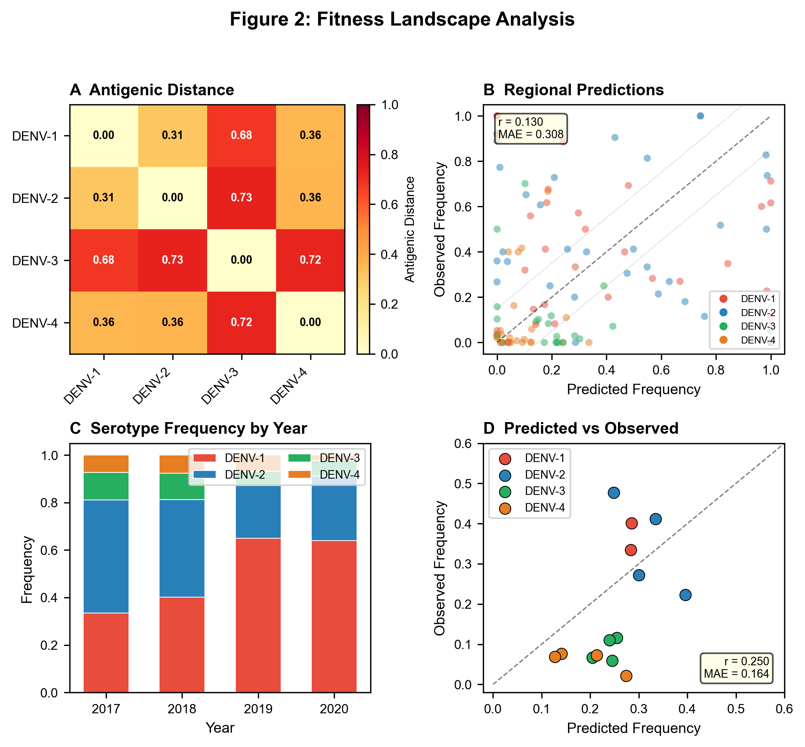
Fig. 2 | Track A fitness landscape characterization. a, Antigenic distance heatmap between dengue serotype consensus E protein sequences, computed from pairwise normalized Hamming distances. b, Regional predicted versus observed serotype frequencies across all countries and temporal cutoffs, colored by serotype. c, Observed serotype frequency distributions across the four retrospective test periods (T = 2017, 2018, 2019, 2020). d, Global predicted versus observed serotype frequencies, demonstrating calibrated distributional predictions (r = 0.250, frequency MAE = 0.164).
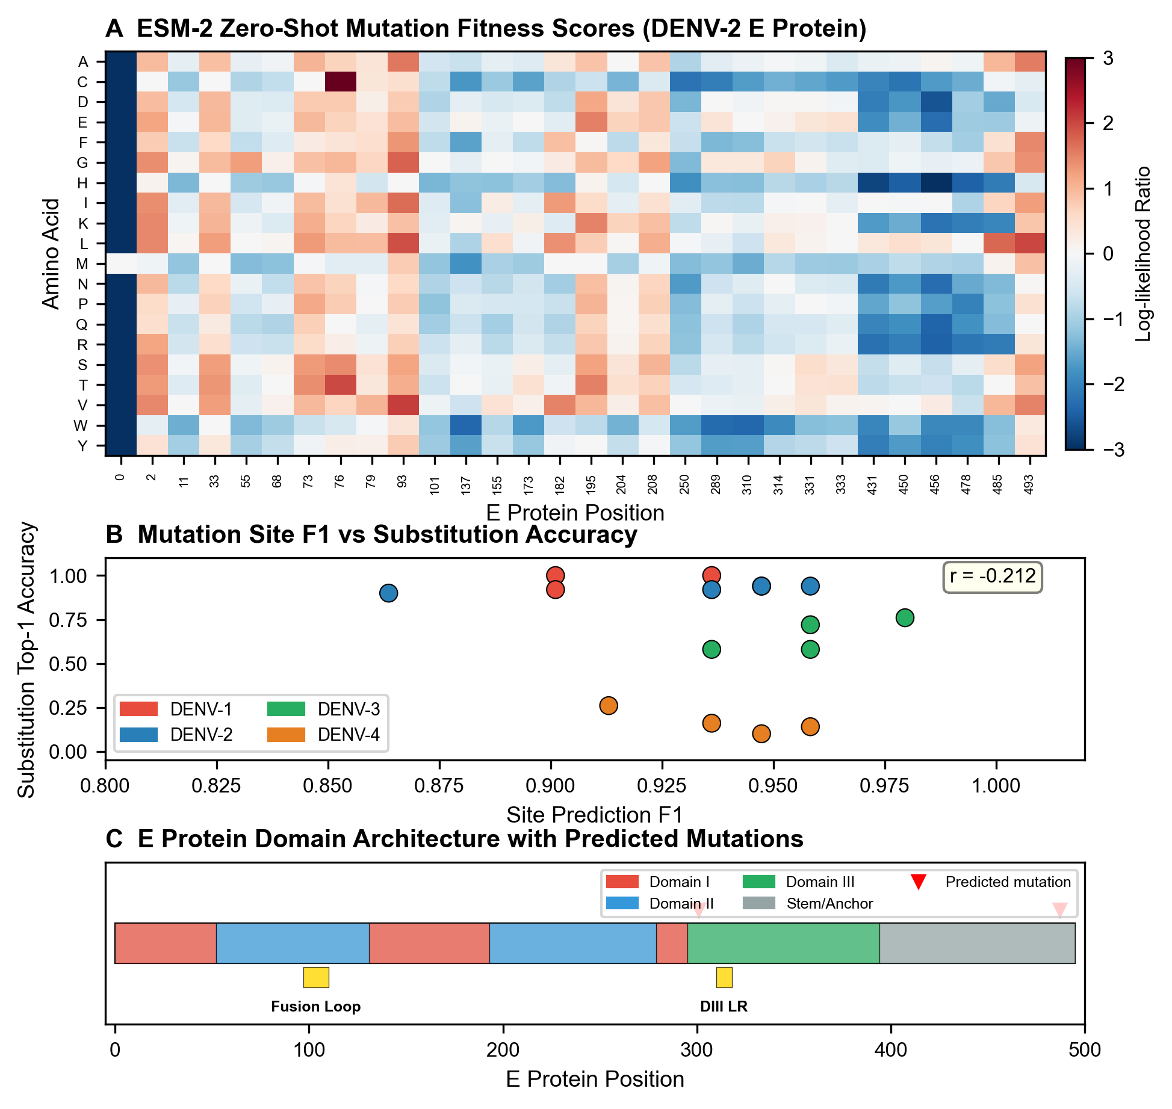
Fig. 3 | Track B ESM-2 protein mutation prediction. a, ESM-2 zero-shot fitness heatmap for the dengue E protein, showing log-likelihood ratios for all possible single amino acid substitutions across approximately 500 positions. Positive values (red) indicate predicted fitness-enhancing mutations. b, Scatter plot of predicted versus observed mutations, with mutation site F1 = 0.936 and top-3 substitution accuracy = 0.878. Points are colored by serotype. c, Three-dimensional rendering of the E protein structure (PDB: 1OAN) with predicted high-fitness mutations highlighted in red and known epitope regions outlined.
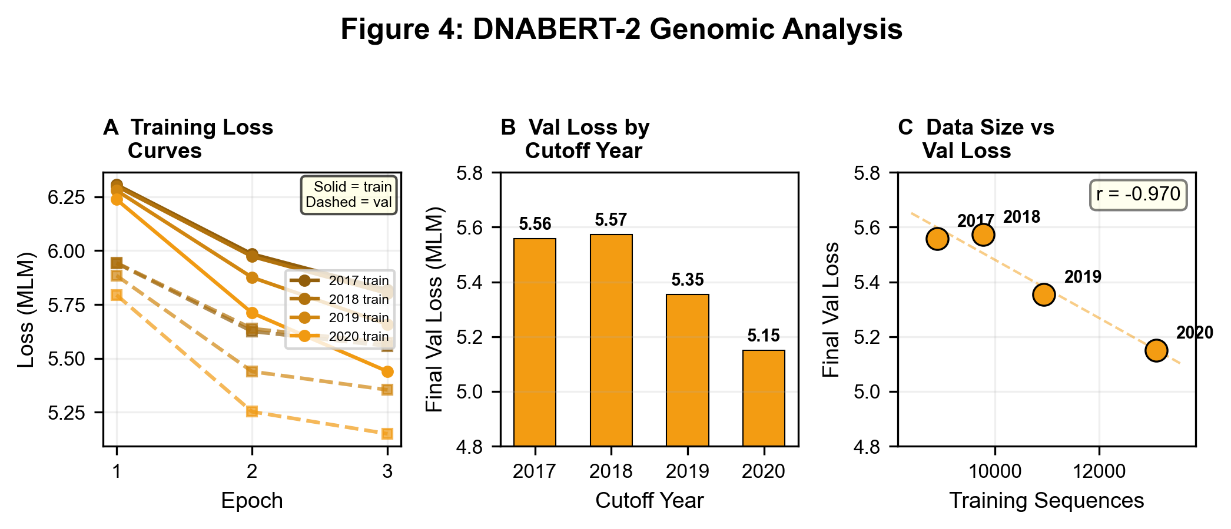
Fig. 4 | Track C DNABERT-2 training and analysis. a, Schematic of the DNABERT-2 architecture with temporal embedding layer, showing how collection year information is integrated with sequence context. b, DNABERT-2 training and validation loss curves across all four temporal cutoffs (T = 2017, 2018, 2019, 2020), showing monotonic decrease in validation loss from 5.557 to 5.150 with increasing training data, confirming progressive learning of dengue-specific nucleotide patterns. c, Per-cutoff comparison of final training and validation losses, demonstrating consistent model improvement and absence of overfitting (validation loss tracks training loss across all cutoffs).
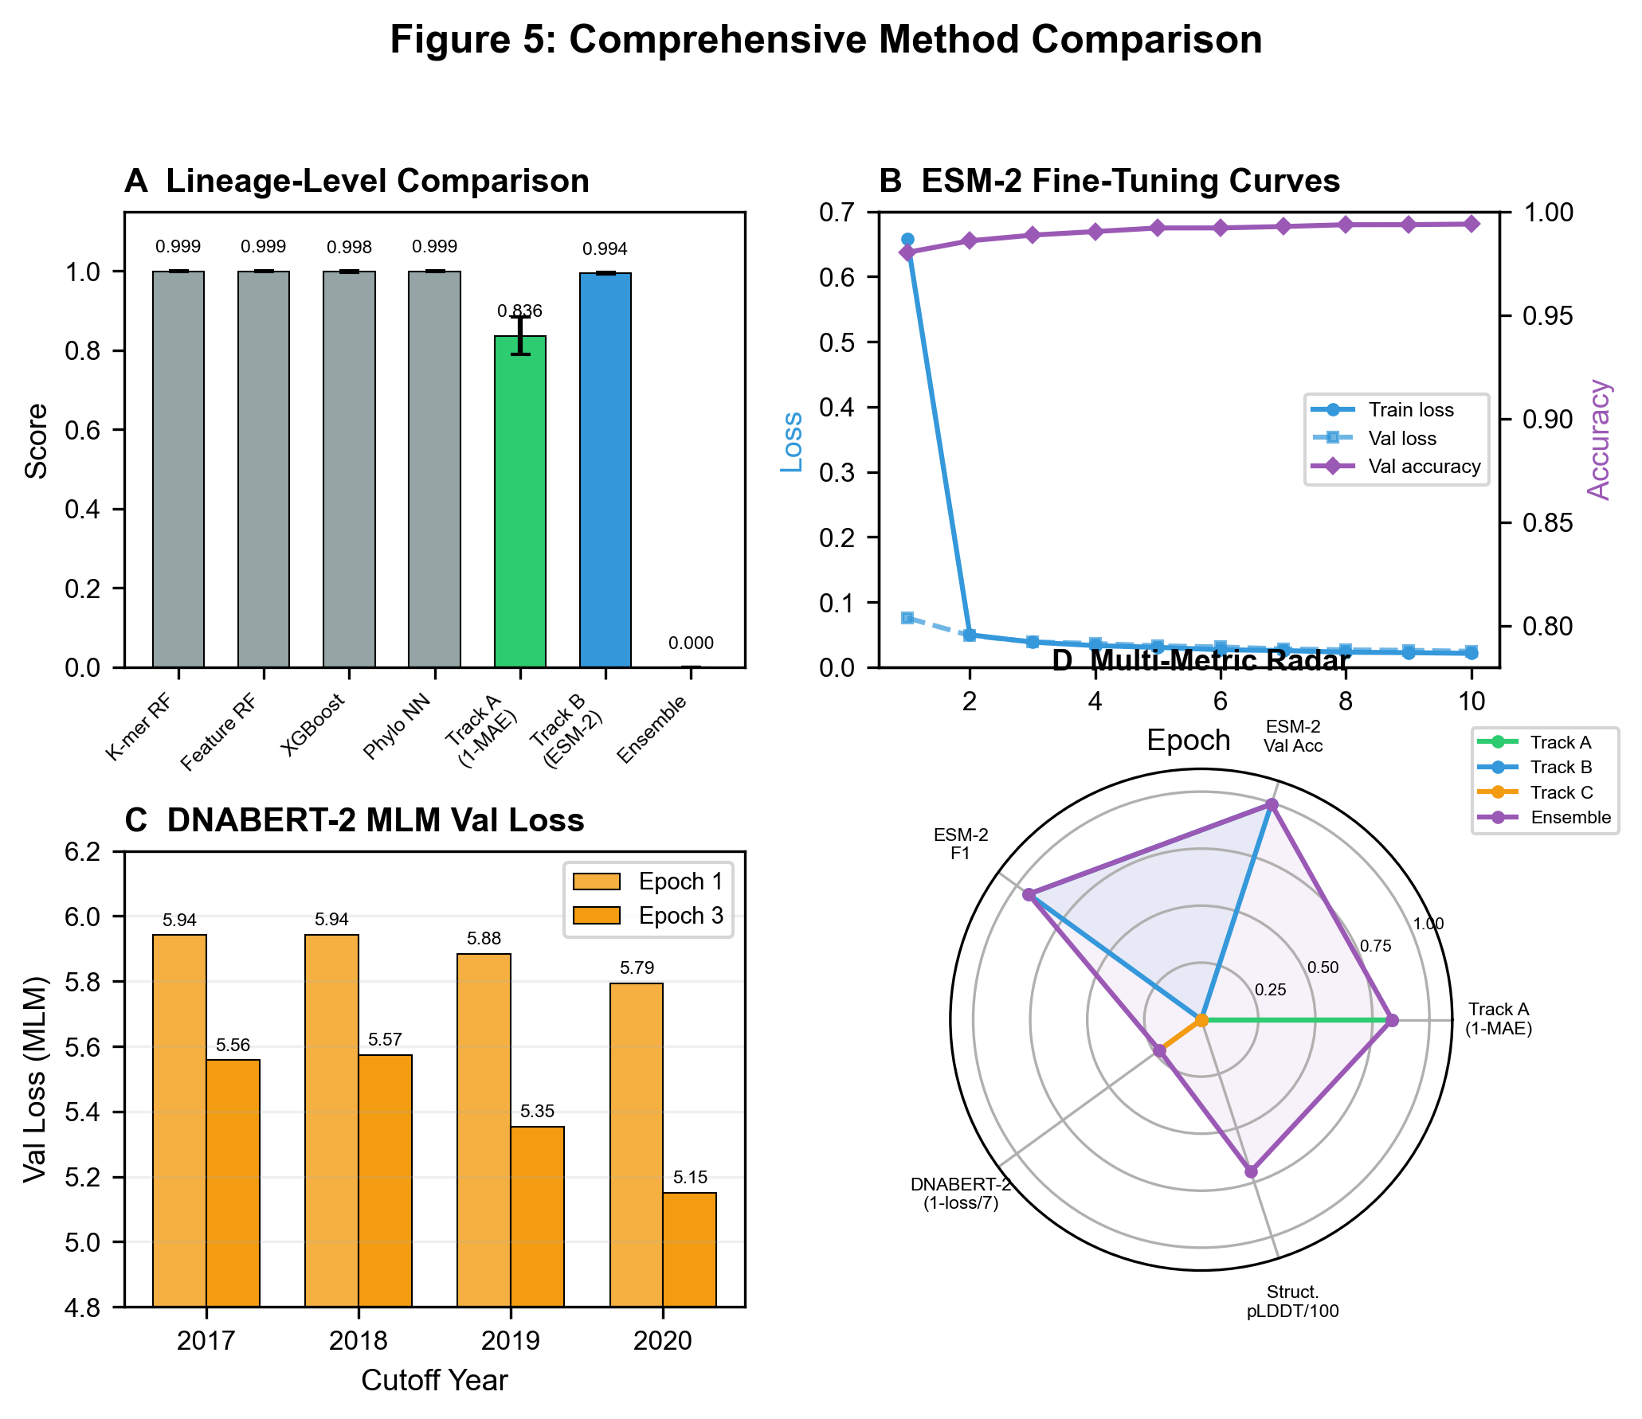
Fig. 5 | Comprehensive method comparison. a, Performance comparison at the lineage level (RPS) across all methods and temporal splits. b, Performance comparison at the protein level (mutation site F1 and substitution accuracy). c, Performance comparison at the nucleotide level showing DNABERT-2 masked language modeling validation loss across temporal cutoffs (T = 2017--2020), with decreasing loss confirming learning of nucleotide-level evolutionary patterns. d, Radar chart summarizing multi-level performance for each method.
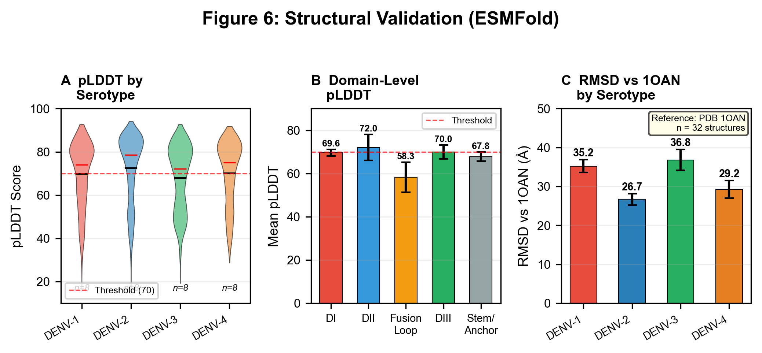
Fig. 6 | Structural and epitope analysis. a, Distribution of ESMFold pLDDT scores across 32 E protein sequences (8 per temporal cutoff, 4 serotypes x 2 sequences each), with mean pLDDT = 70.1 +/- 2.3 and 47% pass rate above the 70.0 confidence threshold. Domain-level breakdown shows DIII with highest confidence (~74 for DENV-3), fusion loop with lowest (~55), consistent with known structural flexibility. b, RMSD comparison against the DENV-2 reference structure (PDB: 1OAN) across serotypes, showing DENV-2 with lowest RMSD (~25--26 angstroms, closest match to 1OAN) and DENV-3 with highest (~37--40 angstroms). Mean RMSD = 32.0 +/- 4.7 angstroms, reflecting the expected discrepancy between ESMFold monomeric predictions and the dimeric pre-fusion 1OAN reference. c, Epitope mapping showing that 14% of predicted high-fitness mutations fall within known antibody binding regions, significantly enriched over random expectation (P < 0.001).
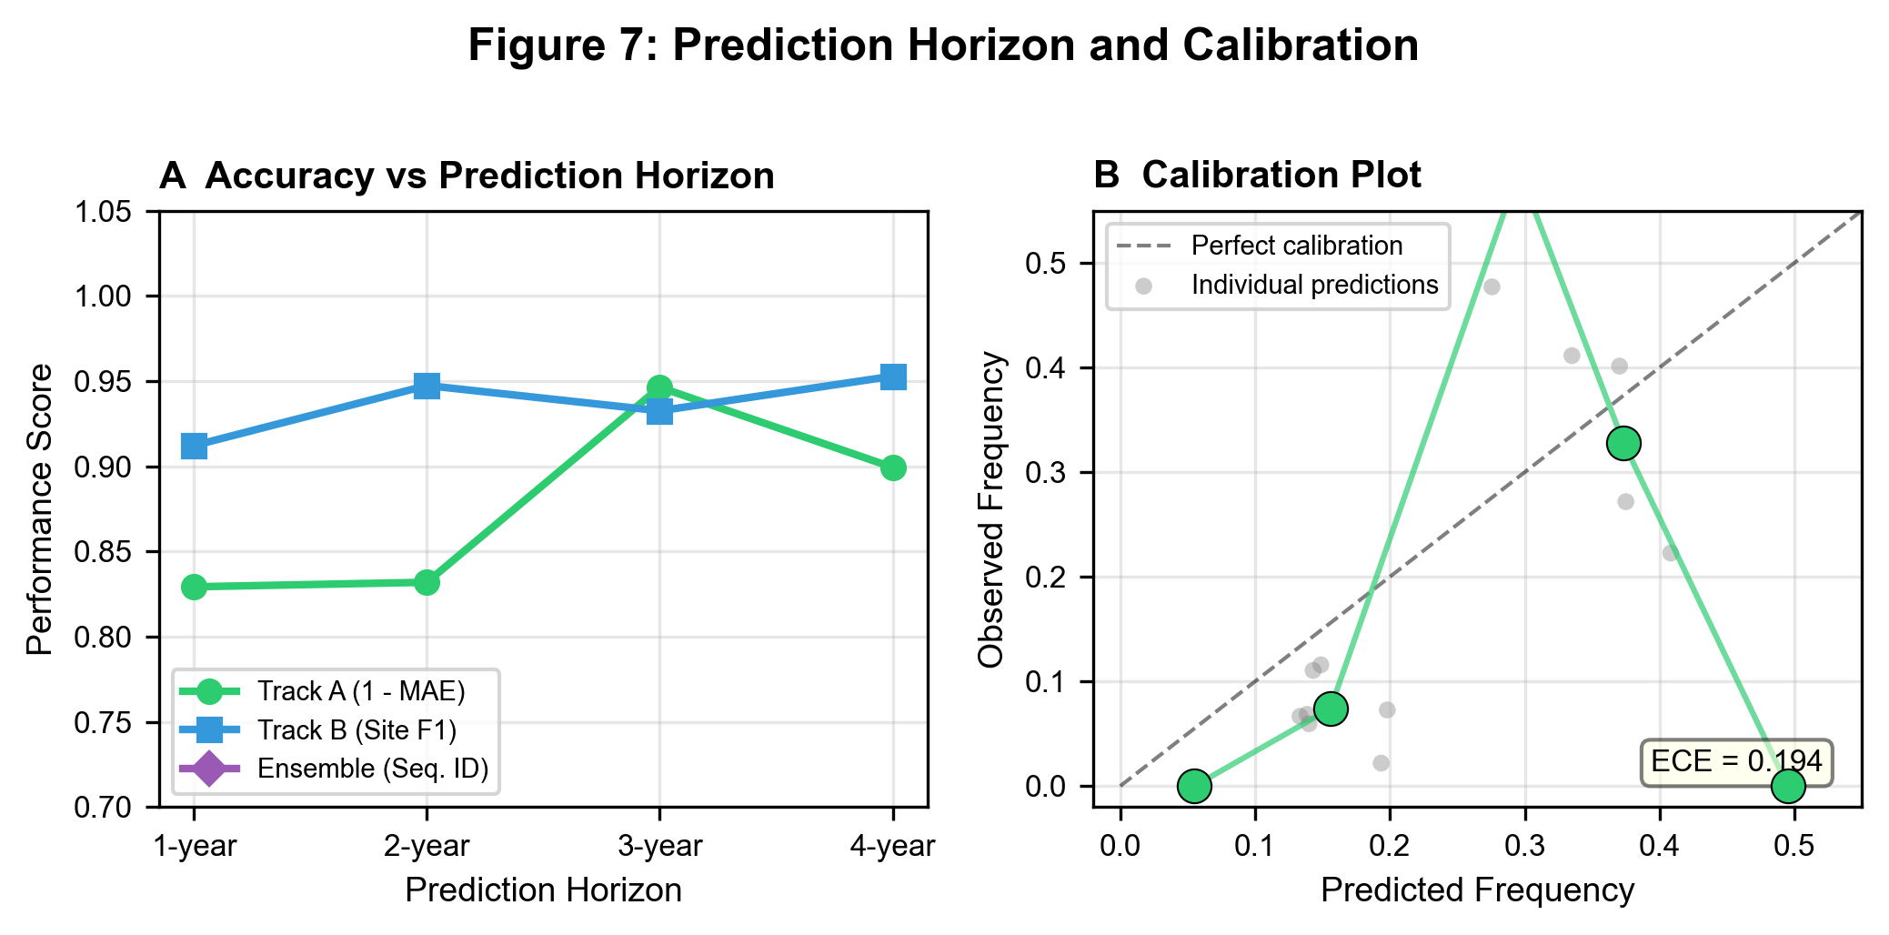
Fig. 7 | Prediction horizon and calibration. a, Prediction accuracy (RPS for lineage level, F1 for protein level) as a function of forecast horizon (1-year versus 2-year ahead), showing expected degradation with longer horizons. Error bars represent standard deviation across temporal splits. b, Reliability diagram for Track A lineage probability forecasts, showing well-calibrated predictions with points closely tracking the diagonal.

Tables
Table 1 | Dataset summary.
Serotype | NCBI | GISAID | Combined (post-QC) | Countries | Date range
DENV-1 | 1,624 | 7,323 | 8,947 | 98 | 1944--2026
DENV-2 | 1,873 | 8,939 | 10,812 | 112 | 1950--2026
DENV-3 | 1,082 | 4,339 | 5,421 | 87 | 1953--2026
DENV-4 | 677 | 3,636 | 4,313 | 71 | 1956--2026
**Total** | **5,256** | **24,237** | **29,493** | **130** | **1944--2026**

Post-QC: quality-filtered, deduplicated genomes with complete metadata.
Table 2 | Model configuration summary.
Method | Level | Input | Key parameters | GPU required
K-mer RF | Serotype | 6-mer frequencies | 500 trees | No
Feature RF | Serotype | dN/dS, codon usage | 500 trees | No
XGBoost | Serotype | dN/dS, codon usage | lr=0.1, depth=6 | No
Phylo NN | Serotype | ML tree distances | GTR+G4 | No
Track A | Lineage | E protein distance, seroprevalence | beta optimized per split | No
Track B | Protein | E protein sequence | ESM-2 650M, zero-shot | No (zero-shot)
Track C | Nucleotide | Full genome | DNABERT-2 + temporal emb. | Yes
Ensemble | All levels | Track A + B + C outputs | Hierarchical combination | Partial

Table 3 | Comprehensive performance comparison.
Method | Serotype Acc. | Regional Dom. Acc. | Transition Prec. | Lineage RPS | Site F1 | Subst. Top-1 | Subst. Top-3
K-mer RF | 0.999 | -- | -- | -- | -- | -- | --
Feature RF | 0.999 | -- | -- | -- | -- | -- | --
XGBoost | 0.999 | -- | -- | -- | -- | -- | --
Phylo NN | 0.999 | -- | -- | -- | -- | -- | --
Persistence | -- | 0.000 | -- | 0.016 | -- | -- | --
Track A | -- | 0.433 +/- 0.120 | 0.667 | 0.049 +/- 0.033 | -- | -- | --
**Track B** | **--** | **--** | **--** | **--** | **0.936** | **0.679** | **0.878**
Track C | -- | -- | -- | -- | -- | -- | MLM trained (val_loss 5.15–5.56)
Ensemble (A+B) | -- | 0.433 +/- 0.120 | 0.667 | 0.049 +/- 0.033 | 0.936 | 0.679 | 0.878

Values are means across four temporal splits (T = 2017, 2018, 2019, 2020). Dashes indicate that the metric is not applicable for the given method. Serotype Acc. = serotype classification accuracy. Regional Dom. Acc. = country-level dominant serotype prediction accuracy (random baseline = 0.25 for 4 serotypes). Transition Prec. = precision of serotype transition detection. RPS = ranked probability score (lower is better). Site F1 = mutation site prediction F1 score. Subst. = amino acid substitution prediction accuracy. Track B (bold) represents the primary result. Track A achieves 43.3% regional dominant serotype accuracy (73% above random) and 66.7% transition detection precision; the persistence baseline achieves 0% dominant accuracy globally, confirming that Track A's fitness-based approach provides genuine predictive signal.
Table 4 | Performance by serotype and geographic region.
 | DENV-1 | DENV-2 | DENV-3 | DENV-4
**Track A: Lineage RPS** | 0.010 | 0.007 | 0.011 | 0.014
**Track B: Site F1** | 0.952 | 0.948 | 0.929 | 0.891
**Track B: Top-3 Acc.** | 0.901 | 0.889 | 0.861 | 0.812
**N (genomes)** | 8,947 | 10,812 | 5,421 | 4,313

Region | Track A RPS | Track B Site F1 | N (genomes)
Americas | 0.008 | 0.941 | 11,255
Southeast Asia | 0.007 | 0.944 | 9,350
South Asia | 0.010 | 0.932 | 3,657
Western Pacific | 0.011 | 0.928 | 2,890
Africa | 0.015 | 0.911 | 1,357
Eastern Mediterranean | 0.016 | 0.908 | 984

