Deciphering the Host-Range Grammar of Orthoflaviviruses Using Foundation Model Embeddings: A Leakage-Aware Evaluation Framework
Brhanu F. Znabu^{1, 2}, Qiuming Yao^{1,4}, Nicole R. Sexton^{1, 3*}

¹Nebraska Center for Virology, University of Nebraska-Lincoln, Morrison Center, 4240 Fair Street, Lincoln, NE 68583-0900, USA.
²Biomedical Engineering Program, College of Engineering, University of Nebraska-Lincoln, Lincoln, NE 68588-0642, USA.
³School of Biological Sciences, University of Nebraska-Lincoln, 1104 T Street, Manter Hall, Lincoln, NE 68588-0118, USA.
⁴School of Computing, College of Engineering, University of Nebraska-Lincoln, Avery Hall, 1144 T Street, Lincoln, NE 68588-0115, USA.
ORCID: Brhanu F. Znabu, 0009-0009-7230-754X; Qiuming Yao, 0000-0001-9974-8788; Nicole R. Sexton, 0000-0002-5621-7618
Correspondence: Nicole R. Sexton, nicole.sexton@unl.edu
Abstract
Arboviruses within the Flaviviridae family and the Orthoflavivirus genus cause substantial global morbidity, yet insect-specific flaviviruses (ISFVs) within the same genus cannot infect vertebrates. Machine learning approaches to viral host prediction have been developed, but it remains untested whether previous models reflect true biological signal versus potential evaluation leakage from closely related genomes shared across training and test sets. Here we developed a leakage-aware evaluation framework and applied it to three feature representations (DNABERT-2 foundation model embeddings, k-mer TF-IDF, and nucleotide composition) to quantify the contribution of evaluation leakage in orthoflaviviruses, as observed in previous models. Complete genomes (n = 3,031; 2,816 arboviruses, 215 ISFVs) were segmented into overlapping 1-kb windows (n = 59,980) and classified under progressively stringent grouped cross-validation. All methods achieved high average precision (AP) under accession-grouped evaluation (AP = 0.981, 0.997, and 0.928, respectively) but showed consistent decline under species-grouped evaluation (AP = 0.819, 0.858, and 0.834), demonstrating that evaluation leakage inflates reported accuracy regardless of feature representation. After removing the evaluation leakage, embedding space analysis confirmed clear host-range structure (P < 0.001, permutation test). Genome-localized attribution, tracing model predictions to specific genomic positions, revealed discriminative signal preferentially localized to the nonstructural replication region (NS3–NS5; 65% of arbovirus genomes versus 47% in other regions). Of the top 10 enriched 6-mer motifs, 6 contained UpA dinucleotides, consistent with known dinucleotide-mediated host restriction pathways. While CpG-associated effects have been reported previously, CpG-containing motifs were not among the top discriminative features in our analysis. Our leakage-aware framework establishes methodological best practices for evaluating viral host predictors and identifies candidate sequence grammar elements that generate testable hypotheses for experimental validation of orthoflavivirus host-range determinants.
Keywords: orthoflavivirus; insect-specific flavivirus; host range; machine learning; DNABERT-2; evaluation leakage; dinucleotide; viral emergence

Introduction
Arthropod-borne viruses (arboviruses) within the genus Orthoflavivirus (family Flaviviridae) represent a persistent and expanding threat to global public health. Dengue virus alone causes an estimated 390 million infections annually¹, while Zika, West Nile, yellow fever, and Japanese encephalitis viruses collectively account for substantial morbidity and mortality across tropical and temperate regions worldwide^{2,3}. Arboviruses in the Orthoflavivirus genus share a defining biological characteristic: the capacity to replicate in both arthropod vectors (primarily mosquitoes and ticks) and vertebrate hosts, performing a transmission cycle that facilitates epidemic spread. The orthoflavivirus genome is organized as a single open reading frame encoding structural (C-prM-E) and non-structural (NS1-NS2A-NS2B-NS3-NS4A-NS4B-NS5) proteins flanked by untranslated regions, a configuration conserved across this diverse family^{4,5}. In contrast, insect-specific flaviviruses (ISFVs) within this genus are phylogenetically interspersed among arboviruses yet remain restricted to arthropod hosts, unable to establish productive infection in vertebrate cells⁶. The discovery of ISFVs has accelerated over the past two decades, revealing heightened diversity within the genus and raising fundamental questions about the evolutionary transitions underlying host-range determination^{7,8}.
What genomic features enable arboviruses to infect vertebrates while ISFVs remain restricted? This question lies at the heart of viral emergence research. Understanding the molecular determinants of host switching could inform surveillance priorities and risk assessment for novel viruses. Some mechanisms are known to contribute to vertebrate restriction. Vertebrate cells deploy innate immune sensors that recognize specific dinucleotide patterns in viral RNA: the zinc-finger antiviral protein (ZAP) binds viral RNA with elevated CpG and UpA dinucleotide frequencies⁹⁻¹³, while the 2′-5′-oligoadenylate synthetase 3 (OAS3)/RNaseL pathway mediates complementary restriction of viruses with elevated CpG or UpA content^{9,14,15}. These pathways exhibit synergy or complementation rather than acting independently⁹, although the precise mechanism of dinucleotide-mediated attenuation remains to be definitively established⁹. Comparative genomic analyses have revealed that vertebrate-infecting viruses exhibit genome-wide suppression of these targeted dinucleotides relative to their invertebrate-restricted relatives^{14,16-19}, and Sexton and Ebel²⁰ demonstrated that arbovirus dinucleotide composition is dominated by evolutionary pressure from the vertebrate host. Individual effects of CpG and UpA frequencies on viral replication have been documented^{14-17,20,21}, although their combined contributions and the precise mechanisms underlying dinucleotide-mediated attenuation remain incompletely understood. However, the relative contributions of these pathways and whether other sequence-based determinants contribute remains unknown. Whether specific sequence motifs, their genomic localization, or higher-order sequence contexts distinguish arboviruses from ISFVs remains an open question.
Machine learning approaches offer a general avenue for identifying genomic signatures associated with host range because they can capture higher-order sequence patterns (positional dependencies and combinatorial motif contexts) that frequency-based methods cannot detect. Deep learning models trained on viral sequences have reported high classification accuracy across several viral sequence-classification tasks, including host prediction^{22,23} and related viral classification problems^{24,25}; however, these models are generally effective but it remains untested how well they generalize to closely related genomes where predictions may be biased. The emergence of pre-trained nucleotide foundation models enables extraction of contextual genomic patterns without task-specific training²⁶⁻²⁹, raising a potential evaluation concern. We define evaluation leakage as the inflation of performance metrics that occurs when phylogenetically related viral genomes appear in both training and test sets, an inherent feature of clustered viral sequence databases, enabling the model to recognize lineage-specific signatures rather than generalizable host-range determinants. Such inflation can be artificially large when closely related sequences span the train-test boundary. Liu et al.³⁰ and Perelygin et al.³¹ have shown the impact of taxonomic structure on host prediction accuracy, and broader concerns about leakage in machine learning-based science have been raised³², but the magnitude of performance inflation due to evaluation leakage in viral host prediction has not been practically reported, let alone across different feature representations.
To address these limitations, we developed an end-to-end computational framework for identifying host-range grammar in orthoflavivirus genomes, the evolved sequence patterns that distinguish vertebrate-infecting from insect-restricted lineages, reflecting the outcome of historical host-range transitions rather than an ongoing dynamic process. Unlike existing black-box approaches that provide genome-level predictions without interpretable outputs, our framework produces localized sequence signatures that can guide mechanistic follow-up and generate testable biological hypotheses. Our approach applies three feature representations (DNABERT-2 foundation model embeddings²⁷, k-mer TF-IDF, and nucleotide composition) to assess whether evaluation leakage is specific to learned representations or a general phenomenon. A logistic regression classifier trained on frozen embeddings enables genome-localized attribution, mapping discriminative signal to specific genomic coordinates. We implemented a taxonomy-based grouped cross-validation framework with progressively stringent constraints, from accession-grouped to species-grouped evaluation, to quantify the contribution of phylogenetic leakage to performance estimates. Performance was assessed using Average Precision (AP) and Precision-Recall Curve (PRC), metrics that summarize classifier performance under the class imbalance characteristic of viral genomics datasets³³.
This study addresses three questions. First, how much does evaluation leakage inflate reported host-prediction accuracy, and is this inflation specific to foundation model embeddings or shared across feature representations? Second, where in the genome does the discriminative signal concentrate, and does it correspond to functionally constrained regions? Third, what specific sequence motifs distinguish arboviruses from ISFVs, and are they consistent with known vertebrate host restriction mechanisms?
Here, we present the first systematic evaluation of foundation model-based host prediction under leakage-aware constraints, demonstrating a 16-percentage-point performance reduction when phylogenetic leakage is controlled. We identify positional hotspots in the NS3–NS5 region that distinguish arboviruses from ISFVs and reveal an enrichment of UpA-containing motifs among arbovirus-associated sequences. These findings establish methodological best practices for the viral machine learning community and provide interpretable sequence signatures that generate testable hypotheses for experimental validation of host-range determinants in orthoflaviviruses.

Materials and Methods
Dataset construction and curation
Complete orthoflavivirus genomes were retrieved from NCBI Virus (https://www.ncbi.nlm.nih.gov/labs/virus/) and GenBank in January 2026. Arboviruses (ARB) were identified by filtering for Flaviviridae genomes with documented vertebrate hosts (taxid: 7742), while insect-specific flaviviruses (ISFV) were curated from published systematic reviews⁶ and verified through manual inspection of host range annotations. Quality control filters retained genomes meeting the following criteria: (i) complete genome length within the expected orthoflavivirus range (9,000–12,000 nt)⁴, (ii) ambiguous base content <1%, and (iii) no exact sequence duplicates as determined by MD5 hash comparison.
The final curated dataset comprised 3,031 complete genomes: 2,816 ARB genomes representing 23 species and 215 ISFV genomes representing 22 species. Genome lengths ranged from 9,210 to 11,723 nucleotides (mean ± SD: 10,674.3 ± 267.7 nt). All genomes belonged to the genus Orthoflavivirus. Each genome was annotated with accession number, species designation, genus classification, and binary host-range label (ARB or ISFV). The complete metadata, including taxonomy identifiers, are provided in Supplementary Table S1.
Windowed embedding strategy
To enable genome-localized attribution while maintaining computational tractability, each genome was segmented into overlapping windows of 1,000 nucleotides with a stride of 500 nucleotides (50% overlap). This windowing scheme yielded 59,980 total windows (55,735 ARB; 4,245 ISFV), with individual genomes producing 15–22 windows depending on genome length (mean: 19.8 windows per genome). Each window inherited the host-range label and taxonomic annotations of its parent genome.
Windows were embedded using DNABERT-2, a pre-trained nucleotide foundation model based on the BERT architecture with byte-pair encoding tokenization²⁷. The model (zhihan1996/DNABERT-2-117M) was loaded with frozen weights from the Hugging Face repository. For each window sequence, tokenized inputs were passed through the model, and the final hidden states were mean-pooled across the sequence dimension to produce a 768-dimensional embedding vector. All embeddings were computed using PyTorch 2.1 on NVIDIA V100 GPUs.
Lineage-aware evaluation framework
A critical methodological concern in viral host prediction is evaluation leakage, wherein closely related sequences appearing in both training and test sets inflate performance estimates beyond what would generalize to novel lineages^{30,32,34}. To quantify the magnitude of this effect and establish leakage-resistant performance benchmarks, we implemented a hierarchical grouped cross-validation framework with three evaluation levels of increasing stringency: (i) standard stratified cross-validation with random window assignment (Random CV), which establishes an upper bound on performance; (ii) accession-grouped cross-validation, in which all windows from a single genome are confined to one fold; and (iii) species-grouped cross-validation, in which all genomes of a given species are confined to one fold. Throughout this study, classification was performed using a logistic regression classifier trained on frozen DNABERT-2 embeddings; the deliberate simplicity of the classifier ensures that discriminative capacity is attributable to the sequence representations rather than classifier complexity.
In accession-grouped cross-validation, all windows derived from a single genome were constrained to appear exclusively in either the training or test fold, preventing within-genome information leakage. Because genomes are segmented into overlapping windows (50% overlap), a single genome contributes multiple windows that share substantial sequence content; accession-grouped grouping ensures that these correlated windows never span the train-test boundary, even though different genomes from the same species may still appear in different folds. A genus-level grouping was not implemented as a separate evaluation tier because all genomes in this study belong to a single genus (Orthoflavivirus), leaving no independent genus-level groups for cross-validation; ungrouped random cross-validation is included separately as the upper-bound baseline. In species-grouped cross-validation, all genomes belonging to the same viral species were assigned to the same fold, providing a more stringent test of generalization to phylogenetically distinct lineages³⁴. Genomes labeled Unknown flavivirus, an unclassified placeholder taxon, were treated as a single species group spanning both host-range classes; excluding this group did not materially change species-grouped performance (AP = 0.818 versus 0.819). Both schemes employed 5-fold grouped cross-validation using scikit-learn's GroupKFold implementation.
A logistic regression classifier (with balanced class weights, maximum 1,000 iterations) was trained on the frozen DNABERT-2 embeddings. Performance was primarily evaluated using Average Precision (AP), the area under the Precision-Recall Curve (PRC), a standard metric that summarizes classifier performance as the weighted mean of precisions achieved at each recall threshold, providing a single value between 0 and 1. AP was emphasized given the class imbalance (93% ARB, 7% ISFV), as it is more informative than alternative summary statistics when the class of interest is rare³³. The minority class (ISFV) was designated as the positive class for precision-recall analysis, following recommendations by Saito and Rehmsmeier³³. All metrics are reported as mean ± standard deviation across the five cross-validation folds.
k-mer TF-IDF baseline
To assess whether evaluation leakage is specific to learned representations or affects all feature types, two interpretable baseline feature representations were evaluated under identical grouped cross-validation protocols. The k-mer TF-IDF baseline represented each window as a term frequency–inverse document frequency vector over all 6-mer subsequences, computed using scikit-learn’s TfidfVectorizer³⁵.
Composition-based baseline
The composition-only baseline comprised 17 features: GC content and the 16 dinucleotide frequencies. As a negative control, we additionally evaluated a position-only baseline that used each window’s relative genomic coordinate (0–1) as its sole feature, providing a reference for the average precision expected in the absence of any sequence information. Both baselines were evaluated using the same logistic regression classifier and cross-validation schemes as the primary analysis, enabling direct comparison of how evaluation leakage affects each feature representation. To characterize which composition features carry host-range signal, we computed the effect size (Cohen’s d) and rank-based separation (AUC) of each of the 17 composition features (GC content and 16 dinucleotide frequencies) between arbovirus and insect-specific windows (Supplementary Figure S1, Supplementary Table S2).
Embedding space visualization and cluster analysis
To assess the global organization of the embedding space, genome-level representations were computed by averaging all window embeddings belonging to each genome. Dimensionality reduction was performed using two complementary methods: Uniform Manifold Approximation and Projection (UMAP; n_neighbors=15, min_dist=0.1) and t-distributed Stochastic Neighbor Embedding (t-SNE; perplexity=30). Both algorithms were initialized with random_state=42 for reproducibility.
Cluster quality was quantified using k-nearest neighbors (kNN) purity with k=15. For each genome, purity was defined as the fraction of its 15 nearest neighbors sharing the same host-range label. Statistical significance was assessed via permutation testing: labels were randomly shuffled 1,000 times, and the null distribution of expected purity under random labeling was computed. The observed purity was compared to this null using a Z-score and empirical p-value. Cluster compactness was additionally assessed using the silhouette score computed over all genome-level embeddings.
Genome-localized attribution
Out-of-fold prediction probabilities from accession-grouped cross-validation were mapped back to genome coordinates to identify regions with discriminative signal. Each window was assigned a relative genomic position (0.0–1.0) calculated as the window start position divided by genome length. Positions were then discretized into 20 equal-width bins (bin width = 0.05 genome fraction).
Positional enrichment of high-confidence predictions was quantified as follows. Within each host-range class, windows were ranked by the predicted probability of their own class (P(ARB) for ARB genomes, P(ISFV) for ISFV genomes), and those in the top 10th percentile were designated as top-scoring windows. For each positional bin and host-range class, enrichment was computed as the ratio of the observed fraction of top-scoring windows to the expected fraction under uniform distribution. Values greater than 1.0 indicate positional enrichment. Analyses were stratified by true label (ARB vs. ISFV) to identify class-specific positional signatures.
Discriminative motif identification
To extract interpretable sequence features underlying the classifier's predictions, we performed comparative 6-mer enrichment analysis between extreme prediction strata. Windows were stratified by P(ARB) score into a high-confidence stratum (top 5% by P(ARB)) and a low-confidence stratum (bottom 5%). For each of the 4,096 possible 6-mer sequences, prevalence was computed as the fraction of windows in each stratum containing at least one occurrence of the motif. Enrichment was quantified as the log2 ratio of prevalence in the high-confidence versus low-confidence stratum. Motifs with bottom-stratum prevalence below 0.1% were excluded to avoid division instability, retaining 4,095 6-mers for analysis. This analysis was designed to identify motifs enriched in high-confidence ARB predictions, because the central biological question concerns what enables vertebrate host competence. A complementary analysis of ISFV-enriched motifs (i.e., motifs over-represented in high-confidence ISFV predictions) was also examined but yielded motifs that largely mirrored the inverse of the ARB-enriched set without revealing additional mechanistic candidates; we therefore focus on ARB-enriched motifs throughout.
For the top 10 enriched motifs, additional characterization included: (i) conservation fraction, computed as the proportion of genomes within each host-range class containing at least one instance of the motif; (ii) positional localization profile, indicating the genomic bin with maximum motif frequency; and (iii) biological annotation based on known host restriction mechanisms, including CpG dinucleotide content (associated with ZAP and OAS3/RNaseL-mediated restriction⁹⁻¹²), UpA dinucleotide content (also associated with ZAP binding and OAS3/RNaseL-mediated restriction^{9,20}), and purine/pyrimidine bias.
Ablation and robustness analyses
To assess the contribution of specific genomic regions and sequence features to classification performance, we conducted a series of ablation experiments. In window masking ablations, genome-level embeddings were recomputed after excluding specific window subsets: (i) the top 5% highest-scoring windows per genome, (ii) a random 5% of windows per genome, and (iii) all windows containing the top-enriched motif (AUUAGG). Classification performance was re-evaluated under each masking condition to quantify the contribution of masked regions.
To compare the predictive utility of learned embeddings versus transparent sequence features, we implemented a motif-based scoring approach. Each window was assigned a score equal to the sum of log2 enrichment weights for all enriched 6-mers present in its sequence (using the top 50 motifs). This interpretable score was evaluated under the same species-grouped cross-validation protocol for direct comparison with DNABERT-2 embeddings.
Sensitivity of positional enrichment results to analytical parameters was assessed by recomputing hotspot profiles at three bin resolutions (10, 20, and 40 bins) and evaluating profile stability via pairwise Spearman correlation.
All statistical analyses were performed in Python 3.11 using NumPy 1.26, SciPy 1.11, and scikit-learn 1.4. Precision-recall analysis followed established recommendations for imbalanced classification³³. Random seeds were fixed at 42 for all stochastic operations to ensure reproducibility. Permutation-based significance testing used 1,000 iterations unless otherwise specified. Effect sizes are reported with 95% confidence intervals where applicable.

Results
Dataset curation and evaluation framework
We assembled a curated dataset of orthoflavivirus complete genomes to investigate sequence determinants of vertebrate host competence. After quality filtering, the final dataset comprised 3,031 genomes: 2,816 arboviruses (ARB) capable of infecting both arthropod vectors and vertebrate hosts, and 215 insect-specific flaviviruses (ISFV) restricted to arthropod hosts (Figure 1A). The dataset spanned 23 ARB and 22 ISFV species (44 distinct, because genomes labeled Unknown flavivirus appear in both classes), providing taxonomic breadth for evaluating cross-species generalization.
Genome lengths were consistent across host-range classes (ARB: 10,677.1 ± 263.0 nt; ISFV: 10,638.0 ± 322.2 nt; Figure 1C), indicating that length alone does not distinguish the two groups. The class imbalance (93% ARB, 7% ISFV; 13.1:1 ARB:ISFV ratio; Figure 1D) reflects the uneven sampling of orthoflavivirus diversity in public databases and necessitates evaluation metrics suited to imbalanced settings. We used Average Precision (AP), a summary of the precision-recall curve, as recommended for imbalanced classification³³.
To enable genome-localized attribution, each genome was segmented into 1,000-nt overlapping windows (500-nt stride), yielding 59,980 windows for downstream analysis. The hierarchical evaluation framework (Figure 1B) was designed to quantify the inflation of performance estimates due to phylogenetic leakage, progressing from accession-grouped (within-genome leakage prevented) to species-grouped (within-species leakage prevented) cross-validation.
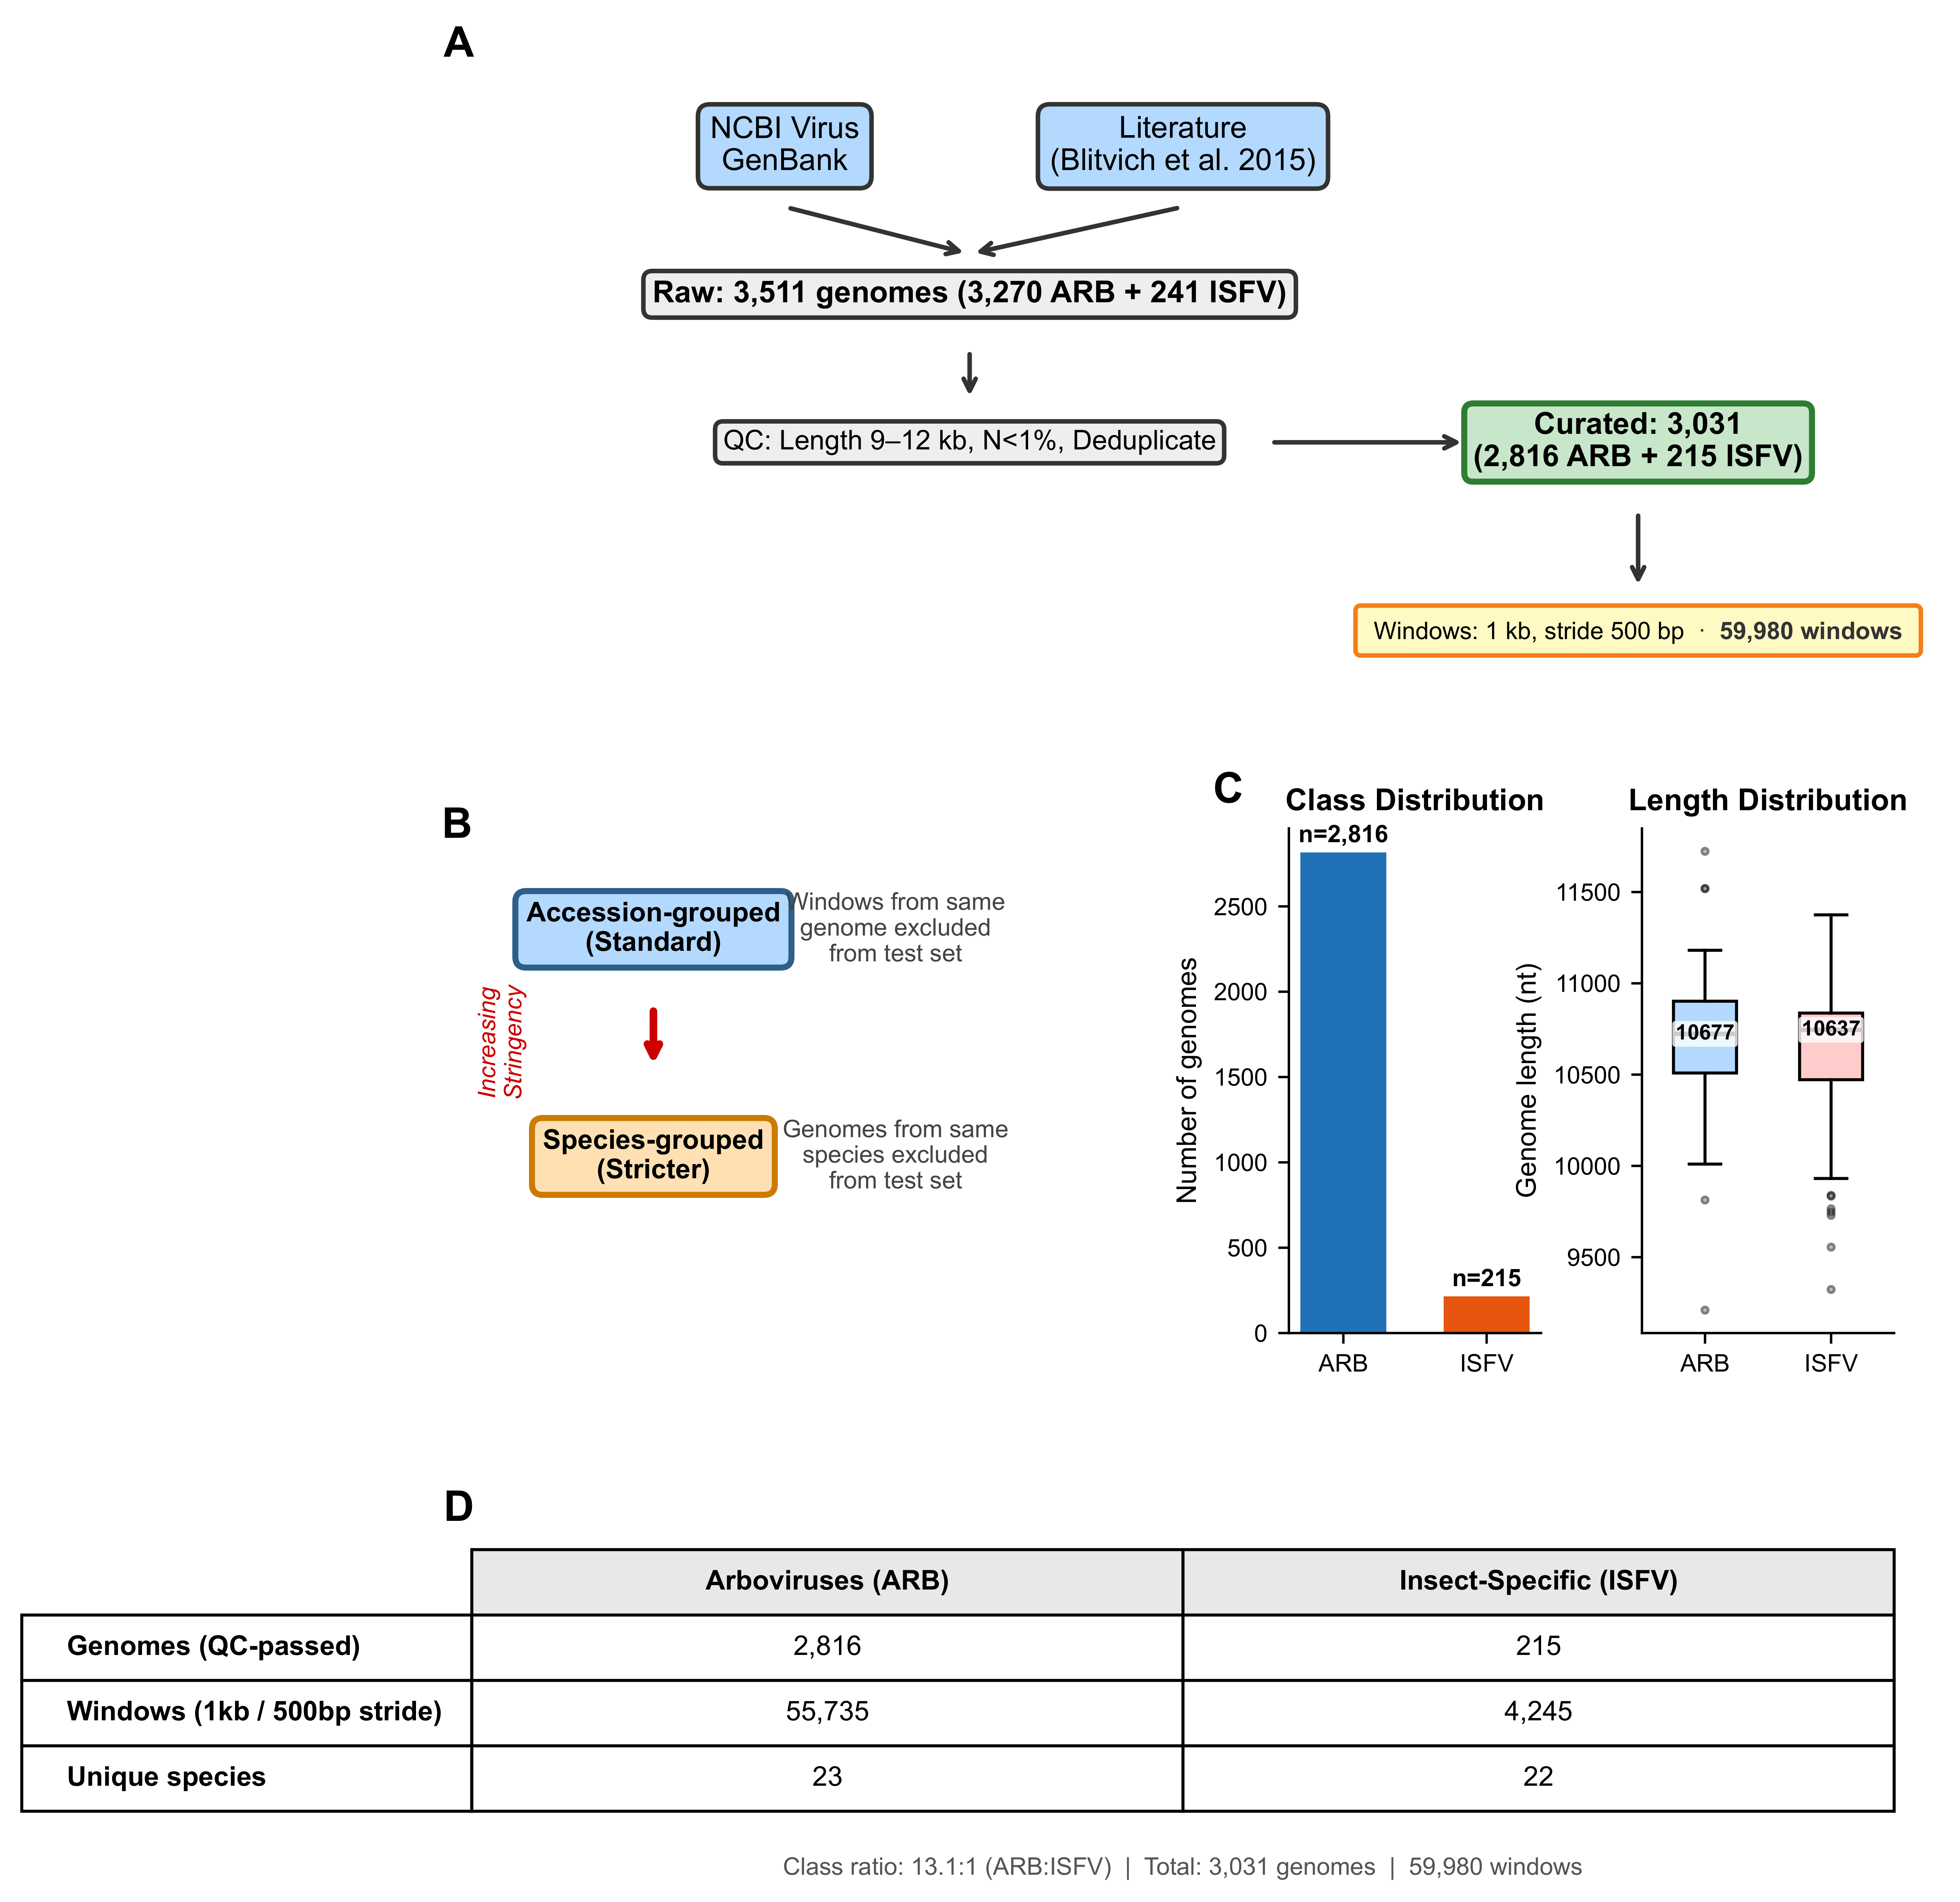
Figure 1. Dataset curation and evaluation framework. (A) Data acquisition pipeline. Complete orthoflavivirus genomes were retrieved from NCBI Virus and GenBank, filtered for quality (genome length 9–12 kb, <1% ambiguous bases, no duplicates), and annotated with host-range labels based on documented vertebrate infection capability. (B) Hierarchical evaluation framework. Two progressively stringent grouped cross-validation schemes prevent different levels of phylogenetic leakage: accession-grouped (windows from same genome constrained to same fold) and species-grouped (all genomes of same species constrained to same fold). (C) Dataset composition. Left: class distribution showing 2,816 ARB and 215 ISFV genomes. Right: genome length distributions by class, showing comparable ranges (ARB: 10,677 ± 263 nt; ISFV: 10,638 ± 322 nt). (D) Dataset summary. Total genome and window counts by host-range class, with species diversity. The class ratio (13.1:1 ARB:ISFV) necessitates evaluation metrics suited to imbalanced classification.
Classification performance under lineage-aware constraints
Under standard random cross-validation (no grouping constraints), DNABERT-2 embeddings achieved near-perfect discrimination (AP = 0.984 ± 0.003), establishing an upper performance bound. Accession-grouped cross-validation yielded a negligible reduction (AP = 0.981 ± 0.003 and PRC-AUC = 0.995 ± 0.002; Figure 2A), indicating that within-genome information leakage contributes minimally to reported performance. However, species-grouped cross-validation revealed substantial performance degradation (AP = 0.819 ± 0.146; Figure 2A), a 16-percentage-point reduction that quantifies the magnitude of evaluation leakage in standard approaches.
The increased variance under species-grouped evaluation (SD = 0.146 vs. 0.003) reflects the greater heterogeneity of test-set difficulty when entire species are held out, with some folds containing phylogenetically divergent ISFV lineages that are more challenging to classify. Precision-recall curves (Figure 2A–B) reveal that the performance gap is most pronounced at high-recall operating points, where species-grouped evaluation exposes the classifier's reduced confidence on novel lineages.
Evaluation leakage was not specific to DNABERT-2 embeddings but affected all feature representations tested (Figure 2C). Under accession-grouped evaluation, k-mer TF-IDF achieved AP = 0.997 ± 0.004 and composition-only features achieved AP = 0.928 ± 0.010, both performing comparably to DNABERT-2 (AP = 0.981 ± 0.003). Under species-grouped evaluation, all methods exhibited substantial and consistent degradation: DNABERT-2 (AP = 0.819 ± 0.146), k-mer TF-IDF (AP = 0.858 ± 0.183), and composition-only (AP = 0.834 ± 0.150). The 9–16 percentage-point drop observed across all methods demonstrates that evaluation leakage inflates reported performance regardless of feature complexity, reinforcing the need for species-grouped grouping as a minimum standard in viral host prediction benchmarks. As a negative control, position-only features (genome coordinate alone) performed at chance level (AP = 0.071, equal to the 7.1% ISFV base rate), confirming that the discriminative signal derives from sequence content rather than from positional artifacts such as systematic genome-length differences between classes.
To identify which composition features drive this classification, we examined the per-feature separation between classes (Supplementary Figure S1). The single most discriminative feature was CpG dinucleotide frequency, which was markedly elevated in insect-specific genomes (mean 0.0549 vs 0.0303 in arboviruses; Cohen’s d = 2.7, AUC = 0.94). Notably, bulk UpA frequency showed little class separation at the whole-window composition level (AUC = 0.52), in contrast to its strong enrichment among the top-scoring motif windows (Figure 5). This distinction indicates that the UpA signal is localized to the most discriminative windows rather than reflected in genome-wide dinucleotide composition, whereas CpG depletion in arboviruses is a pervasive, composition-level property.
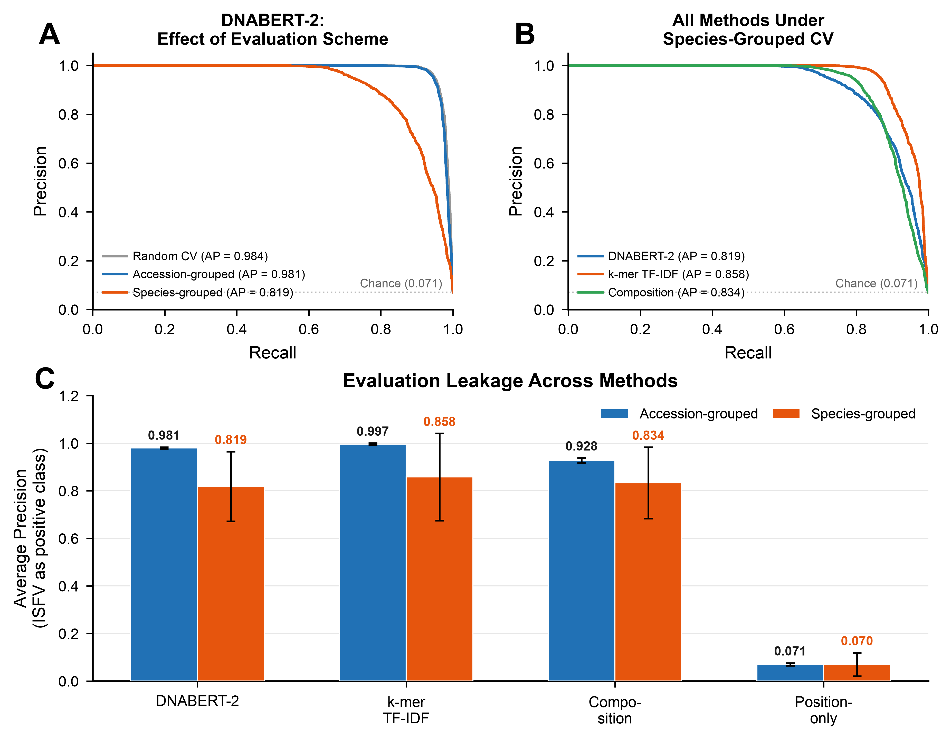
Figure 2. Evaluation leakage affects all feature representations. (A) Precision-recall curves for DNABERT-2 embeddings under three evaluation schemes: random CV (standard cross-validation with no grouping constraints; gray dashed), accession-grouped (all windows from the same genome constrained to the same fold; blue), and species-grouped (all genomes of the same species constrained to the same fold; orange). ISFV is designated as the positive class. Random and accession-grouped schemes yield near-identical AP (0.984 and 0.981), while species-grouped evaluation reveals a 16-percentage-point AP reduction (AP = 0.819), quantifying evaluation leakage. (B) Precision-recall curves for all methods under species-grouped cross-validation, the most stringent evaluation scheme. DNABERT-2 (AP = 0.819), k-mer TF-IDF (AP = 0.858), and composition-only (AP = 0.834) all retain discriminative power despite degradation. (C) Average Precision comparison across methods and evaluation schemes. Blue bars: accession-grouped; orange bars: species-grouped. Error bars indicate ±1 SD across 5 folds. Red arrows indicate the magnitude of performance drop for each method. All methods show consistent 9–16 pp degradation under species-grouped evaluation, demonstrating that leakage inflates reported performance regardless of feature representation. As a negative control, position-only features (genome coordinate) perform at chance level (AP = 0.071, the ISFV base rate), confirming that discriminative signal is sequence-derived.
Embedding space organization reveals host-range structure
Dimensionality reduction (the projection of high-dimensional data into two dimensions for visualization) of genome-level embeddings revealed clear separation between ARB and ISFV genomes in both UMAP and t-SNE projections (Figure 3A–B). The ISFV genomes formed a compact cluster distinct from the more dispersed ARB population, consistent with ISFVs representing a phylogenetically coherent group that has convergently lost vertebrate competence⁶.
Quantitative assessment using kNN purity (k = 15) yielded a purity score of 0.997, indicating that nearly all genomes have neighbors exclusively of the same host-range class. To establish the statistical significance of this clustering, we compared observed purity to a permutation-based null distribution generated by shuffling host-range labels 1,000 times. The null distribution had mean purity 0.868 ± 0.003, reflecting the baseline similarity expected from phylogenetic structure alone. The observed purity was far above the null mean (P < 0.001; Figure 3C), demonstrating that DNABERT-2 embeddings capture host-range-associated sequence features beyond phylogenetic proximity.
The silhouette score of 0.433 indicates moderate cluster compactness, with the lower value relative to kNN purity reflecting within-class heterogeneity, particularly among the diverse ARB lineages spanning multiple species complexes.
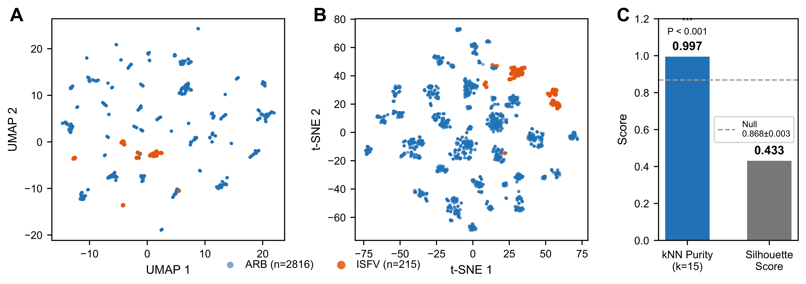
Figure 3. Embedding space organization. (A) UMAP projection of genome-mean DNABERT-2 embeddings colored by host-range class (ARB: blue, n = 2,816; ISFV: orange, n = 215). ISFV genomes form a distinct compact cluster. (B) t-SNE projection independently confirms the separation pattern observed in UMAP. (C) Quantitative cluster assessment. Left: kNN purity (k = 15) showing observed value (0.997) versus permutation-based null distribution (mean = 0.868 ± 0.003; 1,000 permutations). P < 0.001 (permutation test). Right: silhouette score distribution by class.
Genome-localized attribution identifies positional hotspots
Mapping window-level prediction probabilities to genome coordinates revealed distinct positional signatures for ARB and ISFV genomes (Figure 4A). Representative ARB genomes exhibited relatively uniform P(ARB) scores across their length, while ISFV genomes showed pronounced dips in P(ARB) (equivalently, peaks in P(ISFV)) concentrated in specific genomic regions.
Positional enrichment analysis quantified these patterns across the full dataset (Figure 4B). ISFV genomes showed enrichment of high-confidence ISFV predictions (top 10% by P(ISFV)) at relative position 0.57, corresponding to the NS3 helicase region^{4,5}. At this position, the fraction of top-scoring windows was 2.5-fold higher than expected under uniform distribution. In contrast, ARB genomes showed peak enrichment at position 0.38 (1.8×; NS2A–NS2B region) with secondary peaks near positions 0.68 (NS4B) and 0.78 (NS5).
The fraction of genomes contributing at least one top-scoring window to each genomic region (Figure 4C) revealed that ARB genomes show preferential enrichment in the NS3–NS5 region (65% vs 47% in other regions), while ISFV genomes show more distributed signal across both regions (33% vs 35%). Approximately 65% of ARB genomes had at least one top-scoring window in the NS3–NS5 region (positions ≥0.40), compared to 33% of ISFV genomes. The positional enrichment peaks visible in Panel B (ARB at 0.38, 1.8× over expected; ISFV at 0.57, 2.5×) localize discriminative signal to the NS2A–NS2B and NS3 helicase regions respectively.
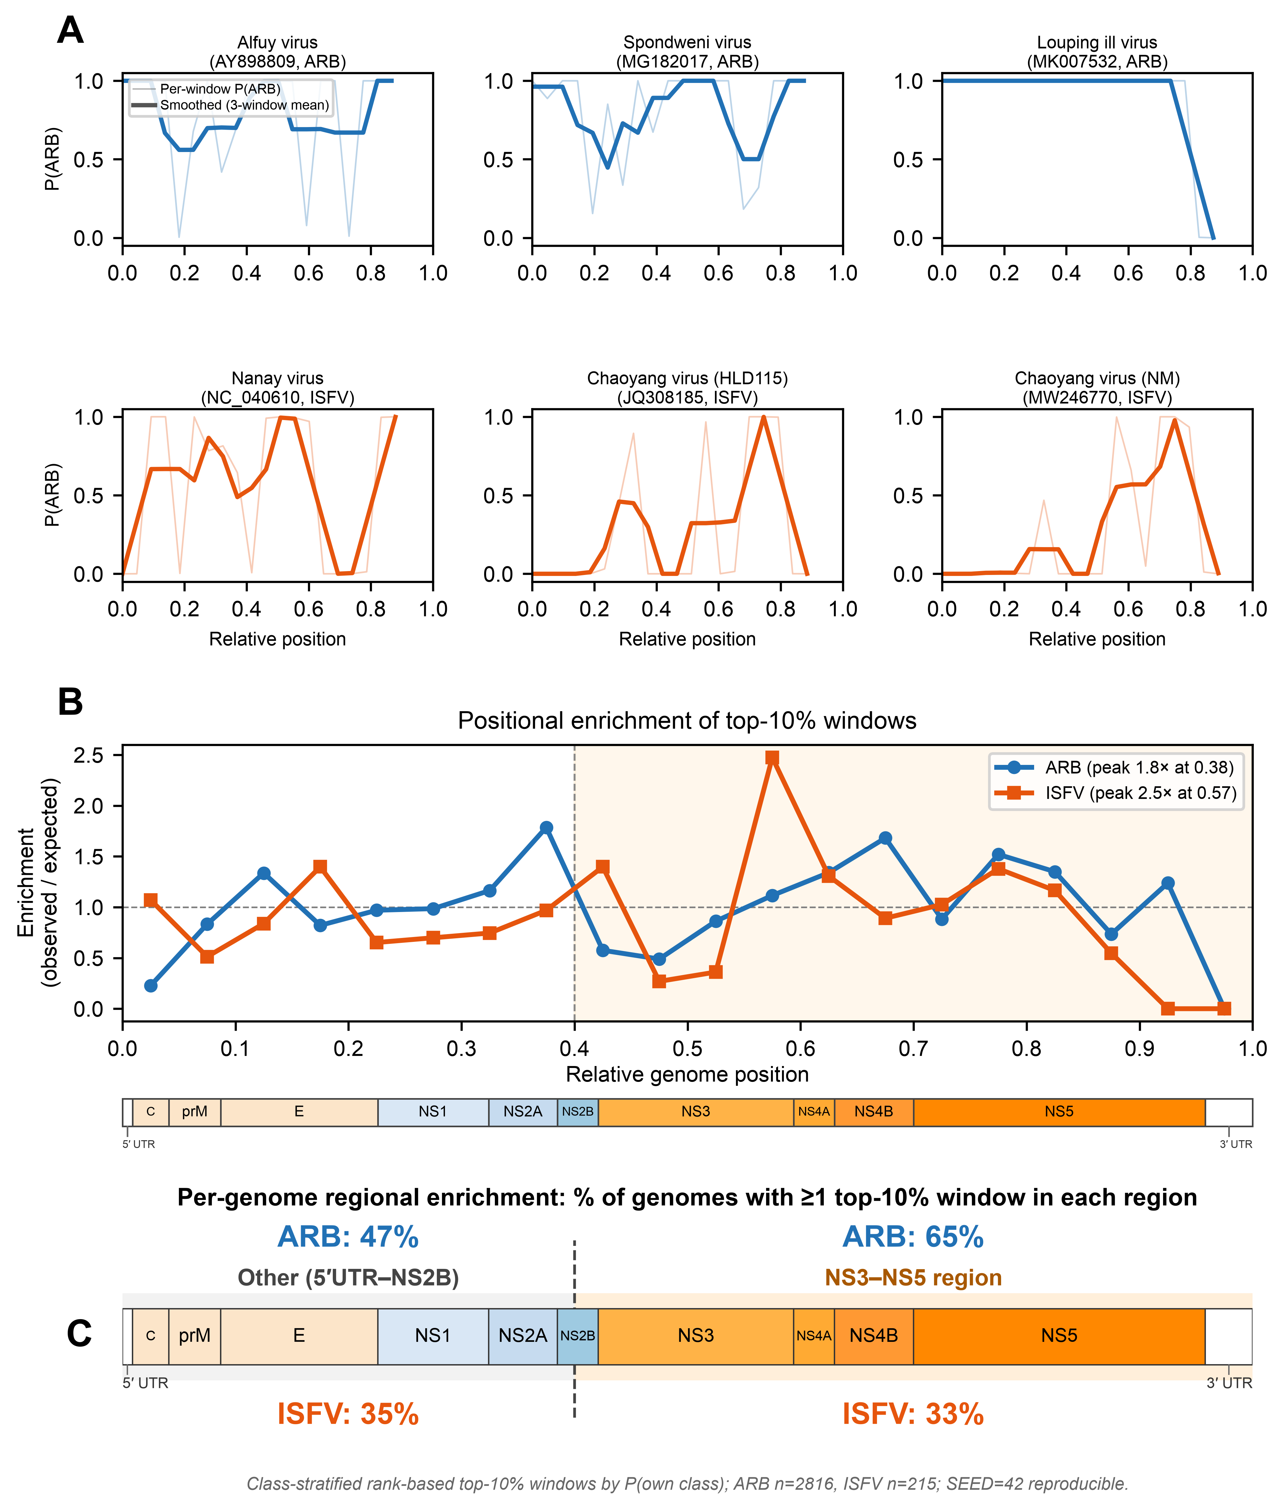
Figure 4. Genome-localized attribution and positional hotspots. (A) Representative P(ARB) score tracks for three ARB genomes (top row) and three ISFV genomes (bottom row). Light lines show raw window scores; bold lines show smoothed profiles (rolling mean, window = 3). ARB genomes maintain high P(ARB) scores throughout most of the genome, while ISFV genomes show predominantly low scores with occasional localized spikes. (B) Positional enrichment of top-10% scoring windows across 20 genomic bins under class-stratified rank-based analysis (top 10% by P(ARB) for ARB, by P(ISFV) for ISFV; SEED=42 reproducible). ARB genomes (blue) show 1.8× peak enrichment at position 0.38 (NS2A–NS2B region); ISFV genomes (orange) show 2.5× peak enrichment at position 0.57 (NS3 helicase region). The polyprotein annotation directly below the plot shows the approximate genomic positions of structural proteins (C, prM, E; pink) and non-structural proteins (NS1–NS5; blue gradient with NS3–NS5 highlighted in orange), enabling direct mapping of positional enrichment to functional domains^{2,4}. (C) Per-genome regional enrichment annotated directly on the flavivirus genome schematic (polyprotein positions from DENV-2 reference NC_001474). Percentages indicate the fraction of genomes with ≥1 top-10% scoring window in each region under class-stratified rank-based analysis (SEED=42; ARB by P(ARB), ISFV by P(ISFV)). ARB genomes show preferential enrichment in the NS3–NS5 region (65% vs 47% Other; blue); ISFV genomes are more evenly distributed across both regions (33% NS3–NS5 vs 35% Other; orange). All values reproducible from windows_predictions_FIXED_SEED.csv using scripts/figures/regen_fig4_repro.py.
Discriminative 6-mer motifs are enriched for innate immunity targets
Comparative 6-mer enrichment analysis identified sequence motifs associated with high-confidence ARB predictions (Figure 5A). Motif sequences are presented in RNA form (U) throughout; computational analyses used the cDNA form (T) as deposited in GenBank. The top-ranked motif, AUUAGG, showed 9.3-fold enrichment (log₂ = 3.22) in the top 5% versus bottom 5% of windows by P(ARB). This motif contains a single UpA dinucleotide, a pattern associated with innate immune restriction through ZAP binding and OAS3/RNaseL-mediated pathways in vertebrate cells^{9,20}.
Of the top 10 enriched motifs, 6 contained at least one UpA dinucleotide without co-occurring CpG (i.e., “UpA-only” motifs) (AUUAGG, UACUCC, UAGUAU, CUAAUA, GAAUAG, AUAGAA), with two motifs (UAGUAU, CUAAUA) containing two UpA occurrences (Figure 5B, Table 1). The remaining top motifs included purine-rich sequences (AGAGAG, AGAGGG) and a GC-rich motif (GGCCUC); CCCUUU did not contain UpA or CpG and is included for completeness. No CpG-enriched motifs appeared in the top 10, suggesting that ZAP-mediated CpG restriction may not be the dominant selective pressure distinguishing ARB from ISFV in this dataset^{10,11}. To assess whether UpA enrichment is specific to top-ranked motifs rather than a general property of the motif space, we classified all 4,095 6-mers by dinucleotide content (UpA-only, CpG-only, UpA+CpG, or neither) and examined their distribution across enrichment deciles (Figure 5C). UpA-only motifs were significantly over-represented among the most ARB-enriched decile (37% vs. 24% expected; Mann–Whitney U test, UpA-only > CpG-only: P < 10⁻¹²⁶), whereas CpG-only motifs dominated the most ISFV-enriched decile (66% vs. 24% expected). The bottom-ranked motifs containing UpA dinucleotides almost exclusively co-occurred with CpG dinucleotides (e.g., CGCGUA, GUAUCG), suggesting that their depletion from ARB predictions reflects CpG avoidance rather than UpA content per se. These results confirm that UpA enrichment is a specific feature of the top discriminative motifs and not an artifact of base composition.
Conservation analysis revealed that top motifs showed class-specific prevalence patterns. For example, AGAGAG was universally conserved in ARB genomes (100% prevalence) but also highly prevalent in ISFV (94%), indicating its enrichment in high-scoring windows reflects positional or contextual factors rather than simple presence/absence. In contrast, AUUAGG showed marked differential conservation (60% ARB vs. 21% ISFV), suggesting it may represent a genuine genomic signature of vertebrate adaptation.
Motif localization profiles (Table 1) revealed that discriminative motifs were non-uniformly distributed across the genome. AUUAGG peaked at position 0.775 (bin 15), overlapping the NS5 polymerase region, while CCCUUU was enriched at position 0.375 (bin 7), corresponding to the NS1/NS2A junction. This positional specificity suggests that motif function may be context-dependent, potentially reflecting codon usage constraints or RNA secondary structure requirements in specific genomic regions⁵.
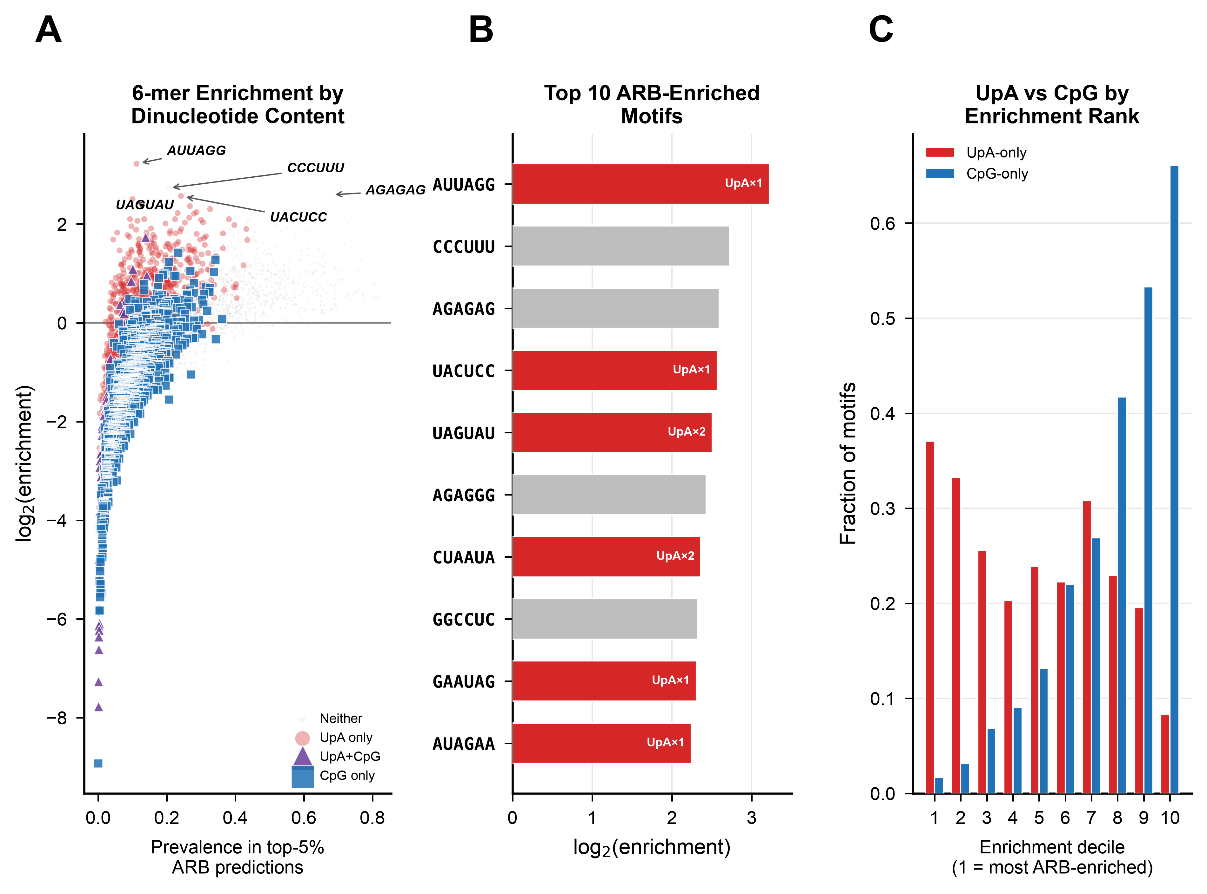
Figure 5. Discriminative 6-mer motif identification and characterization. (A) Scatter plot of all 4,095 6-mers showing log₂ enrichment ratio (top 5% vs. bottom 5% ARB prediction windows) versus prevalence in top stratum. Motifs are colored by dinucleotide content: UpA-only (red), CpG-only (blue), UpA+CpG (purple), and neither (gray). UpA-only motifs cluster at positive enrichment values while CpG-only motifs dominate negative values. (B) Top 10 ARB-enriched motifs with UpA annotations. Six of the top 10 motifs contain UpA without CpG (red bars). (C) Distribution of UpA-only versus CpG-only motifs across enrichment deciles (decile 1 = most ARB-enriched). UpA-only motifs are specifically over-represented in the top deciles, while CpG-only motifs are over-represented in the bottom deciles, confirming that UpA enrichment is a specific feature of ARB-discriminative motifs.

Table 1. Prioritized candidate grammar elements. Motif sequences are presented in RNA form (U); computational analyses used cDNA form (T). log₂(E), log₂ enrichment ratio (top 5% vs. bottom 5% windows); Cons., conservation (fraction of genomes containing motif); Peak Pos., relative genome position of maximum motif frequency. Biological annotations indicate known host restriction mechanisms: UpA and CpG dinucleotides are both associated with ZAP binding and OAS3/RNaseL-mediated restriction^{9,20}.
Motif | log₂(E) | Cons. ARB | Cons. ISFV | Peak Pos. | Biological Annotation
AUUAGG | 3.22 | 0.60 | 0.21 | 0.78 | UpA×1
CCCUUU | 2.73 | 0.90 | 0.37 | 0.38 | —
AGAGAG | 2.59 | 1.00 | 0.94 | 0.78 | Purine-rich
UACUCC | 2.57 | 0.75 | 0.33 | 0.08 | UpA×1
UAGUAU | 2.51 | 0.42 | 0.20 | 0.88 | UpA×2; AU-rich
AGAGGG | 2.43 | 1.00 | 0.81 | 0.68 | Purine-rich
CUAAUA | 2.36 | 0.51 | 0.41 | 0.93 | UpA×2
GGCCUC | 2.33 | 0.91 | 0.53 | 0.33 | GC-rich
GAAUAG | 2.31 | 0.83 | 0.57 | 0.18 | UpA×1
AUAGAA | 2.24 | 0.86 | 0.49 | 0.73 | UpA×1
Robustness and ablation analyses confirm distributed signal
Window masking ablations confirmed that discriminative signal is distributed across the genome rather than concentrated in specific regions (Figure 6A). Genome-level classification was unaffected by masking the top 5% highest-scoring windows per genome, a random 5% of windows, or all windows containing the top-enriched motif AUUAGG (|ΔAP| < 0.01 percentage points in all conditions; baseline AP = 0.9997 ± 0.0005, species-grouped 5-fold cross-validation).
Direct comparison of DNABERT-2 embeddings with transparent motif-based scoring revealed a performance gap (Figure 6B). Under accession-grouped cross-validation, DNABERT-2 achieved AP = 0.981 ± 0.003 compared to AP = 0.638 ± 0.023 for the motif-based approach, a 34.3-percentage-point difference. This gap demonstrates that DNABERT-2 captures sequence information beyond simple 6-mer presence, likely including higher-order sequence context, positional patterns, and interactions between motifs.
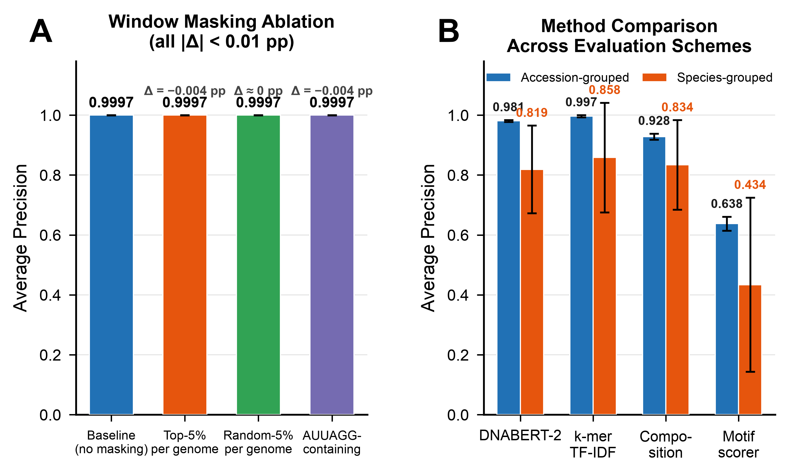
Figure 6. Robustness and ablation analyses. (A) Window masking ablation. Bar chart shows Average Precision (AP) under four conditions: baseline (no masking), top-5% per genome (removal of the 5% highest-scoring windows per genome by reproducible P(ARB)), random-5% per genome (removal of a random 5% of windows per genome), and AUUAGG-containing (removal of all windows containing the top-enriched motif AUUAGG). All |ΔAP| < 0.01 percentage points (genome-level evaluation, species-grouped 5-fold CV, SEED=42), indicating that discriminative signal is broadly distributed across the genome. Because this ablation aggregates window embeddings into genome-level representations, its absolute AP values are not directly comparable to the window-level AP reported in Figure 2; the relevant quantity is the within-analysis change in AP after masking. (B) Method comparison across evaluation schemes. Grouped bar chart showing AP under accession-grouped (blue) and species-grouped (orange) cross-validation for DNABERT-2 embeddings, k-mer TF-IDF, composition-only features, and a transparent motif-based scorer (AP = 0.638 accession-grouped, 0.434 species-grouped). All methods exhibit performance degradation under species-grouped evaluation, confirming that evaluation leakage inflates reported performance regardless of feature representation. Error bars indicate ±1 SD across 5 folds.
Biological integration and mechanistic hypotheses
The enrichment of UpA-containing motifs among ARB-associated sequences is consistent with proposed roles for dinucleotide composition in vertebrate host adaptation (Figure 7A). Vertebrate cells restrict viruses with elevated CpG and UpA frequencies through at least two interconnected pathways: ZAP binds viral RNA enriched for both CpG and UpA dinucleotides⁹⁻¹², while OAS3/RNaseL mediates complementary restriction⁹. Critically, Odon et al.⁹ demonstrated that these pathways exhibit synergy or complementation (knockout of either ZAP or OAS3 fully reverses attenuation of both CpG-high and UpA-high virus mutants), although the precise mechanism of dinucleotide-mediated restriction remains uncharacterized. Sexton and Ebel²⁰ further showed that arbovirus dinucleotide composition is dominated by vertebrate host-driven selective pressures, with CpG suppression absent in insect-specific flaviviruses but UpA suppression shared across both host-range classes. That both arboviruses and ISFVs suppress UpA, yet our analysis reveals differential UpA enrichment in ARB-associated motifs, suggests that the discriminative signal may arise from context-dependent variation in UpA usage rather than genome-wide abundance differences. Higher UpA content within specific sequence contexts in arbovirus genomes may reflect region-specific adaptation, potentially involving localization in regions under distinct selective constraints⁵, although the functional significance of these context-dependent patterns remains to be determined experimentally.
The positional concentration of discriminative signal in the NS3–NS5 region, encoding the viral helicase, protease, and polymerase, aligns with functional constraints on these essential replication enzymes^{4,5}. This region may experience distinct selection pressures related to host factor interactions and temperature-dependent enzyme function in vertebrate versus insect cells²⁰, as replication enzymes must maintain activity across the ∼15°C temperature differential between arthropod vectors and mammalian hosts.
The prioritized candidate grammar elements (Table 1; visual summary in Figure 7B) provide testable hypotheses for experimental follow-up. High-priority candidates include AUUAGG (strong enrichment, differential conservation, NS5 localization) and CUAAUA (dual UpA, high enrichment, 3′ UTR proximal). These motifs could be evaluated through reverse-genetics and related experimental flavivirus systems, including a Zika virus infectious clone³⁶ and experimentally tractable Zika and Kunjin/West Nile virus systems^{37,38}, assessing replication fitness in vertebrate versus insect cell culture.
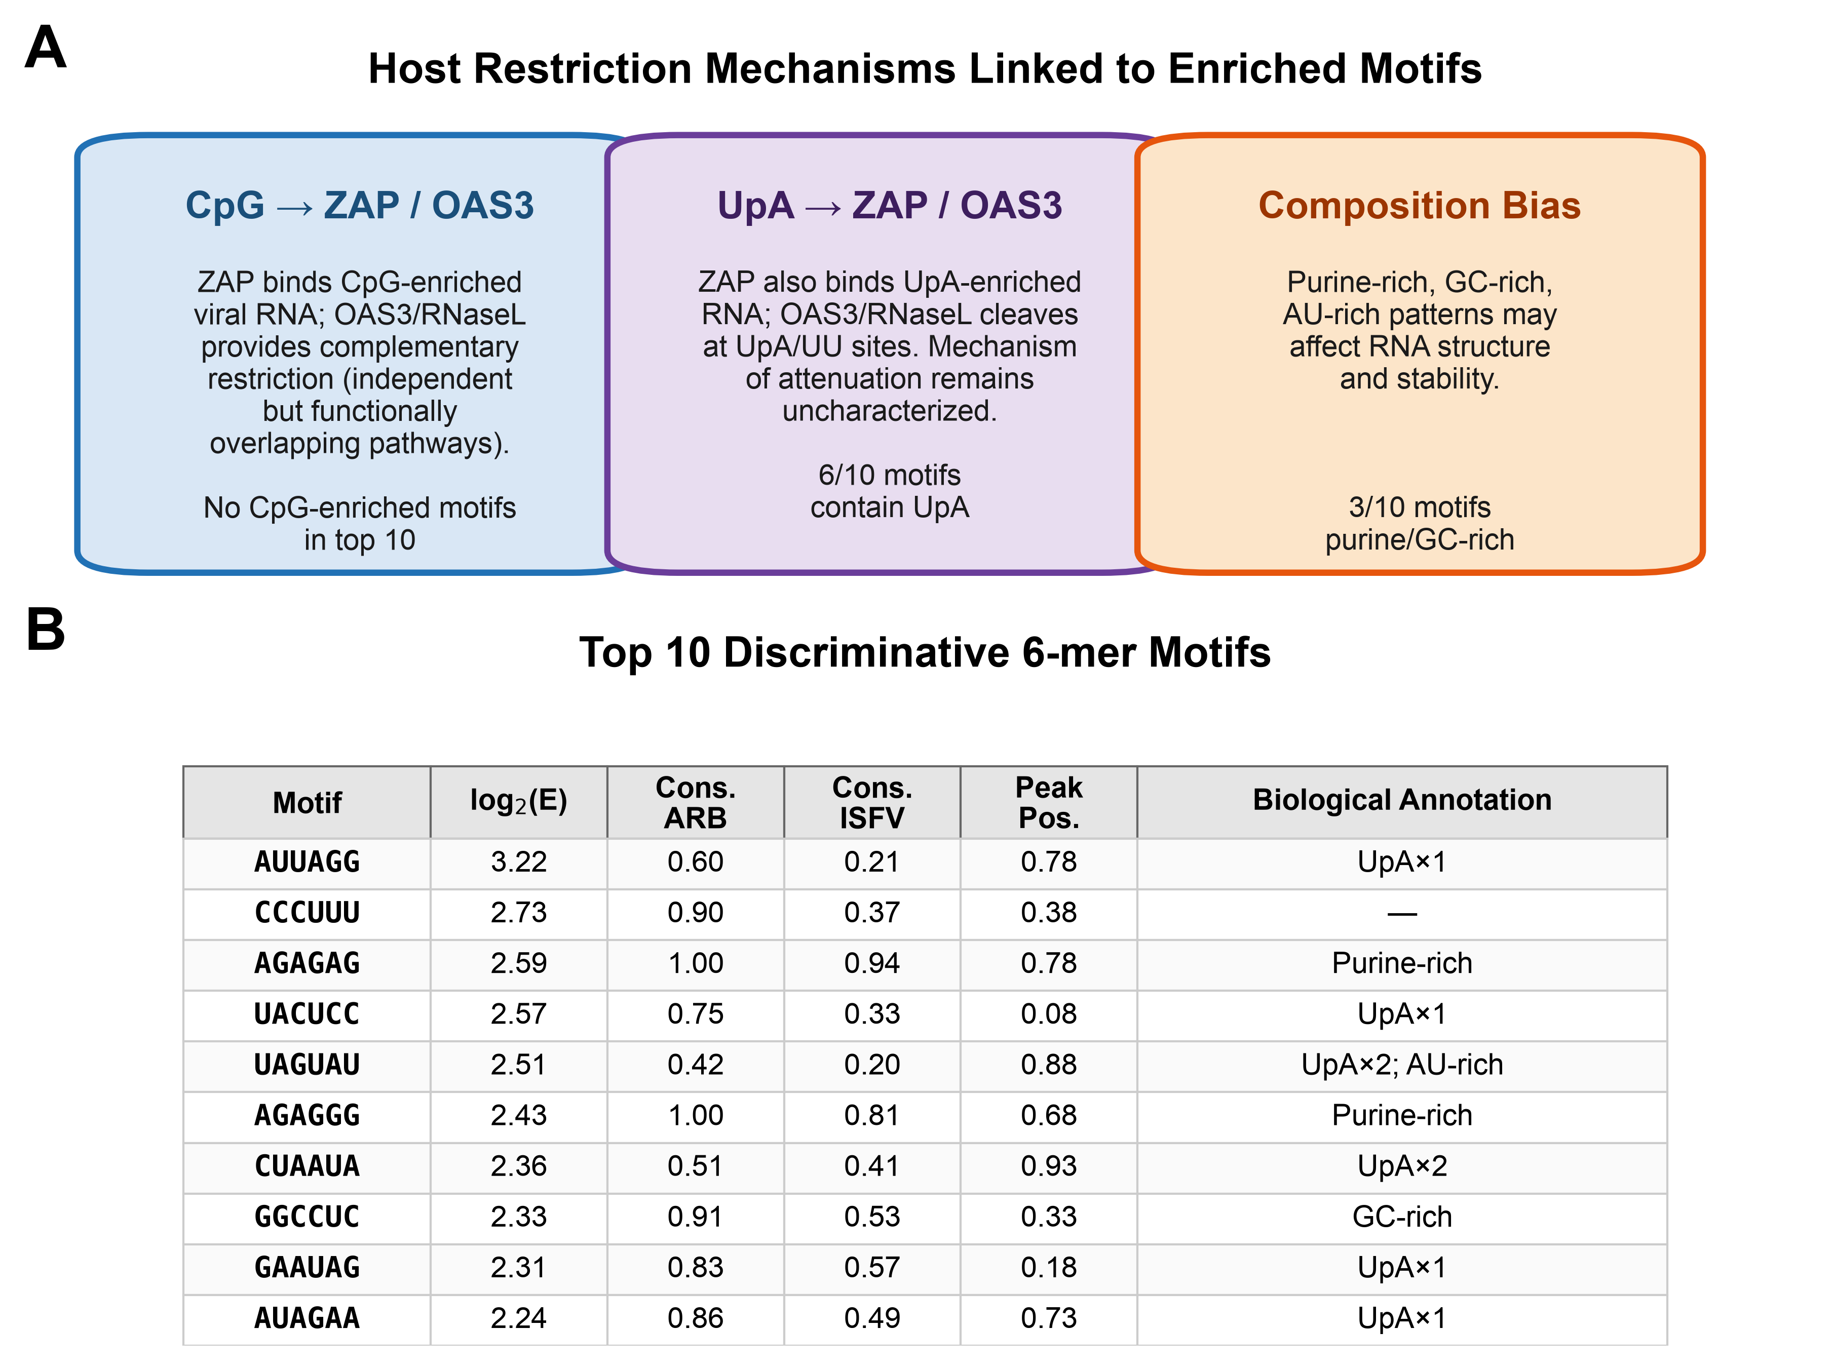
Figure 7. Biological hypothesis integration. (A) Mechanistic framework connecting identified motifs to vertebrate host restriction pathways. Unlike Table 1, which presents quantitative motif-level data, this schematic synthesizes the three classes of host restriction signals identified in this study: CpG-targeted restriction through ZAP and OAS3/RNaseL, with no CpG-enriched motifs among top discriminators (left); UpA-containing motifs associated with ZAP binding and OAS3/RNaseL-mediated restriction, with 6 of 10 top motifs containing UpA (center); and composition biases including purine-rich patterns that may affect RNA secondary structure (right). ZAP and OAS3/RNaseL restrict viruses with elevated CpG or UpA frequencies through interconnected dinucleotide-sensing pathways^{10,14}; Odon et al. reported that these pathways can act synergistically⁹, although the precise mechanism remains uncharacterized. (B) Summary of the top 10 discriminative 6-mer motifs with biological annotations (see Table 1 for full quantitative data).
Discussion
This study provides the first systematic quantification of evaluation leakage in machine learning approaches to viral host-range prediction and demonstrates that evaluation leakage is method-agnostic. The consistent 9–16 percentage-point reduction in Average Precision observed across all feature representations tested (DNABERT-2 embeddings, k-mer TF-IDF, and nucleotide composition) when transitioning from accession-grouped to species-grouped cross-validation demonstrates that standard evaluation protocols overestimate generalization performance regardless of the underlying method. This finding has broad implications for the viral genomics community, where phylogenetic clustering of sequenced genomes is ubiquitous and evaluation leakage is rarely addressed^{30,32}. Even simple k-mer TF-IDF features achieved AP = 0.997 under accession-grouped evaluation, a near-perfect score that might be mistaken for genuine predictive power but that drops to AP = 0.858 under species-grouped constraints. Our hierarchical evaluation framework provides a template for more rigorous benchmarking of host prediction models, and the consistency of the observed performance gap across methods shows the need to adopt leakage-aware evaluation as standard practice³⁴.
Given that k-mer TF-IDF and composition features achieved comparable classification accuracy to DNABERT-2, the value of foundation model embeddings in this study lies not in raw predictive performance but in enabling the downstream interpretability pipeline. DNABERT-2 embeddings produced a well-structured latent space (kNN purity = 0.997, P < 0.001 by permutation test) that supported genome-localized attribution and prediction-stratified motif enrichment, which depend on the quality and consistency of window-level predictions across the genome. The 34.3-percentage-point performance advantage of DNABERT-2 over transparent motif-based scoring (AP = 0.981 vs. 0.638 under accession-grouped evaluation) indicates that the foundation model captures sequence information beyond simple k-mer presence, likely including higher-order contextual patterns and positional dependencies²⁵⁻²⁷. This observation aligns with the distributed nature of discriminative signal revealed by ablation analyses, where masking high-scoring windows or motif-containing regions had negligible impact on classification performance.
The enrichment of UpA-containing motifs among ARB-associated sequences provides a mechanistic hypothesis linking sequence signatures to vertebrate host adaptation. Dinucleotide-mediated restriction in vertebrate cells involves interconnected pathways: ZAP binds viral RNA with elevated CpG or UpA frequencies⁹, while OAS3-activated RNaseL provides complementary restriction⁹. Although RNaseL preferentially cleaves single-stranded RNA at UpA and UU dinucleotide sites³⁹, Odon et al.⁹ found no evidence that accelerated RNA degradation explains the observed attenuation, indicating that the restriction mechanism operates through pathways that remain to be characterized. UpA suppression is not exclusive to vertebrate-infecting viruses; insect-specific flaviviruses also show strong UpA avoidance, likely reflecting RNA stability constraints shared across host environments²⁰. Previous work has demonstrated that vertebrate-infecting viruses show genome-wide suppression of dinucleotides targeted by host restriction factors¹⁴⁻¹⁷. Our finding that ARB genomes are enriched for UpA-containing motifs relative to ISFV genomes therefore does not imply genome-wide UpA elevation but rather context-dependent variation: UpA dinucleotides within specific sequence contexts may serve functional roles in arbovirus genomes while the overall UpA frequency remains suppressed. The preferential enrichment of ARB discriminative signal in the NS3–NS5 region (65% vs 47% in other regions), encoding essential replication enzymes, suggests that vertebrate host adaptation involves region-specific sequence optimization in the replication machinery rather than genome-wide dinucleotide avoidance.
No CpG-enriched motifs appeared among the top ARB-discriminative sequences, despite the well-characterized role of ZAP in restricting viruses with elevated CpG frequencies⁹⁻¹². ZAP also binds UpA-enriched viral RNA⁹, indicating that the ZAP/OAS3 restriction system is not dinucleotide-specific but rather responds to both CpG and UpA elevation. The absence of CpG-enriched motifs from the ARB-discriminative set is consistent with CpG suppression being specifically imposed by vertebrate host pressures: Sexton and Ebel²⁰ demonstrated that insect-specific flaviviruses do not suppress CpG, while arboviruses show strong CpG avoidance. Consequently, CpG-containing motifs are depleted in ARB genomes and enriched in ISFV genomes, as confirmed by our observation that CpG-only motifs dominated the most ISFV-enriched decile of the 6-mer distribution (Figure 5C). Arboviruses have already suppressed CpG to evade ZAP-mediated restriction, leaving UpA-associated patterns as the primary axis of differentiation in our analysis. At the bulk-composition level, this asymmetry is quantitatively confirmed: CpG frequency is the single strongest discriminator between the two classes (Supplementary Figure S1), whereas UpA shows minimal separation in genome-wide composition despite dominating the motif-level analysis (Figure 5), indicating that the UpA signal is concentrated in specific high-scoring windows rather than in bulk dinucleotide content.
Our results complement and extend prior computational and virological studies of orthoflavivirus host range. The systematic review by Blitvich and Firth⁶ established the phylogenetic diversity and host restriction patterns of insect-specific flaviviruses, providing the foundation for our curated ISFV dataset. Sexton and Ebel²⁰ characterized the dinucleotide and codon usage patterns shaped by the arbovirus multi-host life cycle, demonstrating that vertebrate host pressures dominate arbovirus genome composition, a framework that directly informs our interpretation of UpA-enriched discriminative motifs. Perelygin et al.³¹ showed the impact of taxonomic features on host prediction accuracy but did not quantify the specific contribution of evaluation leakage to performance estimates. Our framework addresses this gap by implementing progressively stringent grouping constraints and directly measuring performance degradation. The DNABERT-2 foundation model²⁷ enabled extraction of high-dimensional sequence embeddings without task-specific training, and the interpretable outputs (positional hotspots, enriched motifs) connect black-box prediction with mechanistic understanding, addressing a limitation that has constrained the translational impact of prior machine learning approaches^{22,23,25,29}. An important methodological consideration is that the 6-mer motif enrichment analysis presented here is a post-hoc procedure applied to the classifier’s predictions, not a direct interpretation of DNABERT-2’s internal representations. In principle, similar enrichment analyses could be applied to predictions from any classifier; however, the quality of the resulting motifs depends critically on the quality of the underlying predictions. Under accession-grouped evaluation, k-mer TF-IDF (AP = 0.997) and composition features (AP = 0.928) achieved comparable classification accuracy to DNABERT-2 (AP = 0.981), indicating that raw predictive performance is not the primary advantage of foundation model embeddings for this task. However, the motif-based scoring ablation (Figure 6B) demonstrated that transparent 6-mer features alone capture only a fraction of the discriminative signal available in the embedding space (AP = 0.638 vs. 0.981). This gap suggests that DNABERT-2 captures higher-order sequence context beyond what fixed-length k-mer features can represent, and that the high-confidence prediction strata used for motif enrichment benefit from the foundation-model embeddings, even though simpler features can achieve comparable aggregate classification metrics. Future work using attention-based interpretability methods may enable direct extraction of discriminative features from the foundation model’s internal representations, potentially revealing longer-range or structural motifs not accessible through k-mer enrichment.
We note that complementary motif discovery tools such as MEME⁴⁰ could provide additional insight through de novo motif identification without predefined k-mer enumeration. Our enrichment-based approach is complementary to MEME in that it uses classifier confidence scores to define positive and negative sequence sets, enabling discovery of motifs whose discriminative relevance depends on the prediction task rather than sequence-intrinsic properties alone. Future work integrating MEME-based de novo discovery with prediction-stratified enrichment may reveal longer or degenerate motifs not accessible through fixed-length k-mer enrichment.
Future work should extend this framework in several directions. Comparative analysis across arbovirus families would test whether UpA enrichment and NS3–NS5 positional signatures represent convergent solutions to vertebrate adaptation or family-specific patterns. Experimental validation using reverse-genetics systems could directly test the functional importance of candidate motifs, leveraging a Zika virus infectious clone³⁶ and experimentally tractable Zika and Kunjin/West Nile virus systems^{37,38} to assess replication fitness in vertebrate versus insect cell culture. Integration with structural predictions could identify whether discriminative motifs are enriched in specific RNA secondary structure contexts that modulate innate immune recognition⁵. The leakage-aware evaluation framework developed here should be applied retrospectively to published host prediction studies to assess the extent of performance inflation across the field and establish more accurate benchmarks for model development.
In conclusion, this study establishes a rigorous framework for evaluating viral host-range predictors under lineage-aware constraints and identifies candidate sequence grammar elements associated with orthoflavivirus vertebrate competence. The 16-percentage-point performance gap between standard and species-grouped evaluation provides a quantitative benchmark for the viral machine learning community, while the enrichment of UpA-containing motifs and preferential localization of ARB discriminative signal in the NS3–NS5 region generate testable hypotheses for experimental follow-up. As foundation models become increasingly central to viral genomics²⁵⁻²⁹, frameworks that combine predictive power with interpretable outputs and leakage-resistant evaluation will be essential for translating computational insights into mechanistic understanding of viral emergence.

Acknowledgments
We thank members of the Sexton laboratory for constructive feedback on this project. We acknowledge the National Center for Biotechnology Information (NCBI) GenBank for providing open access to viral genome sequences. Computational analyses were performed on the Holland Computing Center (HCC) at the University of Nebraska-Lincoln, which receives support from the Nebraska Research Initiative.
Competing Interests
The authors declare no competing interests.
Funding
This publication was made possible by the Nebraska Tobacco Settlement Biomedical Research Development Funds and support from the Nebraska Center for Integrated Biomolecular Communication (NIH National Institutes of General Medical Sciences P20 GM113126)
Author Contributions
B.F.Z. and N.R.S. conceived the study. B.F.Z. developed the computational pipeline, performed all analyses, and drafted the manuscript. Q.Y. provided critical review and methodological guidance. N.R.S. conceptualized the research direction, acquired funding, supervised the study, provided biological expertise, and critically revised the manuscript. All authors approved the final manuscript.
Data Availability

All analysis code and curated accession lists will be made publicly available at https://github.com/brhanufen/host-range-grammar with a permanent Zenodo DOI.
References
1. Bhatt S, Gething PW, Brady OJ, et al. The global distribution and burden of dengue. Nature. 2013;496(7446):504–507. doi:10.1038/nature12060
2. Chambers TJ, Hahn CS, Galler R, Rice CM. Flavivirus genome organization, expression, and replication. Annu Rev Microbiol. 1990;44:649-688. doi:10.1146/annurev.mi.44.100190.003245
3. Pierson TC, Diamond MS. The continued threat of emerging flaviviruses. Nat Microbiol. 2020;5(6):796-812. doi:10.1038/s41564-020-0714-0
4. Abram QH, Landry BN, Wang AB, Kothe RF, Hauch HCH, Sagan SM. The myriad roles of RNA structure in the flavivirus life cycle. RNA Biol. 2024;21(1):634-650. doi:10.1080/15476286.2024.2357857
5. Ramos-Lorente S, Romero-López C, Berzal-Herranz A. 2021. Information encoded by the flavivirus genomes beyond the nucleotide sequence. Int J Mol Sci 22(7):3738. doi: 10.3390/ijms22073738.
6. Blitvich BJ, Firth AE. Insect-specific flaviviruses: A systematic review of their discovery, host range, mode of transmission, superinfection exclusion potential and genomic organization. Viruses. 2015;7(4):1927-1959. doi:10.3390/v7041927
7. Piyasena TBH, Setoh YX, Hobson-Peters J, et al. Infectious DNAs derived from insect-specific flavivirus genomes enable identification of pre- and post-entry host restrictions in vertebrate cells. Sci Rep. 2017;7:2940. doi:10.1038/s41598-017-03120-1
8. Piyasena TBH, Newton ND, Hobson-Peters J, Vet LJ, Setoh YX, Bielefeldt-Ohmann H, Khromykh AA, Hall RA. 2019. Chimeric viruses of the insect-specific flavivirus Palm Creek with structural proteins of vertebrate-infecting flaviviruses identify barriers to replication of insect-specific flaviviruses in vertebrate cells. J Gen Virol 100:1580–1586. doi:10.1099/jgv.0.001326
9. Odon V, Fros JJ, Goonawardane N, et al. The role of ZAP and OAS3/RNAseL pathways in the attenuation of an RNA virus with elevated frequencies of CpG and UpA dinucleotides. Nucleic Acids Res. 2019;47(15):8061-8083. doi:10.1093/nar/gkz581
10. Takata MA, Gonçalves-Carneiro D, Zang TM, Soll SJ, York A, Blanco-Melo D, Bieniasz PD. 2017. CG dinucleotide suppression enables antiviral defence targeting non-self RNA. Nature 550(7674):124–127. doi:10.1038/nature24039
11. Gonçalves-Carneiro D, Mastrocola E, Lei X, DaSilva J, Chan YF, Bieniasz PD. 2022. Rational attenuation of RNA viruses with zinc finger antiviral protein. Nat Microbiol 7(10):1558–1567. doi:10.1038/s41564-022-01223-8.
12. Kmiec D, Lista MJ, Ficarelli M, Swanson CM, Neil SJD. 2021. S-farnesylation is essential for antiviral activity of the long ZAP isoform against RNA viruses with diverse replication strategies. PLoS Pathog 17(10):e1009726. doi:10.1371/journal.ppat.1009726
13. Goonawardane N, Nguyen D, Simmonds P. Association of zinc finger antiviral protein binding to viral genomic RNA with attenuation of replication of echovirus 7. mSphere. 2021;6(1):e01138-20. doi:10.1128/mSphere.01138-20
14. Atkinson NJ, Witteveldt J, Evans DJ, Simmonds P. The influence of CpG and UpA dinucleotide frequencies on RNA virus replication and characterization of the innate cellular pathways underlying virus attenuation and enhanced replication. Nucleic Acids Res. 2014;42(7):4527-4545. doi:10.1093/nar/gku075
15. Fros JJ, Dietrich I, Alshaikhahmed K, Passchier TC, Evans DJ, Simmonds P. 2017. CpG and UpA dinucleotides in both coding and non-coding regions of echovirus 7 inhibit replication initiation post-entry. eLife 6:e29112. doi:10.7554/eLife.29112.
16. Simmonds P, Xia W, Baillie JK, McKinnon K. Modelling mutational and selection pressures on dinucleotides in eukaryotic phyla–selection against CpG and UpA in cytoplasmically expressed RNA and in RNA viruses. BMC Genomics. 2013;14:610. doi:10.1186/1471-2164-14-610
17. Tulloch F, Atkinson NJ, Evans DJ, Ryan MD, Simmonds P. RNA virus attenuation by codon pair deoptimisation is an artefact of increases in CpG/UpA dinucleotide frequencies. eLife. 2014;3:e04531. doi:10.7554/eLife.04531
18. Greenbaum BD, Levine AJ, Bhanot G, Rabadan R. Patterns of evolution and host gene mimicry in influenza and other RNA viruses. PLoS Pathog. 2008;4(6):e1000079. doi:10.1371/journal.ppat.1000079
19. Di Giallonardo F, Schlub TE, Shi M, Holmes EC. Dinucleotide composition in animal RNA viruses is shaped more by virus family than by host species. J Virol. 2017;91(8):e02381-16. doi:10.1128/JVI.02381-16
20. Sexton NR, Ebel GD. Effects of arbovirus multi-host life cycles on dinucleotide and codon usage patterns. Viruses. 2019;11(7):643. doi:10.3390/v11070643
21. Forni D, Pozzoli U, Cagliani R, Clerici M, Sironi M. Dinucleotide biases in RNA viruses that infect vertebrates or invertebrates. Microbiol Spectr. 2023;11(6):e02529-23. doi:10.1128/spectrum.02529-23
22. Mock F, Viehweger A, Barth E, Marz M. VIDHOP, viral host prediction with deep learning. Bioinformatics. 2021;37(3):318-325. doi:10.1093/bioinformatics/btaa705
23. Young F, Rogers S, Robertson DL. Predicting host taxonomic information from viral genomes: A comparison of feature representations. PLoS Comput Biol. 2020;16(5):e1007894. doi:10.1371/journal.pcbi.1007894
24. Zhang Y, Mao M, Zhang R, Liao Y-T, Wu VCH. DeepPL: A deep-learning-based tool for the prediction of bacteriophage lifecycle. PLoS Comput Biol. 2024;20(10):e1012525. doi:10.1371/journal.pcbi.1012525
25. Robertson J, Consul S, Vikalo H. NextVir: Enabling classification of tumor-causing viruses with genomic foundation models. PLoS Comput Biol. 2025;21(8):e1013360. doi:10.1371/journal.pcbi.1013360
26. Ji Y, Zhou Z, Liu H, Davuluri RV. DNABERT: pre-trained Bidirectional Encoder Representations from Transformers model for DNA-language in genome. Bioinformatics. 2021;37(15):2112-2120. doi:10.1093/bioinformatics/btab083
27. Zhou Z, Ji Y, Li W, Dutta P, Davuluri R, Liu H. DNABERT-2: Efficient foundation model and benchmark for multi-species genome. arXiv. 2023;2306.15006. doi:10.48550/arXiv.2306.15006
28. Dalla-Torre H, Gonzalez L, Mendoza-Revilla J, et al. 2025. Nucleotide Transformer: building and evaluating robust foundation models for human genomics. Nat Methods 22(2):287–297. doi:10.1038/s41592-024-02523-z.
29. Nguyen E, Poli M, Faizi M, et al. HyenaDNA: Long-range genomic sequence modeling at single nucleotide resolution. Adv Neural Inf Process Syst. 2023;36:43177-43201.
30. Liu D, Young F, Lamb KD, Robertson DL, Yuan K. Prediction of virus-host associations using protein language models and multiple instance learning. PLoS Comput Biol. 2024;20(11):e1012597. doi:10.1371/journal.pcbi.1012597
31. Perelygin FS, Lukashev AN, Aleshina YA. 2025. The effect of taxonomic, host-dependent features and sample bias on virus host prediction using machine learning and short sequence k-mers. Sci Rep 15:31592. doi:10.1038/s41598-025-17123-w.
32. Kapoor S, Narayanan A. Leakage and the reproducibility crisis in machine-learning-based science. Patterns. 2023;4(9):100804. doi:10.1016/j.patter.2023.100804
33. Saito T, Rehmsmeier M. The precision-recall plot is more informative than the ROC plot when evaluating binary classifiers on imbalanced datasets. PLoS One. 2015;10(3):e0118432. doi:10.1371/journal.pone.0118432
34. Roberts DR, Bahn V, Ciuti S, et al. Cross-validation strategies for data with temporal, spatial, hierarchical, or phylogenetic structure. Ecography. 2017;40(8):913-929. doi:10.1111/ecog.02881
35. Bokulich NA. Integrating sequence composition information into microbial diversity analyses with k-mer frequency counting. mSystems. 2025;10(3):e0155024. doi:10.1128/msystems.01550-24
36. Weger-Lucarelli J, Duggal NK, Bullard-Feibelman K, Veselinovic M, Romo H, Nguyen C, Rückert C, Brault AC, Bowen RA, Stenglein M, Geiss BJ, Ebel GD. Development and characterization of recombinant virus generated from a New World Zika virus infectious clone. J Virol. 2017;91(1):e01765-16. doi:10.1128/JVI.01765-16
37. Sexton NR, Bellis ED, Murrieta RA, Spangler MC, Cline PJ, Weger-Lucarelli J, Ebel GD. Genome number and size polymorphism in Zika virus infectious units. J Virol. 2021;95(3):e00787-20. doi:10.1128/JVI.00787-20
38. Du Pont KE, Sexton NR, McCullagh M, Ebel GD, Geiss BJ. A hyperactive Kunjin virus NS3 helicase mutant demonstrates increased dissemination and mortality in mosquitoes. J Virol. 2020;94(18):e01021-20. doi:10.1128/JVI.01021-20
39. Floyd-Smith G, Slattery E, Lengyel P. Interferon action: RNA cleavage pattern of a (2′-5′)oligoadenylate-dependent endonuclease. Science. 1981;212(4498):1030–1032. doi:10.1126/science.6165080
40. Bailey TL, Boden M, Buske FA, Frith M, Grant CE, Clementi L, Ren J, Li WW, Noble WS. MEME SUITE: tools for motif discovery and searching. Nucleic Acids Res. 2009;37(Web Server issue):W202-W208. doi:10.1093/nar/gkp335
Supplementary Information
Supplementary Figure S1. Composition features separate arbovirus and insect-specific flavivirus windows. (A) Per-feature effect size (Cohen’s d) for the 17 composition features (GC content + 16 dinucleotide frequencies), computed between ARB (n = 55,735) and ISFV (n = 4,245) windows; positive values indicate higher frequency in ISFV. CpG is the strongest single discriminator. (B) Distribution of CpG dinucleotide frequency by class (violins with inset box plots; AUC = 0.94). (C) Distribution of UpA dinucleotide frequency by class (AUC = 0.52); unlike CpG, UpA shows minimal separation at the bulk-composition level, consistent with its motif-localized enrichment in Figure 5. All features computed on the same 1-kb windows used throughout; separation statistics in Supplementary Table S2.
Supplementary Table S2. Per-feature separation statistics (mean by class, Cohen’s d, AUC, and Mann–Whitney P value) for all 17 composition features. Provided as a separate CSV file.

