PerturbVAE: A Leakage-Aware Benchmark for Single-Cell Perturbation-Response Prediction
Brhanu F. Znabu, University of Nebraska-Lincoln, June 2026
A conditional variational autoencoder that predicts the transcriptional response to a genetic perturbation it has never seen, evaluated under three leakage-controlled held-out splits on two real Perturb-seq datasets (Norman et al. 2019; Replogle et al. 2022). The focus of the project is the evaluation rather than the architecture, which is deliberately small and standard: how much of the apparent ability to predict perturbation responses survives when held-out perturbations are not allowed to be functional neighbors of the training perturbations, and where a learned model adds value over a baseline that ignores perturbation identity.

Summary
Question | Answer
Does the cVAE beat a strong baseline anywhere? | Yes, on compositional generalization. Predicting unseen double perturbations from singles (Norman), it reaches delta-Pearson 0.748 vs the mean-of-training baseline's 0.551 (+0.20), and nearly doubles the top-20 DE-gene overlap (0.34 vs 0.20).
Does it beat the baseline on single-perturbation prediction? | No. On every single-perturbation split of both datasets the mean-of-training baseline is higher. The advantage is specific to composition, not single-gene response.
Is there a leakage gap between a random and a leakage-free split? | Yes, but dataset-dependent. Large on Norman (cVAE -0.27, baseline -0.20); nearly absent on Replogle (about -0.02). A random-split number can overstate generalization by up to 0.2 to 0.27 Pearson.
Is the evaluation honest about scale? | Yes. Two datasets, three split designs, deterministic hashing, a zero-effect control and a strong mean baseline on every split, and DE-gene overlap reported alongside correlation.

1. Motivation
Perturb-seq couples a CRISPR perturbation to single-cell RNA-seq, so each cell carries both which gene was hit and what the transcriptome did about it. Models that predict the response to an unseen perturbation are attractive because the combinatorial space of perturbations, and especially of combinations of perturbations, is far too large to measure exhaustively. Two things make reported delta-correlations easy to over-read, and both are the subject of this project.
The baseline is unusually strong. Most perturbations share a large common component, a stress / growth-arrest / cell-cycle signature, so predicting the average training perturbation, ignoring which gene was perturbed, already correlates respectably with held-out responses. A learned model has to clear that bar to be useful.
The held-out perturbations leak. A random split routinely puts a gene's pathway partners or complex members in the training set, so the model can interpolate to the held-out gene from a functional neighbor it has already seen, the same failure mode as phylogenetic leakage in sequence models. PerturbVAE makes both unavoidable: a zero-effect control and a mean-of-training baseline on every split, and a leakage-free, function-grouped split next to the usual random one.

2. Data
Both datasets are loaded through the GEARS PertData processed AnnData and used exactly as distributed (log-normalized expression). No synthetic or simulated data is used anywhere in the results; the only synthetic arrays in the repository are inside tests/, explicitly as correctness checks.
Dataset | Cells | Genes | Single conds | Double conds
Norman 2019 (K562, combinatorial) | 91,205 | 5,045 | 152 | 131
Replogle 2022 (K562, essential-gene) | 162,751 | 5,000 | 1,092 | 0
The prediction target is the pseudobulk delta: for each condition, the mean expression over its cells minus the mean over non-targeting control cells.

3. Evaluation design and contribution
Three held-out splits, each isolating a different kind of generalization, all deterministic (BLAKE2b hashing) so splits are identical across machines.
- A, random singles. A random 80/20 split over single-gene conditions; the optimistic number matching common practice.
- B, function-grouped singles (leakage-free). Genes are clustered into functional groups from their control-cell co-expression signature, and entire groups are held out, so no gene from a held-out group ever appears in training. The gap between A and B is the leakage gap.
- C, combinatorial. Train on all singles, test on all doubles (Norman only). A fixed mean vector structurally cannot predict an interaction, so this is the split where a learned model can outperform the baseline.
Each held-out perturbation is scored by delta-Pearson, delta-MSE, and the Jaccard overlap of the top-20 differentially expressed genes. Each gene is represented by a generalizable embedding, the PCA of its co-expression signature on control cells, so a condition embedding (mean of its perturbed genes) is defined for unseen genes, and a double can be embedded from two singles.

4. Model
A conditional VAE on the per-cell delta: an encoder q(z|x) from the observed delta, a prior p(z|e) from the perturbation embedding e, and a decoder x_hat(z,e) conditioned on both the latent and the perturbation embedding. Because the model is trained on deltas, the predicted response is read off by sampling z from the perturbation prior and decoding, averaged over draws. It is deliberately small (64-d latent, 512-d hidden, beta-annealed KL, 40 epochs, Adam 1e-3, single L40S/H100) and held fixed across all splits.

5. Baselines
control-mean predicts zero change for every perturbation (an MSE floor; its Pearson is undefined). mean-of-training predicts the average training delta for every test perturbation, ignoring gene identity, the strong baseline that captures the shared stress/growth component.

6. Results

6.1 Per-split performance
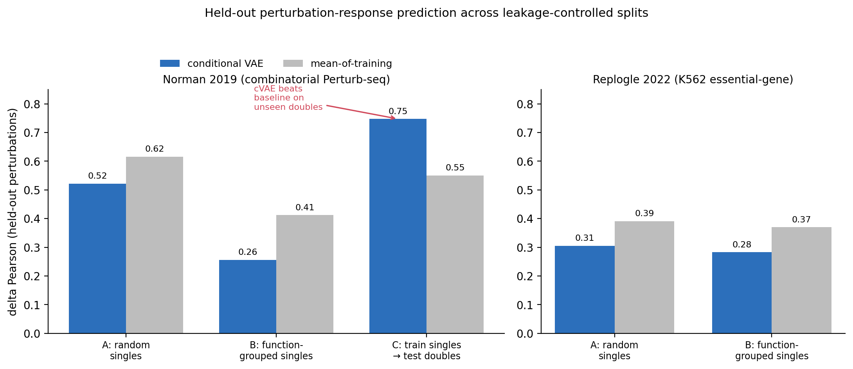
Figure 1. Mean delta-Pearson over held-out perturbations, conditional VAE (blue) vs mean-of-training (grey). The learned model exceeds the strong baseline only on the combinatorial split.
Dataset | Split | n test | cVAE r | MoT r | cVAE Jacc | MoT Jacc
Norman | A random | 20 | 0.522 | 0.616 | 0.243 | 0.266
Norman | B function | 28 | 0.257 | 0.412 | 0.125 | 0.173
Norman | C combinatorial | 131 | 0.748 | 0.551 | 0.341 | 0.199
Replogle | A random | 237 | 0.305 | 0.391 | 0.084 | 0.072
Replogle | B function | 86 | 0.283 | 0.370 | 0.082 | 0.076
Finding 1: the compositional win. On Norman's combinatorial split the cVAE reaches delta-Pearson 0.748 vs 0.551 for mean-of-training (+0.197), and the top-20 DE-gene overlap rises from 0.199 to 0.341. This is the one regime where the prediction is genuinely about interaction, and a model that composes two single-gene embeddings captures structure a fixed vector cannot. This is the project's positive result.
Finding 3: single-perturbation calibration (honest negative). On every single-perturbation split of both datasets, the mean-of-training baseline is higher than the cVAE. A small VAE does not beat predicting the average response when the test perturbation is itself a single gene, consistent with the documented difficulty of beating simple baselines on single-perturbation benchmarks. It is reported rather than hidden.

6.2 The leakage gap
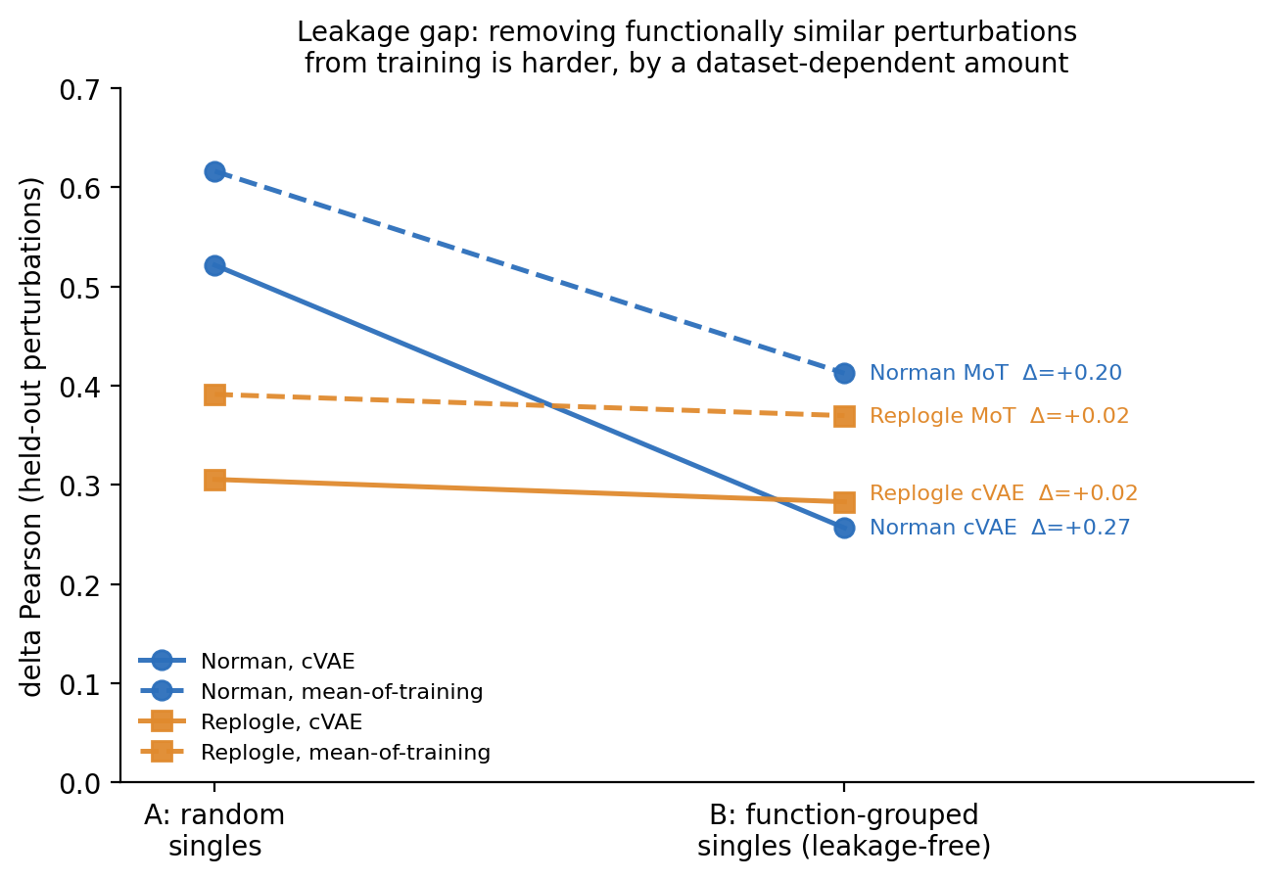
Figure 2. Delta-Pearson on the random split (A) vs the leakage-free function-grouped split (B). The slope is the leakage gap: large on Norman, almost flat on Replogle.
Dataset | Method | A random | B function | gap (A-B)
Norman | cVAE | 0.522 | 0.257 | 0.265
Norman | mean-of-training | 0.616 | 0.412 | 0.204
Replogle | cVAE | 0.305 | 0.283 | 0.023
Replogle | mean-of-training | 0.391 | 0.370 | 0.021
Finding 2: the leakage gap is real but dataset-dependent. On Norman, withholding whole functional groups instead of random genes drops delta-Pearson by 0.265 for the cVAE and 0.204 even for the baseline: a fifth to a quarter of the apparent random-split performance was interpolation between functionally similar perturbations. On Replogle the same procedure moves the number by only about 0.02, because its 1,092-gene essential-gene responses are dominated by a single shared growth-arrest signature, so the mean baseline is already near the ceiling. The leakage gap is not a universal constant; its size tracks how much perturbation-specific structure a dataset contains. On a diverse set a random-split number can overstate leakage-free generalization by 0.2 to 0.27 Pearson.

7. What this shows, and what it does not
It shows (i) a learned conditional model can beat a strong, identity-blind baseline specifically on compositional prediction of unseen perturbation combinations; (ii) on single-perturbation prediction that same model does not beat the baseline at this scale; (iii) a leakage-free split changes measured generalization substantially on a diverse dataset and barely on a homogeneous one. It does not show this particular cVAE is a competitive perturbation model: the architecture is small and untuned, the functional groups are a coarse co-expression proxy, and the metric is pseudobulk delta-correlation. The contribution is the benchmark design and the honest cross-dataset accounting.

8. Reproducibility
Every number is produced by the repository scripts from the public datasets with deterministic splits: run_baselines.py and train.py on each perturb_processed.h5ad, then make_figures.py. tests/test_smoke.py checks the splits, metrics, baselines, and model on small synthetic arrays, correctness tests explicitly labeled as such, not part of any reported result.

References
[1] Norman, T.M., Horlbeck, M.A., Replogle, J.M., et al. Exploring genetic interaction manifolds constructed from rich single-cell phenotypes. Science 365(6455):786-793, 2019.
[2] Replogle, J.M., Saunders, R.A., Pogson, A.N., et al. Mapping information-rich genotype-phenotype landscapes with genome-scale Perturb-seq. Cell 185(14):2559-2575, 2022.
[3] Roohani, Y., Huang, K., Leskovec, J. Predicting transcriptional outcomes of novel multigene perturbations with GEARS. Nature Biotechnology 42:927-935, 2024.
[4] Lotfollahi, M., Klimovskaia Susmelj, A., De Donno, C., et al. Predicting cellular responses to complex perturbations in high-throughput screens (CPA). Molecular Systems Biology 19(6):e11517, 2023.
[5] Ahlmann-Eltze, C., Huber, W., Anders, S. Deep-learning-based gene perturbation effect prediction does not yet outperform simple linear baselines. Nature Methods 22:1657-1661, 2025.
[6] Kernfeld, E., Yang, Y., Weinstock, J.S., Battle, A., Cahan, P. A systematic comparison of computational methods for expression forecasting. bioRxiv 2023.07.28.551039, 2023.

