Improving subgrid-scale clouds and precipitation in large-scale models: thesis proposal

Benjamin R. Hillman

10/12/14

## 1 Introduction

Clouds are a key piece of the global climate system, but accurate modeling of clouds in large-scale models is difficult, and cloud feedbacks in global climate models (GCMs) are recognized as a primary contributor to inter-model differences in responses to climate forcings (e.g., Cess et al., 1990; Bony and Dufresne, 2005; Williams and Webb, 2009; Medeiros et al., 2008).

The complexity of simulating the climate system with current computational resources limits GCM resolutions to tens or hundreds of kilometers, but clouds occur and vary on much smaller spatial scales. This means that traditional GCMs are unable to resolve individual clouds, and instead descriptions of clouds in GCMs are limited to large-scale statistical summaries of cloud properties on the scale of the model grid (Randall et al., 2003). But radiative fluxes depend on cloud properties in a non-linear manner and so the details of the unresolved structure and variability of clouds is important for model radiative transfer parameterizations (e.g. Barker et al., 1999). Most GCMs however, fail to completely account for unresolved cloud structure and variability in a sufficient manner.

The goal of this project is to reduce errors in radiative fluxes and simulated satellite-observable cloud diagnostics in large-scale models by improving the treatment of unresolved clouds and precipitation.

## 2 Background

The description of clouds in GCMs typically includes profiles of partial cloudiness (cloud area fraction by level) and the in-cloud liquid and ice cloud condensate (e.g. Collins et al., 2004; Neale et al., 2010a). The gridbox mean description of clouds does not in itself specify how the clouds should be distributed horizontally and vertically within model gridboxes, and characterization of the unresolved structure depends on additional assumptions about how clouds in overlapping layers are aligned vertically and how cloud properties vary within model gridboxes.

Early radiative transfer parameterizations in large-scale models used relatively simple assumptions about how subgrid-scale overlapping cloudy layers align vertically (e.g. Collins, 2001). These include maximum overlap, in which the cloudy portions of overlapping cloudy layers are assumed to be perfectly correlated (i.e., vertically projected cloud area is minimized); random overlap, in which the cloudy portions of overlapping cloudy layers are uncorrelated; and the popularly used maximum-random overlap, in which adjacent cloudy layers are maximimally overlapped but layers separated by at least one clear layer are randomly overlapped (Geleyn and Hollingsworth, 1979). The maximal-random overlap assumption in particular has been used in a number of GCMs (e.g. Collins et al., 2004; Neale et al., 2010a, 2010b). However, these assumptions have been shown to be insufficient to capture the complexity of clouds seen in observations (e.g. Hogan and Illingworth, 2000; Mace and Benson-Troth, 2002; Barker, 2008), and sensitivity tests using high resolution model simuations have shown that unrealistic overlap assumptions can lead to large errors in calculated fluxes and heating rates (Barker et al., 1999; Wu and Liang, 2005).

Subgrid-scale variability in cloud condensate is often completely neglected in GCMs, despite the fact that clouds can exhibit large variability on scales much smaller than GCM gridboxes (e.g. Stephens and Platt, 1987). This is problematic because radiative fluxes and heating rates calculated from model radiative transfer parameterizations are sensitive to subgrid-scale variations in cloud condensate (e.g. Barker et al., 1999; Wu and Liang, 2005; Oreopoulos et al., 2012). The sensitivity to both cloud overlap and condensate variability emphasizes the need to provide descriptions of clouds in large-scale models radiative calculations that include both horizontal variability in cloud properties and more realistic cloud overlap.

One way to account for subgrid-scale variations in cloud structure and condensate amount is to actually generate ensembles of subcolumns from the gridbox mean properties and calculate the radiative fluxes and heating rates on each generated subcolumn independently using the independent column approximation (ICA; Cahalan et al., 1994). This can become computationally demanding due the need to integrate radiative transfer calculations over a large number of spectral intervals for each subcolumn, but Pincus et al. (2003) introduced an approach that reduces the computational burden substantially by stochastically sampling both cloud state and spectral interval simultaneously. This approach, known as the Monte Carlo Independent Column Approximation (McICA), allows for fast ICA-like radiative transfer calculations (at the cost of artifically increased random noise) that can treat inhomogeneous clouds and has been incorporated into the widely used RRTMG radiation package and used in a number of state-of-the-art models (Iacono et al., 2008; von Salzen et al., 2012; Neale et al., 2010a, 2010b; Donner et al., 2011; Hogan et al., 2014),

McICA separates the treatment of cloud structure and variability from radiative transfer parameterization, leaving the task of describing complex cloud structure and variability up to subcolumn sampling schemes. In principle, arbitrarily complex cloud geometries and condensate distributions can be generated by incorporating more sophisticated subcolumn schemes. However, the subcolumn schemes currently used in most GCMs make many of the same simplifications used by earlier models, including maximum-random overlap and homogeneous cloud properties (e.g. Neale et al., 2010a, 2010b). Improved subcolumn schemes are needed to take full advantage of the flexibility offered by McICA.

Unresolved cloud structure and condensate variability is important not only for calculations of radiative fluxes, but also for cloud diagnostics commonly used for evaluation of model cloud properties themselves. Satellite instrument simulators such as those provided by the CFMIP Observational Simulator Package (COSP; Bodas-Salcedo et al., 2011) are often used to remove ambiguities in model evaluation studies that arise from uncertainties and limitations in satellite retrievals of cloud properties by producing psuedo-observations from the model state that are more directly comparable to the satellite observations (e.g. Klein and Jakob, 1999; Webb et al., 2001; Zhang et al., 2005, 2010; Kay et al., 2012; Klein et al., 2013). A key first step in simulating satellite observations from GCM cloud properties is accounting for the mismatch in resolved scales between the satellite pixel and model resolution by downscaling the gridbox mean cloud properties. This is done in COSP by stochastically generating subcolumns consistent with an overlap assumption to account for correlations in overlapping cloudy layers in the same manner as described for McICA above. However, the current implementation of COSP allows for only the simple maximum, random, or maximum-random overlap, and treats subcolumn clouds and precipitation as homogeneous. To the extent that the simulated satellite-observables are sensitive to these assumptions, failing to accurately characterize the subgrid cloud structure and condensate variability potentially introduces ambiguities into satellite-model comparisons. This problem deserves a closer look to build confidence in conclusions derived from these evaluation efforts. A strategy for assessing these sensitivities and for improving the representation of subgrid scale cloud and precipitation overlap and variability is presented in the following sections.

## 3 Proposed work

### 3.1 Sensitivity of simulated satellite-observable cloud diagnostics to unresolved clouds and precipitation

A straightforward analysis method is used to evaluate the sensitivity of COSP diagnostics to assumptions about subgrid-scale cloud and precipitation overlap and variability. The subcolumn sampling scheme within the COSP code can be bypassed by providing fields with resolved clouds and precipitation. Assumptions about variability and overlap can then be mimicked by modifying the resolved fields used as input to the simulators, and the differences in the outputs can be taken to represent sensitivities to the modeled assumptions.

Previous studies have used cloud resolving model simulations in a similar manner to evaluate the sensitivity of radiative fluxes and heating rates to overlap and unresolved variability (e.g. Barker et al., 1999; Wu and Liang, 2005). A more comprehensive sampling of different cloud regimes is obtained for this study by using output from the Multi-scale Modeling Framework (MMF; Khairoutdinov and Randall, 2001; Randall et al., 2003). The MMF replaces the cloud parameterizations in a traditional GCM with a 2D cloud resolving model in each gridbox. This provides global fields with resolved subgrid structure that can be passed directly to the individual instrument simulators within COSP.

In order to separately evaluate the sensitivity to overlap and heterogeneity, the following sets of modified fields are performed:

• CRM: The original CRM fields within each gridbox of the MMF are used as inputs to the individual instrument simulators in COSP.

• CRM-HOM: hydrometeor cloud mixing ratios are replaced with in-cloud averages (and precipitation mixing rations with in-precipitation averages), but the locations of hydrometeors (both cloud and precipitation) are retained from the full CRM fields (i.e., occurrence overlap is retained from the CRM).

• CRM-RES: cloud and precipitation mixing ratios are re-sampled from the full CRM fields, but the locations of these hydrometeors and there type are retained from the full CRM fields.

• MRO-HOM: hydrometeor mixing ratios and cloud optical properties are first averaged to produce gridbox means, similar to what a GCM would diagnose. Subcolumns are then regenerated consistent with the commonly used maximum-random overlap assumption, and homogeneous cloud properties (the gridbox means) are assigned to the cloudy subcolumns.

An example of these different fields obtained from a single grid cell from the MMF is shown in Figure 1. The only difference between the CRM and CRM-HOM fields is that the CRM-HOM fields have homogeneous cloud and precipitation properties, so differences in COSP diagnostics calculated from these two cases represent the sensitivity to unresolved variability in cloud and precipitation properties alone. Differences between the diagnostics calculated from the CRM-HOM and MRO-HOM fields represent errors arising due to assumptions about cloud (and precipitation) overlap. The CRM-RES modification destroys any correlation between condensate amount at different levels, so differences between the CRM and CRM-RES simulations represent errors arising due to condensate amount overlap and the overlap between hydrometeor condensate of different types (clouds and precipitation).

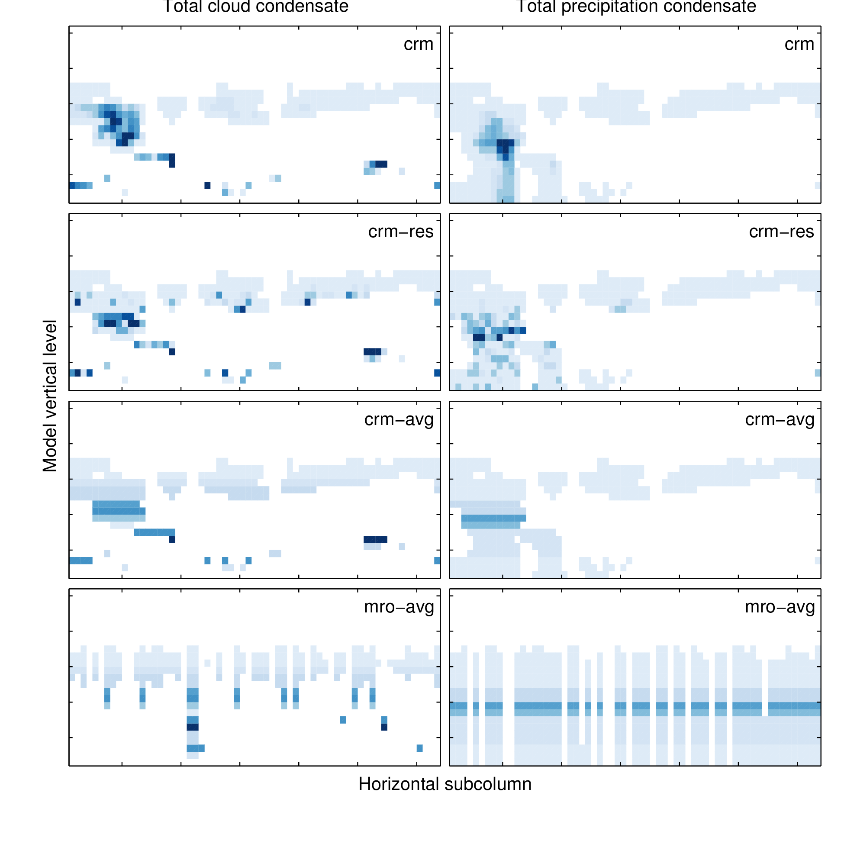

Figure 1: Total cloud and precipitation condensate mixing ratios modified from the embedded CRM condensate mixing ratios within a single MMF gridbox.

Simulated CloudSat (Stephens et al., 2002) radar reflectivity factor with height histograms from these four cases are shown in Figure 2. The CRM-RES simulation has more hydrometeors in middle levels above about 7 km with radar reflectivity factor between −20 and 10 dBZ than the CRM-full simulation. Because these cases have the same level-by-level PDF of condensate amount by construction, differences between these two cases arise due to differences in the vertical alignment of condensate amount between levels. That is, attenuation by upper levels reduces … The differences shown here highlight the importance of accounting for this alignment in an improved subcolumn generator.

The CRM-AVG simulation has too many hydrometeors along the entire characteristic curve of the histogram relative to the CRM case, but this is especially evident at low levels and for radar reflectivity factor greater than 0 dBZ. Hydrometeros in this height and reflectivity range are attributed to low-level drizzle and rain (Marchand et al., 2009), and the overestimation of hydrometeor occurrence in this mode in the CRM-AVG simulation relative to the CRM case would imply that there is too much precipitation in the CRM-AVG case. However, these cases were drawn from the same CRM simulation and by construction the precipitation fraction at each level in each large-scale gridbox (number of subcolumns containing precipitation divided by total number of subcolumns) is consistent between the two cases. This emphasizes the need to account for subgrid variability in condensate amounts (especially precipitation) in order to be able to draw correct conclusions from simulator comparisons.

The MRO-AVG has even larger hydrometeor occurrence along the characteristic curve than the CRM-AVG simulation, especially for low-level hydrometeors with radar reflectivity greater than 0 dBZ. This suggests that the MRO-AVG simulation has even more widespread precipitation than the already too high CRM-AVG simulation. This is likely true in the MRO-AVG simulation due to the simple treatment of precipitation subcolumn generation used here, in which precipitation is not constrained by the actual precipitation fraction, but assigned to any level in a column in which the precipitation fraction is non-zero and contains cloud in the current column or precipitation in the column above. This likely leads to an overestimation of precipitation occurrence (suggested by the single-column example shown in Figure 1), and this is consistent with the overestimation of hydrometeors with large radar reflectivity factor shown here. Di Michele et al. (2012) demonstrate considerable sensitivity of simulated radar reflectivity (using a different simulator) to different approaches of generating precipitation subcolumns. Yuying Zhang and Stephen Klein (personal communication) have been working on an improvement to this treatment of precipitation that constrains the generated subcolumn precipitation to a precipitation fraction diagnosed from the model. Results from their own sensitivity tests to their improvements are in preparation, and it will be interesting to see how these changes affect the sensitivity to subgrid-scale variability shown here.

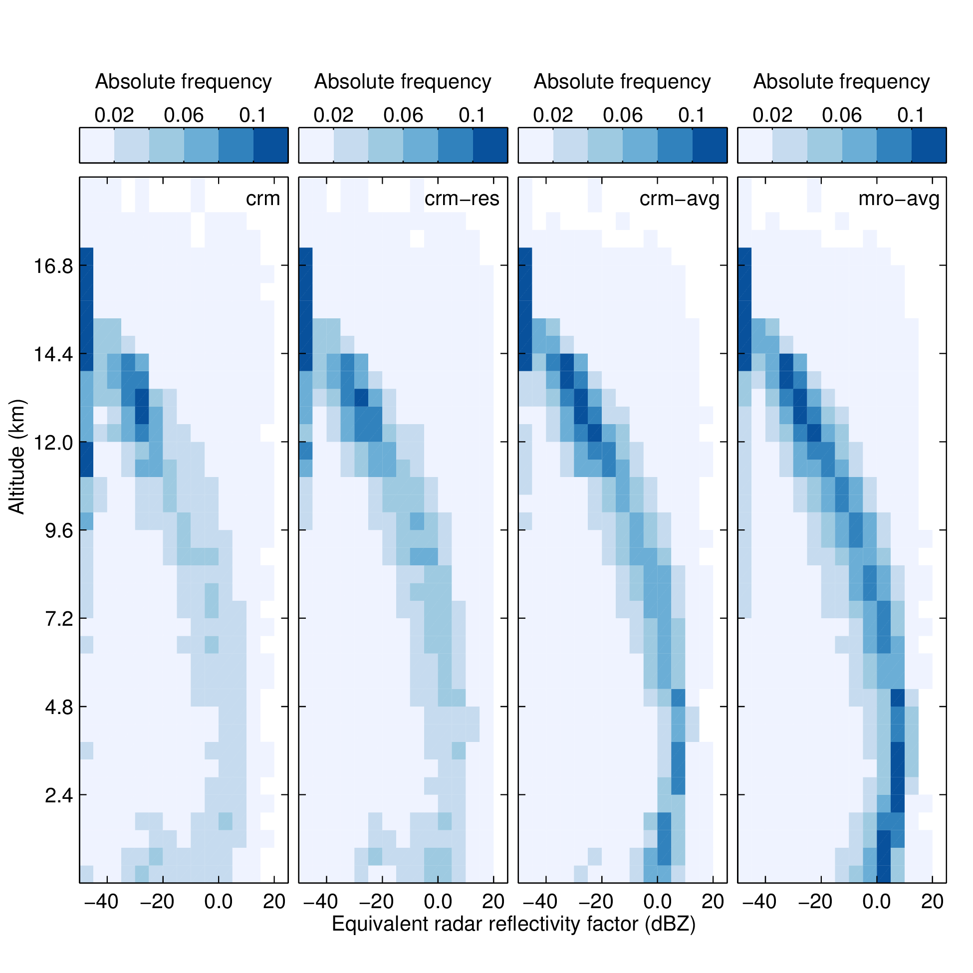

Figure 2: Simulated CloudSat radar reflectivity factor with height histogram for the Tropical Warm Pool region.

Figure 3 shows simulated ISCCP, MODIS, and MISR cloud top presure (or height, in the case of MISR) histograms for the same Tropical Warm Pool region from each of the subcolumn schemes. There are some noteworthy differences in the simulated cloud top height between the different cases, especially for the high-topped clouds. Cloud amount in the ISCCP highest cloud top pressure bin is underestimated while cloud in the second highest cloud top pressure bin is OVERestimated in both cases with averaged optical properties (CRM-AVG and MRO-AVG) relative to the cases without the averaging. These differences are up to about 5% is absolute cloud cover. The MODIS-simulated cloud top pressure has smaller differences that appears inconsistent with the ISCCP-simulated cloud top pressure. The largest differences are in the MISR-simulated cloud top height, and all of the modified cases overestimate clouds with top between 11 and 13 kilometers relative to the full CRM case. The MRO-AVG has the largest departure from the cRM case, and also underestimates mid-level and low-level clouds.

Differences between the MRO-AVG and CRM-AVG simulations SHOW that overlap does play a role in these differences, but the differences between the CRM and the CRM-AVG cases also SHOWS that the subgrid variability in optical properties is important as well.

Overall, the simulated ISCCP, MODIS, and MISR cloud top height diagnostics appear to be less sensitive to the subgrid variability and condensate overlap than the simulated radar reflectivity, but there are some differences that need to be explored further. It is unclear from this simple analysis whether these differences are significant or if they are greater in magnitude than the uncertainty in the observations or simulators themselves. A separate study is underway evaluate the sensitivity of the MISR simulator comparisons using hydrometeor profiles derived from a combination of CloudSat and CALIPSO data, which will help determine the limits to which we can assign biases to significant differences between models and observations.

Total cloud cover (area under these curves) should be the same! Perhaps mention/discuss this.

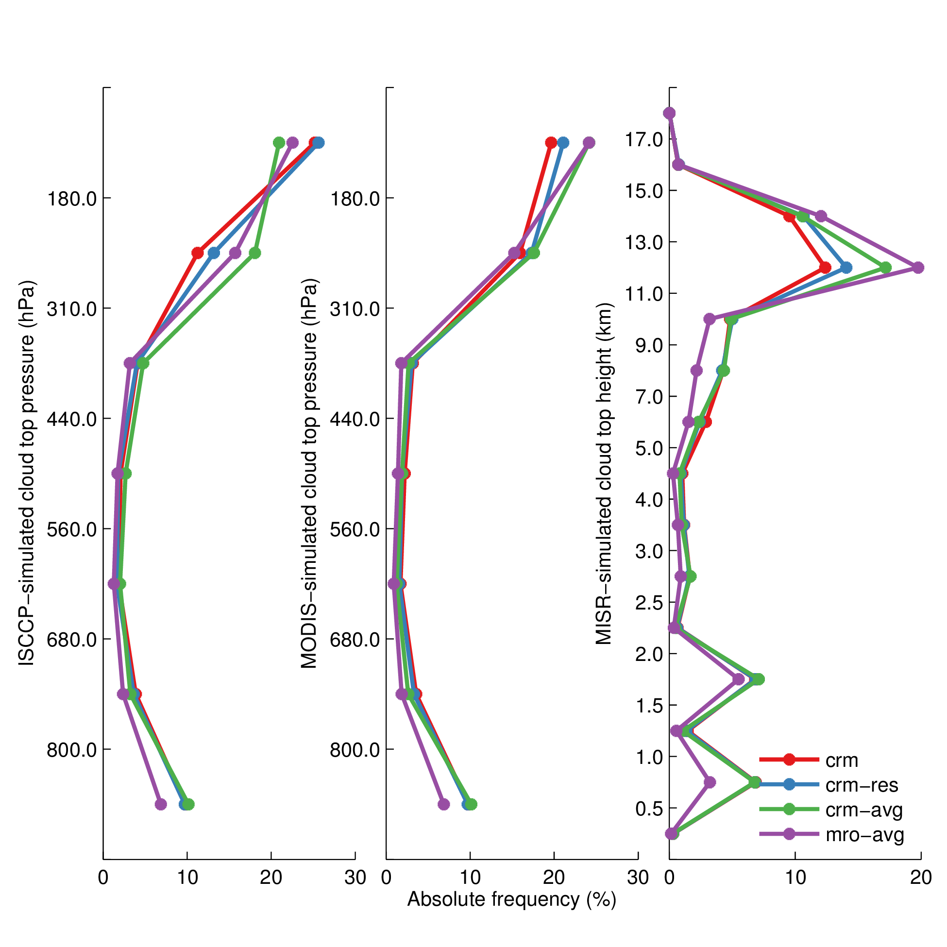

Figure 3: Simulated ISCCP, MODIS, and MISR clout top pressure (height) histograms for the Tropical Warm Pool region.

The sensitivities identifed in this section motivate improvements to the treatment of subgrid variability and overlap for use in COSP.

### 3.2 Improving treatment of cloud and precipitation overlap and subgrid scale variability

Räisänen et al. (2004) present the details of a scheme that can generate cloudy subcolumns with more flexible occurrence overlap and variable in-cloud condensate. Their scheme allows for overlap that is a combination of maximum and random (e.g. Hogan and Illingworth, 2000), which has been demonstrated to better fit both observations and high resoluation model simulations than simple maximum-random overlap (Hogan and Illingworth, 2000; Mace and Benson-Troth, 2002; Pincus et al., 2005; Barker, 2008). The weighting between maximum and random overlap is determined by a decorrelation length scale that describes how overlap changes from maximum to random with separation distance. Variable in-cloud condensate for subcolums is possible if the probability distribution function (PDF) of condensate can be input to the subcolumn generator. The vertical alignment of condensate amount is determined by a separate decorrelation length scale that describes how the rank correlation of condensate amount between layers varies with separation distance. Räisänen et al. (2004) demonstrate improvements in radiative fluxes calculated using their improved subcolumn generator by resampling subcolumns from high-resolution model output with decorrelation depths and condensate distribution derived directly from the high-resolution model output.

Oreopoulos et al. (2012) tested the sensitivity of a global climate model to improved subgrid clouds using the Räisänen et al. (2004) generator. They derive approximate decorrelation depths that vary with latitude and season from an analysis of CloudSat data (Stephens et al., 2002), and use beta distributions to describe the variability of in-cloud condensate. Their results suggest that improvements in radiative fluxes due to implementation of this scheme may be significant, but their simple latitude and seasonal dependence of decorrelation depths are not guaranteed to hold in a changing climate, and parameterization of these quantities in terms of model fields is probably a better approach for operational use in a model intended to aid understanding of the climate system in response to changes. Pincus et al. (2005) derive decorrelation depths from cloud resolving model data, and suggest parameterizing these in terms of large-scale fields such as wind shear and convective strength. They provide such a parameterization, but limited to a single domain over the ARM SGP site. Nonetheless, this is a good start, and this is an attractive avenue for further parameterization of these quantities. A major contribution of the present work will be to provide a more comprehensive characterization of the subgrid-scale structure of clouds and precipitation.

Another promising subgrid method is the Subgrid Importance Latin Hypercube Sampler (SILHS; Larson et al., 2005; Larson and Schanen, 2013), which can generate stochastic subcolumns from an assumed PDF of an arbitrary number of mixing ratios and has been set up to work with the Cloud Layers Unified By Binormals (CLUBB; Golaz et al., 2002) in the development version of CAM5 (Peter Caldwell, personal communication).

I propose a characterization of overlap statistics using output from the MMF and to separately diagnose overlap of clouds and precipitation, which our senstivity test show will be important and is difficult to do using only CloudSat radar observations. The advantage of using the MMF for these studies is that it provides a complete description of subgrid-scale clouds and precipitation across all regimes and inludes the large-scale fields available in a traditional GCM, which will likely be useful for parameterizating the overlap characteristics. The limitation with this approach is that the MMF is still a model, and may not completely capture the complexity of the real atmosphere. In order to address this issue, I also plan to use hydrometeor occurrence profiles derived from CloudSat (Stephens et al., 2002) and CALIPSO (Winker et al., 2007) observations to independently derive overlap statistics in a similar manner as done by Barker (2008) to compare with my characterization of overlap derived from MMF output. The goal is for this analysis to result in a parameterization of decorrelation lengths for both cloud and precipitation occurrence and condensate overlap based on large-scale fields. As suggested in the previous section, treating the precipitation in a more realistic manner will be important in accurately simulating radar reflectivities.

Subgrid-scale variability of cloud and precipitation condensate amount will also need to be characterized. With recent interest in PDF-based cloud parameterizations (e.g. Tompkins, 2002), it makes sense to connect the subcolumns used by the radiative transfer and COSP modules to those used in the cloud physics parameterizations directly. There is an on-going project to implement the Cloud Layers Unified By Binormals (CLUBB Golaz et al., 2002) into the National Center for Atmospheric Research (NCAR) Community Atmosphere Model (CAM), which would naturally provide the subgrid-scale variability in total water and rain water mixing ratios needed. Work as already been done to pass PDFs of condensate from CLUBB to the radiation code in the development version of CAM5 (Andrew Gettelman, personal communication), and it would likely be straightforward to extend this to either pass the subcolumns generated by the McICA code to COSP, or to similarly pass the PDFs of condensate to an improved COSP subcolumn sampler to include the subgrid variability.

In the interest of also providing a stand-alone parameterization for use in offline calculations of simulator diagnostics using COSP, I also propose to develop an independent characterization of subgrid-scale cloud and precipitation variability. I plan to base this on output from both the MMF and available observations. The basic outline of this is to use the MMF to provide a first-guess at the distribution, and then to compare that to observations where possible. CloudSat reflecitivies have been used by others to derive variability parameters (Oreopoulos et al., 2012), but these carry large uncertainties due to the strong sensitivity to precipitation and difficulty in separating clouds from precipitation using radar reflectivity alone. Because of this, it might be necessary to look at variability derived from in-situ measurements as an additional check of variability derived from MMF output.

### 3.3 Sensitivity of radiative fluxes and COSP simulator diagnostics to improvements in the treatment of cloud and precipitation overlap and subgrid-scale variability

Following the characterization of overlap statistics and subgrid-scale variability, the next step is to implement the improved scheme into COSP and into a GCM and test the sensitivity of the fluxes and simulated satellite-observables to the improvements.

Implementation of the improved subgrid treatment is relatively straightforward in the stand-alone COSP code, and the new subcolumn generator can just replace the “SCOPS” and “PREC_SCOPS” modules in that code. For use in CAM5, however, these modules should be bypassed and common subcolumns between COSP and the McICA radiative transfer code should be used to enforce consistency between the radiative transfer and the (radiatively-important) satellite-observable cloud diagnostics.

As mentioned above, the infrastructure to sample subcolumns with variable condensate from CLUBB PDFs has already been implemented in the development version of the CAM5. It should then be straightforward to either pass subcolumns with subgrid variability generated for the radiation code to COSP, or to pass CLUBB PDFs of condensate to COSP for generation of the subcolumns. This will allow for concurrent evaluation of the sensitivity of both radiative fluxes and COSP diagnostics to changes in the treatment of the subgrid cloud and precipitation structure and variability, with variability specified by the CLUBB physics parameterization. It is not clear yet whether or not their implementation generates subcolumns of precipitating hydrometeors. This will be important for the COSP diagnostics, and may need to be added or improved depending on what they have done.

Sensitivity of the COSP diagnostics will be tested alongside the radiative fluxes and heating rates in the context of the CAM5 implementation. The stand-alone COSP subcolumn scheme will be tested using MMF output and a similar framework as described above for the baseline sensitivity tests of the COSP outputs.

## 4 Expected outcomes and timeline

The following outcomes are expected from this work:

• Quantitative evaluation of the sensitivity of COSP diagnostics to unresolved cloud and precipitation structure and variability (Fall 2014)

• Characterization of subgrid-scale cloud and precipitation structure and variability (Winter and Spring 2015)

• Quantitative evaluation of the sensitivity of COSP diagnostics and radiative fluxes in CAM5 to improved treatment of subgrid-scale cloud and precipitation overlap and variability (Spring and Summer 2015)

Additionally, a comparison of ISCCP and MISR observations and corresponding ISCCP and MISR-simulated observations from profiles derived from CloudSat and CALIPSO observations will be completed to better understand uncertainties in the simulated ISCCP and MISR diagnostics.

## 5 Summary and impacts

Subgrid-scale variability in cloud structure and cloud properties have been shown by others to affect radiative fluxes and heating rates calculated by 1D radiative transfer codes in large-scale models, and are shown in the first part of this work to affect calculations of simulated satellite-observable cloud diagnostics. The latter are commonly used to assess the fidelty of models in simulating cloud properties consistent with present day observations, and so ambiguities arising due to neglect of important subgrid structure and variability potentially weaken some of the conclusions reached with these studies. The results of the present work will improve the representation of the subgrid-scale structure and variability of clouds and precipitation, and thereby lead to improved simulation of fluxes and heating rates and simulated satellite observerable cloud diagnostics in models. The improvement in fluxes and heating rates may reduce compensating errors in cloud properties, where tuning efforts have historically been needed to adjust cloud properties away from reasonable values in order to obtain radiative balance in climate simulations. The improvement in simulated satellite-observable cloud diagnostics will reduce ambiguities and uncertainties in comparisons between modeled and observed clouds and lead to more robust model evaluation.

References

Barker, H. W., 2008: Overlap of fractional cloud for radiation calculations in GCMs: A global analysis using CloudSat and CALIPSO data. *J. Geophys. Res.*, **113 (D00A01)**, 10.1029/2007JD009677.

Barker, H. W., G. L. Stephens, and Q. Fu, 1999: The sensitivity of domain-averaged solar fluxes to assumptions about cloud geometry. *Q. J. R. Meteorol. Soc.*, **125 (558)**, 2127–2152, 10.1256/smsqj.55809.

Bodas-Salcedo, A., et al., 2011: COSP: Satellite simulation software for model assessment. *Bull. Amer. Meteor. Soc.*, **92 (8)**, 10.1175/2011BAMS2856.1.

Bony, S. and J.-L. Dufresne, 2005: Marine boundary layer clouds at the heart of tropical cloud feedback uncertainties in climate models. *Geophys. Res. Lett.*, **32 (20)**, 10.1029/2005GL023851.

Cahalan, R. F., W. Ridgway, W. J. Wiscombe, T. L. Bell, and J. B. Snider, 1994: The albedo of fractal stratocumulus clouds. *J. Atmos. Sci.*, **51 (16)**, 2434–2455, 10.1175/1520-0469(1994)051<2434:TAOFSC>2.0.CO;2.

Cess, R. D., et al., 1990: Intercomparison and interpretation of climate feedback processes in 19 atmospheric general circulation models. *J. Geophys. Res.*, **95 (D10)**, 16 601–16 615, 10.1029/JD095iD10p16601.

Collins, W. D., 2001: Parameterization of generalized cloud overlap for radiative calculations in general circulation models. *J. Atmos. Sci.*, **58 (21)**, 3224–3242, 10.1175/1520-0469(2001)058<3224:POGCOF>2.0.CO;2.

Collins, W. D., et al., 2004: Description of the NCAR Community Atmosphere Model (CAM 3.0). NCAR Technical Note TN-464+STR, NCAR.

Di Michele, S., M. Ahlgrimm, R. Forbes, M. Kulie, R. B. M. Janisková, and P. Bauer, 2012: Interpreting an evaluation of the ECMWF global model with CloudSat observations: ambiguities due to radar reflectivity forward operator uncertainties. *Q. J. R. Meteorol. Soc.*, **138**, 2047–2065.

Donner, L. J., et al., 2011: The dynamical core, physical parameterizations, and basic simulation characteristics of the atmospheric component AM3 of the GFDL global coupled model CM3. *J. Climate*, **24 (13)**, 3484–3519, 10.1175/2011JCLI3955.1.

Geleyn, J. F. and A. Hollingsworth, 1979: An economical analytical method for the computation of the interaction of between scattering and line absorption of radiation. *Contrib. Atmos. Phys.*, **52**.

Golaz, J.-C., V. E. Larson, and W. R. Cotton, 2002: A PDF-based model for boundary layer clouds. part I: Method and model description. *J. Atmos. Sci.*, **59 (24)**, 3540–3551, 10.1175/1520-0469(2002)059<3540:APBMFB>2.0.CO;2.

Hogan, R. J. and A. J. Illingworth, 2000: Deriving cloud overlap statistics from radar. *Q. J. R. Meteorol. Soc.*, **126**, 2903–2909, 10.1256/smsqj.56913.

Hogan, T. F., et al., 2014: The navy global environmental model. *Oceanography*, **27 (3)**, 10.5670/oceanog.2014.73.

Iacono, M. J., J. S. Delamere, E. J. Mlawer, M. W. Shephard, S. A. Clough, and W. D. Collins, 2008: Radiative forcing by long-lived greenhouse gases: Calculations with the AER radiative transfer models. *J. Geophys. Res.*, **113 (D13103)**, 10.1029/2008JD009944.

Kay, J. E., et al., 2012: Exposing global cloud biases in the Community Atmosphere Model (CAM) using satellite observations and their corresponding instrument simulators. *J. Climate*, **25**, 5190–5207, 10.1175/JCLI-D-11-00469.1.

Khairoutdinov, M. F. and D. A. Randall, 2001: A cloud-resolving model as a cloud parameterization in the NCAR Community Climate System Model: Preliminary results. *Geophys. Res. Lett.*, **28**, 3617–3620.

Klein, S. A. and C. Jakob, 1999: Validation and sensitivities of frontal clouds simulated by the ECMWF model. *Monthly Weather Review*, **127 (10)**, 2514–2531, 10.1175/1520-0493(1999)127<2514:VASOFC>2.0.CO;2.

Klein, S. A., Y. Zhang, M. D. Zelinka, R. Pincus, J. Boyle, and P. J. Gleckler, 2013: Are climate model simulations of clouds improving? an evaluation using the ISCCP simulator. *J. Geophys. Res.*, **118 (3)**, 1329–1342, doi:10.1002/jgrd.50141.

Larson, V. E., J.-C. Golaz, H. Jiang, and W. R. Cotton, 2005: Supplying local microphysics parameterizations with information about subgrid variability: Latin hypercube sampling. *J. Atmos. Sci.*, **62**, 4010–4026.

Larson, V. E. and D. P. Schanen, 2013: The Subgrid Importance Latin Hypercube Sampler (SILHS): a multivariate subcolumn generator. *Geosci. Model Dev.*, **6**, 1813–1829, 10.5194/gmd-6-1813-2013.

Mace, G. G. and S. Benson-Troth, 2002: Cloud-layer overlap characteristics derived from long-term cloud radar data. *J. Climate*, **15**, 10.1175/1520-0442(2002)015<2505:CLOCDF>2.0.CO;2.

Marchand, R., J. Haynes, G. G. Mace, and T. Ackerman, 2009: A comparison of simulated radar output from the multiscale modeling framework global climate model with CloudSat cloud radar observations. *J. Geophys. Res.*, **114**, 10.1029/2008JD009790.

Medeiros, B., B. Stevens, I. M. Held, M. Zhao, D. L. Williamson, J. G. Olson, and C. S. Bretherton, 2008: Aquaplanets, climate sensitivity, and low clouds. *J. Climate*, **21 (19)**, 4974–4991, 10.1175/2008JCLI1995.1.

Neale, R. B., et al., 2010a: Description of the NCAR Community Atmosphere Model (CAM 4.0). NCAR Technical Note TN-485+STR, NCAR.

Neale, R. B., et al., 2010b: Description of the NCAR Community Atmosphere Model (CAM 5.0). NCAR Technical Note TN-486+STR, NCAR.

Oreopoulos, L., D. Lee, Y. C. Sud, and M. J. Suarez, 2012: Radiative impacts of cloud heterogeneity and overlap in an atmospheric General Circulation Model. *Atmos. Chem. Phys.*, **12**, 9097–9111, 10.5194/acp-12-9097-2012.

Pincus, R., H. W. Barker, and J.-J. Morcrette, 2003: A fast, flexible, approximate technique for computing radiative transfer in inhomogeneous cloud fields. *J. Geophys. Res.*, **108 (D13)**, 10.1029/2002JD003322.

Pincus, R., C. Hannay, S. A. Klein, K.-M. Xu, and R. Hemler, 2005: Overlap assumptions for assumed probability distribution function cloud schemes in large-scale models. *J. Geophys. Res.*, **110 (D15S09)**, 10.1029/2004JD005100.

Räisänen, P., H. W. Barker, M. F. Khairoutdinov, J. Li, and D. A. Randall, 2004: Stochastic generation of subgrid-scale cloudy columns for large-scale models. *Q. J. R. Meteorol. Soc.*, **130**, 2047–2067, 10.1256/qj.03.99.

Randall, D., M. Khairoutdinov, A. Arakawa, and W. Grabowski, 2003: Breaking the cloud parameterization deadlock. *Bull. Amer. Meteor. Soc.*, **84 (11)**, 1547–1564, 10.1175/BAMS-84-11-1547.

Stephens, G. L. and C. M. R. Platt, 1987: Aircraft observations of the radiative and microphysical properties of stratocumulus and cumulus cloud fields. *J. Climate Appl. Meteor.*, **26**, 1243–1269, 10.1175/1520-0450(1987)026<1243:AOOTRA>2.0.CO;2.

Stephens, G. L., et al., 2002: The CloudSat mission and the A-Train. *Bull. Amer. Meteorol. Soc.*, **83 (12)**, 1771–1790, 10.1175/BAMS-83-12-1771.

Tompkins, A. M., 2002: A prognostic parameterization for the subgrid-scale variability of water vapor and clouds in large-scale models and its use to diagnose cloud cover. *J. Atmos. Sci.*, **59**, 1917–1942, 10.1175/1520-0469(2002)059<1917:APPFTS>2.0.CO;2.

von Salzen, K., et al., 2012: The Canadian fourth generation atmospheric global climate model (CanAM4): Simulation of clouds and precipitation and their responses to short-term climate variability. *Atmos.-Ocean*, submitted.

Webb, M., C. Senior, S. Bony, and J.-J. Morcrette, 2001: Combining ERBE and ISCCP data to assess clouds in the Hadley Centre, ECMWF and LMD atmospheric climate models. *Clim. Dyn.*, **17 (12)**, 905–922, 10.1007/s003820100157.

Williams, K. D. and M. J. Webb, 2009: A quantitative performance assessment of cloud regimes in climate models. *Clim. Dyn.*, **33 (1)**, 141–157, 10.1007/s00382-008-0443-1.

Winker, D. M., B. H. Hunt, and M. J. McGill, 2007: Initial performance assessment of CALIOP. *Geophys. Res. Lett.*, **34 (L19803)**, 10.1029/2007GL030135.

Wu, X. and X.-Z. Liang, 2005: Radiative effects of cloud horizontal inhomogeneity and vertical overlap identified from a monthlong cloud-resolving model simulation. *J. Atmos. Sci.*, **62**, 4105–4112.

Zhang, M., et al., 2005: Comparing clouds and their seasonal variations in 10 atmospheric general circulation models with satellite measurements. *J. Geophys. Res.*, **110 (D15)**, 10.1029/2004JD005021.

Zhang, Y., S. A. Klein, J. Boyle, and G. G. Mace, 2010: Evaluation of tropical cloud and precipitation statistics of Community Atmosphere Model version 3 using CloudSat and CALIPSO data. *J. Geophys. Res.*, **115 (D12205)**, 10.1029/2009JD012006.