Submitted By: | Derron Foo (230185B)
Tutorial Group: | AA2303 ( Group 3 )
Tutor: | Mr Chan Gilbert
Date of Submission: | 14082023
IT1303 PROGRAMMING
2023 SEM 1 Assignment
MINI LIBRARY MANAGEMENT SYSTEM PROGRAM

Table of Contents
Overview
Overall Program Breakdown
Menu
Book List Nav
Book Search
Book Update / Remove
Add Book
Settings
Database Validation
Database Save / Load
Directory

Overview
Given the context of a Mini Library Management System to store book details, the main functions “Add New Book”, “Update Existing Book”, “Remove Existing Book” and “View Books” mainly revolves around the manipulation, viewing and editing, of book data. The program serves as a simplified tool for managing and organizing resources as well as bring ease in operations, involving a set of functionalities to help librarians efficiently handle tasks related to book inventory, user interaction and overall library maintenance in which the functions, starting with the main, will be listed below.
Functions:
- Menu
  - Consistent Layout
- Book List Nav
  - Page Listing
  - Page Navigation
- Book Search
  - Keyword Highlight
  - Error Detection
- Book Update / Remove
  - Error Diagnosis
  - Random Number Validation
- Book Add
  - Error Detection
  - Error Diagnosis
- Settings
  - Keybind Change
  - Change book amount per page
- Directory

Overall Program Breakdown

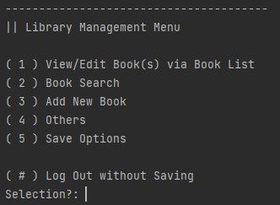
Menu

The menu serves as the user interface element through which users can engage with the program's functions without the need to recall specific commands or guidelines. It maintains a uniform structure comprising:
- A directory on the top
- A list of unique options
- A “Back” button
- A prompt for option selection

Book List Nav
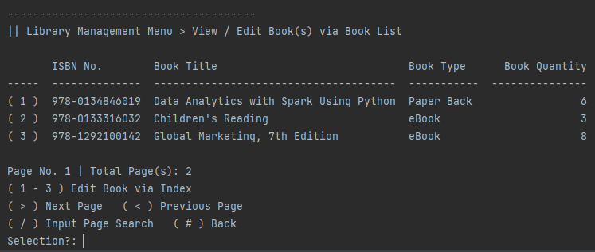
Selecting the first option of the menu leads to the listing of books in the database, the Book List option allows the user to mainly scroll through the database while following the same consistent layout as other pages.
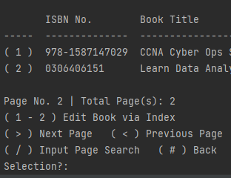
A real world library database typically should have hundreds or thousands of books, listing every book in the database in one go is troublesome therefore unreasonable for viewing. Therefore the Book List has a page navigation that lists a set amount of books for each page, with given options to go to:
- ( > ) Next page
- ( < ) Previous page
- ( / ) Manually input page count
The page is constantly updated when suitable, examples being the current page count getting updated.

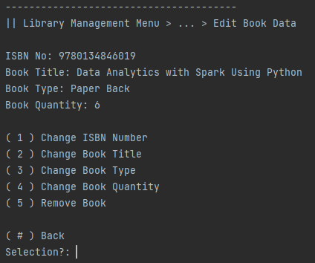
The option to “Edit Book via Index” also changes on the last page as the last page may not have enough books to fill up a page. In this case the total number of books is 5 while each page contains 3, leaving the last page 2 books.
In the scenario of seeing an oddity in the database, using the index of the book with relation to the list page, the user can select the book containing the anomaly.
More information on editing database contents will be continued under “Book Update / Remove”.

Book Search
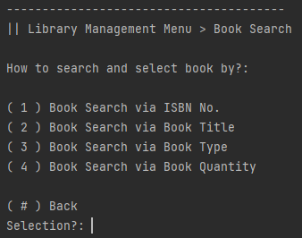
In the scenario of a real world library management system, the user should not have to scroll through the pages and the list of books in a page to find the desired book to edit. Therefore a search engine has been implemented to the program to allow the user to search, specifically four types of search for the respective four book data types.

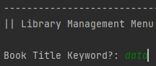
After selecting a search option, the search prompt will ask the user for an input. The program has in error detection, included examples being but not limited to:
- ISBN has logical assumptions for dash or space placement
  - ex. 1234-123456789 -> False
- Quantity Search can only be integers.
- Book type limited to the three types given.
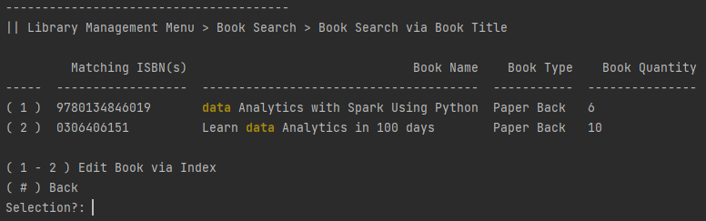
After choosing data type search and giving the keyword input, a tabulated list similar to the “Book List Nav” list will appear showing the list of books that have the keyword.
The keyword is highlighted in the program ,with import colorama, to indicate where the keyword was found.

Book Update / Remove
Choosing a book within the "Book Search" or "Book List Nav" options seamlessly directs the user to the "Edit Book Data" page, shows the current data of the book then shows the range of actions below:
- Update the contents of any of the four data types associated with the chosen book.
- Remove specific book data from the database with ease

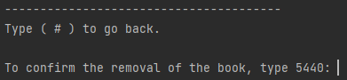
The Book Update / Remove has an built error diagnosis to check whether the data type follows the standard, after the update and the removal process the user is required to confirm their input by typing a, import random, generated number to verify their action.

Add Book
This option is crucial for the program as the program serves as a database, without the ability to add will render the four previous functionalities as futile as there will be no data to manipulate if there were no ability to add data in the first place.
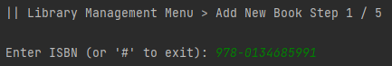

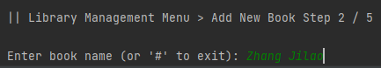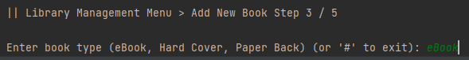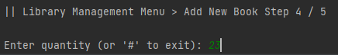
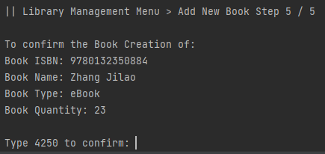
Similar to the previous function, the user is required to confirm by typing a randomly generated number to validate their input, this is to ensure there no erratum occurred during the book creation process.

Settings
Similar to any real-world program, the program has in-built settings that allow the user to customize and configure the behaviour and appearance of the software according to their preferences and needs. In this case, the settings rest in the “Others” Option.

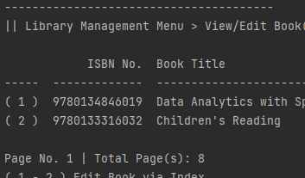
Settings ( Items Per Page )
Settings can include options to modify the program's visual output to accommodate users with different accessibility requirements, an example being the case of monitor size that determines the amount of content displayed on the screen, determining the size of the book list.
By allowing the user to edit the number of books shown on a page, the user can:
- Decrease the number of books shown per page if the list view exceeds the monitor height.
- Increase the number of books shown per page if there is still plenty of wasted space after the printing of a list.

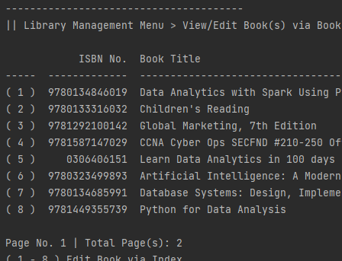

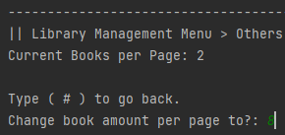

Settings ( Keybinds )
Settings allow users to personalize the software to align with their specific workflow, requirements, and or in this case comfort level and adapt to individual preferences by allowing the user to change the keybind of the option found throughout the program, the back button.

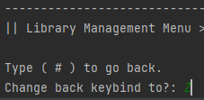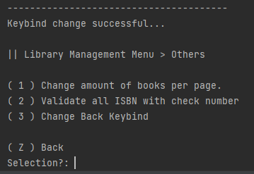

Database Validation

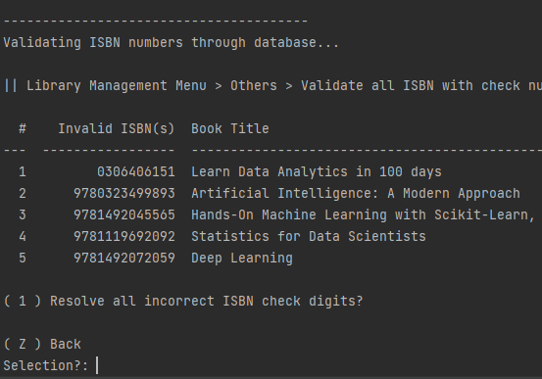
Being the last digit of an ISBN, the check digit is to catch any errors that might occur during the transcription or printing of the ISBN. It's calculated based on the other digits in the ISBN using a specific mathematical formula. When the check digit is recalculated from the rest of the digits and compared to the provided check digit, any discrepancies indicate a potential error in the ISBN. With the above in mind, there is an option for the user to validate all ISBNs and show any anomalies among the ISBN in the database.

Database Save / Load
Databases are used to store and manage data over a long period of time. In the scenario of a real-world database system, A save function allows you to persistently store the current state of the data in the database in a durable storage medium (like disk or cloud storage), ensuring that the data remains available even after the application or system is shut down or restarted. Therefore a database save and load system has been implemented in the program, reading and writing text files as external storage.
Data Load: Data Save:
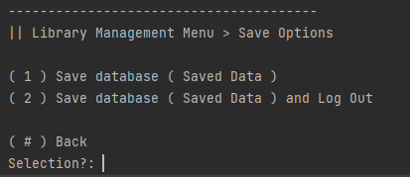
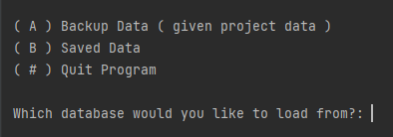

Directory
The presence of a directory allows the user to easily navigate throughout the program without having any prior knowledge of the program, acting as a navigation guide and a “map” for the user to understand which part of the program they are at.
