PLPA6820_CodingChallenge4
Bria Smith
2026-02-19
Article from Plant Disease

Question 1: Explain the following

- YAML Header: gives information on the file title, author, data, and output.My YAML header has my name, shows that I created my R markdown file today, and that it will render as a word document.

- Literate programming: allows individuals to understand the purpose of your code and different steps by combining the programming language with daily language.

Question 1b: Read the data using a relative file path
Mycotoxin <- read.csv("MycotoxinData.csv", na.strings = "na")

Question 1c: Make a separate code chunk for the figures plotting the data

Plot 1
library(ggplot2)
library(ggpubr)
Plot_1 <- ggplot(Mycotoxin, aes(x = Treatment, y = DON, color = Cultivar, fill = Cultivar)) +
geom_boxplot() +
geom_point(position=position_jitterdodge(dodge.width = 0.6), color = "#009E73") + # coloring points, setting jitter and jitter width
scale_fill_manual(values=c("#F0E442", "#0072B2")) + # filling and coloring boxplots
xlab("") + # labeling x-axis
ylab("DON(ppm)") + # labeling y-axis
theme_classic() + # classic theme
facet_wrap(~Cultivar) # faceted by Cultivar
Plot_1t <- Plot_1 +
geom_pwc(aes(group = Treatment), method = "t_test", label = "{p.adj.format}{p.adj.signif}")
plot(Plot_1t)
## Warning: Removed 8 rows containing non-finite outside the scale range
## (`stat_boxplot()`).
## Warning: Removed 8 rows containing non-finite outside the scale range
## (`stat_pwc()`).
## Warning: Removed 8 rows containing missing values or values outside the scale range
## (`geom_point()`).
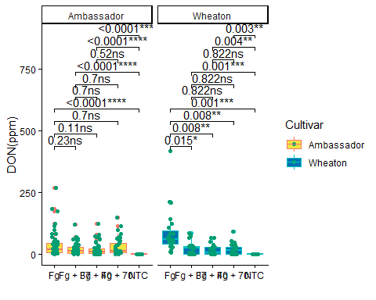 ### Plot 2
Plot_2 <- ggplot(Mycotoxin, aes(x = Treatment, y = X15ADON, color = Cultivar, fill = Cultivar)) +
geom_boxplot() +
geom_point(position=position_jitterdodge(dodge.width = 0.6), color = "#009E73") + # coloring points, setting jitter and jitter width
scale_fill_manual(values=c("#F0E442", "#0072B2")) + # filling and coloring boxplots
xlab("") + # labeling x-axis
ylab("15ADON") + # labeling y-axis
theme_classic() + # classic theme
facet_wrap(~Cultivar) # faceted by Cultivar
Plot_2t <- Plot_2 +
geom_pwc(aes(group = Treatment), method = "t_test", label = "{p.adj.format}{p.adj.signif}")
plot(Plot_2t)
## Warning: Removed 10 rows containing non-finite outside the scale range
## (`stat_boxplot()`).
## Warning: Removed 10 rows containing non-finite outside the scale range
## (`stat_pwc()`).
## Warning: Removed 10 rows containing missing values or values outside the scale range
## (`geom_point()`).
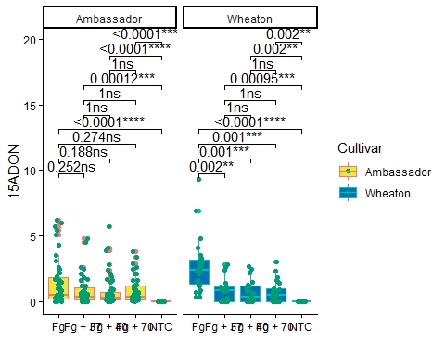 ### Plot 3
Plot_3 <- ggplot(Mycotoxin, aes(x = Treatment, y = MassperSeed_mg, color = Cultivar, fill = Cultivar)) +
geom_boxplot() +
geom_point(position=position_jitterdodge(dodge.width = 0.6), color = "#009E73") + # coloring points, setting jitter and jitter width
scale_fill_manual(values=c("#F0E442", "#0072B2")) + # filling and coloring boxplots
xlab("") + # labeling x-axis
ylab("Seed Mass (mg)") + # labeling y-axis
theme_classic() + # classic theme
facet_wrap(~Cultivar) # faceted by Cultivar
Plot_3t <- Plot_3 +
geom_pwc(aes(group = Treatment), method = "t_test", label = "{p.adj.format}{p.adj.signif}")
plot(Plot_3t)
## Warning: Removed 2 rows containing non-finite outside the scale range
## (`stat_boxplot()`).
## Warning: Removed 2 rows containing non-finite outside the scale range
## (`stat_pwc()`).
## Warning: Removed 2 rows containing missing values or values outside the scale range
## (`geom_point()`).
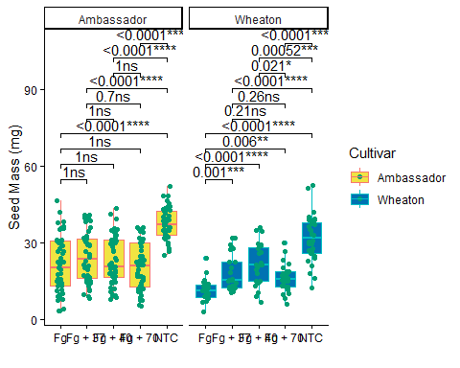 ### Combined Plots
combined_plot <- ggarrange( # combining the plots
Plot_1t,
Plot_2t,
Plot_3t,
ncol = 3,
nrow=1,
labels = "auto", # labeling the subplots as a, b, and c
common.legend = TRUE # RESPONSE TO QUESTION 4: common.legend gives all the plots one legend when their keys contain the same items.
)
## Warning: Removed 8 rows containing non-finite outside the scale range
## (`stat_boxplot()`).
## Warning: Removed 8 rows containing non-finite outside the scale range
## (`stat_pwc()`).
## Warning: Removed 8 rows containing missing values or values outside the scale range
## (`geom_point()`).
## Warning: Removed 8 rows containing non-finite outside the scale range
## (`stat_boxplot()`).
## Warning: Removed 8 rows containing non-finite outside the scale range
## (`stat_pwc()`).
## Warning: Removed 8 rows containing missing values or values outside the scale range
## (`geom_point()`).
## Warning: Removed 10 rows containing non-finite outside the scale range
## (`stat_boxplot()`).
## Warning: Removed 10 rows containing non-finite outside the scale range
## (`stat_pwc()`).
## Warning: Removed 10 rows containing missing values or values outside the scale range
## (`geom_point()`).
## Warning: Removed 2 rows containing non-finite outside the scale range
## (`stat_boxplot()`).
## Warning: Removed 2 rows containing non-finite outside the scale range
## (`stat_pwc()`).
## Warning: Removed 2 rows containing missing values or values outside the scale range
## (`geom_point()`).
plot(combined_plot)
