Supplemental Materials

Abstract

Supplemental Materials

Supplemental Materials
Table 1
Average number and SD of completed trials for participants in each age group in the dataset. The Participants column counts unique participants within each age group; 74 participants contributed data at two different ages (having played the game more than once) and are therefore counted in two rows. The column consequently sums to 4280 rather than the 4206 unique participants reported in the main text.
Age Group (yrs) | Mean Num Trials | SD Num Trials | Participants
3 | 56.57 | 31.90 | 84
4 | 62.87 | 28.90 | 87
5 | 54.44 | 31.55 | 100
6 | 45.85 | 30.18 | 116
7 | 21.35 | 10.37 | 194
8 | 21.38 | 8.28 | 649
9 | 19.92 | 7.65 | 740
10 | 20.50 | 9.76 | 542
11 | 21.63 | 7.49 | 526
12 | 22.74 | 6.92 | 489
13 | 22.42 | 7.68 | 305
14 | 21.89 | 4.98 | 237
Adults | 36.07 | 1.26 | 211
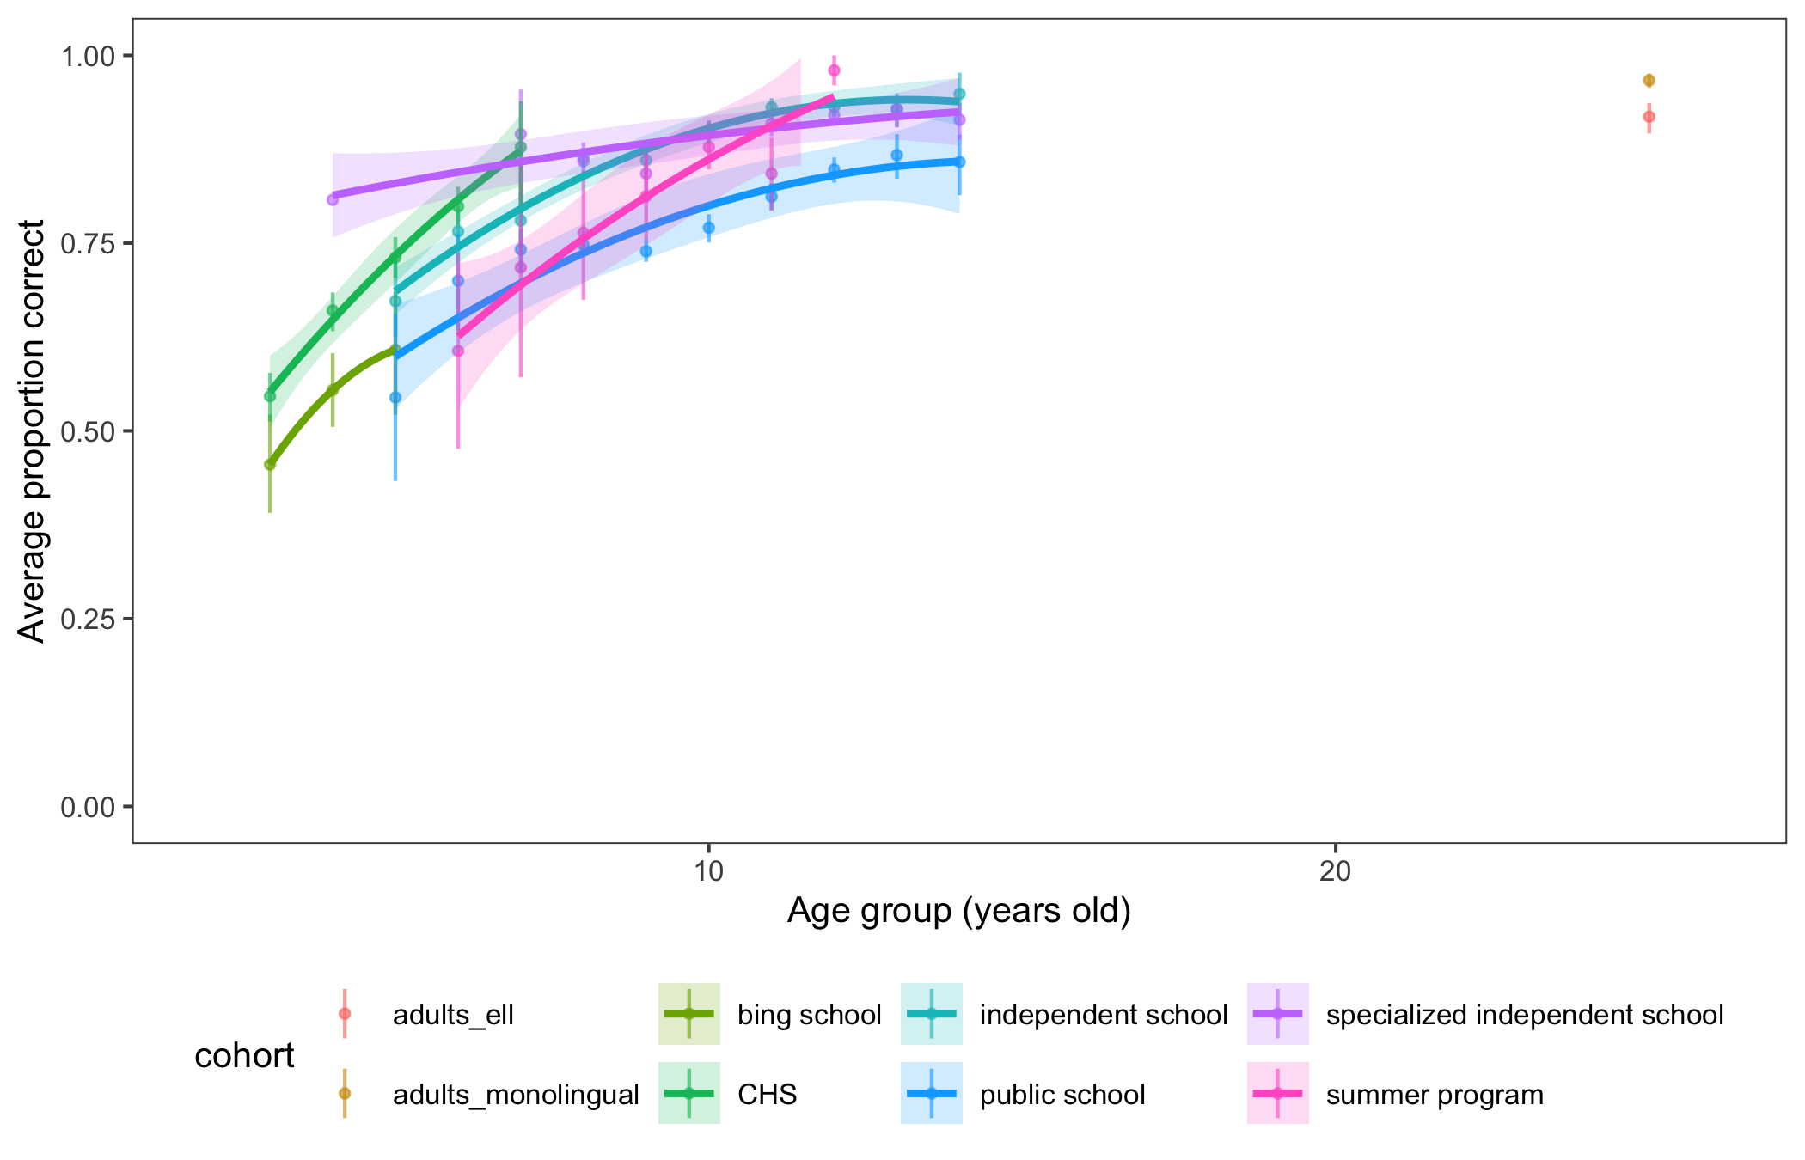
Figure 1: Proportion correct as a function of the age group of the child participating as well as the cohort in which the task was administered. All error bars are bootstrapped 95% confidence intervals.
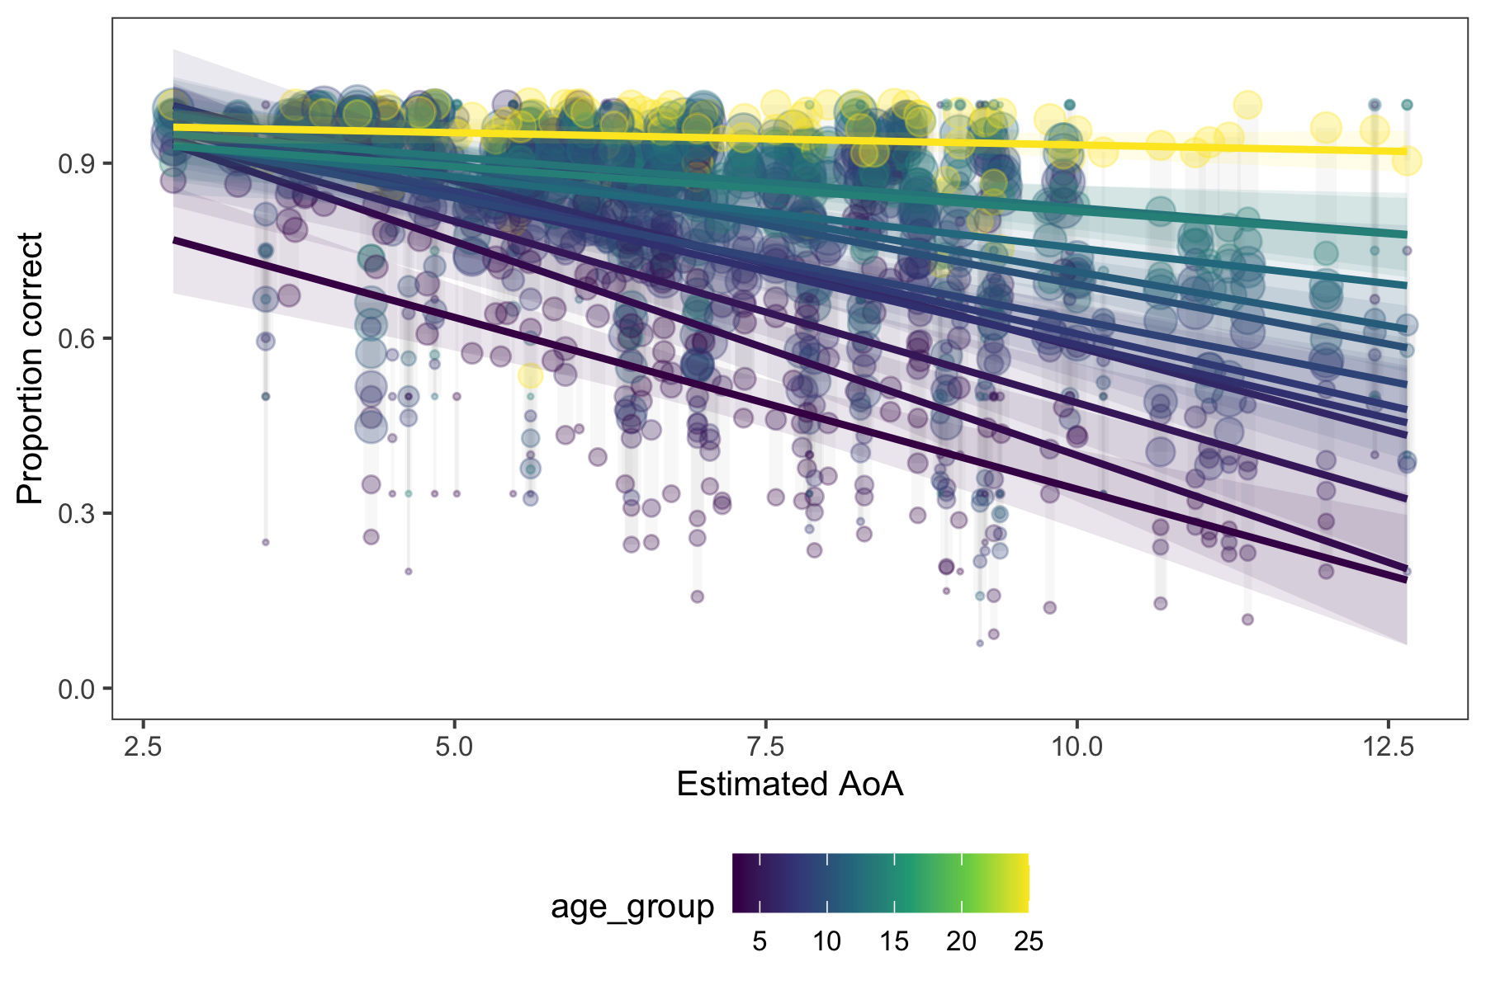
Figure 2: Proportion correct as a function of the AoA of the target word, shown continuously. Vertical lines connect data points for individual words across age groups.
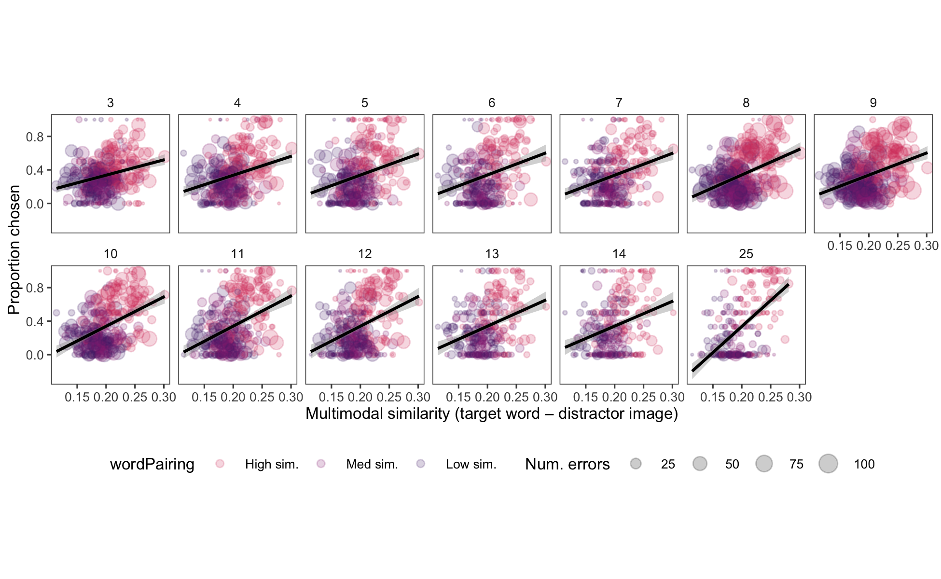
Figure 3: Proportion times an image was chosen as a function of the multimodal similarity between the target word and distractor image. Dot size scales with the number of errors for that image in the dataset. Trend lines show weighted best fit lines by the number of errors, faceted by each age group in the dataset.
Table 2
Model coefficients for the linear mixed-effect model of error proportions. Predictors include multimodal similarity (target word to distractor image), the residual of the semantic similarity after regressing on visual similarity, phonological similarity, the AoA of the target and answer words, the log frequency of the target and answer words, the concreteness of the target word, the total number of errors per (item, age) cell, the age group of the participant, and the interaction of the residual semantic similarity with age. Random intercepts for target word were included. All predictors were standardized prior to analysis. All VIFs were < 2.2.
Term | $\hat{β}$ | 95% CI | $t$ | $df$ | $p$
Intercept | 0.33 | [0.32, 0.35] | 47.92 | 82.45 | < .001
AoA (target) | 0.01 | [-0.01, 0.03] | 0.53 | 132.01 | .597
AoA (answer) | 0.01 | [-0.01, 0.02] | 1.08 | 2882.89 | .282
Multimodal sim. | 0.11 | [0.10, 0.12] | 22.04 | 2424.40 | < .001
Semantic residual | 0.03 | [0.02, 0.04] | 5.26 | 1696.11 | < .001
Age | 0.00 | [-0.01, 0.01] | -0.24 | 3980.86 | .810
Phonological sim. | 0.05 | [0.04, 0.06] | 9.61 | 1790.96 | < .001
Log. freq. (target) | 0.00 | [-0.02, 0.02] | 0.09 | 86.01 | .925
Log. freq. (answer) | 0.00 | [-0.01, 0.02] | 0.61 | 2776.96 | .541
Concreteness (target) | -0.01 | [-0.02, 0.01] | -1.17 | 84.19 | .244
Total errors | 0.00 | [-0.01, 0.01] | -0.80 | 1369.84 | .426
Semantic residual × Age | 0.02 | [0.01, 0.02] | 3.68 | 3864.64 | < .001

Table 3
Full model coefficients modeling the proportion of errors children (excluding adults) made on each trial. All other model specifications are identical to Supplemental Table 2.
Term | $\hat{β}$ | 95% CI | $t$ | $df$ | $p$
Intercept | 0.33 | [0.32, 0.35] | 50.04 | 80.40 | < .001
AoA (target) | 0.00 | [-0.02, 0.02] | 0.40 | 133.60 | .693
AoA (answer) | 0.01 | [0.00, 0.03] | 1.37 | 2548.68 | .170
Multimodal sim. | 0.11 | [0.10, 0.12] | 20.68 | 2082.28 | < .001
Semantic residual | 0.03 | [0.02, 0.04] | 4.56 | 1446.41 | < .001
Age | 0.00 | [-0.01, 0.01] | -0.16 | 3682.65 | .872
Phonological sim. | 0.05 | [0.04, 0.06] | 9.89 | 1526.30 | < .001
Log. freq. (target) | 0.00 | [-0.01, 0.02] | 0.19 | 84.00 | .850
Log. freq. (answer) | 0.00 | [-0.01, 0.02] | 0.73 | 2456.76 | .466
Concreteness (target) | -0.01 | [-0.02, 0.01] | -1.22 | 82.66 | .225
Total errors | 0.00 | [-0.02, 0.01] | -0.85 | 937.33 | .397
Semantic residual × Age | 0.01 | [0.00, 0.01] | 1.30 | 3582.36 | .192
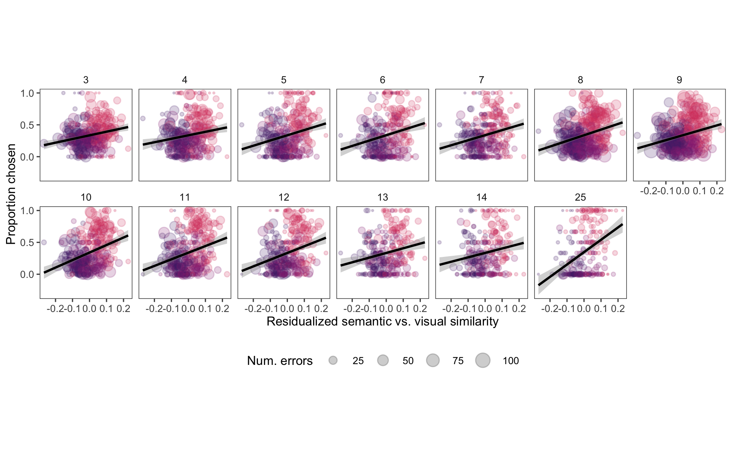
Figure 4: Proportion times an image was chosen as a function of the residualized semantic similarity between the target and distractor images (semantic - visual similarity). Dot size scales with the number of errors for that image in the dataset. Trend lines show weighted best fit lines by the number of errors, faceted by each age group in the dataset.

References

