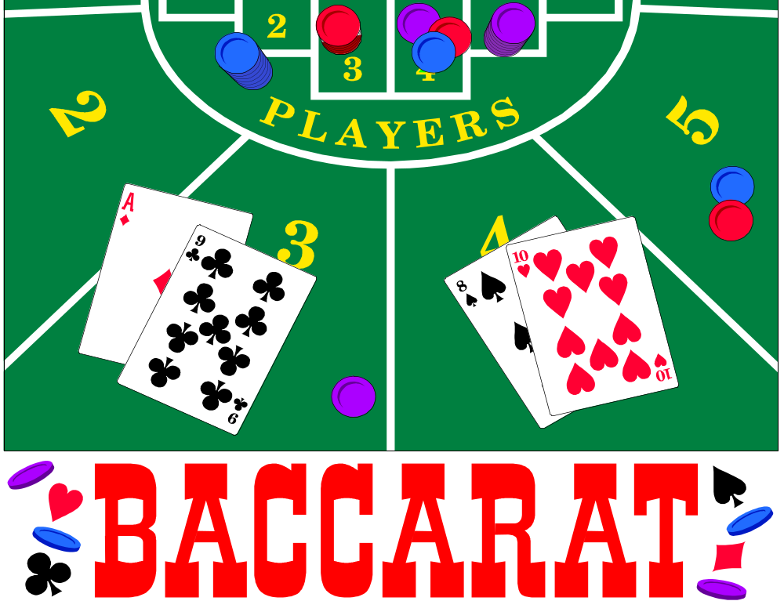

Modeling, Simulation, and Analysis of Baccarat:
A Critical View of Card Counting, Odds, and Bets

By
Charles Madewell
Brian McCormick
Ann Rideout

For Dr. Mike Dorsett
ISE 726

Abstract:

Since Baccarat is one of the easiest casino table card games to play and has one of the lowest house advantages, it provides just enough deception to lure the bettor into a false sense of winning and often teaches the bettor that the effects of long term playing will most assuredly end up in a net loss. This paper investigates the use of card counting to attempt to overcome the house advantage. An introduction to Baccarat, its rules, current card counting strategies, and betting strategies are presented as well as research into probabilities, expected values of betting, and the mathematics of the game. A C++ computer model of Baccarat is developed to verify known results and to further add to the body of knowledge by providing additional results substantiating the fallacy of card counting methods, the low odds of the player winning, and the futility of playing Baccarat on a long-term basis.
Table of Contents

Abstract………………………………………………………………………. i

1.0 Baccarat Introduction ……………………………………………………. 1
1.1 Introduction……………………………………………………… 1
1.2 Rules of Play…………………………………………………….. 1
1.3 Card Counting…………………………………………………… 3
1.4 Betting Strategies………………………………………………... 5
1.5 The Mathematics of Baccarat…………………………………… 6
1.5.1 A Mathematical Introduction to Baccarat…………….. 6
1.5.2 Effects of Shoe Size on House Edge…………………..7
1.5.3 Effects of Commission on House Edge……………….. 8
1.5.4 Effects of Tie Pay-Back Odds on House Edge………...9
1.5.5 Effects of Tie Bets Returned on House Edge………….10
1.5.6 Card Counting Statistics Summary……………………. 11
1.5.7 Gamblers Ruin, Markov Chain………………………… 12
1.6 Problem Statement……………………………………………….. 21

2.0 Technical Approach to Study……………………………………………. 21
2.1 C++ Baccarat Simulation Logic (Verification)…………………... 22
2.2 C++ Baccarat Simulation Logic (Deck Penetration)……………..25
2.3 C++ Baccarat Simulation Logic (Gambler’s Ruin)……………… 27

3.0 Summary and Recommendations………………………………………… 31

References……………………………………………………………………. 33

Appendices…………………………………………………………………… 34

1.0 Baccarat Introduction

1.1 Introduction
Baccarat (pronounced bah-caw-rah) dates to the middle ages in Italy and was originally played with a Tarot deck. The word baccarat is derived from the Italian word baccara, meaning zero, and refers to the value given to all the face cards and tens. Migrating to France, it became the game of choice for the aristocracy. It has since mutated into the multiple different versions of the game that are played today. The French “chemin de fer” game is similar to what is played in casinos today. What is known as American baccarat actually originated in England and spread to South America. The version of the game that is played today came from the Capri Casino in Havana, Cuba. Mini-baccarat is another version played in casinos today.

Since baccarat's introduction in Nevada casinos, the game has assumed an aura of glamour. In most casinos, baccarat is played in a roped-off area. The intention was to attract the high roller, or the more sophisticated moneyed player. With the tuxedo-clad dealers, there is an air of elegance to the game. However, for all the enchantment, baccarat is primarily a simple game. There are no decisions or options; no degree of skill is required for bettor.

1.2 Rules of Play
Baccarat is a card game that is dealt from a shoe that holds 6 or 8 decks of cards. Before the hands are dealt, bets may be placed on the banker hand, on the player hand, or on a tie. Winning bets on banker or player are paid 1:1, but a commission of 5% is charged on bank bets making the net odds on such bets 0.95 to 1. Some casinos may charge a lower commission (e.g., at this writing, Binion's Horseshoe in Las Vegas charges 4%.). At some casinos, tie bets are paid 8:1, while at others tie bets are paid 9:1. If there is a tie, bets on the banker or player are returned. Once a bet has been placed, there are no opportunities for further decisions -- both the banker hand and the player hand are dealt according to fixed rules, resulting in final hands of either two or three cards for each.

The value of a hand is determined by adding the values of its individual cards. Tens and face cards are counted as zero, while all other cards are counted by the number of "pips" on the card face. Only the last digit of the total is used, so all baccarat hands have values in the range 0 to 9 inclusive. The hand with the higher value wins; if the hands
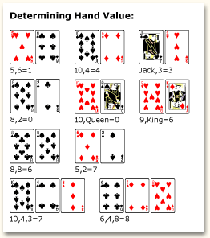

have the same value, the result is a tie. The suit of the card has no affect.

A game is played by dealing two cards for the player hand and two cards for the bank hand. An initial hand with a value of 8 or 9 is called a "natural." If either hand is a natural, its holder must expose it and the game ends. Otherwise play continues, first with the player hand and then with the banker hand, according to the following rules.

Rules for the player hand: If the player's first two cards total 6 or more, then the player must stand without drawing a card. If the player's first two cards total 5 or less, the player must draw one additional card.

Rules for the banker hand: If the banker's first two cards total 7 or more, then the banker must stand without drawing a card. If the banker's first two cards total 0, 1, or 2, then the banker must draw one card. If the banker's first two cards total 3, 4, 5, or 6, the rules become are a bit complex. If the player did not draw a card, the banker will draw a card when his total is 3, 4, or 5. If the player did draw a card, the choice of whether or not to draw for the banker is indicated by the player’s third card as shown in the table below.

Banker’s Hand Total | Draw if Player’s Third Card Is:
3 | 0, 1, 2, 3, 4, 5, 6, 7, 9
4 | 2, 3, 4, 5, 6, 7
5 | 4, 5, 6, 7
6 | 6, 7

1.3 Card Counting Strategies
Since its inception, many card counting strategies have been proposed and used for baccarat. For example, David Sklansky proposed counting two, threes, sevens, and eights because he determined that if the last six cards dealt from a baccarat shoe are three twos and three threes, the player bet enjoys an 80% advantage and if the last six cards are sevens and eights, then the banker bet has the advantage.

Along these lines, in 1982, “Gambling Times” published a series of six-card subsets, which could give the player an advantage at the end of the deck. Joel Friedman investigated all possible six-card sets and he learned that if a bettor has perfect knowledge of the last six cards, he could gain a profit of 26% on that hand. If it is determined that the last hand will be a tie, the player can really make out well, given the higher odds on a tie.

The fundamental problems with systems that involve waiting for the favorable situations at the bottom of the shoe to place big bets are many. First, no casino will ever allow the shoe to play to the very end. Second, keeping track of the total number of cards of each value played is very difficult. Third, casino personnel are on the alert for bettor’s who bet sporadically and may bar them for being card counters. Fourth, the frequency at which these favorable bets can be made is very low.

Currently, the most popular card counting strategy is based on the work of Walden. He determined the relative change of winning probabilities for the player and bank hands when a single card of each value was removed from an 8-deck shoe. The changes in winning probabilities give rise to relative point values for each card as it is removed from the shoe. Table 2 from Walden’s thesis is summarized below.

Removed Card Value | % Change in Player Bet Wins after Card Removal | % Change in Bank Bet Wins after Card Removal | Relative Point Value
0 | -0.002 | 0.002 | 2
1 | -0.004 | 0.004 | 4
2 | -0.005 | 0.005 | 5
3 | -0.007 | 0.007 | 7
4 | -0.012 | 0.012 | 11*
5 | +0.008 | -0.008 | -8
6 | 0.011 | -0.011 | -11
7 | 0.008 | -0.008 | -8
8 | 0.005 | -0.005 | -5
9 | 0.003 | -0.003 | -3

* Arbitrarily reduced from 12 to 11 so points in pack total zero

Given these relative point values, an approximate point count has been determined as:

Ace | Ten | Nine | Eight | Seven | Six | Five | Four | Three | Two
+1 | 0 | 0 | -1 | -2 | -2 | -1 | +2 | +2 | +1

To use these values in a card counting system, start with an initial value of zero and keep a running count of the card count values as they are played. Divide the running count by the number of remaining decks to get the true count. Whenever the true count gets to –1 or lower, bet on the player. When it gets to +1 or higher, bet on the banker.

  - Betting Strategies
The Martingale betting strategy is the easiest to understand and seems quite logical, but it can be quite dangerous to use in practice. This system basically says to make a bet for double the previous bet amount each time a bet is lost. The theory is that when the next time that a hand is won, the bettor will ultimately end up ahead. For example, bet $5 and lose, next time bet $10, and if that bet loses, bet $20 the next time. Say the $20.00 hand is a winner, the bettor will be up $20.00 win - $15.00 loss = $5.00. The problem with this strategy is the bettor must risk losing a significant amount of money and he may run into a table maximum policy that will prevent him from doubling his last bet. The other problem is that he may not have enough resources to continue doubling after each loss even if the table doesn’t have a maximum policy.

Some bettors believe they can take advantage of streaks in shoes. Upon entry into a baccarat game, every player is offered a scorecard. Use it to keep track of which hand wins. If both the player and banker bets are participating in short term streaks, play the streaks with a paroli of three. This means the bettor should parlay his bet twice, going for three hands in a row. If the shoe is choppy, bet whatever side lost the last hand.

The 1-3-2-6 Betting System is also popular. While it may seem otherwise to some newcomers, the odds actually favor the casino and no betting system can change that fact. But many say this system works well for short term betters. What makes the 1-3-2-6 system attractive to bettors is they risk only two betting units for a chance to win ten. In other words, the bettor can make a nice profit with a minimal investment.

The first bet is one unit - if it is a winner:

- Add another unit, making the second bet a total of three units.
- If the second bet is won, there are 6 units on the table. Remove four units, making the third bet two units.
- If it wins add two more units, making it a total of six units for the fourth bet.
- If the fourth bet wins, collect 12 units (which ten units are fabulous profit!)

If lose the first bet, the loss is one unit.
If win the first bet but lose the second bet, the net loss is two units.
If win the second but lose the third bet, the profit is two units.
If win the first three bets but lose the fourth bet, the bettor breaks even.
If lose the second bet five out of six times and win four consecutive bets once, the bettor breaks even.

1.5 The Mathematics of Baccarat

1.5.1 A Mathematical Introduction to Baccarat
The Baccarat deck consists of 8 decks of cards at 52 per deck, totaling 416 cards. The cards are placed in a wooden box called a shoe. At most casinos, the first card is turned over and an additional number of cards are burned corresponding to that card value (face cards counting as 10). A marker is randomly placed near the end of the shoe and when that marker is reached during the game, the remaining cards are discarded and a new shoe (416 cards) is brought into use.

In the remaining parts of this section, other aspects of the game will be exhibited. The effects of deck size, commission, tie pay-back odds, and ties will be shown from the probabilities and edge (mathematical expectation) viewpoint. A brief summary of card counting statistics will be presented. Baccarat will be analyzed using Markov process methods (i.e. “Gambler’s Ruin”) and the expected profits and calculated house advantages for each type of bet will be discussed in detail.

1.5.2 Effects of Shoe Size on House Edge
The number of decks in a shoe influences the odds of the bets of Baccarat. In the charts below, the 8 deck, 6 deck, and single deck statistics are given for the probabilities of play and the House edge. These charts were first found on “The Wizard of Odds” website and have been recreated here. The pay-back odds for the tie bet are 9:1. All tables have a 5% commission for the bank bet (see next section).

8-Deck Summary
Bet on: | Probability (%) | House Edge (%)
Bank | 45.86 | 1.06
Player | 44.62 | 1.24
Tie | 9.52 | 14.36

An example calculation for the bank bet expected value for 8 decks given the published win probability values of 44.62% for player bets and 45.8597% for bank bets for an 8-deck shoe:

Bank Bet Expected Value = Pp (-1 unit) + Pb (1 unit - Vig) = .4462(-1) + .458597(0.95)
Bank Bet Expected Value = -1.06%

An example calculation for the player bet expected value for 8 decks given the published win probability values of 44.62% for player bets and 45.8597% for bank bets for an 8-deck shoe:

Player Bet Expected Value = Pp (1 unit) + Pb (-1 unit) = .4462(1) + .458597(-1)
Player Bet Expected Value = -1.2397%

An example calculation for the tie bet expected value for 8 decks given the published win probability value of 9.5156% for ties bets in an 8-deck shoe is given as:

Tie Bet Exp Value = Pp (-1) + Pb (-1) + Pt (8)] = .4462(-1) + .458597 (-1) + .095156(8)
Tie Bet Exp Value = -14.36%
6-Deck Summary |  | 5% Vig
Bet on: | Probability (%) | House Edge (%)
Bank | 45.87 | 1.06
Player | 44.63 | 1.24
Tie | 9.51 | 14.44

Single-Deck Summary |  | 5% Vig
Bet on: | Probability (%) | House Edge (%)
Bank | 45.96 | 1.01
Player | 44.68 | 1.29
Tie | 9.36 | 15.75

From the charts above, it can be seen that the general trend is that the fewer the number of decks played, the lower the house edge. For instance, at the 8-Deck and Single-Deck games, the house edge for bank bets decreases from 1.06 to 1.01%. On the other hand, the house edge for bets on the player rises from 1.24 to 1.29%. The most apparent change occurs on house edge for tie bets. The house edge for tie bets increases from 14.36 to 15.75%. This shows that when the playing one deck, the bettor should usually bet on the bank (unless card counting indicates otherwise).

1.5.3 Effects of Commission on House Edge
In most casinos, a commission is charged for all money won on the Bank bets. The commission is most commonly referred to as “Vigorish” or “Vig” for short. Commissions vary from 1 to 6% but are most commonly 5%. The chart below, recreated from the website www.icancasino.com, summarizes the house advantage on banker bets for various commissions. For these charts, ties are included and the pay-back odds are 8:1.

Effects of Commission
Commission % | House Edge Bet on the Bank
0 | -1.23
1 | -0.77
3 | 0.15
4 | 0.67
5 | 1.17
6 | 1.52

From the chart above, it can be seen that when the commissions are 0 to 1%, the edge is actually in the card players favor at –1.23 and -.77%. When these opportunities exist, the bettor betting on the bank bet has the advantage. Note at the most common commission rate, the house has an edge of 1.17%. At 6% commission, the house has even more of an edge a 1.52%. One should attempt to stay clear of high commission Baccarat tables.

1.5.4 Effects of Tie Pay-Back Odds on House Edge
The pay-back odds for bets placed on ties is very high at 8:1 or 9:1. The pay-back odds are kept high because the casino knows the probability of a tie ever happening is very low. This is used to lure card players into a false sense of being able to “win big”. The chart below shows the effects of changing the tie pay-back odds for an 8-deck shoe.

Effects of Tie Pay-back Odds
Tie Payback Odds | House Edge  Bet on the Tie
8 to 1 | 4.9%
9 to 1 | 14.36%

Although the pay-back percentage seems somewhat acceptable for the tie bet, it is the usually the worst of the three available bets (unless card counting indicates otherwise). In general, a bettor should avoid the tie bet. Do not be pulled in by the high pay-back odds for ties. They give false hope.

1.5.5 Effects of Tie Bets Returned on House Edge
Previous analysis showed the probabilities including tie bets. Since tie bets are returned to the bettor (he neither wins nor loses his bet amount), it is necessary to look at these probabilities. The chart below shows the probabilities and house edge values for both the ties included and no ties included cases (for an 8-deck shoe and a 5% commission).

Ties Included Case |  |  | Tie Bets Returned
Bet on: | Probability (%) | House Edge (%) | Bet on: | Probability (%) | House Edge (%)
Bank | 45.86 | 1.06 | Bank | 50.6851 | 1.17
Player | 44.62 | 1.24 | Player | 49.3149 | 1.36
Tie | 9.52 | 14.36

The calculations for the probabilities for tie-bets returned case are shown below:

With ties: 45.8597 + 44.620 = 90.4797
100 / 90.47797 = 1.10522
45.8597 * 1.10522 = 50.6851 (Probability of bank win when tie bets are returned)
44.620 * 1.10522 = 49.3149 (Probability of player win when tie bets are returned)

House Edge on Player Bets = Pp (1) + Pb (-1) = .493149 - .506851
House Edge on Player Bets = -1.36%

House Edge on Bank Bets = Pp(-1) + Pb(1-vig) = .506851(1-.05) -.493149
House Edge on Bank Bets = -1.17%

Since the house edge in the no ties bets returned increases, it is to the bettor's advantage to never play Baccarat where tie bet moneys are not returned to the bettor. Interestingly enough, if ties are not returned, Baccarat can be thought as flipping a player/bank coin that is slightly biased towards the bank side and if that bias helps the bettor win, the casino gets a ‘cut’.

1.5.6 Card Counting Statistics Summary
The chart below (reference www.thewizardofodds.com) shows the effects of knowing the first 90, 95, or 98% of the cards played and gives the probability of obtaining a favorable bettor edge for the different bets.

 | Percentage of Time the Bettor has an Edge Over the House
Penetration | Bank Bet | Player Bet | Tie Bet
90 | 0.0131 | 0.0024 | 0.0002
95 | 0.1062 | 0.0381 | 0.0092
98 | 0.5876 | 0.37 | 0.2106

The next chart translates this into the expected profit the bettor would yield if he could perfectly count the cards down to the shown percentage and make bets of $1000 every time a positive expectation occurred.

 | Expected Profit
Penetration | Bank Bet | Player Bet | Tie Bet
90 | $0.01 | $0 | $0
95 | $0.20 | $0.06 | $0.15
98 | $2.94 | $1.77 | $11.93

As the chart above shows, the expected profit is very low and it seems that it is not worth the effort of trying to obtain a count down to this level. For example, assuming it takes one minute to play one hand and further assuming that each hand takes 10 cards on the average, a bettor can expect the cards to reach 98% penetration into the original 8 decks approximately once every 40 minutes. Noting the positive expectation percentage is approximately 1.0% over all the bets at 98% percent penetration, it is easy to see that the expected payoffs for each $1000.00 bet is just not worth it.

Given these grim statistics, it can be concluded, for all practical purposes, that card counting is practically worthless in Baccarat. Unless the bettor is willing to try elaborate means to keep a perfect count, using a simplified card counting procedure (like the one presented earlier) will further lower profits and it should also be noted that the likelihood of obtaining 98% shoe penetration is low. At most casinos, the maximum shoe penetration will be 95%.

Edward O. Thorp and others have concluded the same thing, that card counting is not effective in overcoming the house edge in Baccarat. Compared to blackjack, card counting is about 9 times less effective when used against baccarat. See Thorp's "The Mathematics of Gambling" for details. The remaining sections of this paper will further support this.

    - Gambler Ruin, Markov Chain
This section seeks to show by using Markov chains that the Baccarat bettor is destined to eventually lose all his money if he wants to go all or nothing, that is, break the casino or end up broke himself. The first step in the method is to determine the transition probability matrix for a 21 x 21 matrix. The matrix size was determined using the fact that the highest one hand bet ever recorded is $50000 and also knowing that most people want to win the renowned figure of $1000000 (one million) to become a millionaire. By dividing 1000000 by 50000 gives 20. Thus the columns and rows of the transition probability matrix effectively become multipliers for the state 1 initial bid. The transition probability matrix for the first case is shown below. The first is for the real case using the one time play probabilities given for the no ties included, 8-deck case. The second case shows is a theoretical case where card counting somehow improves the card player edge of knowing the probabilities for the bank or the player winning is .50. The assumption for this analysis is the plays are independent and the card player plays until he is either broke (state 0) or has all the money (state 21). The real case transition probability matrix for the player bet is shown below.

State Transition Matrix for Gambler’s Ruin – Player Bet
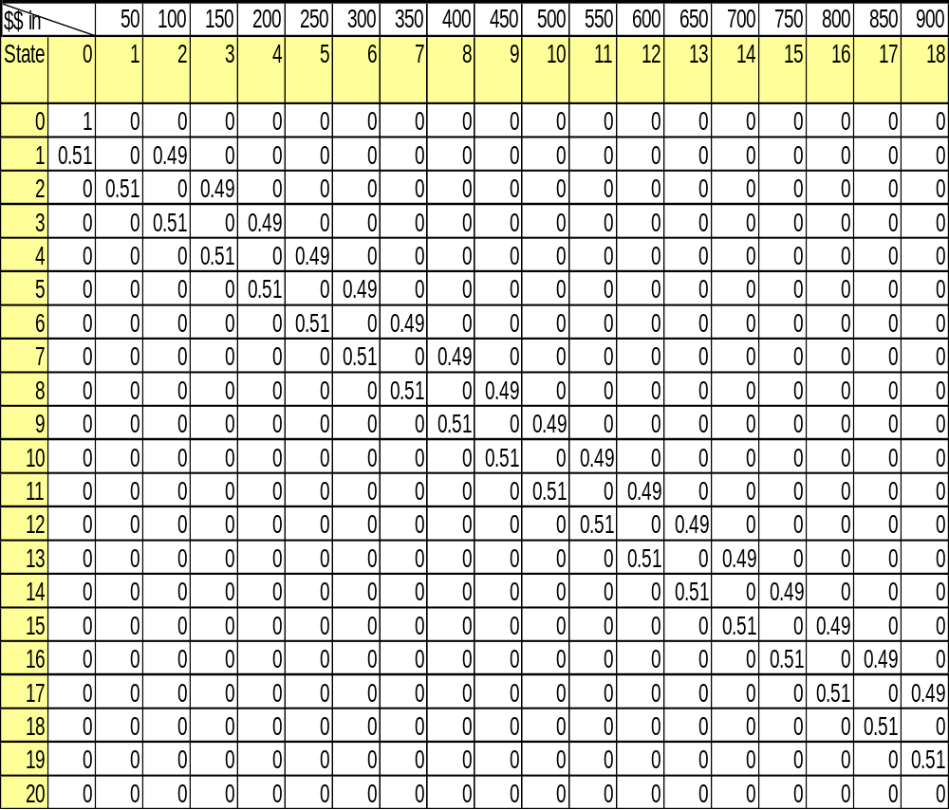
The transition probability matrix for the real case shown above was taken to its steady state probabilities in approximately 800 hands. The steady state probabilities for all cells 1 through 19 were found to be zero (0). This is proof of the fact that the 0 and 20 states are absorbing states and that all other states are transient. In other words, a bettor will either end up with nothing or everything. The probability for states (0,0) and (20,20) are 1.0. A formula used to verify the accuracy of the results calculated by Matlab for the steady state probabilities matrix, is shown below.

1-f_{y0} = sum from x=0 to y-1 of ρ^{x} divided by sum from m=0 to m-1 ρ^{m}
where y = any current state and m = the final state, and
ρ = (1 – P) / P where P is the probability for either the player or bank bet.
Therefore, f_{ym} = 1 - f_{y0}

These equations can be used to find any value of the first and last columns of the steady state probability matrix. The steady state probabilities are shown in the “Probability to T” and “Probability to 0” in the charts to follow.

The next chart below gives the long run play earned values for each of the states. The earned value/profit column was calculated by multiplying “Probability to T” times “Potential Winnings” and subtracting “Probability to 0” times “Potential Loss”. As one can see from the table, the expected value is always negative. This shows that regardless of the beginning state, extended long term play will usually end up with a complete loss of the bettor’s initial amount of betting money.

Player Bet Expected Value - Long Run Play
 | Probability to T | Potential Winnings | Probability to 0 | Potential Loss | Expected Value
From | (Win All) |  | (Lose All)
0 | 0 | 1000000 | 1.0000 | 0 | 0
1 | 0.03806 | 950000 | 0.9619 | 50000 | -11940
2 | 0.07718 | 900000 | 0.9228 | 100000 | -22820
3 | 0.11739 | 850000 | 0.8826 | 150000 | -32610
4 | 0.15872 | 800000 | 0.8413 | 200000 | -41280
5 | 0.20119 | 750000 | 0.7988 | 250000 | -48810
6 | 0.24484 | 700000 | 0.7552 | 300000 | -55160
7 | 0.28971 | 650000 | 0.7103 | 350000 | -60290
8 | 0.33582 | 600000 | 0.6642 | 400000 | -64180
9 | 0.38321 | 550000 | 0.6168 | 450000 | -66790
10 | 0.43192 | 500000 | 0.5681 | 500000 | -68080
11 | 0.48198 | 450000 | 0.5180 | 550000 | -68020
12 | 0.53344 | 400000 | 0.4666 | 600000 | -66560
13 | 0.58632 | 350000 | 0.4137 | 650000 | -63680
14 | 0.64067 | 300000 | 0.3593 | 700000 | -59330
15 | 0.69653 | 250000 | 0.3035 | 750000 | -53470
16 | 0.75395 | 200000 | 0.2461 | 800000 | -46050
17 | 0.81296 | 150000 | 0.1870 | 850000 | -37040
18 | 0.8736 | 100000 | 0.1264 | 900000 | -26400
19 | 0.93594 | 50000 | 0.0641 | 950000 | -14060
20 | 1 | 0 | 0.0000 | 100000 | 0

The next chart shows the calculations for the player advantage in long term play. The values were calculated by subtracting “Probability to 0” from “Probability to T”. As the chart shows, the player does not have an advantage until state 12. Note that even though the bettor is more likely to reach state 20 from state 12, his expected value there (and everywhere else) is still negative.

Player Bet Advantage - Long Run Play
 | Probability to T | Probability to 0 | Player
From | (Win All) | (Lose All) | A
0 | 0 | 1.0000 | -1.0000
1 | 0.03806 | 0.9619 | -0.9239
2 | 0.07718 | 0.9228 | -0.8456
3 | 0.11739 | 0.8826 | -0.7652
4 | 0.15872 | 0.8413 | -0.6826
5 | 0.20119 | 0.7988 | -0.5976
6 | 0.24484 | 0.7552 | -0.5103
7 | 0.28971 | 0.7103 | -0.4206
8 | 0.33582 | 0.6642 | -0.3284
9 | 0.38321 | 0.6168 | -0.2336
10 | 0.43192 | 0.5681 | -0.1362
11 | 0.48198 | 0.5180 | -0.0360
12 | 0.53344 | 0.4666 | 0.0669
13 | 0.58632 | 0.4137 | 0.1726
14 | 0.64067 | 0.3593 | 0.2813
15 | 0.69653 | 0.3035 | 0.3931
16 | 0.75395 | 0.2461 | 0.5079
17 | 0.81296 | 0.1870 | 0.6259
18 | 0.8736 | 0.1264 | 0.7472
19 | 0.93594 | 0.0641 | 0.8719
20 | 1 | 0.0000 | 1.0000

The next two charts show the same two charts shown previously, but for the imaginary case were the card player now has somehow improved his odds to 50% win expectancy for player bet. This time, from state 10 the bettor is expected to reach state 20 at least half the time, and the expected value for long term playing is 0. Even with the better expected value, the player can only break even in the long run. This illustrates the potency of even a tiny casino percentage advantage of winning over the long run.

Imaginary Case - Player Bet Expected Value – Long Run Play
 | Probability to T | Potential Winnings | Probability to 0 | Potential Loss | Expected Value
From | (Win All) |  | (Lose All)
0 | 0.00 | 1000000 | 1.00 | 0 | 0
1 | 0.05 | 950000 | 0.95 | 50000 | 0
2 | 0.10 | 900000 | 0.90 | 100000 | 0
3 | 0.15 | 850000 | 0.85 | 150000 | 0
4 | 0.20 | 800000 | 0.80 | 200000 | 0
5 | 0.25 | 750000 | 0.75 | 250000 | 0
6 | 0.30 | 700000 | 0.70 | 300000 | 0
7 | 0.35 | 650000 | 0.65 | 350000 | 0
8 | 0.40 | 600000 | 0.60 | 400000 | 0
9 | 0.45 | 550000 | 0.55 | 450000 | 0
10 | 0.50 | 500000 | 0.50 | 500000 | 0
11 | 0.55 | 450000 | 0.45 | 550000 | 0
12 | 0.60 | 400000 | 0.40 | 600000 | 0
13 | 0.65 | 350000 | 0.35 | 650000 | 0
14 | 0.70 | 300000 | 0.30 | 700000 | 0
15 | 0.75 | 250000 | 0.25 | 750000 | 0
16 | 0.80 | 200000 | 0.20 | 800000 | 0
17 | 0.85 | 150000 | 0.15 | 850000 | 0
18 | 0.90 | 100000 | 0.10 | 900000 | 0
19 | 0.95 | 50000 | 0.05 | 950000 | 0
20 | 1.00 | 0 | 0.00 | 100000 | 0

Imaginary Case - Player Bet Advantage - Long Run Play
 | Probability to T | Probability to 0 | Player
From | (Win All) | (Lose All) | Advantage
0 | 0.00 | 1.00 | -1.0000
1 | 0.05 | 0.95 | -0.9000
2 | 0.10 | 0.90 | -0.8000
3 | 0.15 | 0.85 | -0.7000
4 | 0.20 | 0.80 | -0.6000
5 | 0.25 | 0.75 | -0.5000
6 | 0.30 | 0.70 | -0.4000
7 | 0.35 | 0.65 | -0.3000
8 | 0.40 | 0.60 | -0.2000
9 | 0.45 | 0.55 | -0.1000
10 | 0.50 | 0.50 | 0.0000
11 | 0.55 | 0.45 | 0.1000
12 | 0.60 | 0.40 | 0.2000
13 | 0.65 | 0.35 | 0.3000
14 | 0.70 | 0.30 | 0.4000
15 | 0.75 | 0.25 | 0.5000
16 | 0.80 | 0.20 | 0.6000
17 | 0.85 | 0.15 | 0.7000
18 | 0.90 | 0.10 | 0.8000
19 | 0.95 | 0.05 | 0.9000
20 | 1.00 | 0.00 | 1.0000

Remember, if the bettor decides to enter into the “Gambler’s Ruin” by on betting on the bank bet, the tables for the player bet “Gambler’s Ruin” above do reverse, but the commission (“Vig”) is not accounted for in the Markov model and hence the expected values do not include this either. For completeness though, these tables (without “Vig”) are shown.

Bank Bet Expected Value - Long Run Play – Tie Bets Returned
 | Probability to T | Potential Winnings | Probability to 0 | Potential Loss | Expected Value, Vig Excluded
From | (Win All) |  | (Lose All)
0 | 0 | 1000000 | 1.0000 | 0 | 0
1 | 0.0641 | 950000 | 0.9359 | 50000 | 14100
2 | 0.1264 | 900000 | 0.8736 | 100000 | 26400
3 | 0.187 | 850000 | 0.8130 | 150000 | 37000
4 | 0.2461 | 800000 | 0.7539 | 200000 | 46100
5 | 0.3035 | 750000 | 0.6965 | 250000 | 53500
6 | 0.3593 | 700000 | 0.6407 | 300000 | 59300
7 | 0.4137 | 650000 | 0.5863 | 350000 | 63700
8 | 0.4666 | 600000 | 0.5334 | 400000 | 66600
9 | 0.518 | 550000 | 0.4820 | 450000 | 68000
10 | 0.5681 | 500000 | 0.4319 | 500000 | 68100
11 | 0.6168 | 450000 | 0.3832 | 550000 | 66800
12 | 0.6642 | 400000 | 0.3358 | 600000 | 64200
13 | 0.7103 | 350000 | 0.2897 | 650000 | 60300
14 | 0.7552 | 300000 | 0.2448 | 700000 | 55200
15 | 0.7988 | 250000 | 0.2012 | 750000 | 48800
16 | 0.8413 | 200000 | 0.1587 | 800000 | 41300
17 | 0.8826 | 150000 | 0.1174 | 850000 | 32600
18 | 0.9228 | 100000 | 0.0772 | 900000 | 22800
19 | 0.9619 | 50000 | 0.0381 | 950000 | 11900
20 | 1 | 0 | 0.0000 | 100000 | 0

Bank Bet Advantage - Long Run Play – Tie Bets Returned
 | Probability to T | Probability to 0 | Player
From | (Win All) | (Lose All) | Advantage
0 | 0 | 1.0000 | -1.0000
1 | 0.0641 | 0.9359 | -0.8718
2 | 0.1264 | 0.8736 | -0.7472
3 | 0.187 | 0.8130 | -0.6260
4 | 0.2461 | 0.7539 | -0.5078
5 | 0.3035 | 0.6965 | -0.3930
6 | 0.3593 | 0.6407 | -0.2814
7 | 0.4137 | 0.5863 | -0.1726
8 | 0.4666 | 0.5334 | -0.0668
9 | 0.518 | 0.4820 | 0.0360
10 | 0.5681 | 0.4319 | 0.1362
11 | 0.6168 | 0.3832 | 0.2336
12 | 0.6642 | 0.3358 | 0.3284
13 | 0.7103 | 0.2897 | 0.4206
14 | 0.7552 | 0.2448 | 0.5104
15 | 0.7988 | 0.2012 | 0.5976
16 | 0.8413 | 0.1587 | 0.6826
17 | 0.8826 | 0.1174 | 0.7652
18 | 0.9228 | 0.0772 | 0.8456
19 | 0.9619 | 0.0381 | 0.9238
20 | 1 | 0.0000 | 1.0000

Additional analysis of the Markov model could easily show that betting on the bank bet in the “Gambler’s Ruin” does produce small improvements in the expected values in the long run, but these improvements will be only marginal and the bettor’s expected value will still be negative. This can be easily determined by simply noting that the win probability (tie bets returned) is less than 50% and a similar chain to that above would be produced. It will also be shown later in this paper via a C++ computer simulation.

1.6 Problem Statement
The need exists to create a quantitative model to verify published results and substantiate the fallacy of card counting methods, and to provide proof of the futility of playing Baccarat on a long term basis.

2.0 Technical Approach to Study
Several baccarat simulations will be developed using C++. For the first simulation, many hands from different initial card arrangements of a complete 8-deck shoe will be played. The win percentages for each of the three bets will be recorded for a statistically significant number of runs and a comparison will be made between the win percentages for the three bets to the published values in order to verify the hand playing portion of the simulation is working correctly.

Next, a deck penetration experiment similar to the one Thorpe conducted will be performed. Thorpe found that taking the shuffling an 8 deck shoe 29 times and looking at the last 13 cards, a positive expectation existed in only 2 out of 58 cases. The only differences between that experiment and this one will be that this one will look at the last 20 cards and the code will check for statistical significance regarding the number of positive expectations obtained. Looking at the last 20 cards is a more realistic number under actual casino play than 13. Unfortunately, Thorpe’s analysis only includes 2 positive expectations. From statistics, it is known that the confidence interval procedure is unreliable when estimating an unknown binomial proportion (1/29) that is close to 0 from a small sample size, and to be safe, the number of samples taken should continue until the number of positive expectations is at least 5. The simulation in this paper terminates upon meeting this condition. The results will also be compared to those obtained from the wizard of odds website.

Finally, a simulation will simulate a bettor making $50,000 bets until he has nothing left or he is a millionaire. For the first scenario, the bettor bets only on the player bet while the next scenario will have the bettor betting only on the bank bet.

  - C++ Baccarat Simulation Logic (Verification)

PseudoCode for Verification Simulation

START
create a shoe with 416 cards with values: 1, 2, 3, … 9, 0, 0, 0, 1, 2, 3, …9, 0, 0, …
initialize playerWins, bankWins, and ties to zero
set zSqrd = 3.8416, eSqrd = 1e-6
initialize statistically significant flag to false

while (number of samples is not statistically significant)
{
call random_shuffle() function to shuffle the shoe
play hand and increment winner count (playerWins, bankWins, or ties)

// check for statistical significance (ignoring ties)
compute total = playerWins + bankWins
compute bank win percentage, pBank = bankWins/total
compute player win percentage, pPlayer = playerWins/total

// check statistical significance of number of total wins to meet error
if (totalWins >= zSqrd*pBank*pPlayer/eSqrd)
{
compute total = playerWins + bankWins + ties
output bank win percentage, pBank = bankWins/total
output player win percentage, pPlayer = playerWins/total
output tie win percentage, pTie = ties/total

output tie error, tieError = sqrt(zSqrd*tie*(1-tie)/total²)
set statistically significant flag to true
}
}
END
The statistically significant check is performed to make sure the number of samples is sufficient to meet the desired confidence interval and error. The statistically significant check comes from the following theorem:

If phat is the proportion of successes in a random sample of size n, and qhat = 1-phat, an approximate (1-α) 100% confidence interval for binomial parameter p is given by

phat – z_{α/2} √ (phat *qhat / n) < p < phat + z_{α/2} √ (phat *qhat / n)

where z_{α/2} is the z-value leaving an area of α/2 to the right.

This leads to the following theorem (which is used in the simulation)

If phat is used as an estimate of p, there is a (1-α) 100% confidence that the error will be less than a specified amount e when the sample size is

n = (z²_{α/2} * phat * qhat) / e²

The shuffle algorithm is a part of the C++ standard template library. The shuffle is performed using Knuth’s shuffling logic. Its running time is linear with respect to the number of cards to be shuffled. Basically, it works according to following logic:

Array[] = { element₁, element₂, …, element_{n}}
for (n = ArraySize; n>1; n--)
{
// generate a random number from 1 to n
randomNumber = GenerateRandonNumber(n)
swap the value of Array[n] with value at Array[randomNumber]
}

Thus Knuth’s algorithm will generate a value between 1 and 416 for the first iteration of an 8 deck shuffle. It will swap the last array value with the value at the index corresponding to the random number generated. On the next iteration, it will generate a value between 1 and 415 and it will swap the second to last array value with the value at the index corresponding to the random number generated. This process continues until the second to last element is reached. Thus the number of permutations for the Knuth shuffle are 416 * 415 * … * 2. This corresponds exactly to the number of permutations of 416 distinct elements, 416 factorial.

For the verification run with the C++ code found in Appendix A1, α = 0.95 and e = 0.001 were used. The results of the C++ simulation are summarized below.
Bet Type | Published Win Probability | Computed Win Probability
Player | 0.4464 | 0.4469
Bank | 0.4586 | 0.4571
Tie | 0.0952 | 0.0959

The computed win probabilities for the player and bank bets are within 0.001 of the expected true values with 95% confidence. The computed tie probability is within 0.000002 of the expected true value with 95% confidence. The reason the tie interval is different that the player and bank lies in the logic used in the simulation. The logic treats the player and bank bets as a binomial distribution and determines when the statistics regarding that distribution are statistically significant. Next it treats the tie bet and the player plus the bank bet as a binomial distribution. In this case, the sample sizes, desired confidence level, and estimates of the binomial distribution approximations are known and the error needs to be determined.

The winning percentage solutions match closely to the published values. Given the confidence interval is 95% and the fact that there was no check to ensure sure that a randomly shuffled hand does not show up more than the allowable permutations, the answers produced are deemed correct.

Note that a check prohibiting the maximum number of permutations for a particular hand is not performed in this simulation because of the enormous computation time and memory allocation that would be involved. Given the low probability of a hand occurring more than the number of theoretical possible times it can occur for all 416 factorial combinations, this is certainly reasonable.

  - C++ Baccarat Simulation Logic (Deck Penetration)

PseudoCode for Deck Penetration Analysis

START
create a shoe with 416 cards with values: 1, 2, 3, … 9, 0, 0, 0, 1, 2, 3, …9, 0, 0, …
initialize totalCompleteShuffles to zero
initialize maxDesiredCompeteShuffles to 100
set zSqrd = 3.8416, eSqrd = 6.25e-6, vig = 0.05

while (totalCompleteShuffles < maxDesiredCompleteShuffles) // start of loop 1
{
call random_shuffle() function to shuffle the shoe
increment total complete shuffles

set bottomDeck[] to the last 20 elements of the shuffled shoe
initialize statistically significant flag to false
initialize playerWins and bankWins to zero

while (number of samples is not statistically significant) // start of loop 2
{
call random_shuffle() function to shuffle bottomOfDeck[]
determine if upcoming hand has exceeded max allowable permutations

if (upcomingHandHasNotExceededMaxAllowablePermutations)
{
play hand from bottom of deck
increment winner’s count (for ties, return to loop 2)

// check for statistical significance (ignoring ties)
compute total = playerWins + bankWins
compute bank win percentage, pBank = bankWins/total
compute player win percentage, pPlayer = playerWins/total

if (totalWins >= zSqrd*pBank*pPlayer/eSqrd)
{
// test for positive expectation
if (pPlayer > pBank) output player advantage
else if (pBank > pPlayer/(1-vig)) output bank advantage
else output no advantage for player or bank

set statistically significant flag to true
}
}
}
}
END

This simulation is similar to that last simulation and its logic is fairly easy to follow. Two points concerning it will be made. First, computing the number of permutations for a specific hand is a little complicated in the C++ simulation itself but is conceptually very easy to understand. The general formula for the maximum number of permutations is given as

maxPermutions = (num1’s_{bottomdeck})! / (num1’s_{bottomdeck} – num1’s_{hand})! *
(num2’s_{bottomdeck})! / (num2’s_{bottomdeck} – num2’s_{hand})! *
.
.
.
(num0’s_{bottomdeck})! / (num0’s_{bottomdeck} – num0’s_{hand})!

Second, note that the estimated win probabilities for the player and bank are used in the test for positive expected values using the formulas discussed previously.

For the simulation run with the C++ code found in Appendix B1, α = 0.95, e = 0.0025, maxIterations = 100, and a 5% commission were used.

The results of running the indicate a positive expectation was achieved in only 15 out of 100 hands, 13 times by the player hand and only 2 times by the bank hand. Two important points need to be made. The first point is only twice did the player hand achieve a significant advantage over 0.5, those values being 0.516 and 0.512, while both bank bets achieved a significant advantage, those values being 0.514 and 0.513.

Thorpe’s criteria for deciding if a probability is statistically significant may hay been more stringent than merely achieving a theoretical positive expectation. This would explain the discrepancy in Thorpe’s 2/58 positive expectations and the simulations 15/100 positive expectations. A stricter requirement might have rejected the player’s win probabilities that just barely made it over 0.5 and may have indicated only 4/100 times did a positive expectation exist and the results here would be well in line with his results.

On a very positive note, for 20 cards unknown (~95% deck penetration for 8 decks) and having a perfect count to base the last bet on, the simulation matches very closely with the previously referenced table from the wizard of odds website. This table indicates at 95% deck penetration for 8 decks, the percentage of time the deck is favorable for either the bank or player bets is 14.43%. This is very close to the 15% value computed in the simulation for the 100 samples.

Thus, it is once again seen that the frequency of occurrence of positive expectation bets is quite low and certainly shows that even perfect card counting has no merit for the realistic case of 20 cards unknown on the final available bet.

2.3 C++ Baccarat Simulation Logic (Gambler’s Ruin)

PseudoCode for Gambler’s Ruin

START
create a shoe with 416 cards with values: 1, 2, 3, … 9, 0, 0, 0, 1, 2, 3, …9, 0, 0, …
set zSqrd = 3.8416, eSqrd = 6.25e-6, vig = 0.05
initialize statistically significant flag to false
initialize bet amount to 50000
initialize the money amount to 50000.0
initialize the bet type to either player or bank
initialize the lose all and win all counters to zero

while (number of samples is not statistically significant) // start of main loop
{
call random_shuffle() function to shuffle the shoe
play hand

if (playerHandWins and betting on player hand)
{
add winning amount to money, money = money + bet
}
else if (bankerHandWins and betting of bank hand)
{
add winning amount to money, money = money + bet * (1-vig)
}
else if (tie)
{
return to start of main loop
}
else
{
subtract bet from money, money = money - bet
}

if (money <= 0.0)
{
increment lose all counter
reset money back to 50000. 0 for next loop
}
else if (money >= 1000000)
{
increment win all counter
reset money back to 50000.0 for next loop
}

// check for statistical significance (ignoring ties)
compute total = lose all counter + win all counter
compute lose all percentage, pLoseAll = lose all counter/total
compute win all percentage, pWinAll = win all counter/total

if (total >= zSqrd*pLoseAll*pWinAll/eSqrd)
{
set statisticallySignificant to true
}
}
END

The results of running the C++ code found in Appendix C1, with α = 0.95, e = 0.01, and a 5% commission were determined for a bettor with an initial bank roll of 50000 and each bet to be made is 50000. The probability of losing the initial bankroll betting exclusively on the player bet is 0.9554. This matches very closely to that determined by the steady state Markov chains previously and gives confidence to using the model to generate the probabilities for the “Gambler’s Ruin” for betting on the bank bet when commission is included. Remember the Markov model could not be used previously when the bank bet involved commission deductions. The results of these runs are shown in the table below.

Bank Bet Expected Value - Long Run Play – Tie Bets Returned
 | Probability to T | Potential Winnings | Probability to 0 | Potential Loss | Expected Value, 5% Vig
From | (Win All) |  | (Lose All)
0 | 0 | 1000000 | 1.0000 | 0 | 0
1 | 0.0328 | 950000 | 0.9672 | 50000 | -17123
2 | 0.0832 | 900000 | 0.9168 | 100000 | -16780
3 | 0.1165 | 850000 | 0.8835 | 150000 | -33468
4 | 0.1682 | 800000 | 0.8318 | 200000 | -31814
5 | 0.2018 | 750000 | 0.7982 | 250000 | -48190
6 | 0.2370 | 700000 | 0.7630 | 300000 | -62953
7 | 0.2825 | 650000 | 0.7175 | 350000 | -67514
8 | 0.3260 | 600000 | 0.6740 | 400000 | -74011
9 | 0.3835 | 550000 | 0.6165 | 450000 | -66469
10 | 0.4243 | 500000 | 0.5757 | 500000 | -75706
11 | 0.4672 | 450000 | 0.5328 | 550000 | -82782
12 | 0.5135 | 400000 | 0.4865 | 600000 | -86456
13 | 0.5730 | 350000 | 0.4270 | 650000 | -77021
14 | 0.6211 | 300000 | 0.3789 | 700000 | -78940
15 | 0.6706 | 250000 | 0.3294 | 750000 | -79445
16 | 0.7362 | 200000 | 0.2638 | 800000 | -63772
17 | 0.7818 | 150000 | 0.2182 | 850000 | -68187
18 | 0.8459 | 100000 | 0.1541 | 900000 | -54123
19 | 0.8933 | 50000 | 0.1067 | 950000 | -56743
20 | 1 | 0 | 0.0000 | 100000 | 0

Thus it is seen that the odds and expected values are slightly more favorable for the bank bet than the player bet, but the expected values over the long run is still negative.

3.0 Summary and Recommendations

First a brief history of Baccarat was presented. Next, the rules and bet odds were described. After this, a quick review of some betting strategies was presented. There are many betting strategies to pick from (Martingale, etc.) but the main point to remember about them is that in no way change the expected win probabilities.

Some of the ideas of early card counting attempts were discussed. There were many fundamental problems with these early strategies that dealt with keeping track of certain types of cards until the end of the shoe is reached and betting appropriately on the last bet. The most notable problem with these methods is they require deep (>99%) shoe penetration and the player must keep a perfect count up to that point.

The most popular counting procedure used today was also presented. It is based on Walden’s thesis and specifically applies to an 8-deck shoe, though its idea is easily extensible to other shoe sizes. The fundamental idea is the removal of a certain card value from a shoe changes the expected win percentages. These change in bet winning percentages give rise to relative point values for the different valued cards. For this counting system, the bettor can keep a running total of the relative point values of the cards played in the shoe and bet smarter.

Next, some mathematical expectations for baccarat were presented. The effects of the shoe sizes, commission and ties were shown. A summary of some current literature was used to show that the mathematical expectation achieved during perfect counts with deep deck penetration yields only pennies on the dollar invested and the rate at which these pennies could theoretically be earned was shown to be very slow.

The Gamblers Ruin/Markov Chain further supported the futility of playing Baccarat. The analyses showed that the house enjoys a small but potent long run advantage for the player bet. Its was also concluded that the house enjoys a less potent advantage for the bank bet, but it is nevertheless impossible in the long run to overcome this advantage as well. It was also shown that even if the odds could be improved by card counting so that the probabilities of winning the bank bet were 50%, the best a bettor could do in the long run is break even.

The C++ simulation card playing logic was verified by comparing the theoretical win percentages for an 8-deck shoe to the statistically significant win percentages from the C++ simulation for an 8-deck shoe.

Next, a simulation investigating deck penetration similar to Thorpe’s 13 card experiment was performed using a more realistic number, 20 unknown cards at the end of the deck. Unlike Thorpe’s experiment, this simulation required the number of positive expectation be at least equal to 5 to be on the safe side. This simulation verified what Thorpe concluded as well, that the frequency of occurrence of positive expectations is quite low. Thorpe seems to have used a different criteria for accepting positive expectation hands than those used here. Also, the results matched closely with results found from the wizard of odds website.

Finally, the last simulation simulates a bettor making $50,000 bets until he has nothing left or is a millionaire. For the first run, the bettor bets only on the player bet while the next run has the bettor betting only on the bank bet. The probabilities of winning all or nothing were computed for each case for a statistically significant number of samples. This simulation verified the Gambler Ruin property associated with Baccarat. It also added to the existing literature by producing the long run expected value table for the bank bet with a 5% commission. Note the bank bet runs accounted for commission, something that could not be done in the Markov model.

This paper has shown that the odds are initially against the bettor in Baccarat and even with card counting the odds aren’t improved enough to expect a profit in the long term. The conclusion is that the prospective Baccarat bettor should not waste his time card counting. It is simply not effective. The best advice for the bettor for him to seek a low commission game and to always bet on the bank bet.
REFERENCES

Banks, J. , and J. S. Carson, and B. L. Nelson, and D. M. Nicol. 2001. Discrete
Event Systems Simulation. Third Edition. New Jersey: Prentice-Hall.

Hillier, F. S., and G. J. Lieberman. 2001. Introduction to Operations Research.
Seventh Edition. New York: McGraw-Hill.

Knuth, D. E. 1984. Literate Programming. Computer Journal 27 97-111.

Knuth, D. E. 1998. The Art of Computer Programming, Volume 2: Seminumerical
Algorithms. Third Edition. Reading, Mass: Addision_Wesley

Law, A. M., and W. D. Kelton. 2000. Simulation Modeling and Analysis. Third Edition.
New York: McGraw –Hill.

Thorp, E. O. 1984. “The Mathematics of Gambling”. Open Access Internet.

http://www.absolutebaccarat.com/www/b9.htm
http://www.baccarat-hangout.com/b7.htm

