Colorado JOAD Overview of IANSEO usage.

# Create a new Tournament

Click Competition -> New.

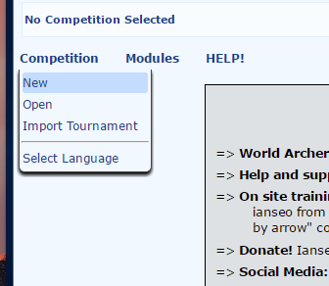

## Fill out the basic Competition Information

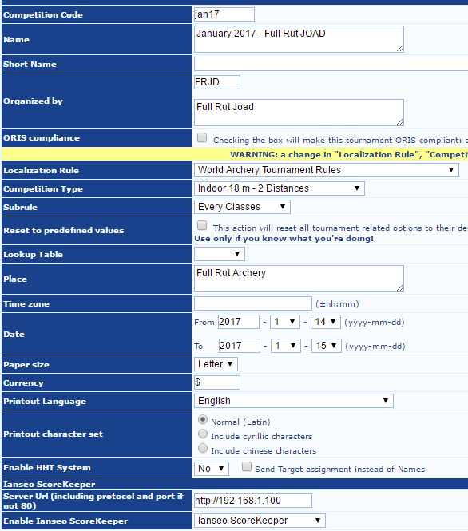

**Fields**

* Competition Code – This is a unique identifier that is used to identify the tournament to the tablet machines. Typically in the format of Month and Year – jan17, feb17, etc.
* Name of the tournament. This will be printed on reports so for our purposes something like “January 2017 – Full Rut JOAD”
* Short Name – Leave Blank
* Organized by – Club Initials and Name
* ORIS compliance – Leave unchecked
* Localization Rule – World Archery Tournament Rules
* Competition Type – Indoor 18m – 2 Distances
* Subrule – Every Classes
* Reset to Predefined values – Leave unchecked
* Place – Name of the range
* Timezone - -07:00
* Date – Dates of the tournaments
* Paper Size – Letter
* Currency - $
* Printout Language – English
* Printout Character set – Normal (Latin)
* Enable HHT System – No
* Server Url – For our purposes this should be <http://192.168.1.100>. This is the IP of the laptop on the private tournament network.
* Enable Ianseo ScoreKeeper – Ianseo ScoreKeeper – This enables the system to talk to the tablets.

## Setting up Sessions

Sessions are the Time Slots that we have groups of archers arrive and shoot. Typically, Colorado JOAD has between 3 and 6 lines.

Click Competition -> Edit Competition Info -> Session

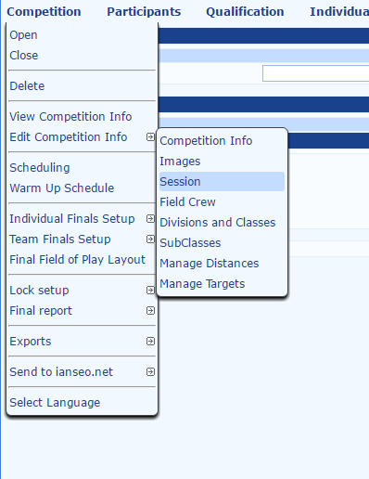

## Sessions

In the Number of Sessions pick the number of lines shooting sessions that the tournament will be using. Under “Target per Session” pick the total number of bales that will have archers shooting on. It is recommended that the number be the physical number available, as archers may need to be moved. All bales do not have to be used.

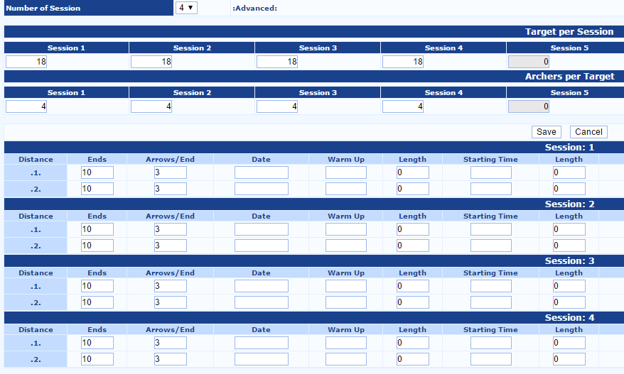

Under Archers per Target enter 4. There are typically 4 40 CM targets or 2 60 CM targets on each bale.

On the list of sessions and distances at the bottom, enter 10 ends, and 3 arrows per end. Other fields can be blank or 0 (Length).

## Setting up Divisions and Classes

Division are the Types of archery. For our purposes they are Recurve, Compound and Barebow. The Classes are the age groups: Junior, Cadet, Cub, Bowman, Yeoman.

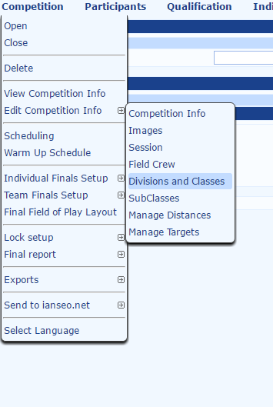

### Divisions

Set the divisions as follows

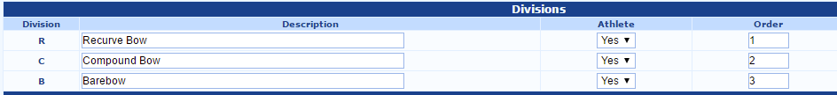

### Classes

Delete existing classes.

Add the following classes back in

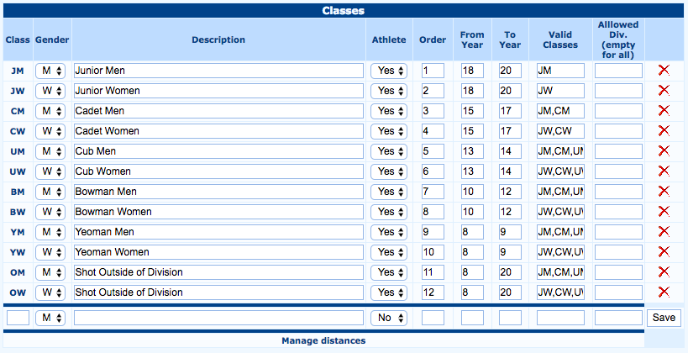

The OM and OW classes are useful when there are shooters that are not shooting with their class. This qualifies the archer for the buckle, but not for a position in the tournament.

## SubClasses

Subclasses can be left as is.

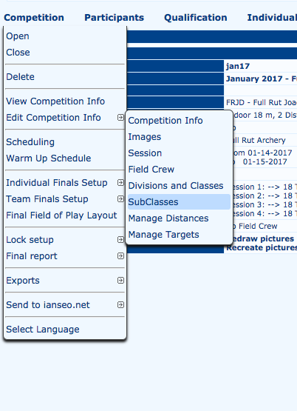



## Distances

Distance should now be setup correctly.

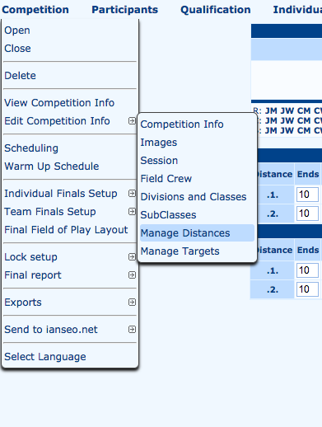

Overview

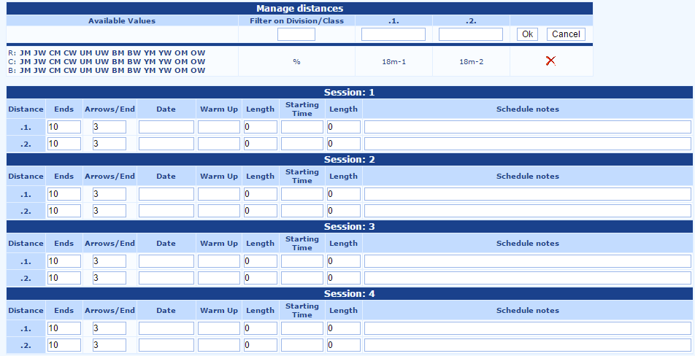

## Manage Targets

Add a new target.

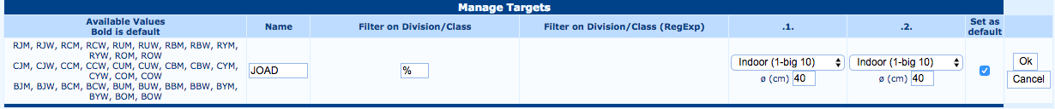

Fields

* Name – JOAD
* Filter on Division / Class - %
* .1 – Indoor (1-big 10) – 40 CM
* .2 – Indoor (1-big 10) – 40 CM
* Set as default – Checked

Click Ok, then delete the other targets.

# Loading Participants

Participants are loaded from a tabbed file. This file is converted from the CognitoForms export.

Click Particpants -> Athletes Sync. -> List Load (SpreadSheet Import)

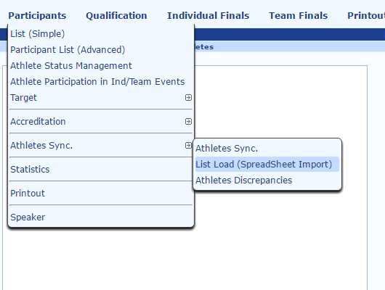

Open file, or paste it in.

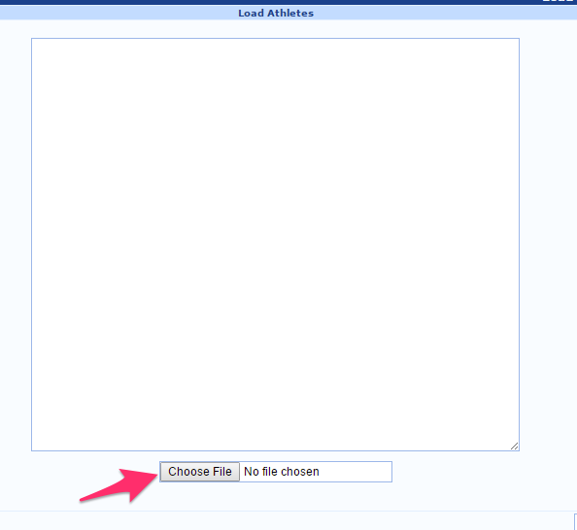

# Listing Participants

To list all of the participants click Participants -> List (Simple)

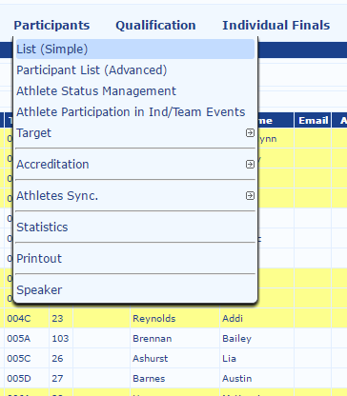

## List of all participants

All participants are listed by session. The easiest way to find people is by searching on the document.

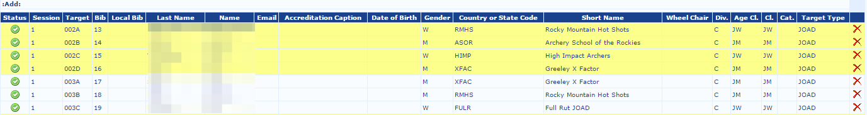

## Edit Participant

Double click on the target row.

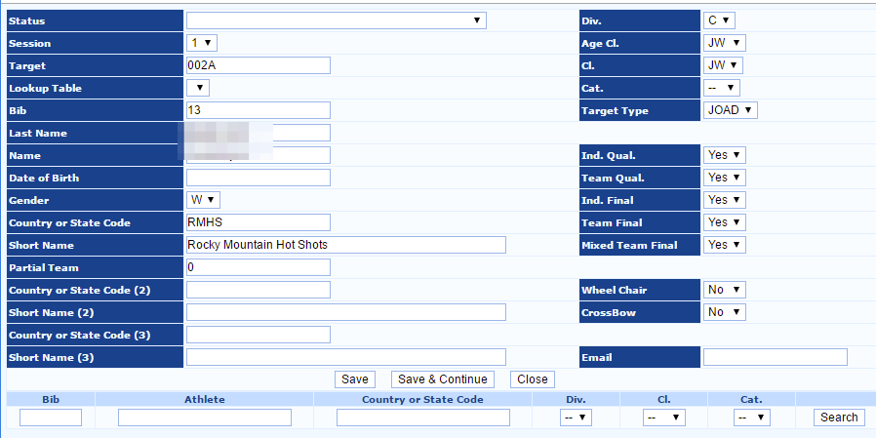

Fields

* Session – Session that the Archer should be assigned to
* Target – Name of the target (001A, 001B, etc.)
* Lookup Table – Empty
* Bib – Unique identifier
* Last Name – Last name of the archer
* Name – First name of the archer
* Date of Birth – Optional.
* Gender – M/F
* Country or State Code – We use an acronym for the Team
* Short Name – Name of the team
* Div. – R/C/B – Recurve, Compound, or Barebow
* Age Class – The class that the archer is by birth date.
* Class – The class that the archer is competing in.
* Category – Leave the category blank
* Target Type – Pick the JOAD target type that was created.

# Modifying Score Totals

There are two primary ways to correct scores. The total score for a round can be adjusted or the individual arrows in each end can be adjusted.

To change the round totals Click Qualification -> Input Score -> Extended Table

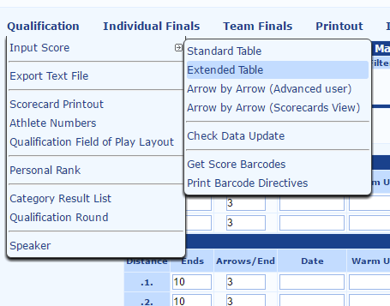

Then select the Session number from the drop down. The first and last bale should automatically select. Leave Distance equal to all, and click ok.

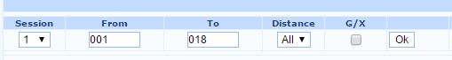

The list of archers is then brought up that matches the query. The totals can be adjusted for each round. The number of 10s, and 9s cannot be adjusted.



# Fixing All Scoring

If there is a major issue with a tablet it is easier to adjust in the Arrow by Arrow view.

Click Qualification -> Input Score -> Arrow by Arrow (Scorecard View)

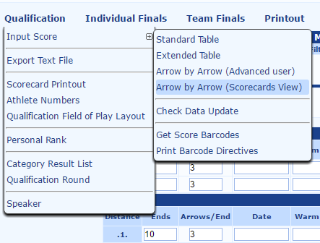

Pick the Session from the dropdown. Then select the “Distance” or “Round” that it needs to be adjusted. Enter the Target that needs to be adjusted.

/var/folders/f9/48sxtgq503d2nls4xr24r9v80000gn/T/com.skitch.skitch/DMDD5DEB2E2-32FF-48A5-8386-05948644612F/Ianseo_win10.png

Once the target is selected. The list of ends and the arrows is listed. Each arrow value can be adjusted independently.

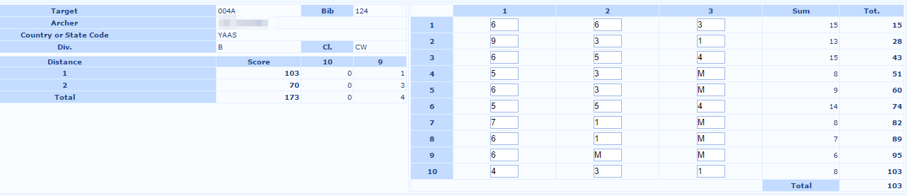

# Printing Scores

To export the scores for review or for posting at the end of the tournament, click Printout -> Div/Class Result List.

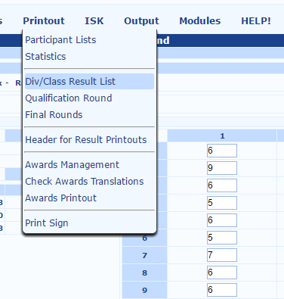

Choose Class & Division Result List - Individual

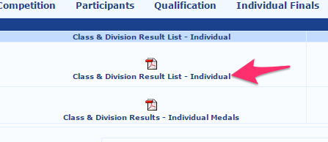

# Exporting Tournament

Exporting the file

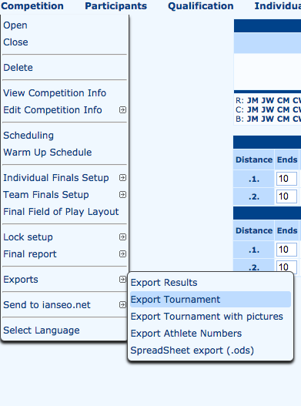

The file is automatically downloaded to a .ianseo file.

