Brian Roche-Campos
Southern New Hampshire University
Professor Akhil Gudivada
CS-499 Computer Science Capstone
March 19th, 2026

Enhancement Two: Algorithms and Data Structure

1. Briefly describe the artifact. What is it? When was it created?
The artifact I selected is a Java-based appointment management system that I originally developed in September 2025 during CS 320: Software Test, Automation, and Quality Assurance. The system includes classes for creating and managing appointments, along with unit tests written using JUnit. It allows users to add, delete, and update appointments while enforcing rules such as unique IDs, valid future dates, and description length limits.

2. Justify the inclusion of the artifact in your ePortfolio.
I chose this artifact because it shows how I can apply algorithms and data structures to improve a working program. In this enhancement, I expanded the original system by adding more advanced logic and improving how the data is handled. One of the main changes I made was replacing the original HashMap with a TreeMap, which helps keep the data organized by automatically sorting the keys. I also added a method to sort appointments by date using a comparator, which makes it easier to view upcoming appointments in order. In addition, I implemented a search feature that uses a linear search to find appointments based on keywords in their descriptions. These changes improved both the structure and usability of the system. Overall, this artifact reflects my ability to choose appropriate data structures and apply algorithms like sorting and searching to solve real problems.

3. Did you meet the course outcomes you planned to meet with this enhancement?
Yes, I met the course outcomes I originally planned in Module One. This enhancement shows how I can use algorithmic thinking and data structures to improve a software solution. I worked with Java collections like TreeMap and ArrayList and applied sorting and searching techniques to extend the system’s functionality. At this point, I don’t see a need to change my outcome coverage plan because this artifact still represents my progress in working with algorithms and data structures.

4. Reflect on the process of enhancing and modifying the artifact.
Working on this enhancement helped me better understand how data structures and algorithms can improve both performance and usability in a program. Adding the sorting feature required me to learn how comparators work and how to organize data within a list. The search feature also helped reinforce my understanding of loops and string matching. One challenge I ran into was making sure the new features didn’t break anything that was already working. I had to be careful when modifying the code and made sure to run all of my unit tests after each change. This helped me confirm that both the original functionality and the new features were working correctly.
Overall, this process improved my confidence in modifying existing code and applying new concepts without introducing errors. It also showed me how important testing is when making changes to a system.

Code Enhancement Screenshots
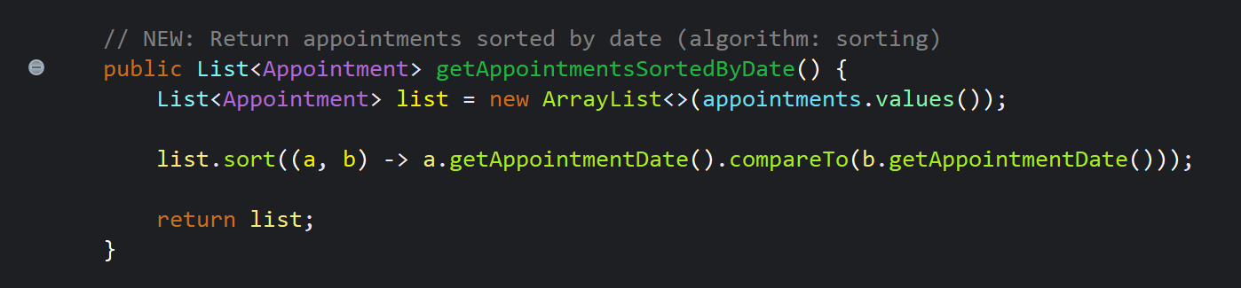
Screenshot of the getAppointmentsSortedByDate() method in AppointmentService.java:

Screenshot of the getAppointmentsSortedByDate() method in AppointmentService.java:
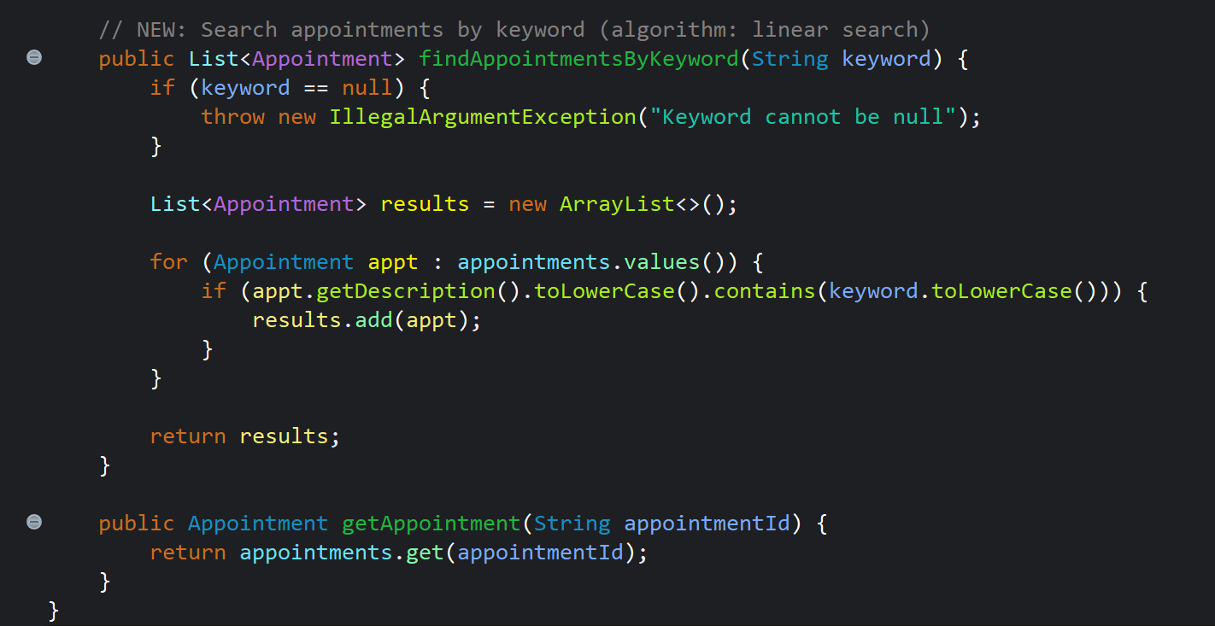
Screenshot of the TreeMap declaration in AppointmentService.java:
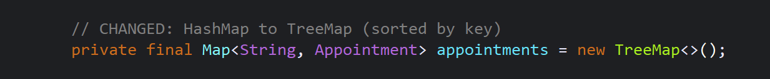

JUnit Results Screenshots
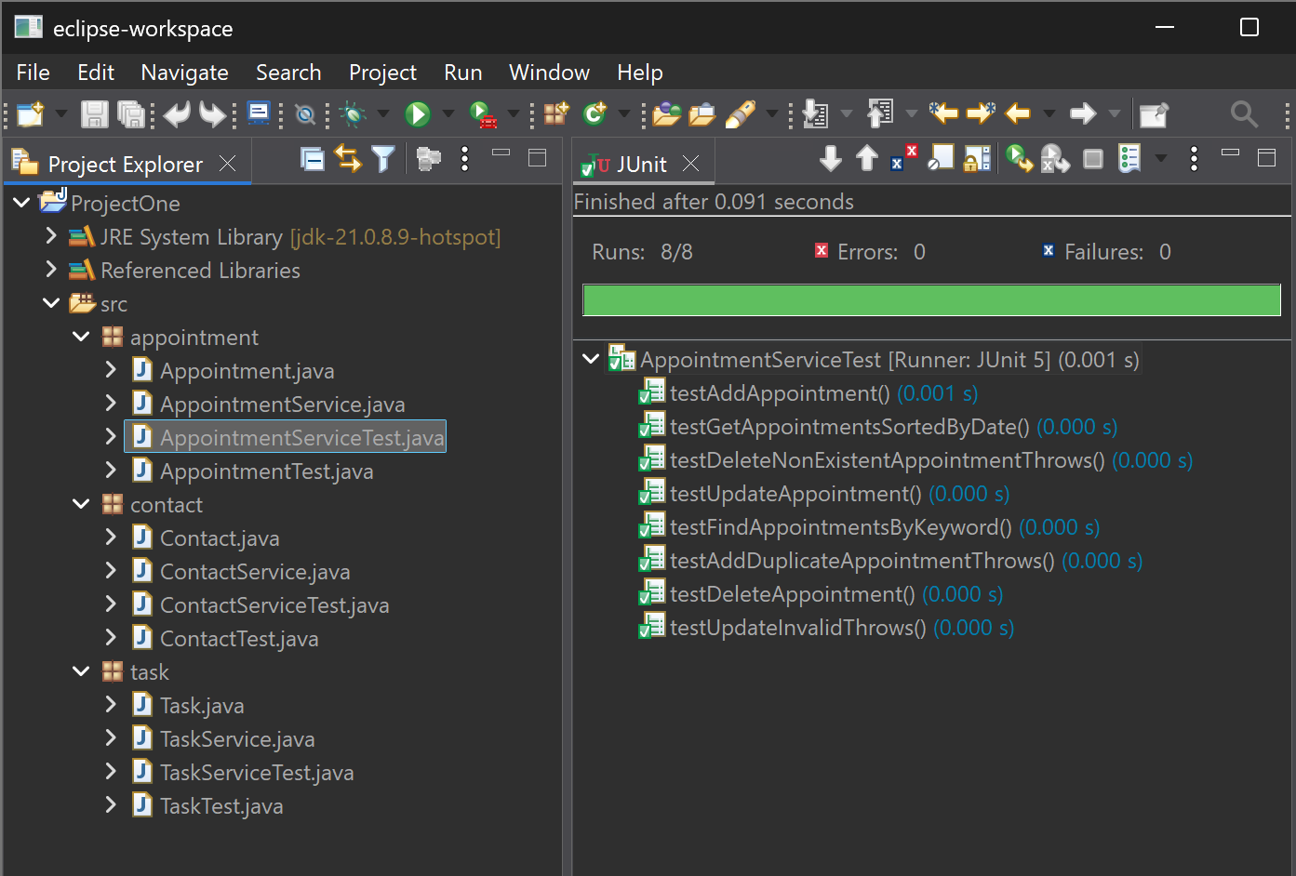
AppointmentServiceTest.java green test results (passed)

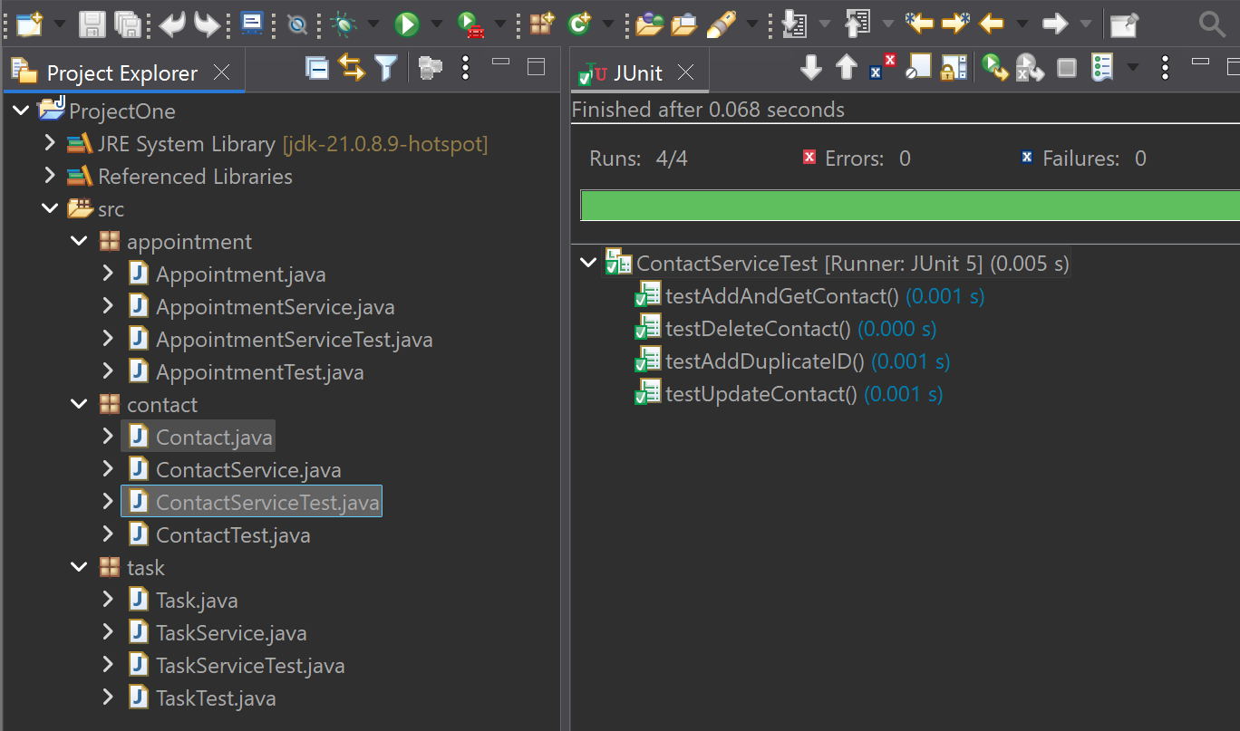
ContactServiceTest.java green test results (passed)

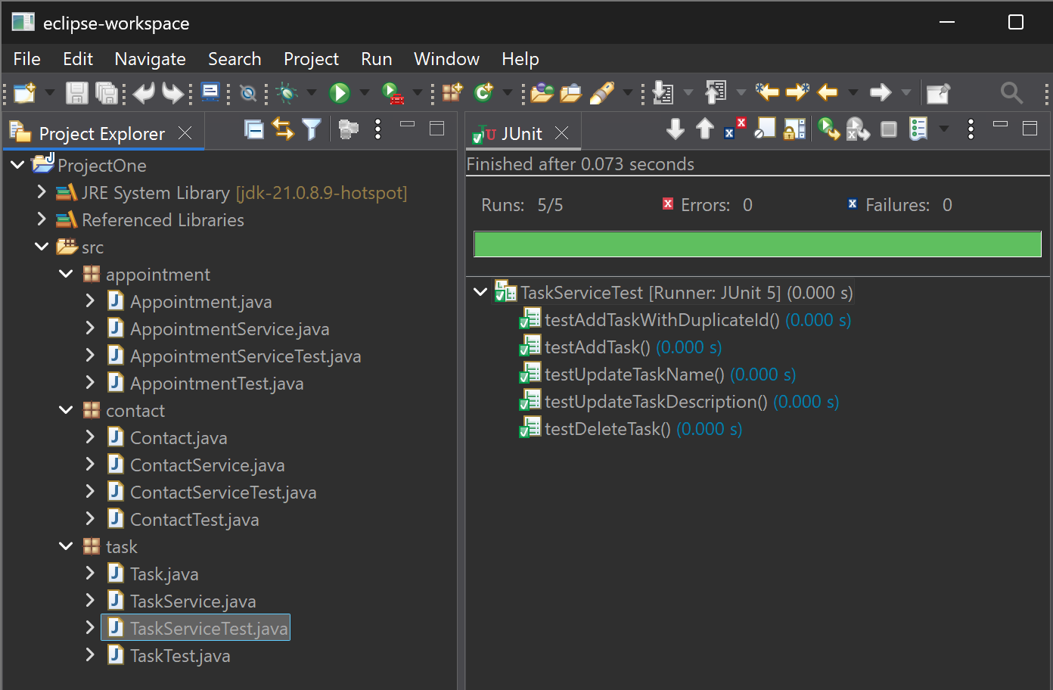
TaskServiceTest.java green test results (passed)

