Brian Roche-Campos
Southern New Hampshire University
Professor Akhil Gudivada
CS-499 Computer Science Capstone
March 19th, 2026

Enhancement One: Software Design/Engineering Narrative

1. Briefly describe the artifact. What is it? When was it created?
The artifact I selected is a Java-based appointment management system that is part of a larger project including contact and task management services. This artifact was originally created in a previous course (CS 320: Software Test, Automation, and QA) in September 2025. The system includes classes for managing appointments, along with corresponding unit tests written using JUnit. The original functionality allowed users to add and delete appointments while enforcing input validation rules such as unique IDs, valid future dates, and description length limits.

2. Justify the inclusion of the artifact in your ePortfolio.
I selected this artifact because it demonstrates my ability to design and implement object-oriented software solutions while applying software engineering best practices such as validation, encapsulation, and unit testing. Specifically, the AppointmentService class showcases my ability to manage data using appropriate data structures, such as a HashMap, and enforce constraints like unique identifiers.
In the original code, the AppointmentService class only supported adding and deleting appointments and did not allow updates to existing records. For this enhancement, I improved the artifact by adding new functionality to update an existing appointment. This required designing and implementing a new method, updateAppointment, which allows modification of an appointment’s date and description while maintaining all validation rules. I also updated the unit tests by adding new test cases to verify both successful updates and expected exceptions when invalid data is provided.
This enhancement helped me apply several important software engineering skills, including extending existing functionality without breaking prior behavior, writing and maintaining unit tests, and preserving data integrity through controlled updates. Additionally, I ensured that all previously existing tests for appointments, contacts, and tasks still passed after my changes, confirming that the enhancement did not introduce regressions into the system.

3. Did you meet the course outcomes you planned to meet with this enhancement?
Yes, I met the course outcomes I planned in Module One. This enhancement demonstrates my ability to design and evaluate computing solutions by extending an existing system with new functionality while maintaining its integrity. I also demonstrated the ability to implement solutions using appropriate tools and techniques, specifically Java and JUnit 5 for testing.
The update functionality required careful consideration of validation rules and system behavior, which aligns with software engineering best practices. At this time, I do not have any changes to my outcome coverage plan, as this artifact continues to effectively demonstrate progress toward multiple program outcomes, particularly in software design and testing.

4. Reflect on the process of enhancing and modifying the artifact.
Through this enhancement process, I learned the importance of building software that is maintainable and extensible. Adding the update functionality required me to think carefully about how to modify existing data while preserving validation rules and avoiding unintended side effects. I also gained more experience working with unit tests, particularly in writing tests that validate both correct behavior and error handling.
One challenge I faced was configuring JUnit 5 correctly in my development environment. I encountered multiple dependency and classpath issues, which required troubleshooting and manually adding the correct libraries. Resolving this issue improved my understanding of how testing frameworks are integrated into Java projects and how dependencies impact execution.
Another challenge was ensuring that my enhancement did not break existing functionality. I addressed this by running all test suites (appointments, contacts, and tasks) after making changes. This reinforced the importance of regression testing and gave me confidence that my solution was stable.
Overall, this experience strengthened my understanding of software design principles, testing practices, and the importance of validating changes within a complete system.

Test Execution Results
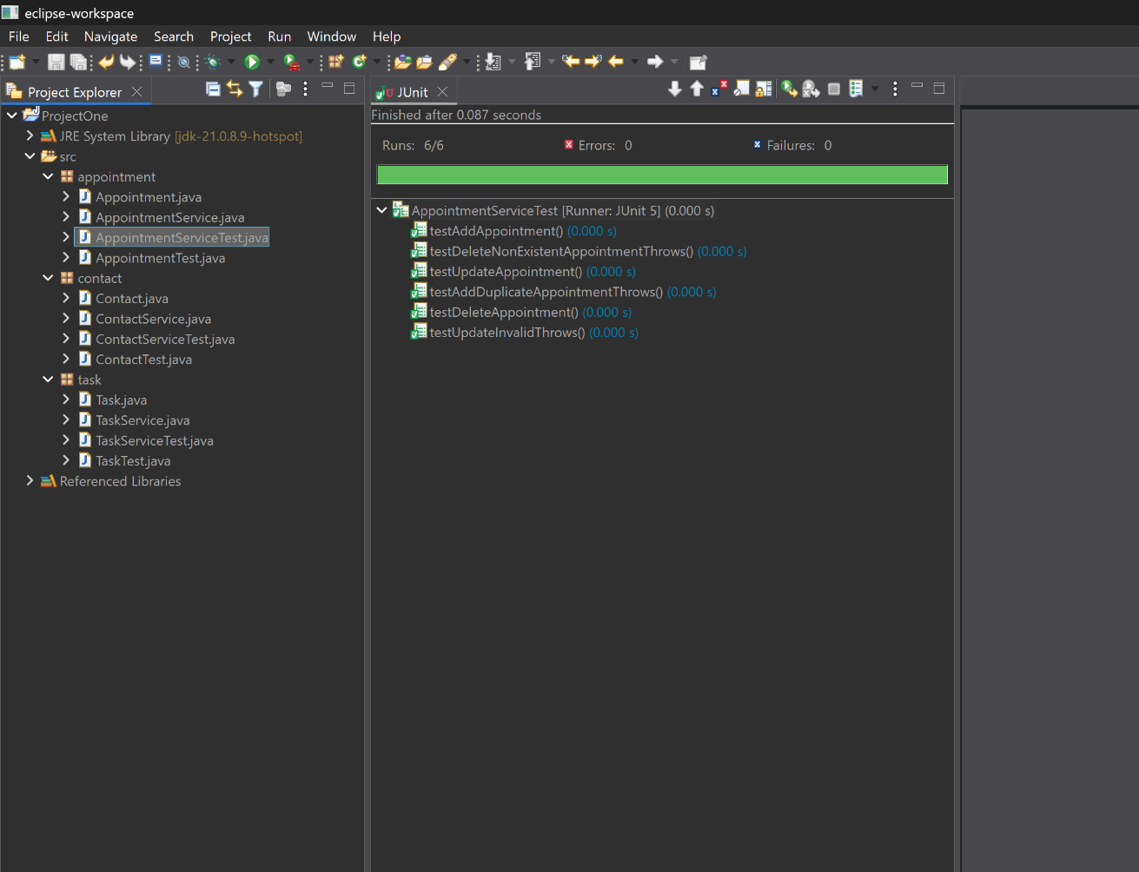
AppointmentServiceTest results showing all tests passed.

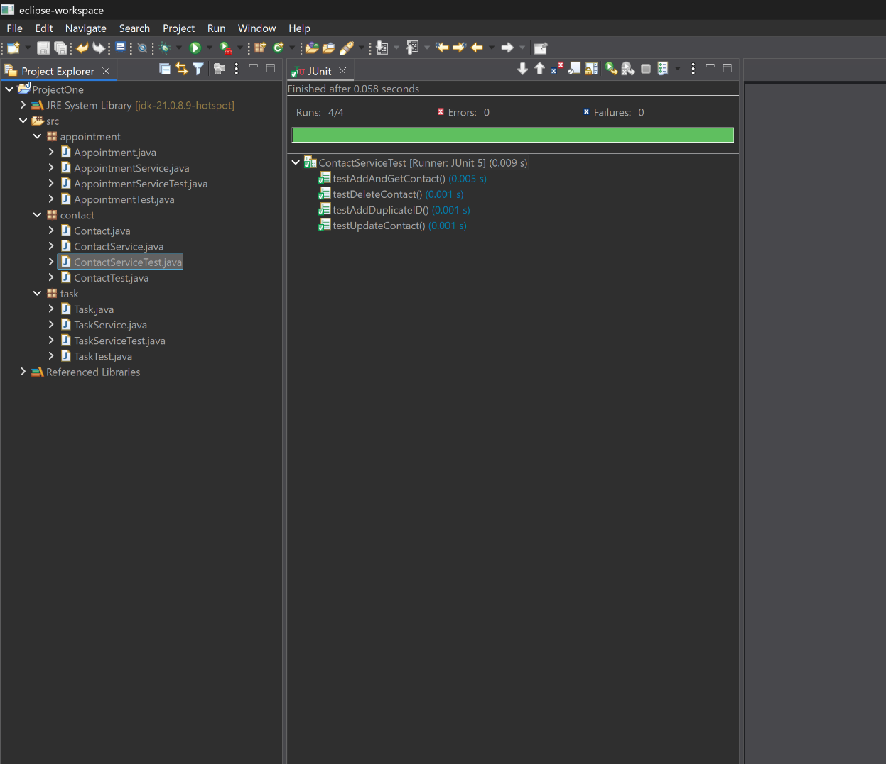
ContactServiceTest results showing all tests passed.

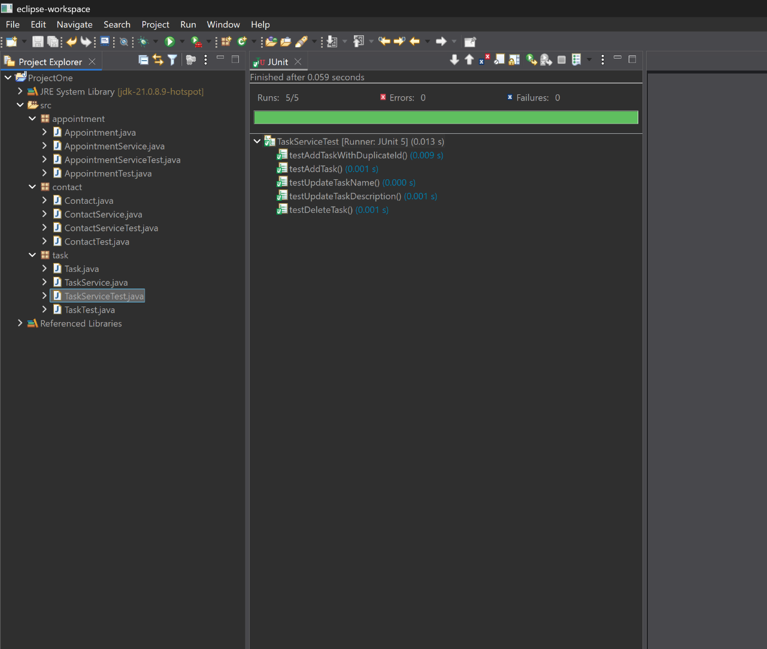
TaskServiceTest results showing all tests passed.

