Brian Roche-Campos
Southern New Hampshire University
Professor Akhil Gudivada
CS-499 Computer Science Capstone
March 26th, 2026

Enhancement Three: Databases

- Briefly describe the artifact. What is it? When was it created?
The artifact I selected is a Java-based appointment management system that I created in September 2025 during CS 320: Software Test, Automation, and Quality Assurance. The system allows users to create, update, and delete appointments while enforcing rules such as unique IDs, valid future dates, and description length limits. It also includes JUnit tests to make sure everything works correctly.

- Justify the inclusion of the artifact in your ePortfolio.
I selected this artifact because it shows how I can improve an existing system by adding database-related functionality. In the earlier version, appointment data was only stored in memory using a TreeMap, so all data was lost when the program ended.
To improve this, I added file-based storage to simulate a database. I created methods to save appointment data to a file and load it back when needed. This allows the system to keep data even after the program closes, which is important in real-world applications.
I also added validation when loading data to make sure the format is correct and to prevent bad data from causing errors. These changes show my ability to store, retrieve, and manage data while keeping the system stable.

- Did you meet the course outcomes you planned to meet with this enhancement in Module One? Do you have any updates to your outcome-coverage plans?
Yes, I met the outcomes I planned in Module One. This enhancement shows that I can design and implement a solution for storing and retrieving data, which connects directly to database concepts. By adding file storage, I improved the system beyond basic in-memory storage and made it more practical. At this time, I do not have any updates to my outcome plan because this artifact already demonstrates my progress in working with data and persistence.

- Reflect on the process of enhancing and modifying the artifact. What did you learn as you were creating it and improving it? What challenges did you face?
While working on this enhancement, I gained a better understanding of how data persistence works and why it is important. I learned how to save data to a file and reconstruct it correctly when loading it back into the system.
One challenge was making sure the data could be saved and loaded without errors. I solved this by converting the date into a numeric format and rebuilding it when reading from the file. I also added checks to skip any invalid data.
Another challenge was making sure I didn’t break the existing system. I ran JUnit tests after making changes to confirm everything still worked. This helped me understand how important testing is when updating software.
Overall, this process improved my understanding of data storage and how to safely extend an existing system.

(Please refer to the next page for the screenshots)

Code Enhancement Screenshots

The screenshot below shows the database enhancement methods used to save and load appointment data using a file.
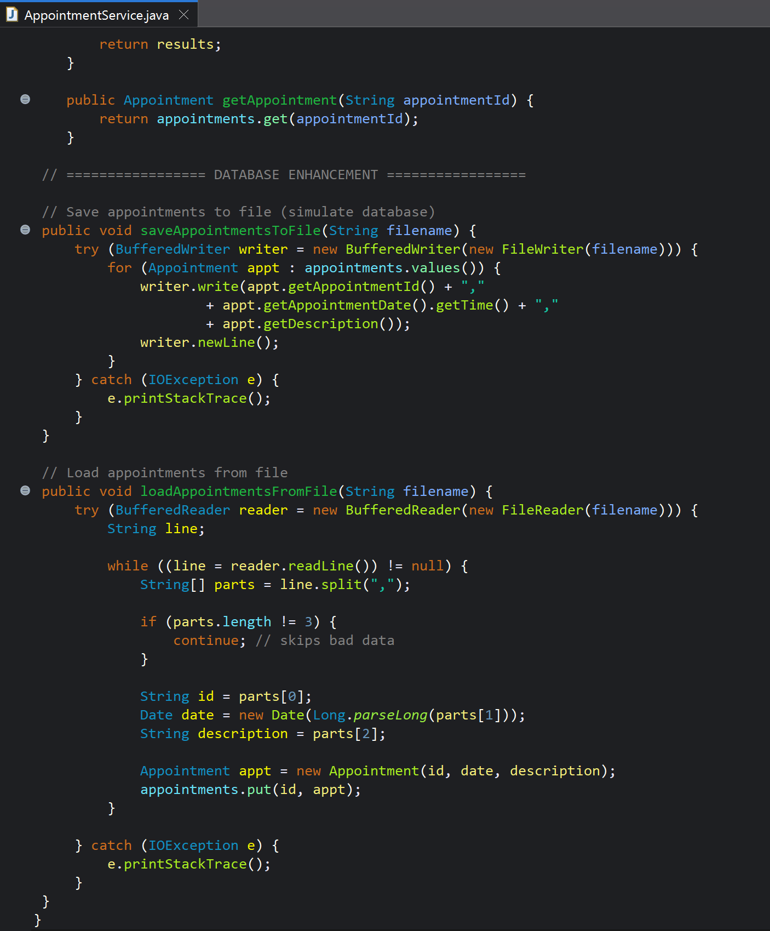
The screenshot below shows the TreeMap used to store and organize appointment records.

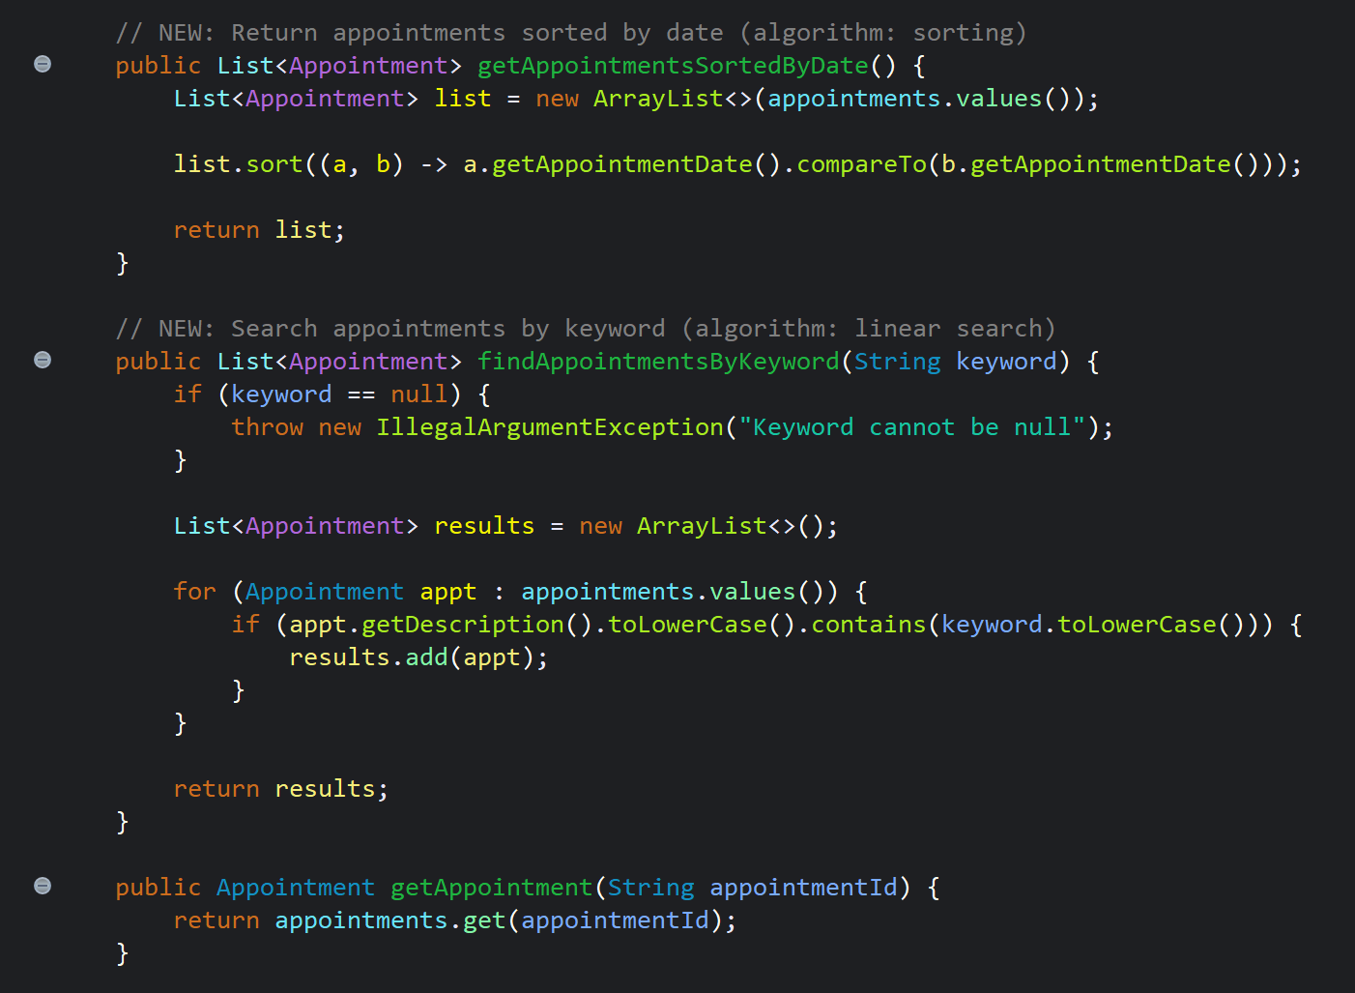
The screenshot below shows the method used to sort appointments by date.
Screenshots of the Junit tests (all passed)
