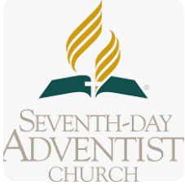
WEST ZIMBABWE CONFERENCE
MAGWEGWE NORTH DISTRICT
MAGWEGWE WEST SDA CHURCH
FILE TRANSFER SYSTEM
SEND AND RECEIVE DOCUMENT IN CONFORT OF YOUR HOME

File transfer system
Church clerk dashboard
Generate service request online or upload upload offline document
Church clerk to add church stamp online
Send to the head elder and sign and then forward to pastor or church clerk must be optional or reject with comment
Send and received on pastor dashboard and on whatsap when it is signed by the Head elder

Pastor dashboard
Must be able to add his signature or sign the document online
Must be able to reject service request with comment
Must be able to sign uploaded document and send back
Must have option to send to church clerk or head elder
Must have archive folder for all processed requests

All documents must be edit protected once they are in the system except the signature portion and phone numbers portion
ALL FILE SHARING MUST HAVE TIMESTAMP

