Admin View:

**/admin**

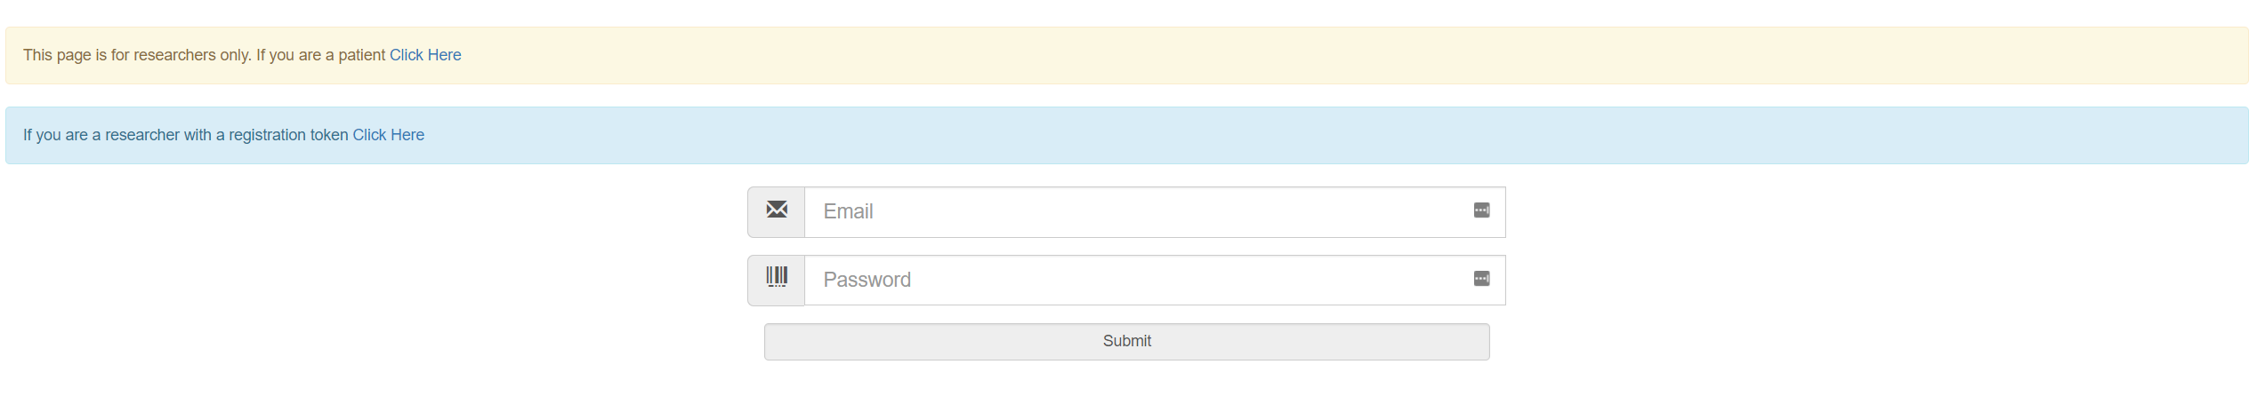**LOGIN**

- In order to begin using the site as a researcher, you must first log in. Enter your email and password and press submit.

- Passwords must be at least 10 characters.

**REGISTER**

- If you need to register and have been provided with a registration token, click the link in the blue box.

- If you have not been provided with a registration token, or have forgotten your password, contact one of the owners of the site so they may assist you.



**SELECT ACTION**

- After logging in you may select from any of the above options. Each links function is described in the yellow box on the main admin page.

**Add Patient to Database**

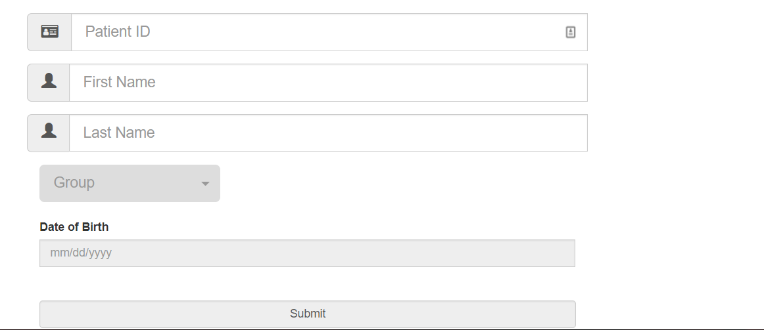

- Use this page to add a new patient to the patient database. This only needs to be done once per patient.

- You must fill in each piece of information including the patient’s group and date of birth.

**Create New Appointment**

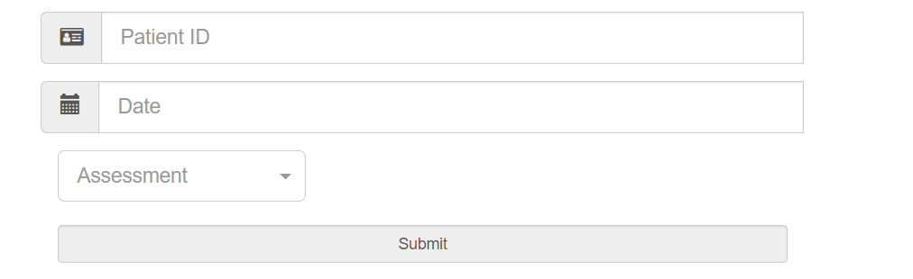

- Use this page to schedule a new appointment for a patient. This must be done every time a patient has an appointment. Select the date of the appointment and which type of assessment you would like the patient to fill out. If you would like them to fill out multiple assessments you must fill out the form multiple times.

- You may only have any given assessment scheduled once per day.

- Below this form is a list of all assessments that have NOT been filled out by patients. This list can be used to remind patients, deleted unneeded assessments or to delete mistakes.

- Check the box indicating the assessments no longer needed and click Delete Checked Sessions.

**Input Appointment Protocol Information**

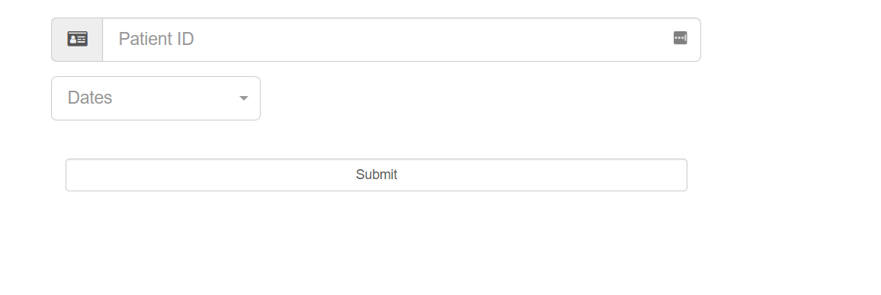

- Use this form to enter protocol information for patients. A patient must first have a Session Self Report appointment made prior filling out a protocol form.

- Enter the patient’s ID and then all available dates will be displayed. Select the corresponding date and click submit.

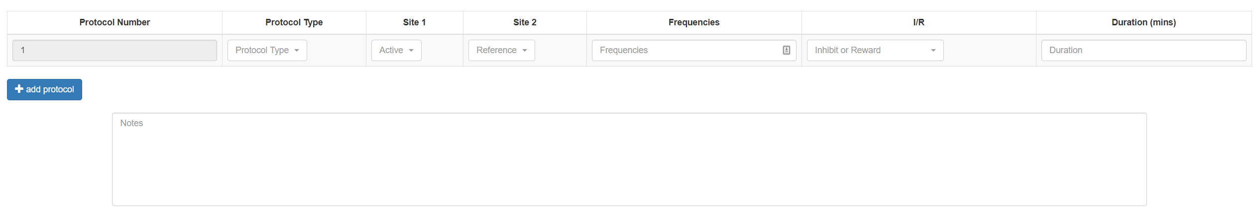

- Fill out protocol information and notes, one frequency range per line. Add protocol will allow for additional lines.

- The last used protocol will be automatically loaded, so if no changes were made you can simply click submit.

**Update Patient Personal Information**

- Patients are asked to enter their own personal information on their portion of the site (see below). This page can be used to view and/or modify any of the information they provided.

- Enter the patients ID and view or change the information on the following form.

**Retrieve Patient Assessment Data**

- Use this form to download in excel format any data collected about a specific patient.

- Filenames are in the format of “PatientID – Eyes Open or Closed (if known) – Todays date”

- Select the type of form and which of those forms you want. You may select “Include Initial Assessment Data” to include the first assessment completed by the patient, even if that is not part of the selected data range.

- You may select “Include Patient Information” to include patient’s phone number, address, etc. You may select “Include Intake Information” to include initial patient information. NOTE: This option only works on Session Self Report.

**Upload Patient Files**

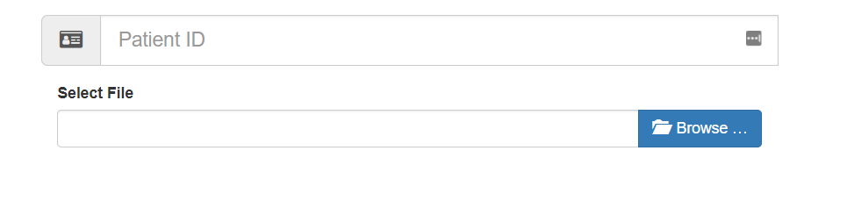- Use this form to upload other miscellaneous files you would like to associate with a patient. WARNING: You should consider whether information contains identifying information before uploading.

- Select the patient and then browse to select the file.

- NOTE: File sizes are limited and you may only upload data documents (Word, Excel)

**Download Patient Files**

- Use this form to view and download miscellaneous files associate with a patient. Enter their ID and submit.

- Click any download link to download the file.

**Update Password**

- Use this form to change your password. Enter your old password then your new password.

- Passwords must be at least 10 characters long.

**Logout**

- Use this to logout of your session.

**MASTER VIEW ONLY**

- Options pertaining to adding and/or removing other researchers is limited to master accounts only. The following options are only available to master accounts.

**Add Researcher**

- Use this form to add a new researcher to the app. Enter their email address and you will receive a token. Provide that token to a researcher and they can use it to register.

- Below the form you will see a list of all researchers who have a form but have not yet registered for an account. It is a lapse in security to allow people to remain on this form for too long. They should be removed if no longer needed.

**- WARNING: Any researcher will have full access to all patient records.**

**Remove Researcher**

**- WARNING: Any researcher will have full access to all patient records.**

- Use this form to remove a researcher from the app. This will immediately remove their ability to access any patient information.

- Below the form you will see a list of ALL researchers. It is considered a lapse in security to have researchers accounts remain after they have fulfilled their new for an account.

- NOTE: Master accounts may not be removed.

**Reset Researcher Password**

- Use this form to reset a researcher’s password and provide them with a new registration token.

- This form should be used if a researcher has forgotten their password and it needs to be reset. Provide them with the new token and they can use it to register.

**REGISTER**

- On the main login page, click on the link in the blue box. If you do not have a registration token, contact the app own to receive one.

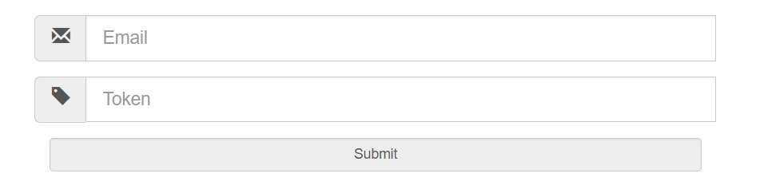

- Enter your email address and the provided token and then complete your registration.

- NOTE: Passwords must be at least 10 characters long.

- Once you have registered you may log in normally.

Patient View

- Patients can log in using their ID, first and last name

- A patient must have at least one form to fill out or they will not be allowed to enter.

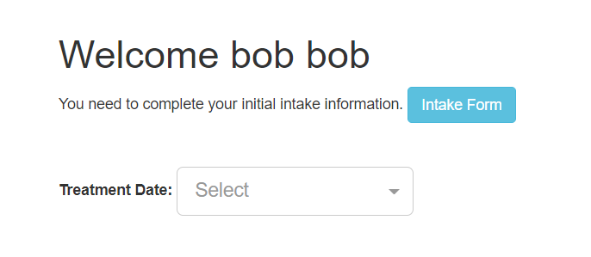

- Patients can either fill out the “Intake Form” or select their treatment date to continue filling out the form.

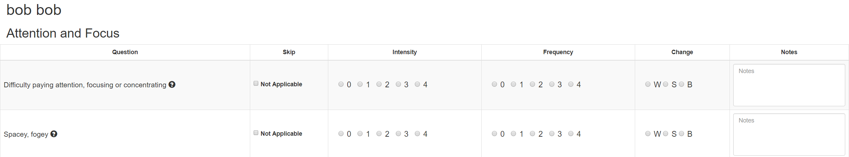

- After selecting a form patients should answer all questions and click submit. They will be taken to a new page until they have finished the entire form.

- If a patient has multiple forms to fill out, they will need to log in multiple times.

- If a question is not answered, it will be marked in red for them to complete.

- A patient may stop filling out a form after any page and pick back up later.

- Hover over the question mark to receive help filling out the form.