新客戶訂單資料表
編號 | 產品名 | 數量 | 單價 | 總價 | 訂購公司 |  | 訂貨日期 | 交貨日期 | 工作天數
B7123 | CD | 100 | 300 | 30000 | 永豐 |  | 1999/2/3 | 1999/3/1 | 26
N3458 | MD | 55 | 450 | 24750 | 松柏 |  | 1999/2/19 | 1999/3/30 | 39
S0126 | VCD | 150 | 950 | 142500 | 快樂 |  | 1999/3/16 | 1999/4/2 | 17
B7123 | CD | 250 | 300 | 75000 | 快樂 |  | 1999/2/22 | 1999/3/10 | 16
S0126 | VCD | 80 | 950 | 76000 | 松柏 |  | 1999/1/18 | 1999/2/25 | 38
B9163 | LD | 190 | 1050 | 199500 | 國際 |  | 1999/3/2 | 1999/3/12 | 10
B7128 | DVD | 170 | 880 | 149600 | 三泰 |  | 1999/4/4 | 1999/4/15 | 11
B9163 | LD | 130 | 1050 | 136500 | 松柏 |  | 1999/4/17 | 1999/4/20 | 3
B7123 | CD | 140 | 300 | 42000 | 國際 |  | 1999/4/25 | 1999/6/1 | 37
B7128 | DVD | 160 | 880 | 140800 | 快樂 |  | 1999/6/3 | 1999/7/23 | 50
D5555 | TAPE | 100 | 100 | 10000 | 中山 |  | 2000/7/1 | 2000/7/13 | 12

- 依產品名遞增排序列出「新客戶訂單資料表」的所有內容。
SELECT *
FROM new_customer_order
ORDER BY pname ASC;

- 找出快樂公司的訂單。
SELECT *
FROM new_customer_order
WHERE buyer = '快樂';

- 找出產品名中有C的且編號是B7開頭的訂單。
SELECT *
FROM new_customer_order
WHERE [no] LIKE 'B7*' AND pname LIKE '*C*';

- 找出1999年4月份的訂單。
SELECT *
FROM new_customer_order
WHERE order_date BETWEEN #1999/4/1# AND #1999/4/30#;
- 找出編號不是B開頭的訂單。
Select *
From new_customer_order
Where [no] not like ‘B*’

- 找出編號為B開頭的前五筆訂單。（提示：對編號遞增排序）
SELECT TOP 5 *
FROM new_customer_order
WHERE [no] LIKE 'B*'
ORDER BY [no] ASC;

- 找出總價100000以上的訂單。
SELECT *
FROM new_customer_order
WHERE [total_price] >= 100000;
- 列出單價500以上的品名。（不可重覆）
SELECT DISTINCT pname
FROM new_customer_order
WHERE [single_price] >= 500;

- 挑出總價前五高的訂單（不要列出工作天數，其餘欄位都要列出）。
SELECT TOP 5 new_customer_order.no, pname, quantity,single_price,total_price,buyer, order_date,deliver_date
FROM new_customer_order
ORDER BY total_price DESC;

- 單價上漲10﹪。
UPDATE new_customer_order
SET single_price = single_price * 1.1;

- 將快樂公司的單價打九折。

UPDATE new_customer_order
SET single_price = single_price * 0.9
WHERE buyer = '快樂';
- 列出品名、單價、票期單價，其中票期單價為單價×105﹪。
Select pname , single_price , single_price*1.05 as new_single_price
From new_customer_order

- 挑出數量介於100~200間的品名單價（不能重覆）。
Select distinct pname,single_price
From new_customer_order
Where quantity >= 100
And quantity <= 200;
***13.1查詢數量介於100~200之間的品名單價(數量=單價)
select t1.pname,t1.single_price,t1.quantity
from new_customer_order t1
where t1.quantity >= 100
and quantity <=200
and not exists
(
Select 1
From new_customer_order t2
Where t1.pname = t2.pname
and t1.single_price = t2.single_price
and t1.quantity <> t2.quantity
)
Order by pname,single_price;
- 挑出數量介於100~200間且是快樂公司的訂單。
Select quantity,buyer
From new_customer_order
Where quantity between 100 and 200
And buyer = ‘快樂’

- 挑出1999年3月、4月或6月的訂單。

SELECT *
FROM new_customer_order
WHERE (order_date >= #1999/3/1# AND order_date < #1999/5/1#) OR (order_date >= #1999/6/1# AND order_date < #1999/7/1#)

- 列出最便宜的單價及其品名。(同樣品名下最便宜的單價，列出單價與品名)
Select pname,min(single_price) as cheap
From new_customer_order
Group by pname

- 分別列出最便宜和最貴的單價及其品名。
SELECT pName, single_price
FROM new_customer_order
WHERE single_price = (
SELECT MIN(single_price)
FROM new_customer_order
)
UNION
SELECT pName, single_price
FROM new_customer_order
WHERE single_price = (
SELECT MAX(single_price)
FROM new_customer_order
)
# 此行可有可無 ORDER BY single_price ASC;
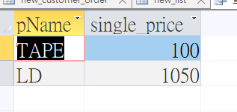
***
Select top 1 pname,single_price
From new_customer_order
Order by single_price asc
union
Select top 1 pname,single_price
From new_customer_order
Order by single_price desc;

- 每筆記錄顯示訂單編號、訂單日期、今天日期。
Select [no] , order_date , date() as today_date
From new_customer_order;

- 列出1999年的訂單。
Select *
From new_customer_order
Where order_date >= #1999/1/1# and order_date < #1999/12/31#;

- 算出平均單價。
Select avg(single_price) as mean
From new_customer_order

- 此資料表中共有幾筆記錄其訂貨日期是< 1999年六月份的。
Select count(*)
From new_customer_order
Where order_date < #1999/6#;

- 計算出共有幾種不同的產品。
Select count (*) as num_products
From (select distinct pname from new_customer_order);

- 計算出每家公司曾訂過幾種不同的產品。
Select buyer, count(*) as buyer_products
from new_customer_order
group by buyer

- 此資料表中有幾筆的記錄，其交易額大於平均交易額。
Select count(*) as record
From new_customer_order
Where total_price > select (avg(total_price) from new_customer_order);

- 計算出到目前為止，每家公司所訂的各種產品的訂貨總量。
select pname,buyer,sum(quanity) as total
from new_customer_order
group by buyer,pname;
- 計算出有幾家公司曾訂過 cd。(ans:3，永豐、快樂、國際)

Select count(*) as ordernum
From (select buyer from new_customer_order where pname='cd'
group by buyer);

- 快樂公司的貨曾在哪幾天送出並且送出哪些貨（列出產品名、訂購公司、交貨日期）。
select buyer,deliver_date,pname
from new_customer_order
where buyer='快樂';

- 找出工作天數介於平均工作天數和最大工作天數中間的記錄。
SELECT *
FROM new_customer_order
WHERE work_days BETWEEN (SELECT AVG(work_days) FROM new_customer_order) AND (SELECT MAX(work_days) FROM new_customer_order);

- 把工作天數大於平均工作天數的記錄按照訂購公司分群，計算每一群的記錄筆數。
select buyer,count(*) as record
from new_customer_order
where work_days > (select avg(work_days) from new_customer_order)
group by buyer;

- 根據編號分群，針對每群中交易額（總價）的合計大於150000的記錄，列出編號並計算其記錄的筆數、交易額的合計、交易稅（交易額*0.05）及平均交易額。
Select
new_customer_order.[no],
count(*) as record_count,
sum(total_price) as total,
sum(total_price*0.05) as 交易稅,
avg(total_price) as 平均交易額
From new_customer_order
Group by new_customer_order.[no]
Having sum(total_price) > 150000;

- 根據編號、單價分群，針對每群中（單價>500且交易額的合計大於150000）的記錄，顯示其記錄編號、交易額的合計、平均交易額。
SELECT
[no],
SUM(total_price) AS '交易額的合計',
AVG(single_price) AS '平均交易額'
FROM
new_customer_order
WHERE
single_price > 500
GROUP BY
[no], single_price
HAVING
SUM(total_price) > 150000

- 把單價>500的記錄，根據編號分群，對每一群中（交易額的合計大於150000）的記錄，顯示其記錄的編號及平均交易額。
Select [no],AVG(single_price) as avg_price
From new_customer_order
Where single_price > 500
Group by [no]
Having sum(total_price) > 150000;

- 將新客戶訂單資料表的結構及資料產生一叫做新客戶訂單備份資料表的資料表。
*** 只有轉移欄位到新的一組(資料沒補上)
CREATE TABLE backup(
no VARCHAR NOT NULL,
pname VARCHAR NOT NULL,
quantity INT NOT NULL,
single_price INT NOT NULL,
total_price INT NOT NULL,
buyer VARCHAR NOT NULL,
order_date DATE NOT NULL,
deliver_date DATE NOT NULL,
work_days INT NOT NULL,
PRIMARY KEY (no)
);
***正解
Select new_customer_order.no,
new_customer_order.pname,new_customer_order.quantity,
new_customer_order.single_price,new_customer_order.buyer,
new_customer_order.order_date, new_customer_order.deliver_date,
new_customer_order.work_days into [backup]
From new_customer_order

***另解
Select * into backup
From new_customer_order
- 把新客戶訂單資料表中訂購公司為快樂的產品名、數量、單價、訂購公司欄位資料，產生一個快樂公司訂購資料表

Select new_customer_order.pname,new_customer_order.quantity,
new_customer_order.single_price,new_customer_order.buyer into [快樂]
From new_customer_order
Where buyer = '快樂';

- 將新客戶訂單備份資料表1999年1月份的訂單記錄刪除。
Delete from backup
Where order_date >= #1999/1/1# and
order_date <= #1999/1/31#;
***另解
Delete from backup
Where year(order_date) = 1999 and month(order_date) = 1;
***另解
Delete from backup
Where order_date like ‘1999/1/*’;

- 將新客戶訂單資料表1999年1月份的訂單記錄加入新客戶訂單備份資料表中。
Inser into backup
From new_customer_order
Where order_date >= #1999/1/1# and #1999/1/31#

- 新增一筆內容為 “D5555”, “TAPE”, “100”, “100”, ”10000”, ”中山”, ”2000/7/1”, ”2000/7/13”,”12” 的記錄到新客戶訂單資料表。
INSERT INTO new_customer_order (no, pname, quantity, single_price, total_price, buyer, order_date, deliver_date, work_days)
VALUES ('D5555', 'TAPE', 100, 100, 10000, '中山', '2000/7/1', '2000/7/13', 12);

- 將新客戶訂單資料表中訂購公司為中山的記錄新增到新客戶訂單備份資料表中。
產品資料表(products)
Insert into backup
Select [no],pname,quantity,single_price,total_price,buyer,order_date,deliver_date,work_days
From new_customer_order
Where buyer=’中山’;
產品代號(pID) | 產品名稱(pName)
1 | MD
2 | CD
3 | LD
4 | DVD
5 | VCD

客戶資料表(customers)
客戶代號(cID) | 客戶名稱(cName)
1 | 永豐
2 | 松柏
3 | 國際
4 | 三泰
5 | 快樂

關聯訂單資料表(orderTable)
訂單編號  (oID) | 產品代號  (pID) | 單價  (single_price) | 數量  (quantity) | 總價  (total_price) | 客戶代號  (cID)
1 | 1 | 495 | 120 | 59400 | 1
2 | 2 | 399 | 60 | 23940 | 2
3 | 3 | 1155 | 250 | 288750 | 5
4 | 1 | 495 | 240 | 118800 | 5
5 | 2 | 399 | 80 | 31920 | 2
6 | 4 | 968 | 120 | 116160 | 3
7 | 5 | 1045 | 78 | 81510 | 4
8 | 4 | 968 | 96 | 92928 | 2
9 | 1 | 495 | 358 | 177210 | 3
10 | 5 | 1045 | 56 | 58520 | 5

- 從關聯訂單資料表選取訂單編號，從客戶資料表中選取客戶名稱一欄，並列出總價，且每一筆記錄必須滿足總價>150000。
Select orderTable.oID , orderTable.total_price , customers.cName
from orderTable
inner join customers on customers.cID = orderTable.cID
where orderTable.total_price > 150000;

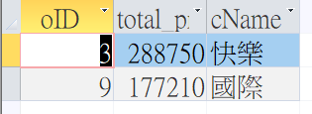
- 從關聯訂單資料表選取訂單編號、單價、數量，從產品資料表選取產品名稱，從客戶資料表選取客戶名稱，並列出總價。
Select orderTable.[oID],orderTable.[single_price],
orderTable.[quantity],orderTable.[total_price],
products.[pName],customers.[cName]
FROM (orderTable
inner join products on orderTable.[pID] = products.[pID])
inner join customers on orderTable.[cID] = customers.[cID];
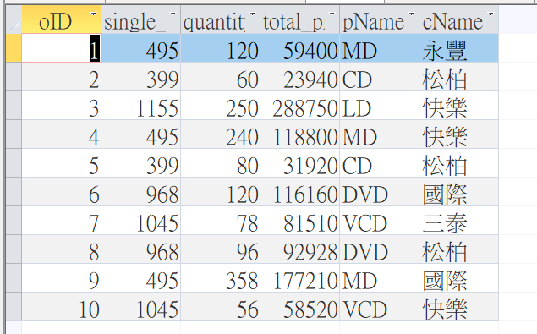
- 從關聯訂單資料表選取訂單編號、單價、數量、總價，從產品資料表選取產品名稱，從客戶資料表選取客戶名稱，其中每筆記錄必須是快樂公司的記錄。
Select orderTable.[oID],orderTable.[single_price],
orderTable.[quantity],orderTable.[total_price],
products.[pName],customers.[cName]
FROM (orderTable
inner join products on orderTable.[pID] = products.[pID])
inner join customers on orderTable.[cID] = customers.[cID]
where customers.cName = '快樂';
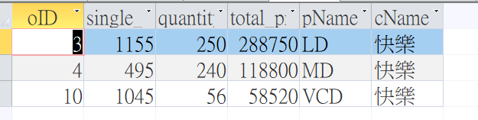
- 從關聯訂單資料表選取訂單編號、單價、數量、總價（單價*數量），從產品資料表選取產品名稱，從客戶資料表選取客戶名稱，並列出總價（關聯訂單資料表.數量*關聯訂單資料表.單價），其中每筆記錄必須滿足單價>平均單價，且結果根據客戶資料表的客戶編號做遞增排序。
select orderTable.[oID],
orderTable.single_price,
orderTable.quantity,
orderTable.total_price,
products.pName,
customers.cName
from ((orderTable
inner join products on products.pID = orderTable.pID)
inner join customers on orderTable.cID = customers.cID)
where orderTable.single_price > (select avg(single_price) from orderTable)
order by customers.cID ASC;
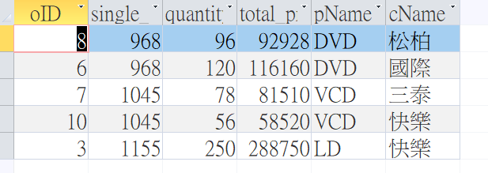
- 每筆記錄必須對產品資料表的產品名和客戶資料表的客戶名稱分群，針對每群記錄計算出合計總價。(從關聯訂單資料表選取合計總價（sum(單價*數量)），從產品資料表選取產品名稱，從客戶資料表選取客戶名稱。)
select products.pName,customers.cName,sum(orderTable.single_price * orderTable.quantity) as '合計總價'
from (orderTable
inner join products on orderTable.pID = products.pID)
inner join customers on customers.cID = orderTable.cID
group by products.pName,customers.cName;
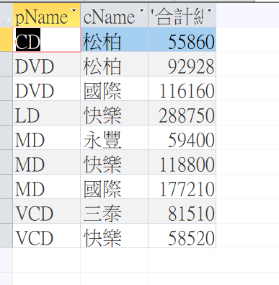
- 列出總價大於平均總價的客戶名稱。（只列出客戶名稱即可，客戶名稱不可重複。）
Select customers.cName
From customers,orderTable
Where customers.cID = orderTable.cID and orderTable.total_price > (select avg(orderTable.total_price) from orderTable)
Group by customers.cName
- 列出每個客戶名稱及計算出該客戶曾經訂過幾種不同的產品。
select cName,count(*) as 產品
from (select cName, count(*)
From customers,orderTable
where customers.cID = orderTable.cID
Group by cName, pID)
Group by cName;
- 計算出到目前為止每家公司訂購各種產品的總量。（列出客戶名稱、產品名稱、數量的合計）
SELECT customers.CName, products.PName, Sum(orderTable.quantity) AS TotalQuantity
FROM (customers INNER JOIN orderTable ON customers.cID = orderTable.cID)
INNER JOIN Products ON orderTable.pID = products.pID
GROUP BY customers.cName, products.pName;
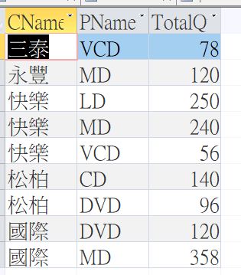

- 從關聯訂單資料表選取訂單編號、單價、數量，從產品資料表選取產品名稱，從客戶資料表選取客戶名稱，將記錄中產品名稱是cd的單價上漲10﹪。

select oID,single_price*1.1 as NEW_cd_single_price,quantity,pName,cName
from customers,orderTable,products
where customers.cID = orderTable.cID
and orderTable.pID = products.pID
and products.pName = 'cd';

union

select oID,single_price as NEW_cd_single_price,quantity,pName,cName
from customers,orderTable,products
where products.pName <> 'cd'
and customers.cID = orderTable.cID
and orderTable.pID = products.pID;
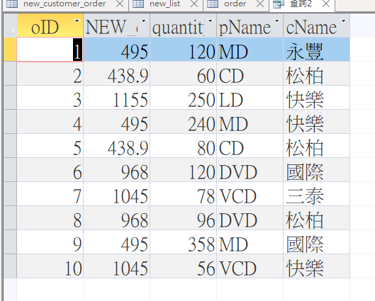
- 從關聯訂單資料表選取訂單編號、單價、數量、總價（單價*數量），從產品資料表選取產品名稱，從客戶資料表選取客戶名稱，產生一個新資料表叫做訂單明細資料表。
SELECT orderTable.pID, orderTable.single_price, orderTable.quantity, orderTable.total_price, products.pName, customers.cName
into new_list
FROM (customers INNER JOIN orderTable ON customers.cID = orderTable.cID)
INNER JOIN products ON orderTable.pID = products.pID;

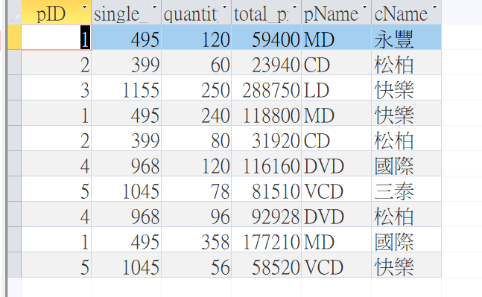

- 建立一資料表名稱為訂單表，所含欄位及資料類型分別為：訂單編號為數字型態，客戶編號為文字型態且大小為5，員工編號為文字型態，訂單日期為日期與時間型態，要貨日期為日期與時間型態，送貨日期為日期與時間型態，運費為數字型態(貨幣)，收貨人為文字型態，送貨地址為文字型態。
CREATE TABLE order (
OrderID INT,
CustomerID TEXT(5),
EmployeeID TEXT,
OrderDate DATETIME,
RequiredDate DATETIME,
ShippedDate DATETIME,
Freight CURRENCY,
ShipName TEXT, ShipAddressTEXT);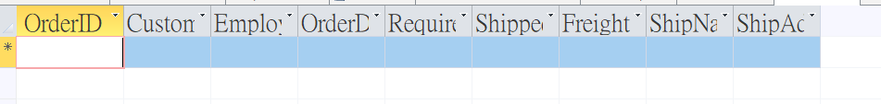

- 針對已存在的訂單表，根據訂單編號建立一索引，名稱為ordnoind。
Create index ordnoind on order(oID);

- 在訂單表資料表中，新增一折扣的欄位，資料類型必須可包含小數 (浮點數)。
Alter table order add column discount float;

- 刪除訂單表資料表中的折扣的欄位。
Alter table order drop column discount;

- 刪除訂單表資料表中名稱為ordnoind的索引。
Drop index ordnoind on order;

- 刪除訂單表資料表。
Drop table order;

