Brian Duenas

CSE 460

HW 1

40 points total

1.

Q: How many processes does the following piece of code create? Why?

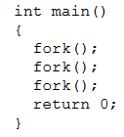

A: The code creates 8 processes. Each fork creates a parent and child process so, 2\*2\*2= 8.

2a.



Output:



2b.



Output:



3a.



3b.



Output:

