Brian Duenas

CSE 460

Lab 1

20 points total

1) Basic Linux Commands

*ls –* List the files in the current directory

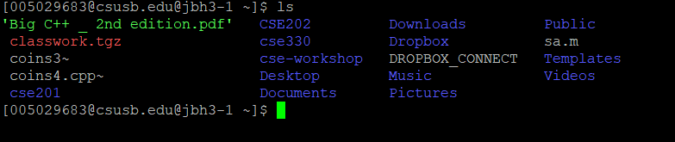

*ls –all –* List the files in the current directory with system access, author, and date created

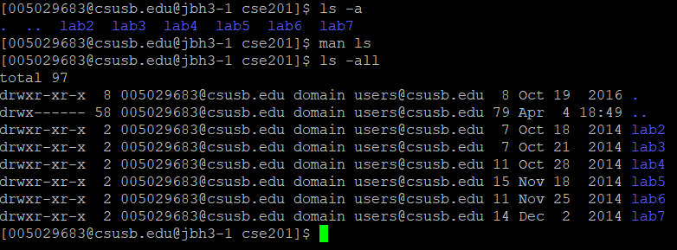

*cp –* Copies files and directories

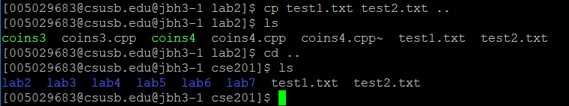

*cp* – Send to directory in current directory

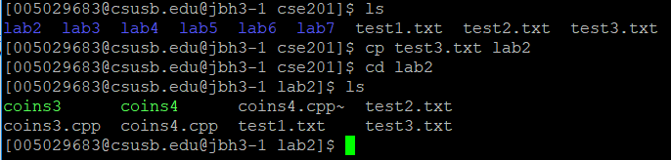

*rm* – remove files or directories

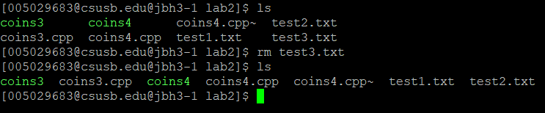

*rm* – remove multiple files

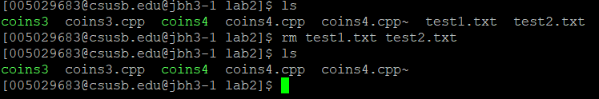

*mv* – move files or directories

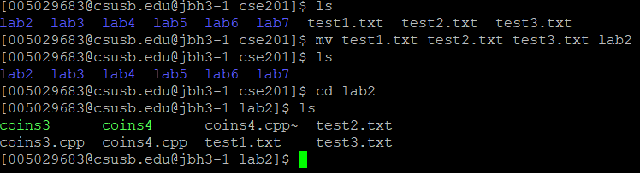

*mv* – Rename a file using mv

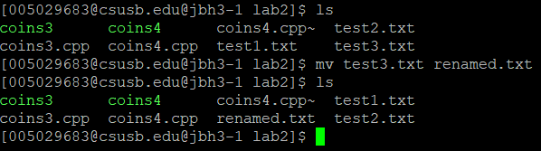

*cd* – “Change Directory” by itself takes you to home directory



*cd ..*- Takes user down one directory

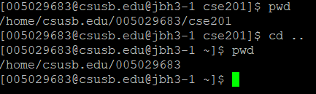

*mkdir* – “make directory” makes a directory

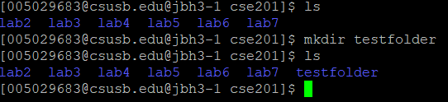

*mkdir [][][]* – Make multiple directories

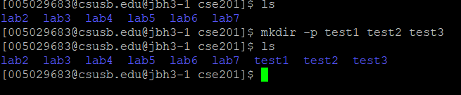

*vi* – a built in text editor, can create files or edit existing files

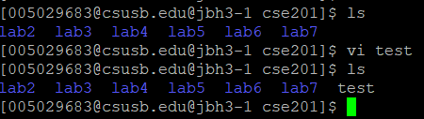

2) Simple C++ program

Main.cpp:

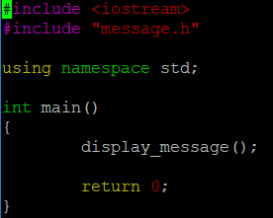

Message.cpp:

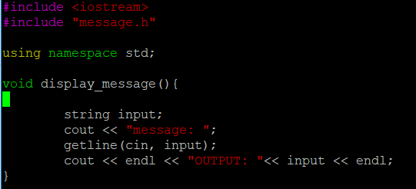

Message.h:



Makefile:

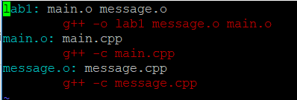

Output:

